HARDWARE IMPLEMENTATION OF RADIX-5 FFT ARCHITECTURE FOR LTE SYSTEMS

A PROJECT REPORT
Submitted in partial fulfilment of the requirements for the Award of the degree of
BACHELOR OF TECHNOLOGY
IN
ELECTRONICS AND COMMUNICATION ENGINEERING
BY

N V ASHOK KUMAR 16001A0414
K NAVYA BHAVANI 16001A0415
A SETHUVARDHAN 17005A0415

Under the guidance of
Assistant Professor Ad-hoc

Mr. M SREEDHAR

Department of Electronics and Communication Engineering
COLLEGE OF ENGINEERING (AUTONOMOUS)
JAWAHARLAL NEHRU TECHNOLOGICAL UNIVERSITY
ANANTHAPURAMU-515002 A.P
2020

JAWAHARLAL NEHRU TECHNOLOGICAL UNIVERSITY ANANTAPUR
COLLEGE OF ENGINEERING (AUTONOMOUS)
ANANTHAPURAMU-515002 A P
DEPARTMENT OF ELECTRONICS AND COMMUNICATION ENGINEERING

CERTIFICATE

This is to certify that the project work entitled “HARDWARE IMPLEMENTATION OF RADIX-5 FFT ARCHITECTURE FOR LTE SYSTEMS” is being submitted in partial fulfilment for the award of “Bachelor of Technology” in Electronics and Communication Engineering, to the Jawaharlal Nehru Technological University is a record of bonafide work carried out by

N V ASHOK KUMAR 16001A0414
K NAVYA BHAVANI 16001A0415
A SETHUVARDHAN 17005A0415

Under the guidance and supervision of

PROJECT GUIDE HEAD OF THE DEPARTMENT

Mr. M SREEDHAR Prof. P RAMANA REDDY
Assistant professor Ad-hoc Head of the Department
Department of ECE Department of ECE
JNTUA College of Engineering JNTUA College of Engineering
Ananthapuramu Ananthapuramu

ACKNOWLEDGEMENTS

It is a great pleasure in expressing deep sense of gratitude and veneration to our guide Mr. M SREEDHAR, Assistant Professor Ad-hoc of Electronics and Communication Engineering for his valuable guidance. His advice, assistance and patience are generally appreciated.
We also express our sincere thanks to Prof. P RAMANA REDDY, Professor and Head of Electronics and Communication Engineering for his encouragement and for providing the required computational facilities throughout the project.
We are greatly indebted to Prof. K. GOVINDA RAJULU, Principal, JNTUA College of Engineering for providing outstanding facilities for completion of project.
We convey our thanks to all teaching and non-teaching staff of department those who have helped in several ways in completion of project successfully.

With gratitude,
Project Associates...

DECLARATION

We hereby declare that the dissertation entitled “Hardware Implementation of Radix-2 FFT architecture for LTE Systems” submitted by us to JNTUA College of Engineering Anantapuramu in partial fulfillment of the requirement of the degree of Bachelor of Technology (B.Tech) in Electronics & Communication Engineering (ECE) is a record of bonafide project work carried out under the guidance of Mr. M SREEDHAR.

We further declare that the work reported by this project has not been submitted & will not be submitted, either in part or full, for the award of any other degree or diploma in this institute or any other institute or university.

Place: Ananthapuramu N. V. Ashok Kumar (16001A0414)
Date: K. Navya Bhavani (16001A0415)
A. Sethuvardhan (17005A0415)

ABSTRACT
The primary objective of this project is to design a Radix-5 FFT architecture that can be used in modern digital signal processing systems. Fast Fourier Transform (FFT) has become extensive in many engineering applications. Nowadays, FFT is most widely used block in many communication and signal processing systems. Especially this radix-5 FFT can be used in mixed radix applications like 4G and upcoming technologies. This project presents a new FFT processor for the FFT calculation of five independent data streams with the help of radix-5 FFT kernel. A new radix-5 algorithm for realization of Fast Fourier transform (FFT) of length N = 5^m (m = 1, 2, 3,.) is presented. The FFT of length N can be realized from five DFT sequences, each of length N/5. The proposed design is synthesized and implemented using spartan 6 Xilinx kit.

CONTENTS
Abstract
List of Figures

- INTRODUCTION 1
  - Problem definition 3
  - Objective of Project 3
  - Organization of Documentation 3
  - Applications 3
- LITERATURE REVIEW 4
- FAST FOURIER TRANSFORM 8
  - Algorithmic explanation of DFT 8
  - Radix-2 FFT Algorithms 9
  - Radix-5 FFT Architecture 12
  - Floating Point Arithmetic 14
  - Vedic Multiplier 17
- VHDL IMPLEMENTATION 19
  - VHDL Introduction 19
    - Power and Flexibility 19
    - Device-Independent design 19
    - Portability 19
    - Benchmarking capabilities 19
  - VHDL DESCRIPTION 20
4.2.1 Entities and Architectures 20
  - XILINX ISE DESIGN 21
    - Xilinx working 21
    - ISE Software tool 22
- SIMULATION & SYNTHESIS RESULTS 31
- CONCLUSION 35
REFERENCES 36

LIST OF FIGURES
3.1 Three stages in 8-point DFT 11
3.2 8-point DIT FFT 11
3.3 Basic Butterfly in DIT FFT 11
3.4 Radix-5 flowgraph 13
3.5 flowchart for floating-point adder 15
3.6 flowchart for floating-point multiplier 16
3.7 block diagram of 24*24 bit vedic multiplier 18
4.1 ISE help topics 22
4.2 Xilinx project navigator window 23
4.3 New project Initiation window 23
4.4 Device and Design flow of project 24
4.5 Create new source window 25
4.6 Creating VHDL-HDL source file 26
4.7 VHDL source window 26
4.8 New project information window 27
4.9 VHDL source code editor window 28
4.10 OR gate description using assign statement 29
4.11 Implementing the design 30
5.1 Input and Output of “fft2” block 31
5.2 Input and Output of “K11” block 31
5.3 Inputs given to system 32
5.4 Obtained outputs 32
5.5 RTL schematic 33
5.6 Enlarged RTL schematic 33

CHAPTER 1
INTRODUCTION
The Fast Fourier transform (FFT) is one of the most important algorithms in the field of digital signal processing. It is used to calculate the discrete Fourier transform (DFT) efficiently. In order to meet the high performance and real-time requirements of modern applications, hardware designers have always tried to implement efficient architectures for the computation of the FFT. The 3GPP Long Term Evolution (LTE) mobile phone system is currently being deployed world wide [1]. This 4G system allows for much higher data rates than its predecessors. The target rate is 100 MBits/s or above in good conditions. Future updates, called LTE advanced, allows for even higher data rates, up to 1 GBits/s. In order to reach these high data rates, the system must be optimized and used efficiently. In current real-time applications, the FFT has to be calculated at very high throughput rates, even in the range of Giga samples per second. These high-performance requirements appear in applications such as orthogonal frequency division multiplexing (OFDM) [2]-[4] and ultra-wideband (UWB). The standard is based on orthogonal frequency division multiplexing (OFDM). The transmitted data is spread over a number of subcarriers on different frequencies. To spread the data the Fast Fourier Transform (FFT) is employed. For the most part the FFT size can be a standard 2^{n} point FFT. However there are situations where other FFT sizes are beneficial. The minimum frequency allocation unit - the resource block (RB) - contains 12 subcarriers, which cannot be factored in twos only [1]. Further, the maximum number of resource blocks allocated in one band is 100, which also cannot be factored in twos only. Certain channel estimation algorithms that want to use the available subcarriers, require FFTs of 1200 or 2400 points [5]. Mainly this radix-5 FFT is used in mixed radix implementation.A mixed radix FFT of 1200 points require 36 real multipliers in a pipelined implementation whereas a 2048 radix 2 FFT needs 30 real multipliers. However, half of the multipliers in the mixed radix case can be constant [6].Because of this always only radix-2 FFT is not enough for different points. So,for that many FFT architectures have evolved to reduce the hardware of the system. Some of the architectures like radix-3 and radix-5 has been evolved for these purposes.
The floating-point number system is attractive for various applications such as graphics, signal processing, and scientific calculations because it can provide an enormous dynamic range. This large range of the floating-point number system enables designers to overcome problems such as overflow that often occur in fixed point implementation. Among the various floating-point number formats that are used, the IEEE-754 standard is used in this report. The IEEE-754 floating point standard is frequently used in Intel, Apple, and most UNIX systems.
The IEEE-754 standard only considers ﬂoating-point formats with a radix of 2 or 10 (although the decimal case will not be further discussed in this paper). This means that a straight-forward implementation of a ﬂoating-point number format with another radix is not compatible with IEEE-754. However, the format is capable of accurately representing all values possible in a single precision IEEE754 number. This means that it is possible to create ﬂoating point operators based on the HRFP₁₆ format that will produce the exact same value as speciﬁed by IEEE-754, as long as a post-processing step is employed that guarantees that the result is a value that can be represented in single precision IEEE-754 [7]. The overall goal of our design was to balance throughput and latency. Low latency is important if the floating point unit is to be used as building blocks for systems where the algorithms are not known beforehand, e.g. if the units are to be used in a processor. In theory, if latency was not a constraint, pipeline stages could have been added until a higher clock frequency could not be achieved [8]. In FFT algorithms, both the sum and the difference of a pair of operands are needed frequently. In view of the limited precision required for most DSP applications, all implementations in this paper (discrete as well as fused) support only the 32-bit IEEE-754 standard format [7]. Although a hardware implementation of subnormal’s is not provided, all four IEEE rounding modes are supported. This facilitates interfacing to other system elements that support the IEEE floating-point standard format.
A floating point multiplier is conceptually easy to construct. The new mantissa is formed as a multiplication of the old mantissas. In order to construct a good multiplier some FPGA specific optimizations were needed [8]. The 24x24 bit multiplication of the mantissa is constructed using 24 bit vedic multiplier. This paper proposes the design of high speed Vedic Multiplier using the techniques of Ancient Indian Vedic Mathematics that have been modified to improve performance. Vedic Mathematics is the ancient system of mathematics which has a unique technique of calculations based on 16 Sutras. The work has proved the efficiency of Urdhva Triyagbhyam– Vedic method for multiplication which strikes a difference in the actual process of multiplication itself. It enables parallel generation of intermediate products, eliminates unwanted multiplication steps with zeros and scaled to higher bit levels using Karatsuba algorithm with the compatibility to different data types [9].

  - PROBLEM DEFINITION
Now-a-days, many applications require simultaneous computation of multiple independent Fast Fourier transform operations with their outputs in their natural order. A mixed radix type of FFT’s became widely useful as to reduce the hardware or the gate count. Therefore this brief report presents a FFT processor for Radix-5 FFT that can be used in mixed radix FFT’s which is useful in 4G and upcoming technologies.

1.2 OBJECTIVE OF THE PROJECT
The main objective of this project to design a FFT processor which can implement Radix-5 FFT kernel. A new radix-5 algorithm for realization of Fast Fourier transform (FFT) of length N = 5^m (m = 1, 2, 3,.) is presented. The FFT of length N can be realized from five DFT sequences, each of length N/5. Implementation of vedic multiplier for low latency in the floating point multiplier block.

  - ORGANIZATION OF DOCUMENTATION
This document provides introduction in Chapter 1. Chapter 2 provides information about Literature review. It provides introduction of Fast Fourier Transform and proposed architecture in 3rd chapter. In chapter 4 explains VHDL implementation which includes VHDL introduction, description, XILINX working and ISE software tool. Chapter 5 deals with the simulation and synthesis results.

  - APPLICATIONS
In ultra-wideband applications FFT processor is the module with high computational complexity. As it is a key component in most of the digital systems it should be designed properly in achieving high speed, low power, low area etc., the design supports all FFT sizes, namely 128-2048/1536, required by the LTE applications. The recent boost of such interest is due to communication applications, in particular 3GPP Long Term Evolution (LTE) and 4G , e.g., 1200 and 2400 point radix and also can be used in many more applications.

CHAPTER 2
LITERATURE REVIEW
The references given in the following are related with the DFT and FFT based control algorithms in power quality issues. A method for the calculation of bus voltage transients in an electric power system is presented (Heydt, 1989) [10]. The fast Fourier transform is used in order to give computational efficiency. Two approximations are found for the calculation of this transfer impedance and one of these is found to be applicable to the cited problem. Examples are used to illustrate the calculation of bus voltage transients and harmonic content. The Gibbs phenomenon appears in a discrete Fourier transform due to incomplete periodic, the waveform has not reached a full cycle within its period. Data flipping furnishes a complete periodic cycle to the waveform and thus suppresses the Gibbs phenomenon [8]. This facilitates the design of a digital filter using fast Fourier transform without windowing. The filter does low-pass, band-pass, high-pass, band-stop, notch or single-frequency-pass simply by manipulating the band limits. The filter can be affected by spectral resolution and the slope discontinuity at the end data points. The reduction of such effects and an alternative design are discussed (Pan, 1993) [10]. The evaluation of DFT spectra usually yields more detailed information than evaluation in the time domain is presented (Breitenbach, 1999). The evaluation of time-discrete spectra, hampered by leakage, which occurs if a non-integral number of periods, is present in the sampled data set. Minimization of spectral leakage is an important prerequisite for spectrum analysis. Measurement errors of the impulse peak value and time parameters have been evaluated via FFT, convolution and IFFT for a commercial divider. Direct determination of the high voltage impulse measurement range, no need for any additional parameters and illustrative graphical presentation of results are the main advantages of this approach. Limitations of different qualification approaches are discussed. The problem of differentiating inrush currents from fault currents that are observed for a feeder at a distribution substation is discussed Baran et al. 2006 [11]. This paper shows that the two approaches the Fourier transform and the Wavelet transform can be adopted to extract features that make it possible to distinguish them from each other by using an artificial-neural-network-based classifier. The paper also illustrates how to address the issues for successful implementation of these schemes; such as prescreening of data, how to apply FFT and wavelet transform on the data and the training of the artificial neural network in order to maximize the performance of the classifier. These issues are illustrated using the actual field data. An approach to simplify the design of IFFT/FFT cores for OFDM applications is presented (Cortes et al., 2006). A novel software tool is proposed, called AFORE. It is able to generate efficient single and multiple mode IFFT/FFT processors. AFORE employs a parallel architecture, where the degree of parallelism can be varied. In order to assess the quality of the proposed approach, results are provided for some of the most widely used OFDM standards, such as, WLAN 802.11 a/g, WMAN 802.16a, DVB-T. The sliding DFT algorithm as an alternative for typical DFT used for spectrum analysis and synthesis is proposed Heriakian (2006) [10]. In the proposed circuit transient performance of APF is improved using non-causal predictive current compensation. An improved FFT-based algorithm to measure harmonics and interharmonics accurately is proposed (Qian et al., 2007). In the proposed algorithm, a frequency-domain interpolation approach is adopted to determine the system fundamental frequency and the inter-polatory polynomial method is applied to reconstruct the sampled time-domain signal; it is followed by using the FFT to calculate the actual harmonic components. The performance of the proposed algorithm is validated by testing the actual measured waveforms. Results are compared with those obtained by directly applying a typical FFT algorithm and by the International Electro technical Commission (IEC) grouping method. The uncertainty analysis of the Root-Mean-Square (RMS) value and phase computed from the DFT spectrum of the non-coherently sampled signal using cosine windows are investigated (Novotny et al., 2007) [12]. The analysis is focused on investigating the influence of quantization noise. Ordinarily, the sampling frequency is equal to the product of the nominal signal frequency and the window width. However, when the signal frequency drifts, to avoid the phase and magnitude errors, the sampling frequency can be adaptively adjusted using the phase-error itself. An integrated phase-locked loop scheme and its parameters like hold-in, pull-in ranges, lock time, steady-state errors are presented in this brief. A strategy of group-harmonic weighting distribution is proposed for system-wide inter-harmonic evaluation in power systems (Lin, 2008). The proposed algorithm can restore the dispersing spectral leakage energy caused by the FFT and calculate the power distribution proportion around the adjacent frequencies at each harmonic to determine the inter-harmonic frequency. The numerical examples are presented to verify the performance of the proposed algorithm. A precise and adaptive algorithm for interharmonics detection based on iterative DFT is proposed (Zhang et al., 2008). Practical formulas to calculate the parameters of harmonics and interharmonics in electric power systems are presented. An algorithm for fundamental frequency and harmonic components detection is presented (Lavopa et al., 2009). The technique is based on a real-time implementation of discrete Fourier transform and it allows fast and accurate estimation of fundamental frequency and harmonics of a distorted signal with variable fundamental frequency. An algorithm for the estimation of the frequency of single-tone signals is presented by Radil et al. (2009). The algorithm works in the frequency domain and is based on best fitting a theoretical spectrum of a single-tone signal that is windowed using a rectangular window on the spectrum of the sampled signal. The three-phase four-wire APF based on a three-level neutral-point-clamped inverter is presented by Vodyakho and Kim (2009). To regulate and balance the split DC-capacitor voltages, a control using the sign cubical hysteresis controller is proposed. The control method discerns the harmonic currents by fast Fourier transform choosing switching states from a switching table based on the hysteresis control. An analysis for simultaneous sensing of multiple primary user activity in cognitive radios has been presented from a signal-processing perspective by Sheikh et al. (2009). It has been shown that a poly-phase DFT filter bank with an optimal window as prototype filter can lead to reliable as well as efficient sensing and detection architecture in cognitive radios with minimal overhead. An analysis of the natural voltage balancing dynamics of a three-phase flying capacitor converter is presented when supplying an induction motor (McGrath et al., 2009). The approach substitutes double Fourier harmonic series for the pulse-width modulation switching waveforms and the frequency response of the motor, to create a linear state-space model of this type of load. Model parameters were measured by applying FFT analysis to variable frequency square waves injected into the motor terminals and fitting parameter values to these measurements using a least squares minimization method. Experimental verification results using a scaled-down flying capacitor converter drive are included. A partial cached FFT processor that accounts for the distribution of allocated resources to the users of the OFDMA system is designed by Chen et al. (2010). The constellation- and power-aware twiddle-factor multiplier for the variable FFT length and modulation order are designed. A closed-form analytical approximation of the output harmonic spectrum of a single-phase two-level inverter under the action of hysteresis current control is derived by Albanna et al. (2010). The analytical approach consists of first describing the error current as a triangular signal of variable duty cycle and frequency and subsequently, deriving the Fourier transform of the complex envelope of the modulated triangular signal. The spectrum of the error current is given in terms of Bessel functions of the first kind. An estimating the amplitude of harmonic components of a harmonically distorted sine wave by the Interpolated Discrete Fourier Transform (IPDFT) method with maximum side lobe decay windows is proposed by Belega et al. (2010). In addition, for a signal corrupted by stationary white noise, the statistical efficiency of the IPDFT method is investigated with respect to the singletone unbiased Cramér–Rao Lower Bound. An application of Fourier transform approach in modulation technique of experimental studies is considered by Khazimullin et al. (2010). The analysis has been confirmed by simulations and measurements of a quartz wedge birefringence by means of the photo elastic modulator. The obtained bias, noise level and measuring speed are comparable and even better than in lock-in amplifier technique. The harmonic components of a carrier-based Pulse Width-Modulated (PWM) voltage source converter (VSC) output voltage are theoretically identified when the modulating wave includes fundamental and baseband harmonic components (Odavic et al., 2010). The analysis is based on a double Fourier series expansion in two variables. This approach to harmonic identification is evaluated by comparison with a fast Fourier transform analysis of simulated PWM waveforms. The Reference Signal Generator (RSG) for voltage-source converters (VSCs) that enables the maximization of its functionality is presented by Borisov et al. (2010). The proposed RSG is based on a combination of the Fortescue decomposition with recursive discrete Fourier transform. The method is characterized by computational efficiency, excellent detection accuracy and fast dynamic response. In addition to simulation results, an experimental setup is designed to prove the advantages of resorting to the DFT. PWM of a sampled signal produces harmonic distortion is analyzed and proposed expressions are obtained for the Fourier transform of the modulated output, which are valid for any input signal (Colodro et al., 2010). In addition, simple expressions are given to compute the harmonic distortion factors for a sinusoidal input signal. Finally, these analytical results are validated by simulation for two data converters based on sigma–delta modulation, where the sampled output of a multibitquantizer is pulse width modulated: one digital-to-analog and one analog-to-digital converter, respectively. The basics of two techniques, named here as the modified harmonic domain and the modified dynamic harmonic domain, proposed for calculating steady and dynamic states are presented, respectively (Ramirez, 2011). These techniques have their fundament in the harmonic domain with a substantial improvement: the inclusion of interharmonics in either steady or dynamic state. This is performed through the use of the discrete Fourier transform which allows an arbitrary frequency-domain discretization, thus permitting the representation of interharmonics.

CHAPTER 3
FAST FOURIER TRANSFORM
FFT circuitry consists of several consecutive multipliers and adders over complex numbers. Until recently, most FFT architectures used fixed-point arithmetic only, before FFTs based on floating-point operations became prominent. Using the IEEE-754-2008 standard for floating-point arithmetic allows FFT co-processors to collaborate with general purpose processors. A Fast Fourier Transform is an algorithm that computes the Discrete Fourier Transform (DFT) of a sequence, or its inverse (IDFT). Fourier analysis converts a signal from its original domain (often time or space) to a representation in the frequency domain and vice versa. The DFT is obtained by decomposing a sequence of values into components of different frequencies. This operation is useful in many fields, but computing it directly from the definition is often too slow to be practical. An FFT rapidly computes such transformations by factorizing the DFT matrix into a product of sparse (mostly zero) factors.
As a result, it manages to reduce the complexity of computing the DFT from O(N^2), which arises if one simply applies the definition of DFT to O(N log N), where N is the data size.

3.1 ALGORITHMIC EXPLANATION OF DFT
In present several methods for computing the DFT efficiently. In view of the importance of the DFT in various digital signal processing applications, such as linear filtering, correlation analysis, and spectrum analysis, its efficient computation is a topic that has received considerable attention by many mathematicians, engineers, and applied scientists. From this point, we change the notation that X (k), instead of y (k) in previous sections, represents the Fourier coefficients of x (n). Basically, the computational problem for the DFT is to compute the sequence {X (k)} of N complex-valued numbers given another sequence of data {x (n)} of length N, according to the formula

$$X\left(k\right)=\sum_{n=0}^{N-1}{x\left(n\right)W_{N}^{kn}}, 0≤k≤N-1 \left(1\right)$$
$$W_{N}=e^{-\frac{j2π}{N}}$$
In general, the data sequence x(n) is also assumed to be complex valued. Similarly, The IDFT becomes
$$x\left(n\right)=\left(\frac{1}{N}\right)\sum_{n=0}^{N-1}{X\left(k\right)W_{N}^{-kn}}, 0≤n≤N-1 \left(2\right)$$
Since DFT and IDFT involve basically the same type of computations, our discussion of efficient computational algorithms for the DFT applies as well to the efficient computation of the IDFT. We observe that for each value of k, direct computation of X(k) involves N complex multiplications (4N real multiplications) and N-1 complex additions (4N-2 real additions). Consequently, to compute all N values of the DFT requires N ² complex multiplications and N ²-N complex additions. Direct computation of the DFT is basically inefficient primarily because it does not exploit the symmetry and periodicity properties of the phase factor W_{N}. In particular, these two properties are:
Symmetry property: $W_{N}^{K+\frac{N}{2}}$= ${-W}_{N}^{K}$
Periodicity property:$W_{N}^{K+N}$= $W_{N}^{K}$ (3)
The computationally efficient algorithms described in this section, known collectively as fast Fourier transform (FFT) algorithms, exploit these two basic properties of the phase factor.
3.2 RADIX-2 FFT ALGORITHM
Consider the computation of the N = 2^{v} point DFT by the divide-and conquer approach. We split the N-point data sequence into two N/2-point data sequences f₁(n) and f₂(n), corresponding to the even-numbered and odd-numbered samples of x(n), respectively, that is,
$f_{1}\left(n\right)$= x(2n)
$f_{2}\left(n\right)$= x(2n+1) n=0, 1, ...(N/2)-1 (4)
Thus f₁(n) and f₂(n) are obtained by decimating x(n) by a factor of 2, and hence the resulting FFT algorithm is called a decimation-in-time algorithm.
Now the N-point DFT can be expressed in terms of the DFT's of the decimated sequences as follows:
$$X\left(k\right)=\sum_{n=0}^{N-1}{x\left(n\right)W_{N}^{kn}}, k=0,1,…,N-1$$
$$=\sum_{n even}{x\left(n\right)W_{N}^{kn}}+\sum_{n odd}{x\left(n\right)W_{N}^{kn}}$$
$$=\sum_{m=0}^{\frac{N}{2}-1}{x\left(2m\right)W_{N}^{2mk}}+\sum_{m=0}^{\frac{N}{2}-1}{x\left(2m+1\right)W_{N}^{k\left(2m+1\right)} } \left(5\right)$$
But W_{N}² = W_{N/2}. With this substitution, the equation can be expressed as
$$X\left(k\right)=\sum_{m=0}^{\frac{N}{2}-1}{f_{1}\left(m\right)W_{\frac{N}{2}}^{km}}+\sum_{m=0}^{\frac{N}{2}-1}{f_{2}\left(m\right)W_{\frac{N}{2}}^{km}}$$
=$F_{1}\left(k\right)+W_{N}^{k}F_{2}\left(k\right), k=0,1,…,N-1$ (6)
Where F₁ (k) and F₂ (k) are the N/2-point DFTs of the sequences f₁ (m) and f₂ (m), respectively.
Since F₁ (k) and F₂ (k) are periodic, with period N/2, we have F₁ (k+N/2) = F₁ (k) and
F₂ (k+N/2) = F₂ (k). In addition, the factor W_{N}^{k+N/2} = -W_{N}^{k}. Hence the equation may be expressed as
X(k) = $F_{1}\left(k\right)+W_{N}^{k}F_{2}\left(k\right)$, k=0, 1, …, (N/2)-1
X(k+$\frac{N}{2}$) = $F_{1}\left(k\right)-W_{N}^{k}F_{2}\left(k\right)$, k=0, 1, …, (N/2)-1 (7)
For N = 2^{v}, this decimation can be performed v = log₂N times. Thus the total number of complex multiplications is reduced to (N/2) log2N. The number of complex additions is Nlog₂N. For illustrative purposes, Figure depicts the computation of N = 8 point DFT. We observe that the computation is performed in three stages, beginning with the computations of four two-point DFTs, then two four-point DFTs, and finally, one eight-point DFT. The combination for the smaller DFTs to form the larger DFT is illustrated in Figure for N = 8.
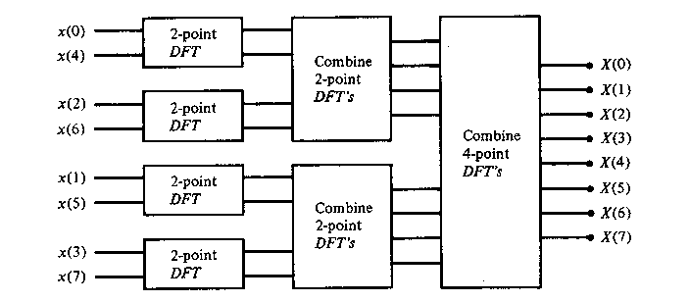
Fig. 3.1. Three stages in the computation of an N = 8-point DFT.

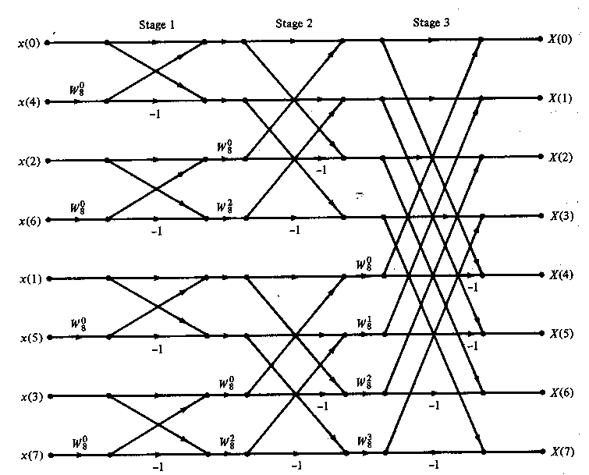
Fig. 3.2. Eight-point decimation-in-time FFT algorithm

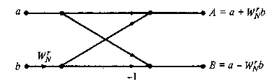
Fig. 3.3. Basic butterfly computation in the DIT FFT algorithm

3.3 RADIX-5 FFT ALGORITHM
An N-point DFT is given as
$$P\left(L\right)=\sum_{n=0}^{N-1}{P\left(n\right)W_{N}^{Ln} } L=0,1,2,…N-1 (1)$$
Where N is the transform size and $W_{N}^{Ln}=ⅇ^{-\dot{j}}\frac{2Π}{N}Ln$
The Radix-5 algorithm is used for realization of FFT of length N = 5^{n}. Therefore, the DFT is divided into smaller DFT’s of length N/5.
$$P\left(L\right)=\sum_{n=0}^{\frac{N}{5}-1}{P\left(n\right)W_{N}^{Ln}}+\sum_{n=\frac{N}{5}}^{\frac{2N}{5}-1}{P\left(n\right)W_{N}^{Ln}}+\sum_{n=\frac{2N}{5}}^{\frac{3N}{5}-1}{P\left(n\right)W_{N}^{Ln}}+\sum_{n=\frac{3N}{5}}^{\frac{4N}{5}-1}{P\left(n\right)W_{N}^{Ln}}+\sum_{n=\frac{4N}{5}}^{N-1}{P\left(n\right)W_{N}^{Ln}} (2)$$
$$P\left(L\right)=\sum_{n=0}^{\frac{N}{5}-1}{[P\left(n\right)W_{N}^{Ln}+W_{N}^{\frac{Ln}{5}}P\left(n+\frac{N}{5}\right)W_{N}^{Ln}}+W_{N}^{\frac{2Ln}{5}}P\left(n+\frac{2N}{5}\right)W_{N}^{Ln}+W_{N}^{\frac{3Ln}{5}}P\left(n+\frac{3N}{5}\right)W_{N}^{Ln}+W_{N}^{\frac{4Ln}{5}}P\left(n+\frac{4N}{5}\right)W_{N}^{Ln}] (3)$$
$$P\left(L\right)=\sum_{n=0}^{\frac{N}{5}-1}{[P\left(n\right)+P\left(n+\frac{N}{5}\right)W_{5}^{L}}+P\left(n+\frac{2N}{5}\right)W_{5}^{2L}+P\left(n+\frac{3N}{5}\right)W_{5}^{3L}+P\left(n+\frac{4N}{5}\right)W_{5}^{4L}]W_{N}^{Ln} (4)$$
On further simplification for 5-points ,we get
$$P\left(0\right)=p\left(0\right)+p\left(1\right)+p\left(2\right)+p\left(3\right)+p\left(4\right) (5)$$
$$P\left(1\right)=p\left(0\right)+W_{5}p\left(1\right)+W_{5}^{2}p\left(2\right)+W_{5}^{3}p\left(3\right)+W_{5}^{4}p\left(4\right) (6)$$
$$P\left(2\right)=p\left(0\right)+W_{5}^{2}p\left(1\right)+W_{5}^{4}p\left(2\right)+W_{5}p\left(3\right)+W_{5}^{3}p\left(4\right) (7)$$
$$P\left(3\right)=p\left(0\right)+W_{5}^{3}p\left(1\right)+W_{5} p\left(2\right)+W_{5}^{4}p\left(3\right)+W_{5}^{2}p\left(4\right) (8)$$
$$P\left(4\right)=p\left(0\right)+W_{5}^{4}p\left(1\right)+W_{5}^{3}p\left(2\right)+W_{5}^{2}p\left(3\right)+W_{5}p\left(4\right) (9)$$
The signal flow graph is shown in the Fig.3.4
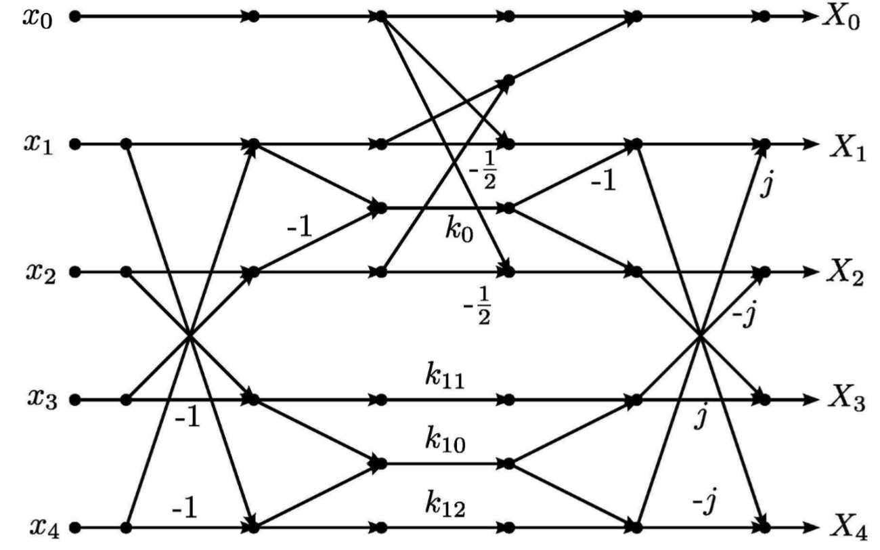
Fig.3.4 Radix-5 Flow Graph
$K_{0}=\cos\left(4π∕5\right)$ $K_{10}=-\sin\left(4π∕5\right)$
$$K_{11}=-sin\left(2π∕5\right)+\sin\left(4π∕5\right)$$
$$K_{12}=\sin\left(2π∕5\right)+\sin\left(4π∕5\right)$$
This signal flow graph has constants explained above and these are converted into suitable form to convert into hardware-efficient. The above flow graph has 5 calculation stages but for simplification and for ease of programming it is divided into four submodules. As can be seen, this radix 5 unit has four internal multiplications in addition to the two trivial divisions by 2. Also four of the five outputs needs to be twiddled.
3.4 FLOATING-POINT ARITHMETIC
An IEEE 754 standard floating point binary word consists of a sign bit, exponent, and a mantissa as shown in the figure below. IEEE 754 single precision floating point number consists of 32 bits of which
1 bit = sign bit(s) ,
8 = Biased exponent bits (e) ,
23 = mantissa (m).
Sign 1 bit  (MSB) | Exponent 8 bit | Mantissa 23 bit  (LSB)
Whereas the double precision floating point number consists of 64 bits of which
1 bit = sign bit(s) ,
11 = Biased exponent bits (e) ,
52 = mantissa (m).
Sign 1 bit  (MSB) | Exponent 11 bit | Mantissa 52 bit  (LSB)
There is also another bit includes in this representation which is also called as hidden bit. This hidden bit should always be one and this is useful while normalizing the number.
3.4.1 FLOATING-POINT ADDER/SUBTRACTOR
Floating-point addition is more complex than multiplication, brief overview of floating point addition algorithm have been explained below
X3 = X1 + X2
X3 = (M1 x 2^{E1}) +/- (M2 x 2^{E2})
- X1 and X2 can only be added if the exponents are the same i.e E1=E2.
- We assume that X1 has the larger absolute value of the 2 numbers. Absolute value of of X1 should be greater than absolute value of X2, else swap the values such that Abs(X1) is greater than Abs(X2).
Abs(X1) > Abs(X2).
- Initial value of the exponent should be the larger of the 2 numbers, since we know exponent of X1 will be bigger , hence Initial exponent result E3 = E1.
- Calculate the exponent's difference i.e. Exp_diff = (E1-E2).
- Left shift the decimal point of mantissa (M2) by the exponent difference. Now the exponents of both X1 and X2 are same.
- Compute the sum/difference of the mantissas depending on the sign bit S1 and S2.
If signs of X1 and X2 are equal (S1 == S2) then add the mantissas
If signs of X1 and X2 are not equal (S1 != S2) then subtract the mantissas
- Normalize the resultant mantissa (M3) if needed. (1.m3 format) and the initial exponent result E3=E1 needs to be adjusted according to the normalization of mantissa.
- If any of the operands is infinity or if (E3>Emax) , overflow has occurred ,the output should be set to infinity. If(E3 < Emin) then it's a underflow and the output should be set to zero.
- Nan's are not supported.
The flow chart of floating-point adder/subtractor can be viewed as
Mantissa of B
Mantissa of A
Exponent of B
Exponent of A

Exponent compare
Shift mantissa to equalize exponents
Add/subtract mantissas

Normalizing and rounding of results

Result mantissa
Result exponent

Fig.3.5 flow-chart for floating point adder
3.4.2 FLOATING POINT MULTIPLIER
A brief overview of floating point multiplication algorithm have been explained below, X1 and X2.
Result X3 = X1 * X2
= (-1)^{s1} (M1 x 2^{E1}) * (-1) ^{s2} (M2 x 2^{E2})
S1, S2 => Sign bits of number X1 & X2.
E1, E2 =>Exponent bits of number X1 & X2.
M1, M2 =>Mantissa bits of Number X1 & X2.
1) Check if one/both operands = 0 or infinity. Set the result to 0 or inf. i.e. exponents = all "0" or all "1".
2) S1, the signed bit of the multiplicand is XOR'd with the multiplier signed bit of S2. The result is put into the resultant sign bit.
3) The mantissa of the Multiplier (M1) and multiplicand (M2) are multiplied and the result is placed in the resultant field of the mantissa (truncate/round the result for 24 bits). =M1 * M2
4) The exponents of the Multiplier (E1) and the multiplicand (E2) bits are added and the base value is subtracted from the added result. The subtracted result is put in the exponential field of the result block. =E1+E2-bias
5) Normalize the sum, either shifting right and incrementing the exponent or shifting left and decrementing the exponent.
6) Check for underflow/overflow. If Overflow set the output to infinity & for underflow set to zero.
7) If (E1 + E2 - bias) >= to Emax then set the product to infinity.
8) If E1 + E2 - bias) is lesser than/equal to Emin then set product to zero.
Mantissa of A
Mantissa of B
Exponent of B
Exponent of A

Multiply
Add

Normalization and rounding of results

Result mantissa
Result exponent

Fig.3.6 flow chart of floating point multiplier
3.5 VEDIC MULTIPLIER
The multiplication of mantissas can be carried out by 24 bit vedic multiplier in which 23 are of mantissa bits and the other one is hidden bit. Floating point multiplication utilizes a 24-bit and 53-bit multiplier for multiplication of its significand in single precision and double precision respectively. Different multiplication algorithms are used for multiplying the significand like wise Booths & Add Shift Technique. Array multiplier, redundant binary structures & tree structures also used but they have problem of larger delay. Floating point multiplication can also be done by using pipelining method wherein addition of exponents, multiplication of significands and calculation of sign bit can be done in parallel. In this we introduced an algorithm using ancient Vedic mathematics rules for fast multiplication which generate partial products concurrently. Multiplication of two floating point number is done by multiplying the normalized 24 bit mantissa. The exponents of both the operands are added to obtain the product exponent. To obtain biased exponent the resultant sum is subtracted from 127 in case of single precision and 1023 in case of double precision. The addition operation involves the use of 8-bit and 11-bit ripple carry adder for single and double precisions respectively. For the sign calculation the input sign bits are XORed.
The vedic multiplication system is based on 16 Vedic sutras which describes natural ways of solving a whole range of mathematical problems. Out of these 16 Vedic Sutras the Urdhva-triyakbhyam sutra is general multiplication formula applicable to all cases. It literally means vertically & crosswise.
3.5.1 PROPOSED DESIGN
The proposed multiplier for floating point numbers can divided in four different units:
- Mantissa calculation unit
- Exponent calculation unit
- Sign calculation unit
- Control unit
Mantissa calculation unit requires a 24 bit multiplier. Exponent calculation unit is implemented by using 8 bit ripple carry adder. The advantage of ripple carry adder is its low area and simple layout.
ALGORITHM STEPS:
- Multiplying the significand (1.M1*1.M2)
- Placing the decimal point in the result.
- Adding the exponents i.e.,(E1+E2-Bias)
- Obtaining the sign; s1 XOR s2
- Normalizing the result ;i.e.obtaining 1 at the MSB of the result’s significand.
- Checking for underflow/overflow occurrence.

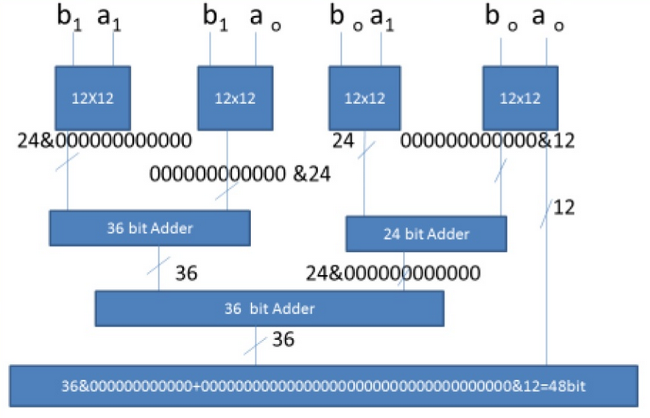
Fig.3.7 Block diagram of 24*24bit vedic multiplier

BLOCK DIAGRAM EXPLANANTION
A 24*24 bit Vedic multiplier is design by using four 12*12 Vedic multipliers based urdhva Triyakbhyam. It requires four 12x12 bit multipliers and two 36 bit ripple carry adders and one 24 bit ripple carry adders. Here first block 12x12 multiplier consists of lower 12 bits of x i.e. x(11 down to 0) and y(11 down to 0),second block 12*12 Vedic multiplier inputs are x(23 down to 12) and y(11 down to 0). Out off 24 bit output of first block lower 12 bits are separated and higher order bits are appended as 12 lower bits in front augmented with “000000000000” (12 zeroes). Higher order 12 bit of y(23 down to 12) and lower order 12 bits of x i.e. x(11 down to 0) are multiplied and appended in-front with “000000000000”(MSB) to make 36 bit data. Similarly both higher order 12 bits of x and y i.e. x(23 down to 12) and y(23 down to 12) are multiplied and 36 bit data is formed by appending “000000000000”(LSB). Resultant of 24*24 bit multiplier is 48 bits consists of 36 higher bits from 36 bit adder output and lower order 12 bits 36+12=48 bits.

CHAPTER 4
VHDL IMPLEMENTATION

4.1 VHDL INTRODUCTION
A design engineer in electronic industry uses hardware description language to keep pace with the productivity of the competitors. With VHDL we can quickly describe and synthesize circuits of several thousand gates. In addition VHDL provides the capabilities described as follows:

4.1.1 Power and flexibility
VHDL has powerful language constructs with which to write succinct code description of complex control logic. It also has multiple levels of design description for controlling design implementation. It supports design libraries and creation of reusable components. It provides Design hierarchies to create modular designs. It is one language fort design and simulation.

4.1.2 Device Independent design
VHDL permits to create a design without having to first choose a device foe implementation. With one design description, we can target many device architectures. Without being familiar with it, we can optimize our design for resource or performance. It permits multiple style of design description.

4.1.3 Portability
VHDL portability permits to simulate the same design description that we have synthesized. Simulating a large design description before synthesizing can save considerable time. As VHDL is a standard, design description can be taken from one simulator to another, one synthesis tool to another; one platform to another-means description can be used in multiple projects.

4.1.4 Benchmarking capabilities
Device–independent design and portability allows benchmarking a design using different device architectures and different synthesis tool. We can take a complete design description and synthesize it, create logic for it, evaluate the results and finally choose the device-a CPLD or an FPGA that fits our requirements.

4.2 VHDL DESCRIPTION
In the search of a standard design and documentation for the Very High Speed Integrated Circuits (VHSIC) program, the United States Department of Defense (DOD) in 1981sponsored a workshop on Hardware Description Languages (HDL) at Woods Hole, Massachusetts. In 1983, the DOD established requirements for a standard VHSIC Hardware Description Language VHDL, its environment and its software was awarded to IBM, Texas Instruments and Inter metrics corporations.

VHDL 2.0 was released only after the project was begun. The language was significantly improved correcting the shortcoming of the earlier versions; VHDL 6.0 was released in 1984. VHDL 1078/1164 formally became the IEEE standard Hardware Description Language in 1987.

A VHDL design is defined as an ‘entity declaration’ and as an associated ‘architecture body’. The declaration specifies its interface and is used by architecture bodies of design entities at upper levels of hierarchy. The architecture body describes the operation of a design entity by specifying its interconnection with other design entities –‘structural description,’ by its behavior –‘behavioral description’, or by a mixture of both. The VHDL language groups, sub programs or design entities by use of packages.

4.2.1 Entities and Architectures
Entity Declaration:
The ENTITY declaration declares the name, direction and data type of each port of component.
Syntax: entity name is
Part ( );
End name:

Architecture Declaration:
The ARCHITECTURE portion of a VHDL description describes the behavior of the component.
Syntax: architecture [arch] <entity name > of <entity name> is
Begin
The ‘begin’ that follows the signal declaration marks the start of the architecture body. The follows a process declaration, marked by the keyword PROCESS and an ensuring BEGIN.
The END statement ending the architecture must be accompanies by the name of the architecture which must match the name shown in the first of the architecture.

4.3 XILINX ISE DESIGN

4.3.1 XILINX WORKING
If you wish to work on this tutorial and the laboratory at home, you must download and install Xilinx and ModelSim. These tools both have free student versions. Please accomplish Appendix B, C, and D in that order before continuing with this tutorial. Additionally if you wish to purchase your own Spartan3 board, you can do so at Digilent’s Website. Digilent offers academic pricing. Please note that you must download and install Digilent Adept software. The software contains the drivers for the board that you need and also provides the interface to program the board.
Xilinx Tools is a suite of software tools used for the design of digital circuits implemented using Xilinx Field Programmable Gate Array (FPGA) or Complex Programmable Logic Device (CPLD). The design procedure consists of (a) design entry, (b) synthesis and implementation of the design, (c) functional simulation and (d) testing and verification. Digital designs can be entered in various ways using the above CAD tools: using a schematic entry tool, using a hardware description language (HDL) – VHDL or VHDL or a combination of both. In this lab we will only use the design flow that involves the use of VHDL HDL.
A VHDL input file in the Xilinx software environment consists of the following segments:
Header: module name, list of input and output ports.
Declarations: input and output ports, registers and wires.
Logic Descriptions: equations, state machines and logic functions.
End: end module
All your designs for this lab must be specified in the above VHDL input format. Note that the state diagram segment does not exist for combinational logic designs.

4.3.2 ISE SOFTWARE TOOL
1. To start ISE, double-click the desktop icon
2. Or start ISE from the Start menu by selecting
Start → All Programs → Xilinx ISE 14.5i → Project Navigator
3. Note: Your start-up path is set during the installation process and may differ from the one above Accessing Help
4. At any time during the tutorial, you can access online help for additional information
5. About the ISE software and related tools.
6. To open Help, do either of the following:
7. Press F1 to view Help for the specific tool or function that you have selected or highlighted.
8. Launch the ISE Help Contents from the Help menu. It contains information about creating and maintaining your complete design flow in ISE.

Fig. 4.1. ISE Help Topics
- Creating a New Project: Xilinx Tools can be started by clicking on the Project Navigator Icon on the Windows desktop. This should open up the Project Navigator window on your screen. This window shows the last accessed project.
Fig. 4.2. Xilinx Project Navigator window

- Opening a project: Select File->New Project to create a new project. This will bring up a new project window on the desktop. Fill up the necessary entries as

Fig. 4.3. New Project Initiation window

Project Name: Write the name of your new project
Project Location: The directory where you want to store the new project (Note: DO NOT specify the project location as a folder on Desktop or a folder in the Xilinx\bin directory. Your H: drive is the best place to put it. The project location path is NOT to have any spaces in it e.g.: C:\Nivash\TA\new lab\sample exercises\o_gate is NOT to be used)
Leave the top level module type as HDL.
Example: If the project name were “o_gate”, enter “o_gate” as the project name and then click “Next”. Clicking on NEXT should bring up the following window:

Fig. 4.4. Device and Design Flow of Project
For each of the properties given below, click on the ‘value’ area and select from the list of values that appear.

- Device Family: Family of the FPGA/CPLD used. In this laboratory we will be using the VERTEX 4 FPGA’s.
- Device: The number of the actual device. For this lab you may enter XC3S250E (this can be found on the attached prototyping board)
- Package: The type of package with the number of pins. The Spartan FPGA used in this lab is packaged in CP132 package.
- Speed Grade: The Speed grade is “-4”.
- Synthesis Tool: XST [VHDL/VHDL]
- Simulator: The tool used to simulate and verify the functionality of the design. ModelSim simulator is integrated in the Xilinx ISE. Hence choose “ModelSim-XE VHDL” as the simulator or even Xilinx ISE Simulator can be used.
- Then click on NEXT to save the entries.
All project files such as schematics, net list, VHDL files, VHDL files, etc., will be stored in a subdirectory with the project name. A project can only have one top level HDL source file (or schematic). Modules can be added to the project to create a modular, hierarchical design. In order to open an existing project in Xilinx Tools, select File->Open Project to show the list of projects on the machine. Choose the project you want and click OK. Clicking on NEXT on the above window brings up the following window

Fig. 4.5. Create new source window

If creating a new source file, Click on the NEW SOURCE.
Creating a VHDL HDL input file for a combinational logic design: In this lab we will enter a design using a structural or RTL description using the VHDL HDL. You can create a VHDL HDL input file (.v file) using the HDL Editor available in the Xilinx ISE Tools (or any text editor). In the previous window, click on the NEW SOURCE A window pops up as shown in Figure 4. (Note: “Add to project” option is selected by default. If you do not select it then you will have to add the new source file to the project manually.)
Fig. 4.6. Creating VHDL-HDL source file

Select VHDL Module and in the “File Name:” area, enter the name of the VHDL source file you are going to create. Also make sure that the option Add to project is selected so that the source need not be added to the project again. Then click on Next to accept the entries. The obtained pop up window is as following.
Fig. 4.7. Define VHDL Source window
In the Port Name column, enter the names of all input and output pins and specify the Direction accordingly. A Vector/Bus can be defined by entering appropriate bit numbers in the MSB/LSB columns. Then click on Next> to get a window showing all the new source information. If any changes are to be made, just click on <Back to go back and make changes. If everything is acceptable, click on Finish > Next > Next > Finish to continue.
Fig. 4.8. New Project Information window
Once you click on Finish, the source file will be displayed in the sources window in the Project Navigator.

If a source has to be removed, just right click on the source file in the Sources in Project window in the Project Navigator and select Remove in that. Then select Project -> Delete Implementation Data from the Project Navigator menu bar to remove any related files.

Editing the VHDL source file: The source file will now be displayed in the Project Navigator window. The source file window can be used as a text editor to make any necessary changes to the source file. All the input/output pins will be displayed. Save your VHDL program periodically by selecting the File->Save from the menu. You can also edit VHDL programs in any text editor and add them to the project directory using “Add Copy Source”.
Fig. 4.9. VHDL Source code editor window in the Project Navigator

Adding Logic in the generated VHDL Source code template: A brief VHDL Tutorial is available in Appendix-A. Hence, the language syntax and construction of logic equations can be referred to Appendix-A.

The VHDL source code template generated shows the module name, the list of ports and also the declarations (input/output) for each port. Combinational logic code can be added to the VHDL code after the declarations and before the end module line. For example, an output z in an OR gate with inputs a and b can be described as, assign z = a | b; Remember that the names are case sensitive. Other constructs for modeling the logic function: A given logic function can be modeled in many ways in VHDL. Here is another example in which the logic function, is implemented as a truth table using a case statement.

module or_gate(a,b,z);
input a;
input b;
output z;
reg z;
always @(a or b)
begin
case ({a,b})
00: z = 1'b0;
01: z = 1'b1;
10: z = 1'b1;
11: z = 1'b1;
end case
end
end module
Suppose we want to describe an OR gate. It can be done using the logic equation as shown in fig. 4.10. These are just two example constructs to design a logic function. VHDL offers numerous such constructs to efficiently model designs.
Fig. 4.10. OR gate description using assign statement

Synthesis and Implementation of the Design: The design has to be synthesized and implemented before it can be checked for correctness, by running functional simulation or downloaded onto the prototyping board. With the top-level VHDL file opened (can be done by double-clicking that file) in the HDL editor window in the right half of the Project Navigator, and the view of the project being in the Module view , the implement design option can be seen in the process view. Design entry utilities and Generate Programming File options can also be seen in the process view. The former can be used to include user constraints, if any and the latter will be discussed later.
To synthesize the design, double click on the Synthesize Design option in the Processes window.

Fig. 4.11. Implementing the Design

CHAPTER 5
SIMULATION AND SYNTHESIS RESULTS
5.1. Simulation Results
The traditional input to the system “fft2” i.e., (intermediate sub-system) will be given 32-bit binary radix format. a_re[31:0],b_re[31:0],a_img[31:0] and b_img[31:0] are taken as the valid input signals and x0_re[31:0],x0_img[31:0],x1_re[31:0] and x1_img[31:0] will produce valid and desired data from the implemented “fft2” module in Radix_5 system. Figure 5.1 represents series of inputs and output of “fft2” sub-system. Figure 5.2 represents the functional verification of “K11” block which is a constant and is represented in a form of module.the inputs are a_re[31:0] and a_img[31:0] and the outputs are a1_re[31:0] and a1_img[31:0].
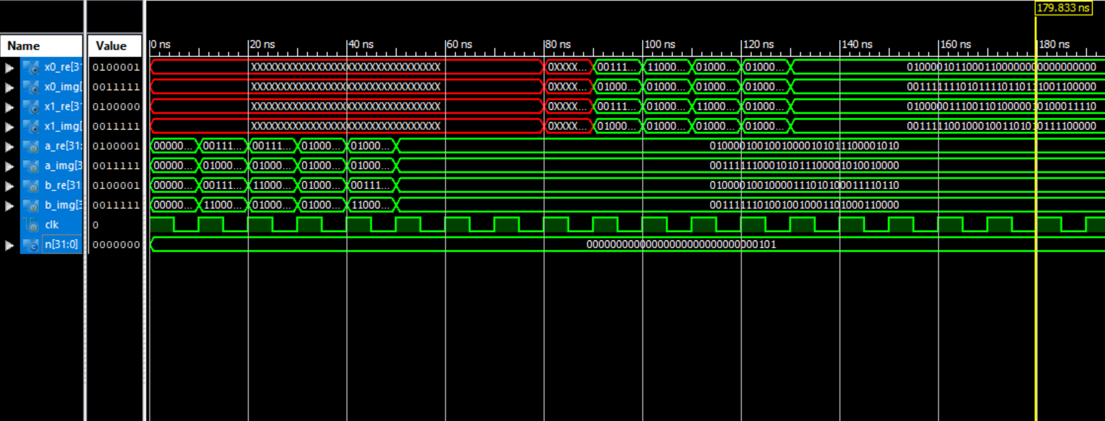
Fig. 5.1. Input and Output of fft2 block

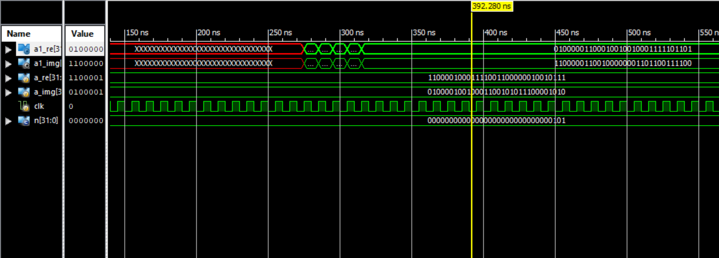
Fig. 5.2. Input and Output of “K11” block
Figure 5.3 represents series of inputs and outputs of the module Radix-5 and those consists of 10 inputs and 10 outputs. They are [a,b,c,d,e]_re,_img[31:0] and the outputs are [ao,bo,co,do,eo]_re,_img[31:0] and are represented in figure 5.4.
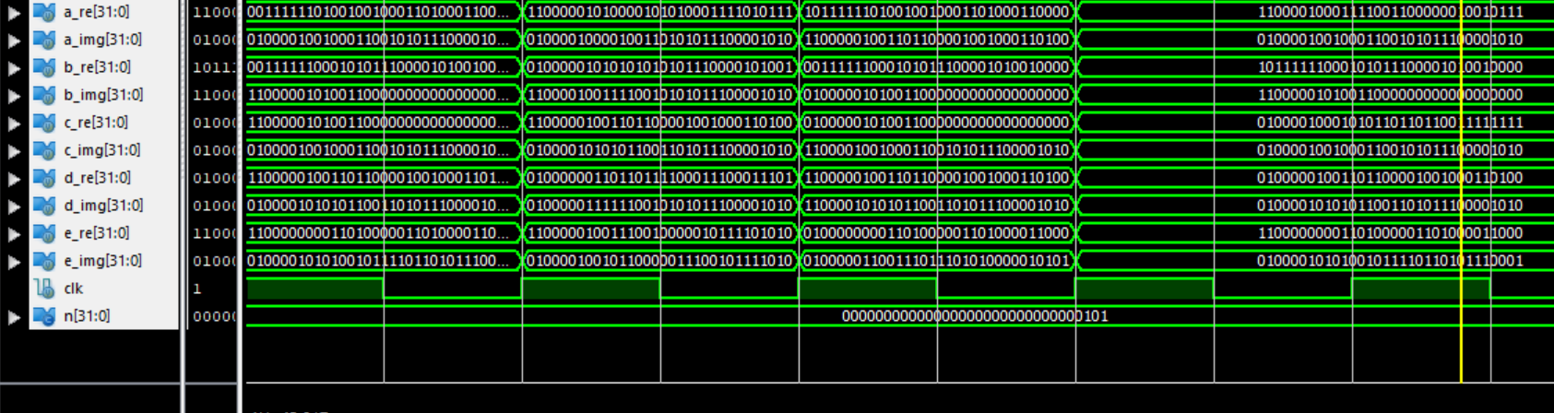
Fig. 5.3. Inputs given to the implemented system

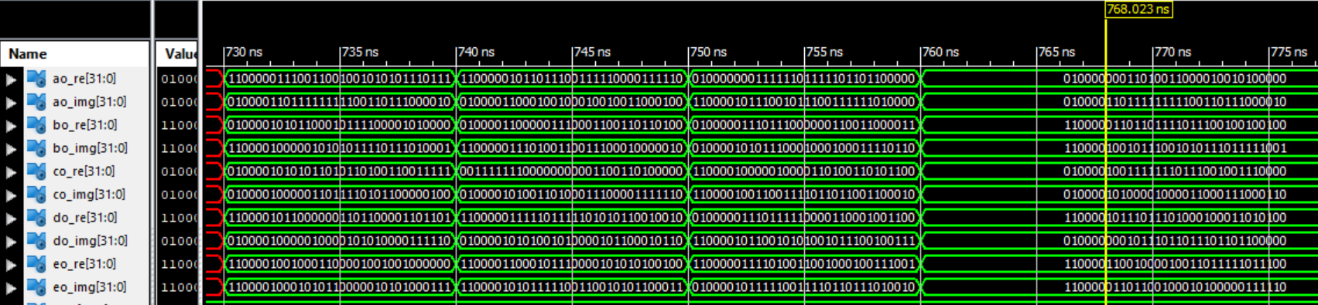
Fig. 5.4. Obtained outputs from the implemented system

5.2. Synthesis Results
5.2.1. RTL View
Figure 5.5 provides the RTL schematic view of the architecture. Figure 5.6 provides the enlarged RTL view of the architecture.

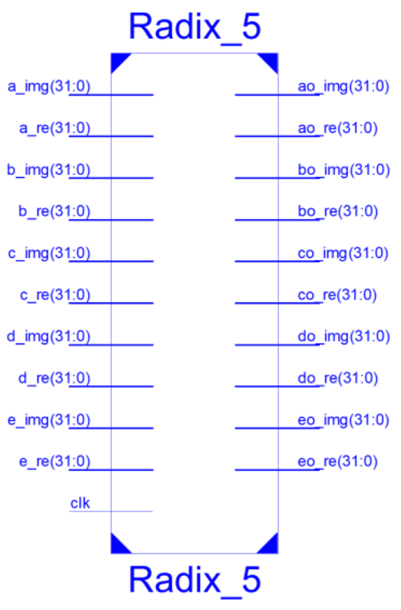
Fig. 5.5. RTL schematic

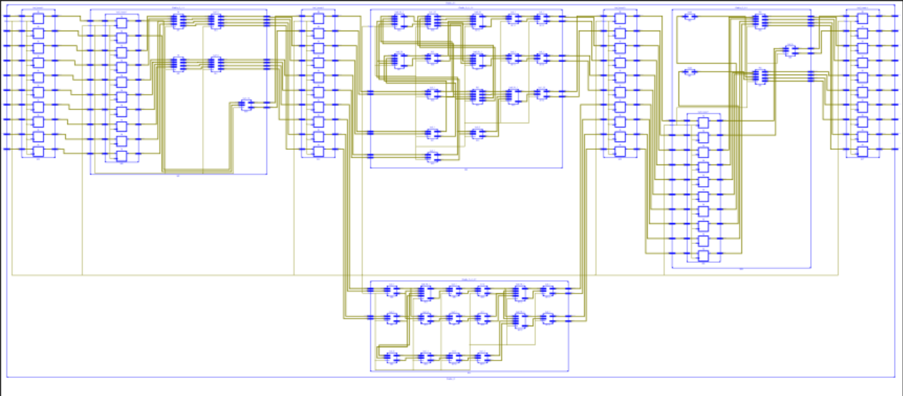
Fig. 5.6. Enlarged RTL schematic
5.2.2. Synthesis Reports:
Timing Summary: -------------------- Speed Grade: -4
Minimum period: 9.720ns (Maximum Frequency: 102.881MHz)
Minimum input arrival time before clock: 2.059ns
Maximum output required time after clock: 4.283ns
Maximum combinational path delay: No path found
Device Utilization Report:
---------------------------
Selected Device : 3s250ecp132-4
Logic Utilization | Used | Available | Utilization
Number of Slice Flip Flops | 16,100 | 4,896 | 328%
Number of SLICEMs | 2,325 | 1,224 | 189%
Number of 4 input LUTs | 44,060 | 4,896 | 899%
Number of occupied Slices | 22,311 | 2,448 | 911%
Number of Slices containing only related logic | 22,311 | 22,311 | 100%
Number of Slices containing unrelated logic | 0 | 22,311 | 0%
Total Number of 4 input LUTs | 44,518 | 4,896 | 909%
Number used as logic | 39,454
Number used as a route-thru | 458
Number used as Shift registers | 4,606
Number of bonded IOBs | 641 | 92 | 696%
Number of BUFGMUXs | 1 | 24 | 4%
Average Fanout of Non-Clock Nets | 3.16

CHAPTER 6
CONCLUSION

Our project deals with radix-5 FFT architecture. we have designed and simulated using VHDL. The proposed architecture can simultaneously process two independent data streams and make it suitable for many real-time high-speed applications. Vedic multiplier sub-module is used in the floating pint multiplier module. Additionally, the proposed architecture offers a higher throughput than previous architectures. We have implemented our project on XILINX 14.7 tool with Spartan 6 (XC6slx150t).

REFERENCES
[1] E. Dahlman, S. Parkvall, J. Skold, and P. Beming, 3G Evolution, Second Edition: HSPA and LTE for Mobile Broadband, 2nd ed. Academic Press, 2008.
[2] C. Cheng and K. K. Parhi, “High-throughput VLSI architecture for FFT computation,” IEEE Trans. Circuits Syst. II, Exp. Briefs, vol. 54, no. 10, pp. 863–867, Oct. 2007.
[3] Y.-N. Chang, “An efficient VLSI architecture for normal I/O order pipeline FFT design,” IEEE Trans. Circuits Syst. II, Exp. Briefs, vol. 55, no. 12, pp. 1234–1238, Dec. 2008.
[4] M. Ayinala, M. Brown, and K. K. Parhi, “Pipelined parallel FFT architectures via folding transformation,” IEEE Trans. Very Large Scale Integr. (VLSI) Syst., vol. 20, no. 6, pp. 1068–1081, Jun. 2012.
[5] J. Lofgren, O. Edfors, and P. Nilsson, "Improved matching pursuit algorithm and architecture for lte channel estimation," in Circuits and Systems (ISCAS), 2011 IEEE International Symposium on, may 201l, pp. 466 -469.
[6] J. Löfgren and P. Nilsson, "On hardware implementation of radix 3 and radix 5 FFT kernels for LTE systems," 2011 NORCHIP, Lund, 2011, pp. 1-4, doi: 10.1109/NORCHP.2011.6126703.
[7] A. Ehliar, "Area efficient floating-point adder and multiplier with IEEE-754 compatible semantics," 2014 International Conference on Field-Programmable Technology (FPT), Shanghai, 2014, pp. 131-138, doi: 10.1109/FPT.2014.7082765.
[8] P. Karlstrom, A. Ehliar and D. Liu, "High Performance, Low Latency FPGA based Floating Point Adder and Multiplier Units in a Virtex 4," 2006 NORCHIP, Linkoping, 2006, pp. 31-34, doi: 10.1109/NORCHP.2006.329238.
[9] Jagadguru Swami Sri Bharath, Krsna Tirathji, “Vedic Mathematics or Sixteen Simple Sutras From The Vedas”, Motilal Banarsidas, Varanasi(India),1986.
[10] W.-C. Yeh and C.-W. Jen, “High-speed and low-power split-radix FFT,” IEEE Trans. Signal Process., vol. 51, no. 3, pp. 864–874, Mar. 2003. [11] C. Cheng and K. K. Parhi, “High-throughput VLSI architecture for FFT computation,” IEEE Trans. Circuits Syst. II, Exp. Briefs, vol. 54, no. 10, pp. 863–867, Oct. 2007. [12] Y.-N. Chang, “An efficient VLSI architecture for normal I/O order pipeline FFT design,” IEEE Trans. Circuits Syst. II, Exp. Briefs, vol. 55, no. 12, pp. 1234–1238, Dec. 2008.

