**Project Report**

**INTRODUCTION :**

**Overview :**

**Apple iPhone is one of the best phone in the world. Now Apple iPhone users increasing in India. Project shows how much the impact of Apple iPhone is in India as compared to other countries.**

**Purpose :**

**This project is useful to visualize the given large data graphically, including data extraction as well as the creation of reports and dashboards.**

**PROBLEM DEFINITION & DESIGN THINKING :**

**Empathy Map :**

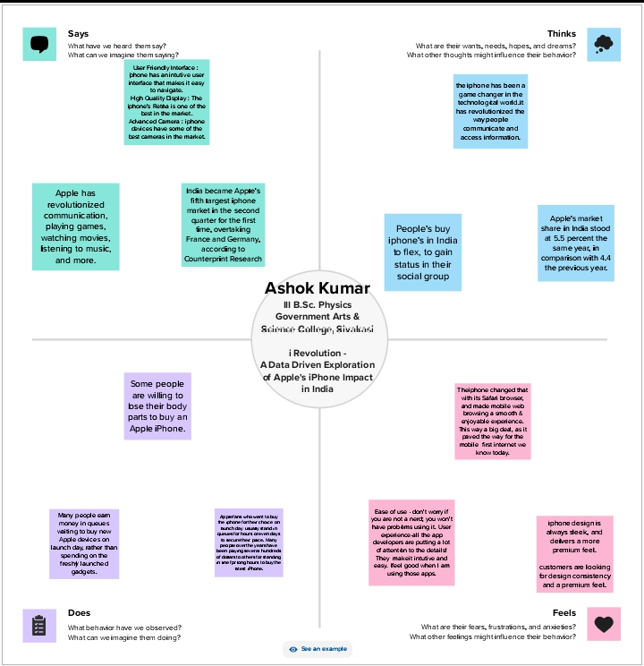

**Brainstorming Map :**

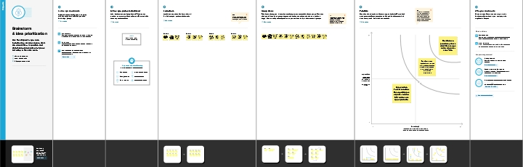

**RESULT :**

**Dashboard :**

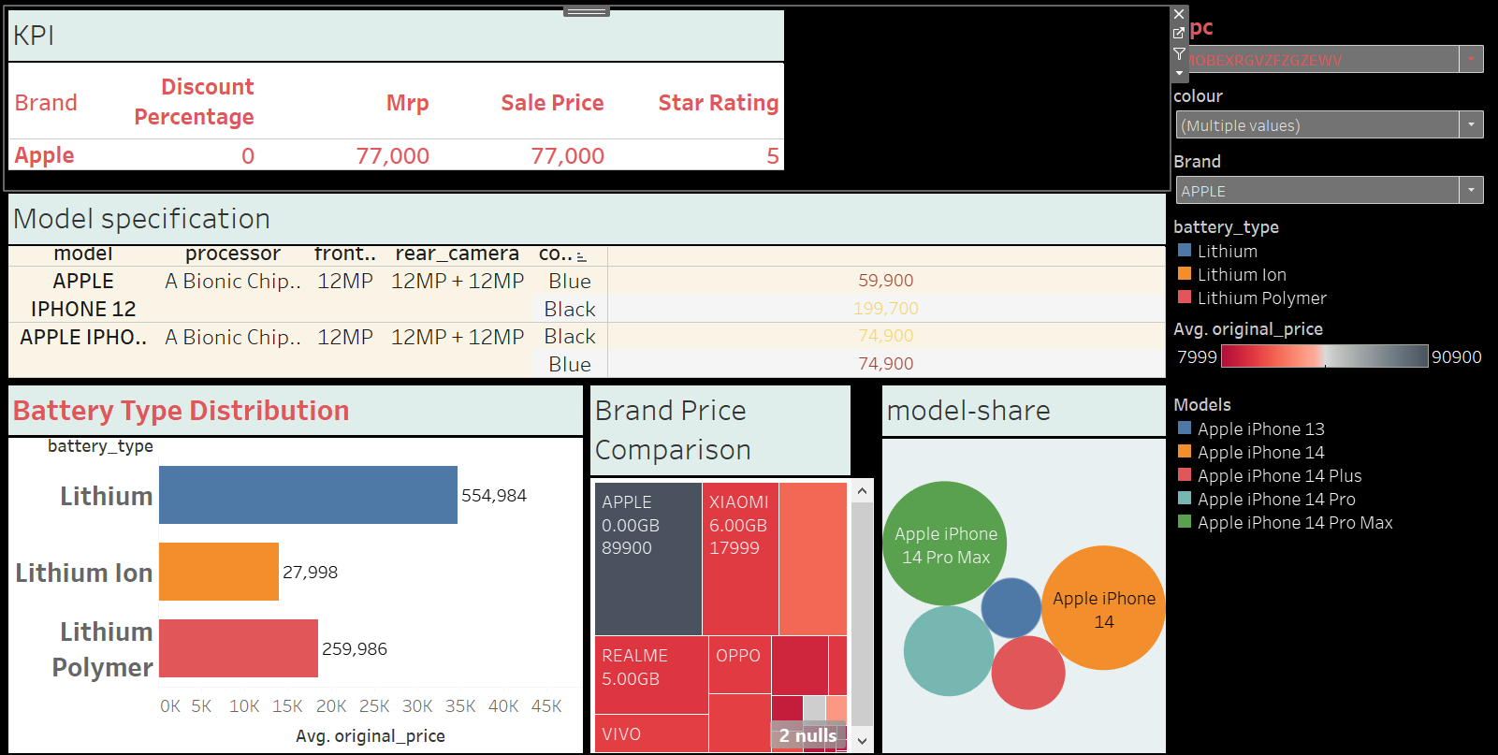

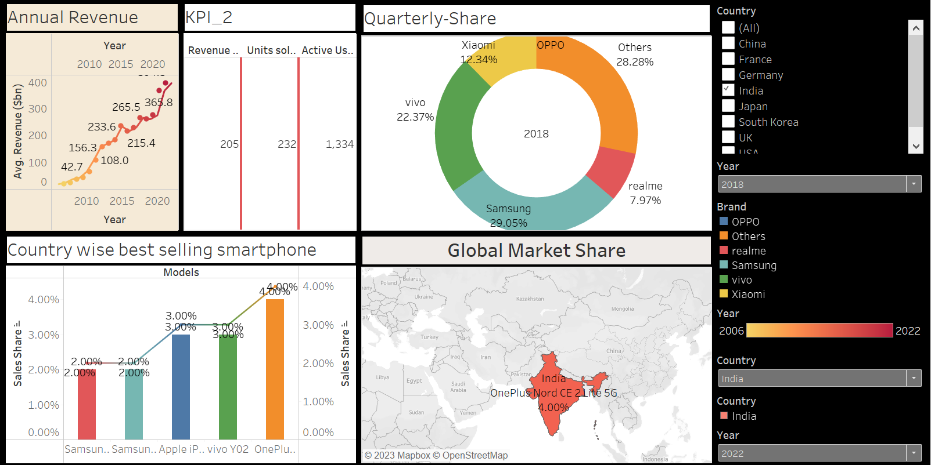

**Story :**

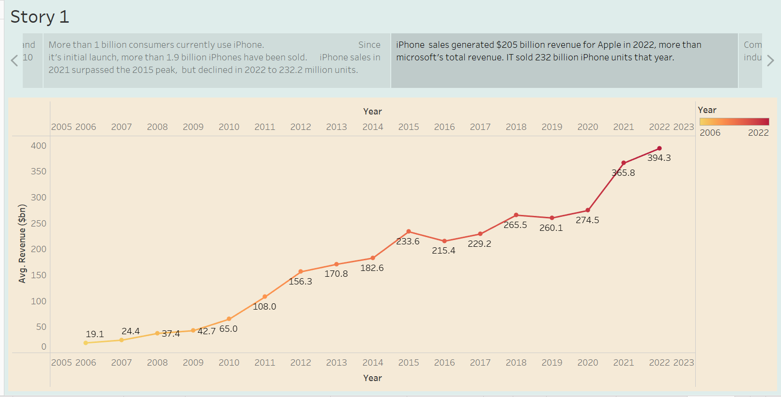

**ADVANTAGES & DISADVANTAGES :**

**Advantages :**

* **Currently, iPhone 14 and iPhone 14 pro Max are selling well in India.**
* **India became Apple’s fifth largest iPhone market in the second quarter for the first time. Overtaking France and Germany, according to Counterpoint Research.**
* **Apple iPhone is easier to use than Android Phones.**
* **High quality display, advanced camera.**

**Disadvantages :**

* **Some people are willing to lose their body parts to buy an Apple iPhone.**
* **Apple iPhone is most expensive.**
* **Apple iPhone’s batteries are non-removable, which means that users cannot replace them.**
* **It’s battery life is short.**
* **Apple iPhone have fixed storage.**

**APPLICATIONS :**

**With the data visualization in this project we can know in which areas it can be used.**

**FUTURE SCOPE :**

**Apple iPhone impact is less in India compared to US. But in future all people in India will be using Apple iPhone. The currently released Apple iPhone is Apple iPhone 15. Similarly, various Apple iPhones will be released in future.**

**CONCLUSION :**

**The Maps help to analyse country wise impact of Apple iPhone. The bubble chart shows Apple iPhone model’s share sales.**