[Setting up Git](https://help.github.com/en/github/getting-started-with-github/set-up-git#setting-up-git)

1. [Download and install the latest version of Git](https://git-scm.com/downloads).

Create your account into <https://github.com/new>

Create a repositary in git

Create a repo

To put your project up on GitHub, you'll need to create a repository for it to live in.

You can store a variety of projects in GitHub repositories, including open source projects. With [open source projects](http://opensource.org/about), you can share code to make better, more reliable software.

1. In the upper-right corner of any page, use the  drop-down menu, and select **New repository**.

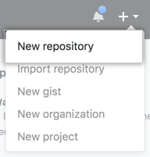

1. Type a short, memorable name for your repository. For example, "hello-world".

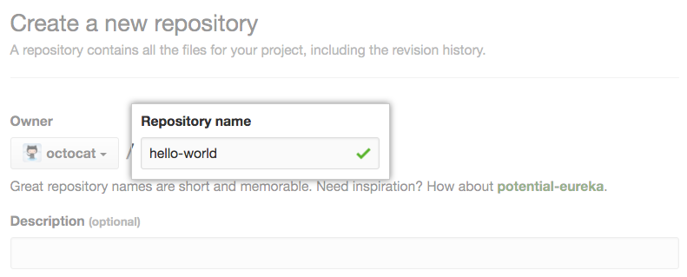

1. Optionally, add a description of your repository. For example, "My first repository on GitHub."

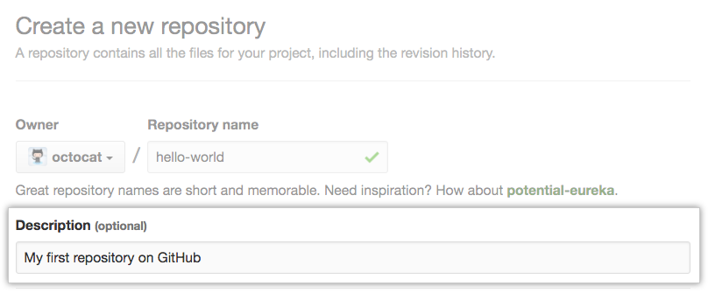

1. Choose a repository visbility. For more information, see "[About repository visibility](https://help.github.com/en/github/creating-cloning-and-archiving-repositories/about-repository-visibility)." Mostly **Public**

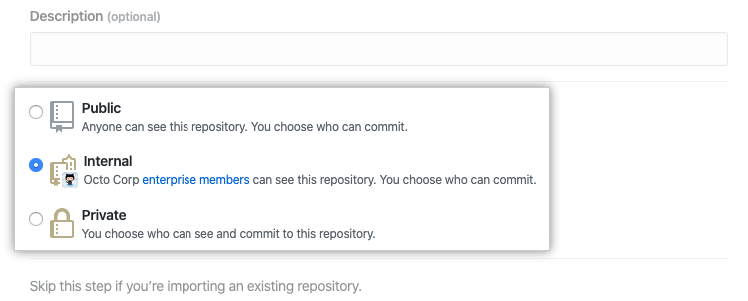

1. Select **Initialize this repository with a README**.

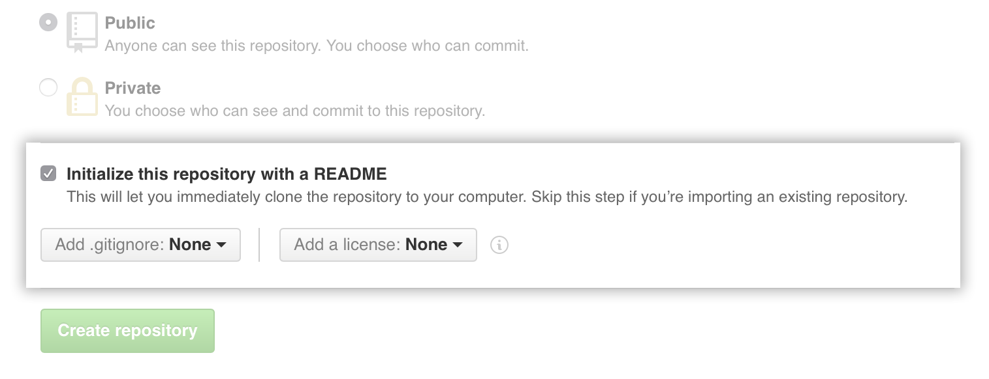

1. Click **Create repository**.

Congratulations! You've successfully created your first repository, and initialized it with a *README* file.

[Commit your first change](https://help.github.com/en/github/getting-started-with-github/create-a-repo#commit-your-first-change)

A [*commit*](https://help.github.com/en/articles/github-glossary#commit) is like a snapshot of all the files in your project at a particular point in time.

When you created your new repository, you initialized it with a *README* file. *README* files are a great place to describe your project in more detail, or add some documentation such as how to install or use your project. The contents of your *README* file are automatically shown on the front page of your repository.

Let's commit a change to the *README* file.

1. In your repository's list of files, click ***README.md***.

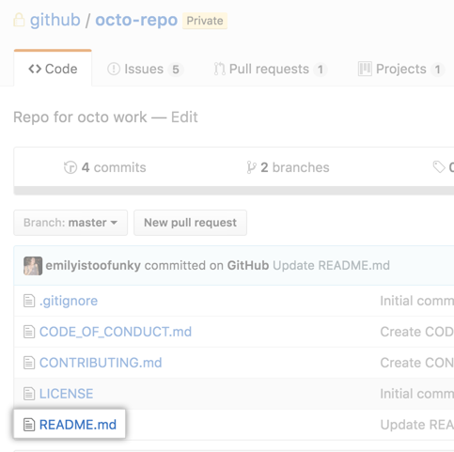

After creating a repository, GitHub displays the repository page. At the top of the page, make sure “HTTPS” is selected.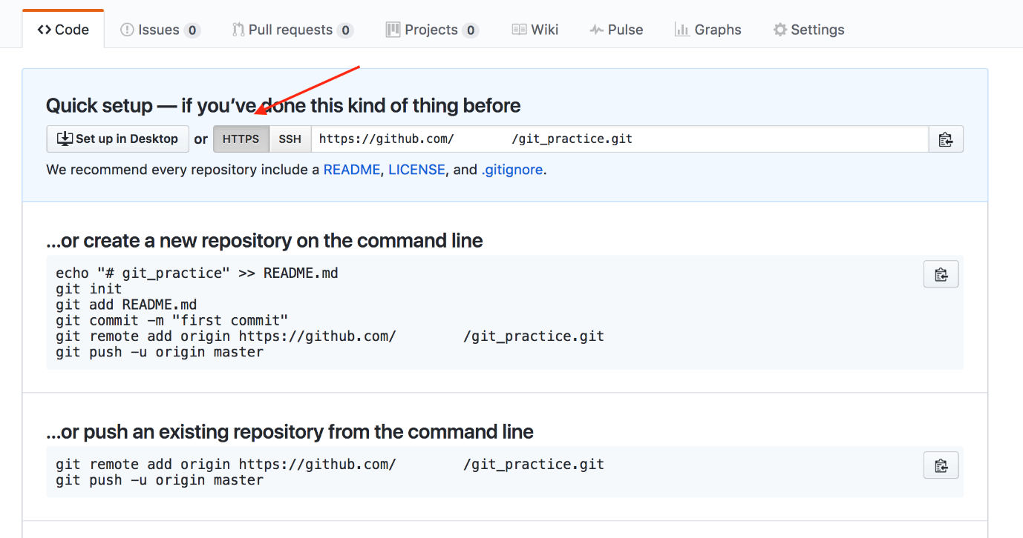

Note down this url.

Now in your machine goto the location where your project is available

Right click and select **Git bash here** in that folder

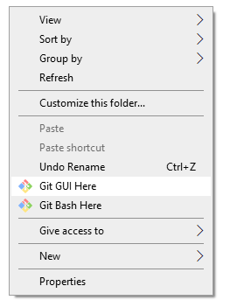

It will open the command prompt.

To create the local repository give command

git init to turn the current, empty directory into a fresh Git repository.

Create a new file or if already project folder is there no need of doing that

git commit -m "First commit"

$ git status

“git remote add <path of your git repository we found above>”

“git push -u origin master”

Now code will be available in the remote repositary

