**Running Test NG using batch file**

**BATCH FILE**

A batch file is a text [file](http://searchexchange.techtarget.com/definition/file) that contains a sequence of commands for a computer [operating system](http://searchcio-midmarket.techtarget.com/definition/operating-system). It's called a batch file because it batches (bundles or packages) into a single file a set of commands that would otherwise have to be presented to the system interactively from a keyboard one at a time. A batch file is usually created for command sequences for which a user has a repeated need. Commonly needed batch files are often delivered as part of an operating system. You initiate the sequence of commands in the batch file by simply entering the name of the batch file on a command line.

In the [Disk Operating System](http://searchsecurity.techtarget.com/definition/DOS) (DOS), a batch file has the file name extension ".BAT". (The best known DOS batch file is the AUTOEXEC.BAT file that initializes DOS when you start the system.) In [UNIX](http://searchenterpriselinux.techtarget.com/definition/Unix)-based operating systems, a batch file is called a [shell script](http://searchenterpriselinux.techtarget.com/definition/shell-script). In IBM's mainframe VM operating systems, it's called an EXEC.

**TEST NG Project**

Create the testNG test cases like below folder structute.

We need to create the lib directory in the project and copy all jar files required in the library folder.

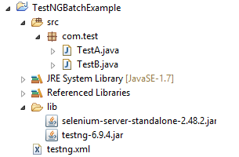

**Creation of BATCH File**

Step 1: Open notepad

Step 2: Paste the below lines of code - You may need to add your project location. In the example, project location is set as 'F:\Selenium\TestNGBatchExample'.( make sure, you don't add any spaces around the equal sign, if so the SET commands will not work)

set projectLocation=F:\Selenium\TestNGBatchExample

cd %projectLocation%

set classpath=%projectLocation%\bin;%projectLocation%\lib\*

java org.testng.TestNG %projectLocation%\testng.xml

pause

Step 3: Save the file as 'testNGBatchFile.bat' in location that you want to save.

Step 4: Now click on .bat file we have just created and see your tests executing.