**Table ofContents**

1. OVERVIEW 1

**Introduction 1**

**Advantagesof Selenium 2**

**DisadvantagesofSelenium 3**

1. ENVIRONMENT SETUP 28

**Download andInstallJava 28**

**Download andConfigureEclipse 34**

**Configure FireBugandFirePath 36**

**ConfigureSeleniumRC 40**

ConfigureSeleniumWebDriver 42

1. SELENIUM RC 44

What isSeleniumRC? 44

SeleniumRCArchitecture 44

RC–Scripting 45

1. SELENESECOMMANDS 54

Actions 54

Accessors 58

Assertions 61

1. WEBDRIVER 65

Architecture 65

Selenium RCVsWebDriver 66

Scriptingusing WebDriver 66

MostUsedCommands 74

1. LOCATORS 76

LocatorsUsage 77

1. INTERACTIONS 84

UserInteractions 84

TextBoxInteraction 84

RadioButtonInteraction 87

CheckBoxInteraction 89

Dropdown Interaction 91

Synchronization 93

Drag&Drop 95

KeyboardActions 97

MouseActions 97

MultiSelectAction 98

FindAll Links 101

1. TESTDESIGNTECHNIQUES 103

PageObjectModel 103

POMFlowDiagram 103

Data DrivenusingExcel 107

Parameterization 112

Log4jLogging 118

Exception Handling 127

MultiBrowserTesting 128

CaptureScreenshots 135

CapturingVideos 141

1. TESTNG 148

WhatisTestNG? 148

Installing TestNGfor Eclipse 148

AnnotationsinTestNG 152

TestNG-EclipseSetup 155

First TestinTestNG 162

1. SELENIUM GRID 166

Architecture 167

Workingwith Grid 167

ConfiguringtheHub 168

ConfiguringtheNodes 169

Develop the Script and Prepare theXMLFile 174

TestExecution 181

ResultAnalysis 183

**Introduction**

**Selenium**

1. OVERVIEW

Selenium is an open-source and a portable automated software testing tool for testing web applications. It has capabilities to operate across different browsers and operating systems. Selenium is not just a single tool but a set of tools that helps testers to automate web-based applications more efficiently.

Let us now understand each one of the tools available in the Selenium suite and their usage.

|  |  |
| --- | --- |
| **Tool** | **Description** |
| Selenium IDE | Selenium Integrated Development Environment (IDE) is a Firefox plugin that lets testers to record their actions as they follow the workflow that they need to test. |
| Selenium RC | Selenium Remote Control (RC) was the flagship testing framework that allowed more than simple browser actions and linear execution. It makes use of the full power of programming languages such as Java, C#, PHP, Python, Ruby, and PERL to create more complextests. |
| Selenium WebDriver | Selenium WebDriver is the successor to Selenium RC which sends commands directly to the browser and retrieves results. |
| Selenium Grid | Selenium Grid is a tool used to run parallel tests across different machines and different browsers simultaneously which results in minimized execution time. |

QTP and Selenium are the most used tools in the market for software automation testing. Hence it makes sense to compare the pros of Selenium over QTP.

|  |  |
| --- | --- |
| **Selenium** | **QTP** |
| Selenium is an open-source tool. | QTP is a commercial tool and there is a cost involved in each one of the licenses. |
| Can be extended for various technologies that expose DOM. | Limited add-ons and needs add-ons for each one of the technologies. |
| Has capabilities to execute scripts across different browsers. | Can run tests in specific versions of Firefox, IE, and Chrome. |
| Can execute scripts on various operating systems. | Works only with Windows. |
| Supports mobile devices. | Supports mobile devices with the help of third-party tools. |
| Executes tests within the browser, so focus is NOT required while script execution is in progress. | Needs Focus during script execution, as the tool acts on the browser (mimics user actions). |
| Can execute tests in parallel with the use of Selenium Grids. | QTP cannot execute tests in parallel, however integrating QTP with QC allows testers to execute in parallel. QC is also a commercial tool. |

Let us now discuss the pitfalls of Selenium over QTP.

|  |  |
| --- | --- |
| **Selenium** | **QTP** |
| Supports only web-based applications. | Can test both web and desktop applications. |
| No feature such as Object Repository/Recovery Scenario | QTP has built-in object repositories and recovery scenarios. |
| No IDE, so the script development won't be as fast as QTP. | More intuitive IDE; automation can be achieved faster. |
| Cannot access controls within the browser. | Can access controls within the browser such as favorites bar, backward, and forward buttons. |
| No default test report generation. | Default test result generation within the tool. |
| For parameterization, users has to rely on the programming language. | Parameterization is built-in and easy to implement. |

In order to develop Selenium RC or WebDriver scripts, users have to ensure that they have the initial configuration done. Setting up the environment involves the following steps.

**Selenium**

3. ENVIRONMENTSETUP

* + - Download and InstallJava
    - Download and ConfigureEclipse
    - Configure FireBug andFirePath
    - Configure SeleniumRC
    - Configure SeleniumWebDriver

**Download and Install Java**

We need to have JDK (Java Development Kit) installed in order to work with Selenium WebDriver/Selenium. Let us see how to download and install Java.

**Step 1**: Navigate to the URL: <http://www.oracle.com/technetwork/java/javase/downloads/index.html>

**Step 2**: Go to "Downloads" section and select "JDK Download".

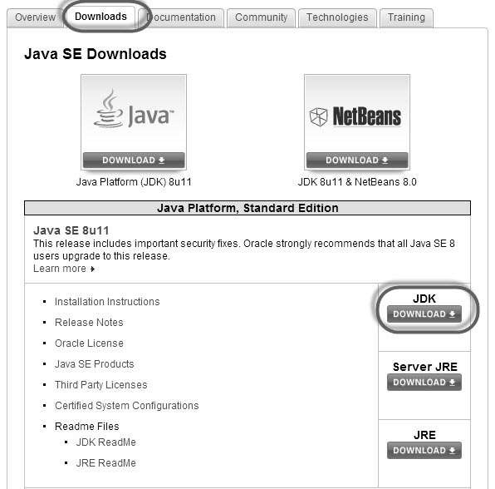

**Step 3**: Select "Accept License Agreement" radio button.

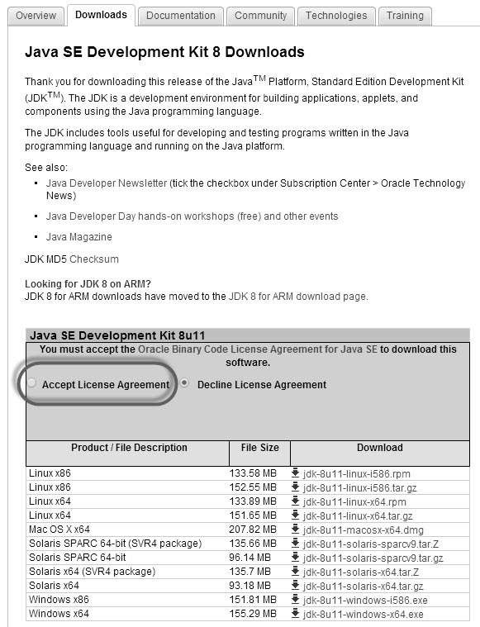

**Step 4** : Select the appropriate installation. In this case, it is 'Windows 7-64' bit. Click the appropriate link and save the .exe file to your disk.

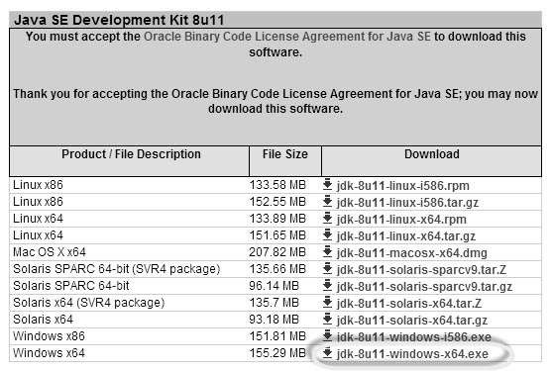

**Step 5** : Run the downloaded exe file to launch the Installer wizard. Click 'Next' to continue.

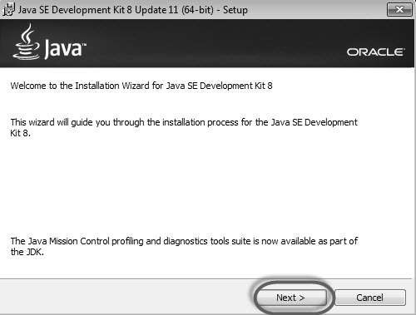

**Step 6** : Select the features and click 'Next'.

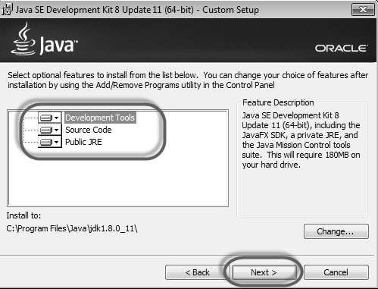

**Step 7** : The installer is extracted and its progress is shown in the wizard.

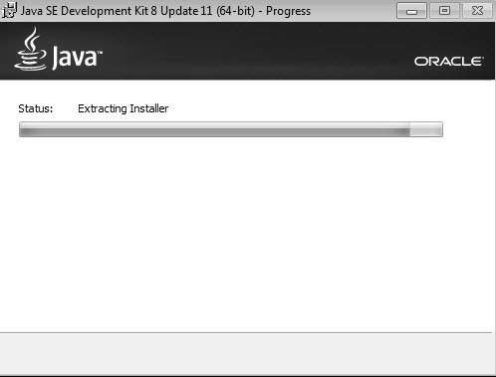

**Step 8** : The user can choose the install location and click 'Next'.

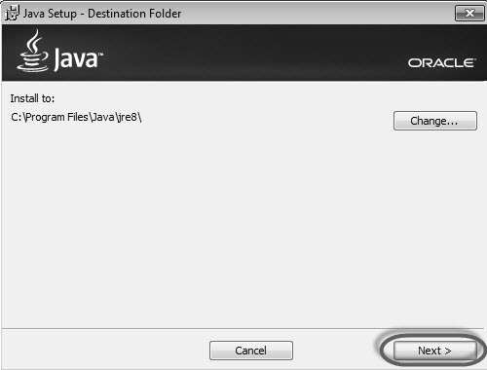

**Step 9** : The installer installs the JDK and new files are copied across.

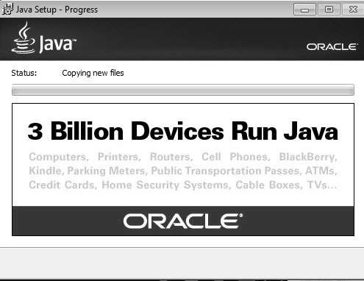

**Step 10** : The Installer installs successfully and displays the same to the user.

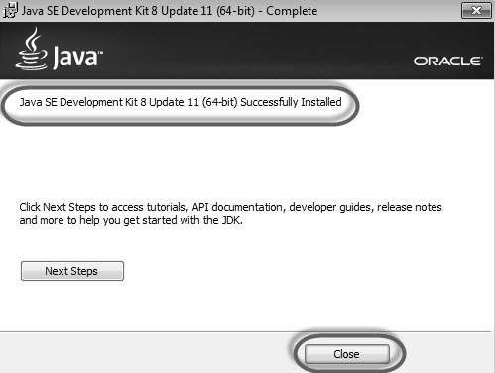

**Step 11** : To verify if the installation was successful, go to the command prompt and just type 'java' as a command. The output of the command is shown below. If the Java installation is unsuccessful or if it had NOT been installed, it would throw an "unknown command" error.

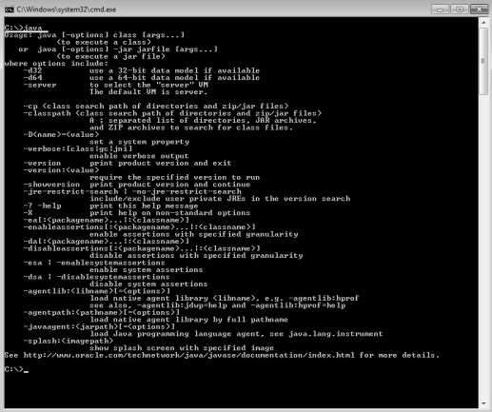

**Download and Configure Eclipse**

**Step 1** : Navigate to the URL: <http://www.eclipse.org/downloads/> and download the appropriate file based on your OS architecture.

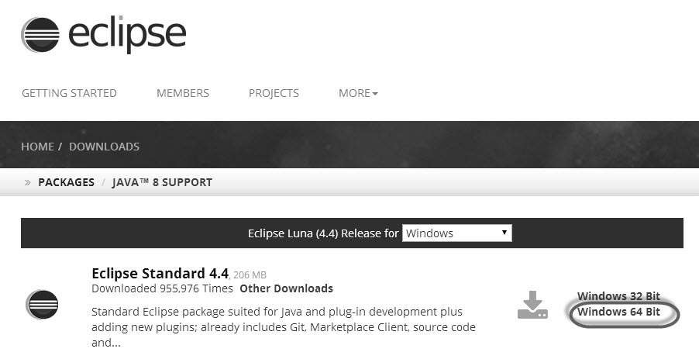

**Step 2** : Click the 'Download' button.

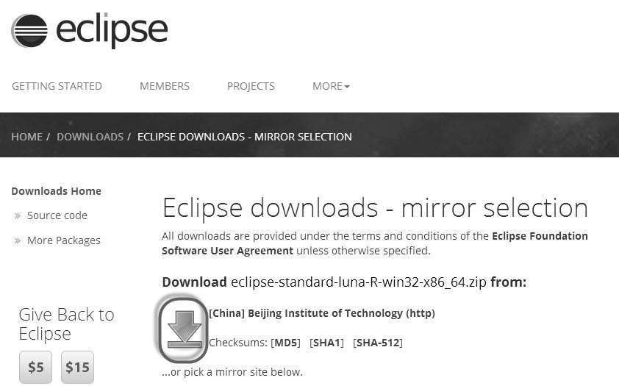

**Step 3** : The download would be in a Zipped format. Unzip the contents.

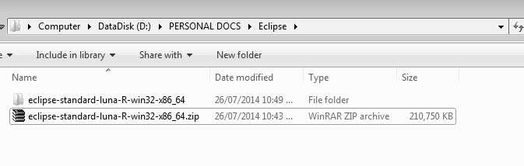

**Step 4** : Locate Eclipse.exe and double click on the file.

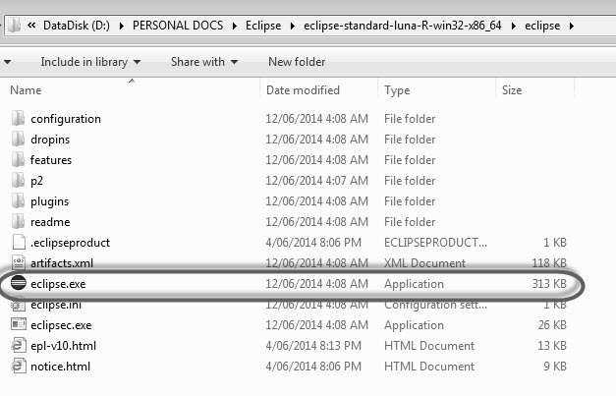

**Step 5** : To configure the workspace, select the location where the development has to take place.

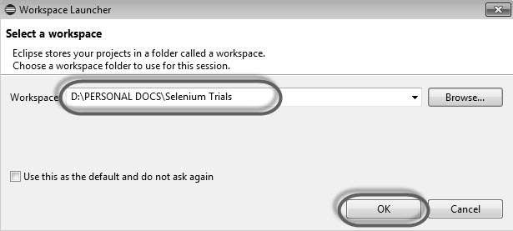

**Step 6** : The Eclipse window opens as shown below.

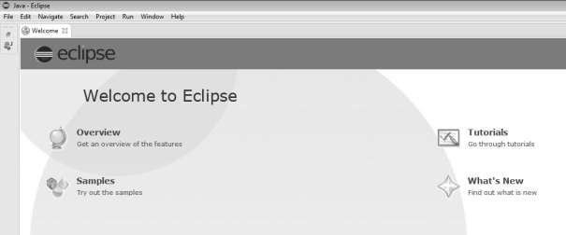

**Configure FireBug and FirePath**

To work with Selenium RC or WebDriver, we need to locate elements based on their XPath or ID or name, etc. In order to locate an element, we need tools/plugins.

**Step 1** : Navigate to the URL: https://addons.mozilla.org/en- US/firefox/addon/firebug/ and download plugin.

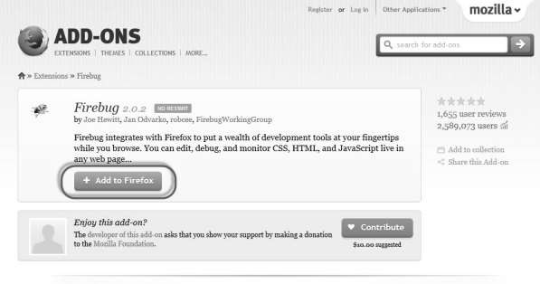

**Step 2** : The add-on installer is shown to the user and it is installed upon clicking the 'Install'button.

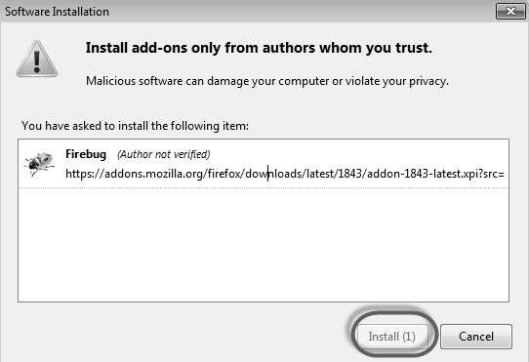

**Step 3** : After installing, we can launch the plugin by navigating to "Web Developer" >> "Firebug".

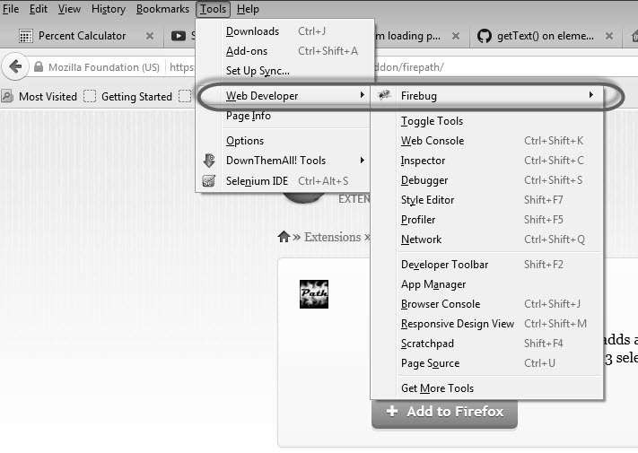

**Step 4** : FirePath, a plugin that works within Firebug, helps users to grab the 'XPath' of an element. Install FirePath by navigating to "https://addons.mozilla.org/en-US/firefox/addon/firepath/"

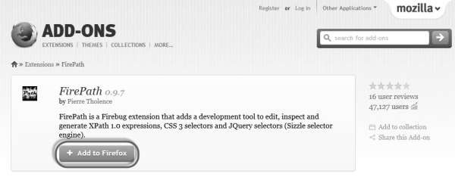

**Step 5** : The add-on installer is shown to the user and it is installed upon clicking the 'Install'button.

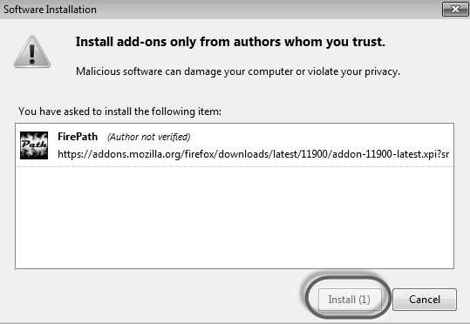

**Step 6** : Now launch "Firebug" by navigating to "Tools" >> "Webdeveloper" >> "Firebug".

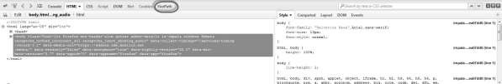

### Example

Now let us understand how to use FireBug and FirePath with an example. For demonstration, we will use [www.google.com](http://www.google.com/) and capture the properties of the text box of "google.com".

**Step 1** : First click on the arrow icon as highlighted in the following screenshot and drag it to the object for which we would like to capture the properties. The HTML/DOM of the object would be displayed as shown below. We are able to capture the 'ID' of the input text box with which we can interact.

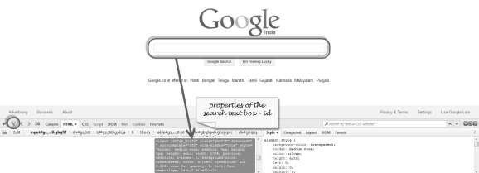

**Step 2** : To fetch the XPath of the object, go to 'firepath' tab and perform the following steps.

* + Click the Spyicon.
  + Select the Control for which we would like to capture theXPath.
  + XPath of the selected control would begenerated.

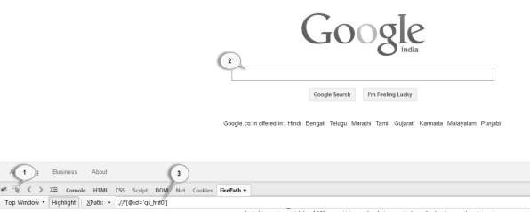

# Configure Selenium WebDriver

Now let us look at how to configure Selenium WebDriver. We will understand how to develop scripts with Selenium WebDriver in later chapters, however for now, we will understand just the configuration part ofit.

**Step 1** : Navigate to the selenium downloads section <http://www.seleniumhq.org/download/> and download Selenium WebDriver by clicking on its version number as shown below.

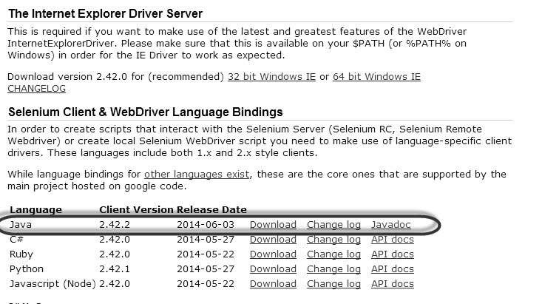

**Step 2** : The downloaded file is in Zipped format and one has to unzip the contents to map it to the project folder.

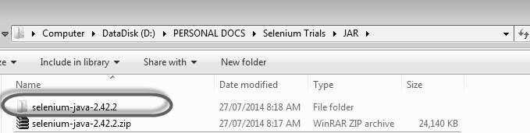

**Step 3** : The Unzipped contents would be displayed as shown below. How to map it to the project folder and how to start scripting would be dealt in the WebDriverchapter.