Selenium installation Two things required

1. java binding
2. driver(gecko/chrome)

**Selenium bindings**

1) **selenium bindings** for java from can be downloaded from https://www.seleniumhq.org/download/

2) It will Download the zip file

3) Extract that zip file the unzipped folder

4) you will find jar files inside lib folder and outside the lib folder

4) Goto project build path by right clicking on project in eclipse, import external jars and add all jar files present in

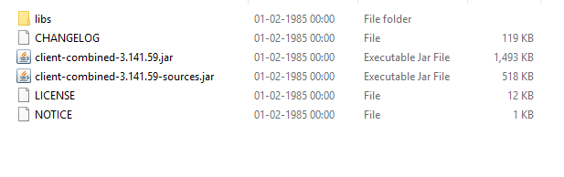

Inside lib folder

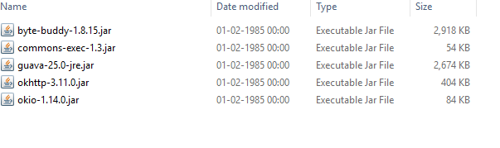

MAKE SURE YOU ARE ADDING ALL JARS **INSIDE LIB and OUTSIDE LIB folder.**

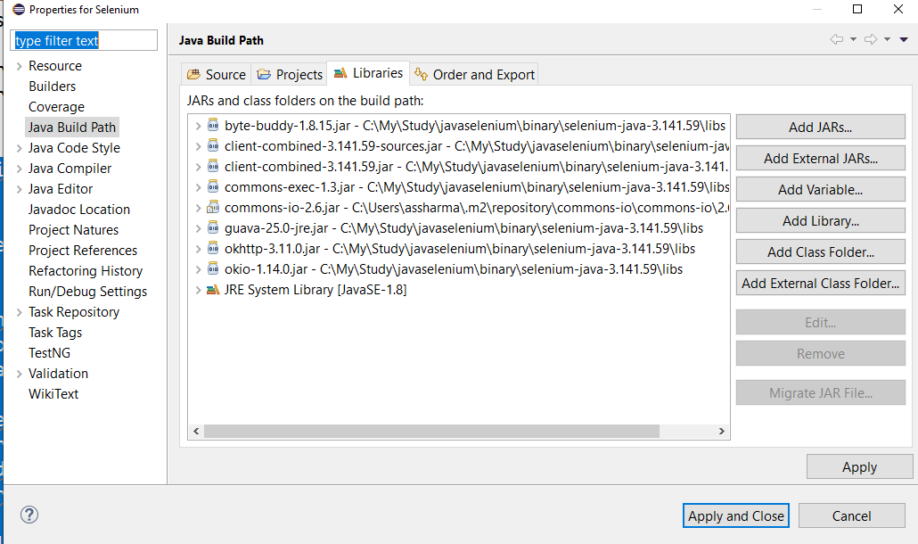

**CHROMEDRIVER/GECKODRIVER**

1. Download chromedriver or Geckodriver or IE server

ChromeDriver is maintained by the Google Chromium team. It can be downloaded from <http://chromedriver.chromium.org/downloads>

unzip the driver folder and set the environment path as per driver path

Firefox

Downloadgeckodriver from https://github.com/mozilla/geckodriver/releases set the enviornment path

Generic error you can face

Exception in thread "main" java.lang.IllegalStateException: The path to the driver executable must be set by the webdriver.chrome.driver system property; for more information, see https://github.com/SeleniumHQ/selenium/wiki/ChromeDriver. The latest version can be downloaded from http://chromedriver.storage.googleapis.com/index.html

This will come if you have not set the gecko/chromedriver in environment path

# Including the ChromeDriver location in MacOS System PATH

The ChromeDriver download path

<https://sites.google.com/a/chromium.org/chromedriver/downloads>

## System PATH Setup

The following**instructions** will help you create your own PATH to a unique folder on your Mac or copy the file to an existing PATH directory for ChromeDriver.

1. Download the [ChromeDriver executable](https://sites.google.com/a/chromium.org/chromedriver/" \t "_blank).
2. Now we need to tell Selenium where it is and for that we have a few choices.To do this:
   1. Open up Terminal
   2. Run sudo nano /etc/paths
   3. Enter your password
   4. Go to the bottom of the file and enter the path you wish to add
   5. My PATH looks like: /Users/name/Documents/WebDriver
   6. Control-x to quit
   7. Y to save
   8. Press enter to confirm
3. To double check, quit Terminal and relaunch it. Run echo $PATH. You should see your newly added path in the stream of other paths already there.
4. Finally, update your tests to run using Chrome and run your tests!

After running your tests, if your PATH isn’t set up correctly you get this helpful message: