JavaScript Environment Setup using Visual Studio Code
Learner Guide | Node.js + VS Code + First JavaScript Program

Purpose: This document explains how to install JavaScript runtime support using Node.js and how to write, run, and verify JavaScript programs using Visual Studio Code instead of Sublime Text.

1. Prerequisites
- Windows laptop or desktop with administrator access.
- Stable internet connection.
- Basic knowledge of creating folders and saving files.
- Command Prompt, PowerShell, or VS Code integrated terminal access.

2. Tools to Install
Tool | Purpose | Download Location
Node.js | Provides the JavaScript runtime. It allows JavaScript programs to run outside the browser. | https://nodejs.org/en/
npm | Node Package Manager. It comes along with Node.js and is used to install JavaScript packages. | Installed automatically with Node.js
Visual Studio Code | Code editor used to write, manage, and run JavaScript programs. | https://code.visualstudio.com/download

3. Download and Install Node.js
Node.js is required because JavaScript normally runs inside a browser, but Node.js allows us to run JavaScript directly from the terminal.
- Open the browser and go to https://nodejs.org/en/
- Click the LTS download option for Windows. LTS is recommended for training and project work because it is stable.
- Run the downloaded installer file.
- Keep the default installation options selected. Ensure that the option to add Node.js to PATH is enabled.
- Click Next until the installation is completed.
- Restart the machine if Node.js commands are not detected immediately after installation.
Screenshot reference:
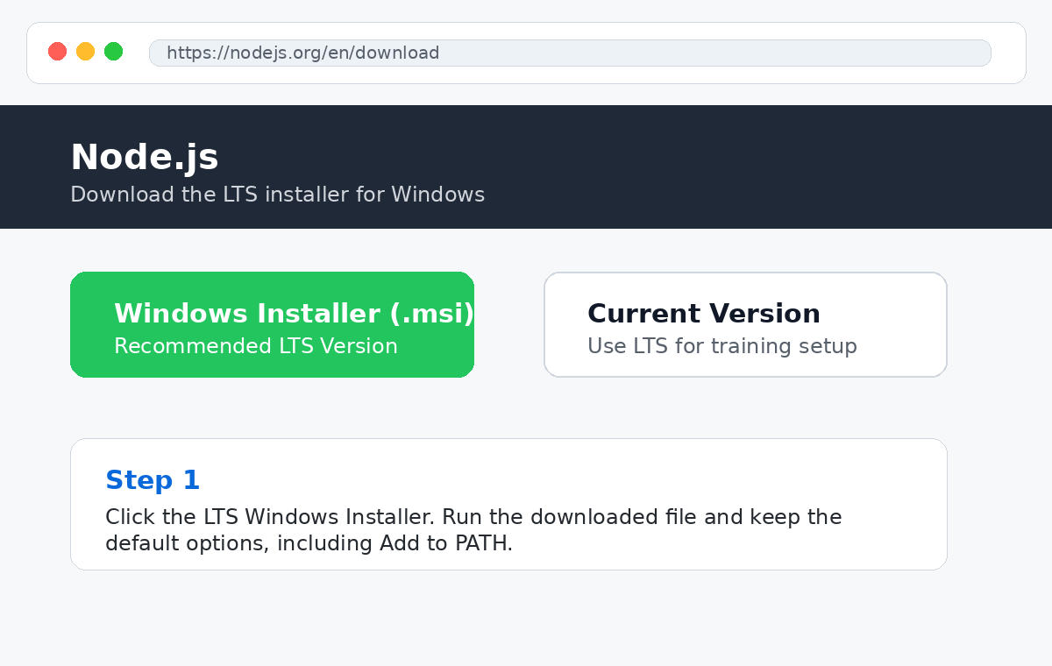

4. Verify Node.js and npm Installation
- Open Command Prompt, PowerShell, or the VS Code terminal.
- Type the command below and press Enter:
node -v
- A version number should be displayed. Example: v20.x.x
- Now verify npm by typing:
npm -v
- A version number should be displayed. Example: 10.x.x
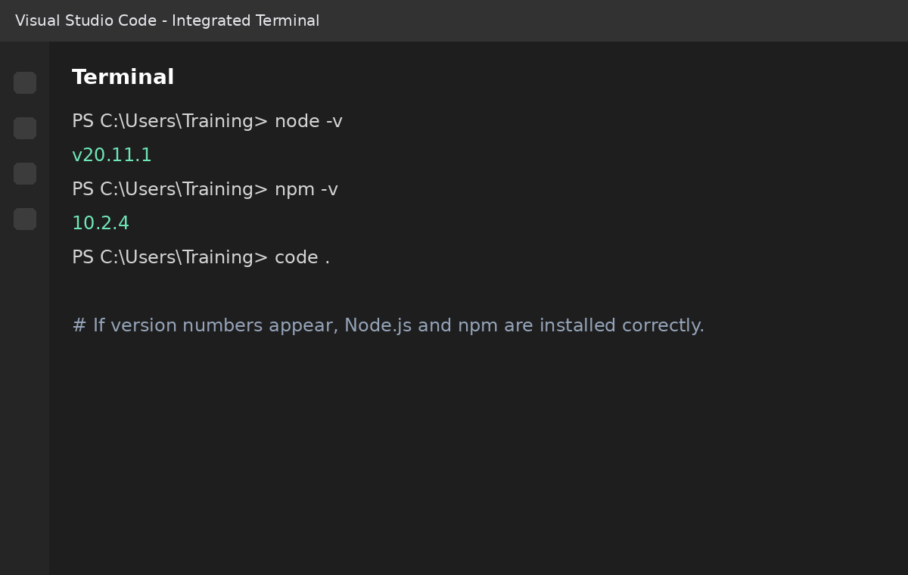

5. Set Environment Path Manually Only If Node Is Not Detected
Important: In most recent Node.js installations, PATH is added automatically. Follow this manual step only if node -v is not recognized.

- Right-click This PC or My Computer and select Properties.
- Open Advanced System Settings.
- Click Environment Variables.
- Under System variables, select Path and click Edit.
- Add this path as a new entry: C:\Program Files\nodejs
- Click OK on all windows.
- Restart Command Prompt or restart the machine.
Do not delete existing PATH values: Only add the Node.js path as a new entry. Deleting existing paths may affect Java, Python, Git, or other tools installed on the system.

6. Download and Install Visual Studio Code
Visual Studio Code is the recommended editor for JavaScript because it provides syntax highlighting, terminal integration, extensions, debugging support, Git integration, and project folder management.
- Open the browser and go to https://code.visualstudio.com/download
- Download the Windows installer.
- Run the installer.
- During setup, select useful options such as Add to PATH, Open with Code, and Create a desktop icon.
- Complete the installation and launch Visual Studio Code.
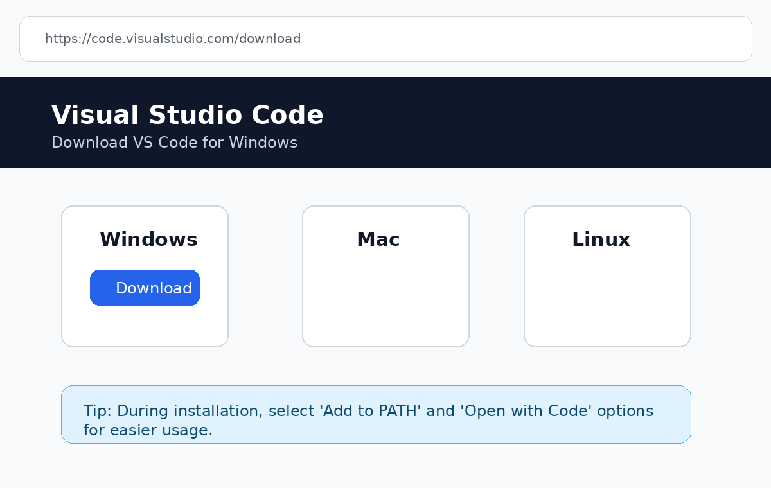

7. Recommended VS Code Extensions
Extension | Purpose
Code Runner | Runs JavaScript files quickly from the editor. Optional, because terminal execution is enough.
ESLint | Helps identify JavaScript syntax and quality issues.
Prettier - Code formatter | Formats code consistently.
JavaScript and TypeScript Nightly | Optional. Useful for advanced language support.

8. Create a JavaScript Practice Folder
- Create a folder on your system, for example: C:\JavaScriptPractice
- Open Visual Studio Code.
- Go to File > Open Folder.
- Select the JavaScriptPractice folder.
- Create a new file and save it as hello.js.

9. Write and Run Your First JavaScript Program
In the hello.js file, type the below code:
const studentName = "Vandana";
console.log("JavaScript setup is ready");
console.log(`Welcome, ${studentName}`);
- Save the file using Ctrl + S.
- Open the terminal inside VS Code using Terminal > New Terminal.
- Run the program using:
node hello.js
Expected output:
JavaScript setup is ready
Welcome, Vandana
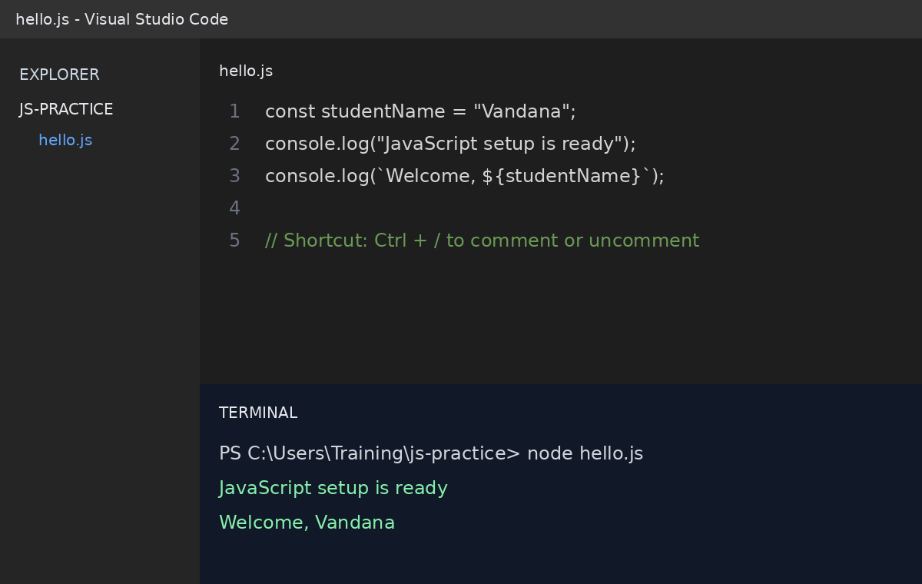

10. Useful VS Code Shortcuts for JavaScript
Shortcut | Use
Ctrl + S | Save file
Ctrl + ` | Open or close integrated terminal
Ctrl + / | Comment or uncomment selected code
Ctrl + Shift + P | Open command palette
Ctrl + B | Show or hide left side panel
Alt + Shift + F | Format document, if formatter is installed

11. Troubleshooting
Issue | Possible Reason | Solution
node is not recognized | Node.js PATH is not set | Add C:\Program Files\nodejs to System Path and restart terminal.
npm is not recognized | npm did not install correctly or terminal was not restarted | Restart terminal. If still failing, reinstall Node.js LTS.
File does not run | File is not saved with .js extension | Save the file as hello.js, not hello.txt.
Cannot find module | A package is missing | Run npm install package-name inside the project folder.
Output not visible | Program was run from wrong folder | Use cd command or open the correct folder in VS Code.

12. Final Verification Checklist
- Node.js is installed successfully.
- node -v shows a version number.
- npm -v shows a version number.
- Visual Studio Code is installed.
- A folder is opened in VS Code.
- hello.js file is created and saved.
- The command node hello.js runs successfully.
- Expected output is visible in the VS Code terminal.

13. Summary
After completing this setup, learners can write JavaScript programs in Visual Studio Code and run them using Node.js from the terminal. This environment is suitable for JavaScript basics, TypeScript learning, Playwright automation, API automation scripting, and modern frontend development practice.

