

SESSION 9


Defects

- Any mismatched functionality found in a application is called as Defect/Bug/Issue.
- During Test Execution Test engineers are reporting mismatches as defects to developers through templates or using tools.
- Defect Reporting Tools:
  - Clear Quest
  - DevTrack
  - Jira
  - Quality Center
  - Bug Jilla etc.

Defect Classification
Defects Categorization

Severity
Priority

Blocker
Critical
Major
Minor
High (P1)
Medium (P2)
Low (P3)




Defect Severity

- Severity describes the seriousness of defect and how much impact on business workflow.
- Tester decides the Severity of the defect.
- Defect severity can be categorized into four classes
  - Blocker(Show stopper): This defect indicates nothing can proceed further.
    - Ex: Application crashed, Login Not worked
  - Critical : The main/basic functionality is not working. Customer business workflow is broken. They cannot proceed further.
    - Ex1: Fund transfer is not working in net banking
    - Ex2: Ordering product in ecommerce application is not working.
  - Major: It cause some undesirable behavior, but the feature is still functional.
    - Ex1: After sending email there is no confirm message
    - Ex2: After booking cab there is no confirmation.
  - Minor: It won't cause any major break-down of the system
    - Ex: Look and feel issues, spellings, alignments.


Defect Priority

- Priority describes the importance of defect.
- Tester decides the Priority of the defect. Developer or product manager can change priority later if needed.
- Defects will be fixed by developer based on priority.

Defect priority can be categorized into three classes
  - P1 (High) : The defect must be resolved immediately as it affects the system severely and cannot be used until it is fixed.
  - P2 (Medium): It can wait until a new versions/builds is created
  - P3 (Low): Developer can fix it in later releases.


Difference Between Severity and Priority

Severity | Priority
Defined by the impact of a specific problem on any application’s functionality. | Defined by the impact on business.
Category decided by testers. | Decided by testers, but developers or product owners can change priority later based on business impact.
Deals with the technical aspects of the application. | Deals with the timeframe or order to fix the defects.
The value does not change with time, it’s fixed. | The priority value is subjective and may change after comparing with other defects.


Examples on Priority & Severity

Issue Description | Priority | Severity
A spelling mistake in a page not frequently navigated by users. | Low | Low
Application crashing in some very corner case. | Low | High
Slight change in logo colour or spelling mistake in company name. | High | Low
Issue with login functionality (user is not able to login). | High | High
Web page not found when user clicks on a link (rarely visited). | Low | High
Any cosmetic or spelling issues within a paragraph or a page. | Low | Low


Defect(Bug) Life Cycle

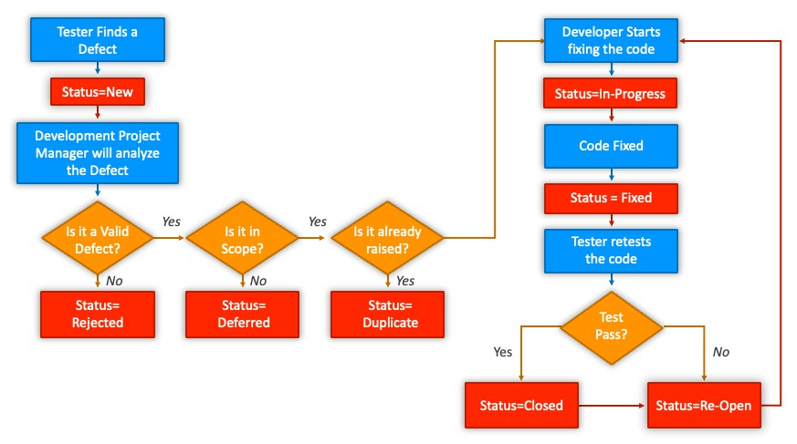


Defect Resolution

- After receiving the defect report from the testing team, development team conduct a review meeting to fix defects. Then they send a Resolution Type to the testing team for further communication.

Resolution Types:-
  - Accept
  - Reject
  - Duplicate
  - Enhancement
  - Need more information
  - Not Reproducible
  - Fixed
  - As Designed

Defect Report Contents

- Defect ID - Unique identification number for the defect.
- Defect Description - Detailed description of the defect including information about the module in which defect was found.
- Version - Version of the application in which defect was found.
- Steps - Detailed steps along with screenshots with which the developer can reproduce the defects.
- Date Raised - Date when the defect is raised
- Reference- where you Provide reference to the documents like . requirements, design, architecture or may be even screenshots of the error to help understand the defect
- Detected By - Name/ID of the tester who raised the defect
- Status - Status of the defect , more on this later
- Fixed by - Name/ID of the developer who fixed it
- Date Closed - Date when the defect is closed
- Severity which describes the impact of the defect on the application
- Priority which is related to defect fixing urgency. Severity Priority could be High/Medium/Low based on the impact urgency at which the defect should be fixed respectively




Test Metrics

SNO | Required Data
1 | No. Of Requirements
2 | Avg. No. of Test Cases written Per Requirement
3 | Total No.of Test Cases written for all Requirement
4 | Total No. Of test cases Executed
5 | No.of Test Cases Passed
6 | No.of Test Cases Failed
7 | No.of Test cases Blocked
8 | No. Of Test Cases Un Executed
9 | Total No. Of Defects Identified
10 | Critical Defects Count
11 | Higher Defects Count
12 | Medium Defects Count
13 | Low Defects Count
14 | Customer Defects
15 | No.of defects found in UAT


Test Metrics

% of Test cases Executed:
No.of Test cases executed / Total No. of Test cases written ) * 100

% of test cases NOT executed:
(No.of Test cases NOT executed/Total No. of Test cases written) * 100

% Test cases passed
(No.of Test cases Passed /Total Test cases executed) * 100

% Test cases failed
(No.of Test cases failed / Total Test cases executed) * 100

%Test cases blocked
(No.of test cases blocked / Total Test cases executed ) * 100


Test Metrics

Defect Density: Number of defects identified per requirement/s
No.of defects found / Size(No. of requirements)

Defect Removal Efficiency (DRE):
(A / A+B ) * 100
(Fixed Defects / (Fixed Defects + Missed defects) ) * 100
- A- Defects identified during testing/ Fixed Defects
- B- Defects identified by the customer/Missed defects

Defect Leakage:
(No.of defects found in UAT / No. of defects found in Testing) * 100

Defect Rejection Ratio:
(No. of defect rejected /Total No. of defects raised) * 100
- Defect Age: Fixed date-Reported date
- Customer satisfaction = No.of complaints per Period of time

