Installing Selenium Webdriver Python Package.

There are two unique ways to install and prepare the Selenium Webdriver Python setup.

First we need to install pip if pip is not present in C:\Python27\Scripts

To do that

* Download [get-pip.py](https://bootstrap.pypa.io/get-pip.py) to a folder on your computer. Open a command prompt window and navigate to the folder containing get-pip.py. Then run python get-pip.py. This will install pip.

Set the the environment variable for pip

C:\Python27\Scripts

Restart machine

A- Use PIP Package Manager To Install Selenium With Python.

**1-** First go to the directory where you’ve installed the python. For example, we’ve installed the latest Python version 2.7.1, and its location is in the <C:\python27> folder.

**2-** Use the <pip> tool to install the Selenium Webdriver package.

C:\python\python35>pip install selenium

Collecting selenium

Downloading selenium-2.53.0.tar.gz (815kB)

←[K 100% |################################| 819kB 108kB/s ta 0:00:01

Installing collected packages: selenium

Running setup.py install for selenium

Successfully installed selenium-2.53.0

←[33mYou are using pip version 7.1.2, however version 8.1.0 is available.

You should consider upgrading via the 'python -m pip install --upgrade pip' comm

and.←[0m

B Download the driver

Geckodriver for Firefox

Chromedriver for chrome

IEserver for internet explorer

Keep the driver in the path variable path , u can keep in python27 folder as well

**CHROMEDRIVER/GECKODRIVER**

1. Download chromedriver or Geckodriver or IE server

ChromeDriver is maintained by the Google Chromium team. It can be downloaded from <http://chromedriver.chromium.org/downloads>

unzip the driver folder and set the environment path as per driver path

Firefox

Downloadgeckodriver from https://github.com/mozilla/geckodriver/releases set the enviornment path

1. Right click to mycomputer and go to properties or Go to **Control Panel -> System and Security -> System.**  
   Under Advanced System Setting option click on **Environment Variables** as highlighted below.  
   [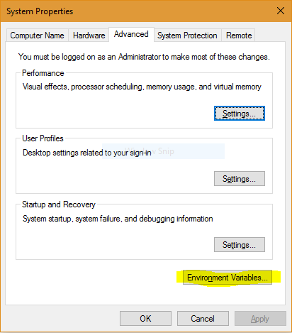](http://cdncontribute.geeksforgeeks.org/wp-content/uploads/Capture10.png)

Now, you have to alter the “Path” variable under System variables so that it also contains the path to the Java environment. Select the “Path” variable and click on Edit button as highlighted below.

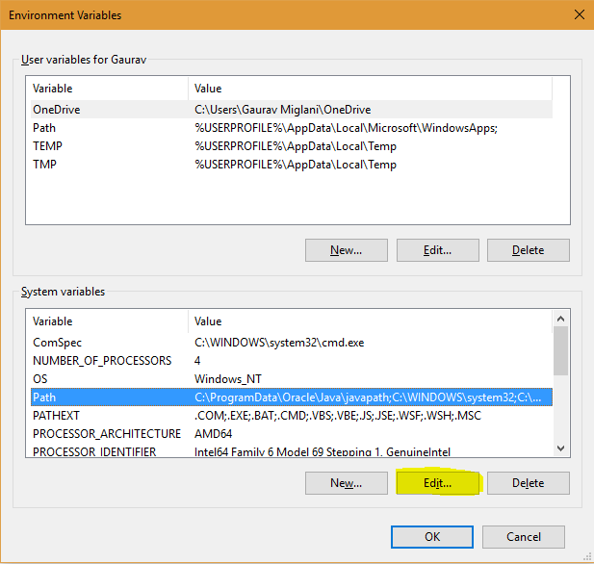

1. You will see list of different paths, click on New button and then add path where java is installed. By default, java is installed in “C:\drivers\” folder OR “C:\driver. In case, you have installed java at any other location,then add that path.

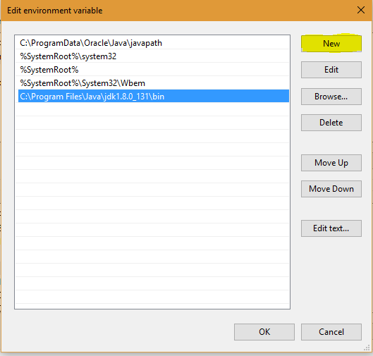

Generic error you can face

Exception in thread "main" java.lang.IllegalStateException: The path to the driver executable must be set by the webdriver.chrome.driver system property; for more information, see https://github.com/SeleniumHQ/selenium/wiki/ChromeDriver. The latest version can be downloaded from http://chromedriver.storage.googleapis.com/index.html

This will come if you have not set the gecko/chromedriver in environment path

IF you do not add all libraries in the project build path below error will come. Make sure all the libraries are added in the project build path. Files which are presend out side the lib and inside lib folder of selenium.zip

Exception in thread "main" java.lang.NoClassDefFoundError: com/google/common/collect/ImmutableMap

at org.openqa.selenium.remote.service.DriverService$Builder.<init>(DriverService.java:259)

at org.openqa.selenium.chrome.ChromeDriverService$Builder.<init>(ChromeDriverService.java:101)

at org.openqa.selenium.chrome.ChromeDriverService.createDefaultService(ChromeDriverService.java:94)

at org.openqa.selenium.chrome.ChromeDriver.<init>(ChromeDriver.java:123)

at Selenium_Learning.SEL_01_BrowserOperation.main(SEL_01_BrowserOperation.java:30)

Caused by: java.lang.ClassNotFoundException: com.google.common.collect.ImmutableMap

at java.net.URLClassLoader.findClass(Unknown Source)

at java.lang.ClassLoader.loadClass(Unknown Source)

at sun.misc.Launcher$AppClassLoader.loadClass(Unknown Source)

at java.lang.ClassLoader.loadClass(Unknown Source)

... 5 more