**Note for users with LiClipse**

PyDev already comes preinstalled in [LiClipse](http://www.liclipse.com/), so, this step can be skipped (note that if [LiClipse](http://www.liclipse.com/) is used, PyDev cannot be installed or update separately, as it must always be updated as a whole).

**Requisites**

PyDev requires **Java 8** and **Eclipse 4.6 (Neon)** in order to run and only supports **Python 2.6** onwards. I.e.:

* [Python](http://www.python.org/) **(2.6 or newer)**
* [Jython](http://www.jython.org/) **(2.6 or newer)**
* [IronPython](http://www.codeplex.com/Wiki/View.aspx?ProjectName=IronPython) **(2.6 or newer)** - excluding 2.7.6 and 2.7.7 have a [bug](https://github.com/IronLanguages/main/issues/1663) which makes them unusable in PyDev.

If you don't have Java 8, the update process may appear to succeed, but PyDev will simply not show in the target installation. Please double-check if you're using a Java 8 vm in **about > installation details > configuration** before trying to install PyDev.

**Need to use older Eclipse/Java/Python**

If you need to use an older version of Eclipse/Java/Python, below is the latest PyDev version to be used based on your requisites.

* Eclipse 4.5, Java 8: PyDev 5.2.0
* Eclipse 3.8, Java 7: PyDev 4.5.5
* Eclipse 3.x, Java 6: PyDev 2.8.2
* Python 2.5 or older: PyDev 5.5.0

**Before starting the install**

The first thing to choose before the install is a folder where you have permissions to write (otherwise, remember to install Eclipse running as an Administrator and remember to run as an Administrator whenever any plugin needs to be updated).

**PyDev Certificate**

PyDev is built with a self-signed certificate, which means that when installed a dialog will be opened to ask if you trust the certificate (which should be OK for most users).

Now, if you don't want that dialog to appear, it's possible to import the certificate before starting the installation process (this is actually a requirement for those that want to install PyDev from the command line because of a bug in the Eclipse p2 director).

The first step for that is downloading the [PyDev certificate](http://www.pydev.org/pydev_certificate.cer) (note that you may want to access **pydev.org** using **https** to make sure that the connection is encrypted).

The second step is discovering the Java being used in Eclipse: go to **Help > About > Installation details and look for 'java.home'**

Then to actually import it, in the command line, go to the Eclipse 'java.home' directory and execute

**bin/keytool.exe -import -file pydev_certificate.cer -keystore lib/security/cacerts**

Note that if you never did anything here, your **password** when requested should be **changeit**

Reference: <http://download.oracle.com/javase/1.4.2/docs/tooldocs/solaris/keytool.html#cacerts>

**Installing with the update site**

**Note: Instructions are targeted at Eclipse 4.6 onwards**

To install PyDev and PyDev Extensions using the Eclipse Update Manager, you need to use the **Help > Install New Software...** menu.

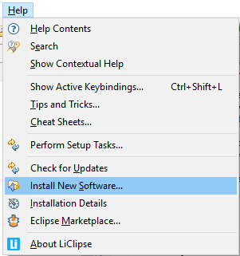

In the next screen, add the update site(s) you want to work with from the list below:

Latest version:

* <http://www.pydev.org/updates>

Nightly builds:

* <http://www.pydev.org/nightly>

Browse other versions **(open in browser to select URL for Eclipse)**:

* <http://www.pydev.org/update_sites>

and press **<Enter>** so that Eclipse will query the update site you just entered for contents.

Before proceeding, it's recommended that you **UNCHECK** the **'Contact all update sites during install to find required software'** (it will still work if you don't do that, but it'll query all the update sites available, which is much slower than querying only the PyDev update site, which should be all that's needed to install PyDev).

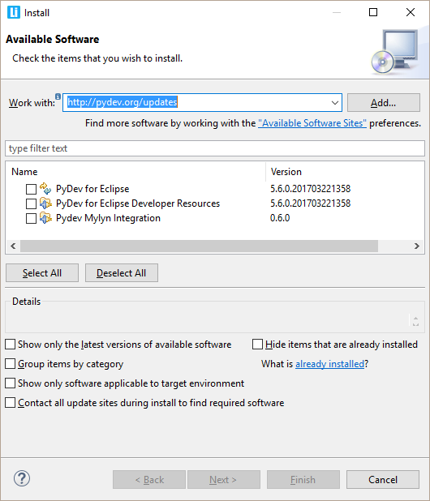

Now, select **PyDev for Eclipse** to install PyDev (and optionally the PyDev Mylyn integration or the developer resources, which provide the PyDev source code) and click **Next**.

Now, read the license agreement and if you accept, select the accept radio button and click **Finish**.

At that point, Eclipse should automatically download the plugin contents and present you to a dialog asking if you want to restart (to which you should say **yes**).

**Installing with the zip file**

The available locations for the zip files are:

* [SourceForge download](http://sourceforge.net/projects/pydev/files/)

After downloading the zip file:

Extract the contents of the zip file in the **eclipse/dropins** folder and restart Eclipse.

If it doesn't work, try restarting Eclipse with the **-clean** flag (if you're a regular user and installing with admin, make sure you call **-clean** logged in as admin, so that Eclipse finds out about it).

If it's still not found, double check the requisites (such as the Java vm version).

**Checking the installation**

You can verify if it is correctly installed going to the menu **'window > preferences'** and checking if there is a **PyDev** item under that.

**Troubleshooting installation problems**

**Unable to load repository**

While most times things work as explained, some users may have messages such as:

Unable to load the repository <http://pydev.org/updates>

Unknown Host: <http://pydev.org/updates/content.xml>

This means there's some issue accessing the update site in your current connection.

In that case, you can try using a direct URL for the download (all the <http://pydev.org/updates/> URLs are actually redirects to the final location). Currently, those redirects point to links on [http://bintray.com](http://bintray.com/), so, you can visit the related update site page (such as <http://pydev.org/updates>) in a browser and see to where it's being redirected (you may want to try that direct link with **http** or **https** to see if it makes a difference in your use case).

**Possible issue on download**

If you have any problem at this point with a message such as:

An error occurred while collecting items to be installed

No repository found containing:

org.python.pydev/osgi.bundle/1.4.7.2843

No repository found containing:

org.python.pydev.ast/osgi.bundle/1.4.7.2843

that might indicate that the mirror you selected is having some network problem at that time, so, please retry it later on (possibly with a direct URL such as in the **Unable to load repository** tip above).

**PyDev does not appear after install!**

Well, the main issue at this time is that PyDev requires Java 8 in order to run.

**Tip**: LiClipse (which is mostly a PyDev standalone plus some goodies) is pre-configured so that none of the hassle of installing PyDev into Eclipse nor any pre-requisite is needed ;)

**Java 8 requisite**

If you don't have Java 8, make sure you download/install the latest Java 8 JRE or JDK, try restarting to see if it got it automatically.

I.e.: in **help > about > installation details > configuration** check if it's actually using the Java 8 version you pointed at.

If it didn't get it automatically, follow the instructions from:

<http://wiki.eclipse.org/Eclipse.ini> to add the -vm argument to eclipse.ini on "Specifying the JVM" to specify the Java 8 vm.

**Note on Mac OS**: You can use the command "/usr/libexec/java_home -v 1.8" to get the base path for the JVM (though you also need to append "/bin/java" to the output of said command to the -vm arg in eclipse.ini).

**Corrupted install**

Eclipse sometimes is not able to correctly get the plugin, from the update site but will do no checking on whether it is really correct (no md5 checking), and when this happens, you'll usually get a ClassNotFoundException (similar to the example below).

When that happens, **you should uninstall it and reinstall again** with the update site... if that still fails, you could try to get the zip files, as it will at least give you a warning when it is corrupt.

Note that the chance of the files being corrupt in the server is pretty low, as that's something that's always checked in a new release, but if you're suspicious about it, please report it at <https://www.brainwy.com/tracker/PyDev> so that it can be double-checked.

Also, there have been reports with that error where the only solution that has been consistent has been **removing all**previous versions of  PyDev and then installing the latest version.

**EXAMPLE**

Unable to create this part due to an internal error. Reason for the failure: The editor class could not be instantiated. This usually indicates that the editor's class name was mistyped in plugin.xml.

java.lang.ClassNotFoundException: org.python.pydev.editor.PyEdit

at

org.eclipse.osgi.framework.internal.core.BundleLoader.findClass(BundleLoader.java:405)

at

org.eclipse.osgi.framework.internal.core.BundleLoader.findClass(BundleLoader.java:350)

at

org.eclipse.osgi.framework.adaptor.core.AbstractClassLoader.loadClass(AbstractClassLoader.java:78)

at java.lang.ClassLoader.loadClass(ClassLoader.java:235) at

org.eclipse.osgi.framework.internal.core.BundleLoader.loadClass(BundleLoader.java:275)

...

**Uninstalling**

Follow the instructons below if at any time you wish to stop using the PyDev plugin (or any other Eclipse plugin):

**Eclipse 3.5 onwards**

If you installed with the update site, go to the menu **help > about > installation details** then on the **Installed Software**tab, select the plugins you want to uninstall  and click **Uninstall**.

If you installed with the zip file, just remove the com.python.pydev and org.python.pydev features and plugins from the dropins folder.