**SOLUTION:**

1. Install Net-SNMP:  
     
   Obtain the installation package from the Net-SNMP site and install by using all default settings. By default, Net-SNMP is installed under **C:\usr**.
2. Configuration:
   1. Open a DOS prompt window and type **snmpconf –i**:  
        
      If the following message is displayed, the Perl module must be installed:  
        
      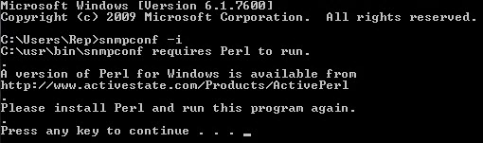
   2. Retype **snmpconf –i** and then select **1: C:/usr/etc/snmp/snmp.conf** to read the default setting:  
        
      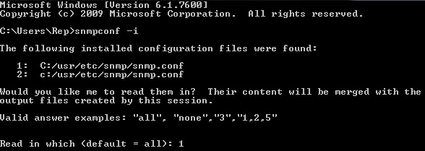
   3. Select **1: snmpd.conf**; this is the configuration file for the Net-SNMP SNMP agent:  
        
      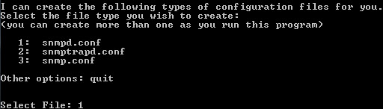
   4. Select **1: Access Control Setup**:  
        
      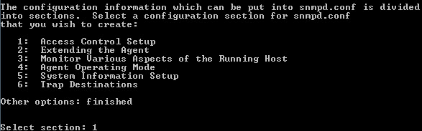
   5. Select **3: a SNMPv1/SNMPv2c read-only access community name**:  
        
      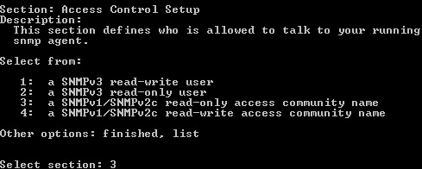
   6. Type **public** as the community string (you can enter any string) and then press the **Enter** key for both **to accept this community name from** and **should be restricted to**:  
        
      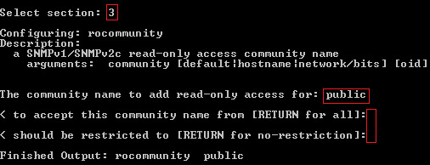
   7. Select **4: a SNMPv1/SNMPv2c read-write access community name**:  
        
      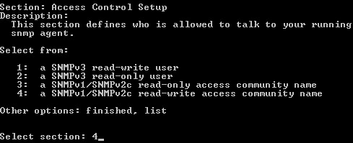
   8. Type **public** as the community string and then press the **Enter** key for both **to accept this community name from** and **should be restricted to**:  
        
      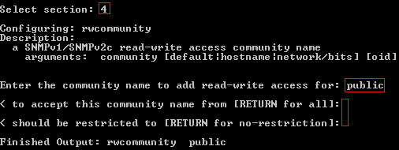
   9. To exit and save **snmpd.conf**, type **finished > finished > quit**:  
        
      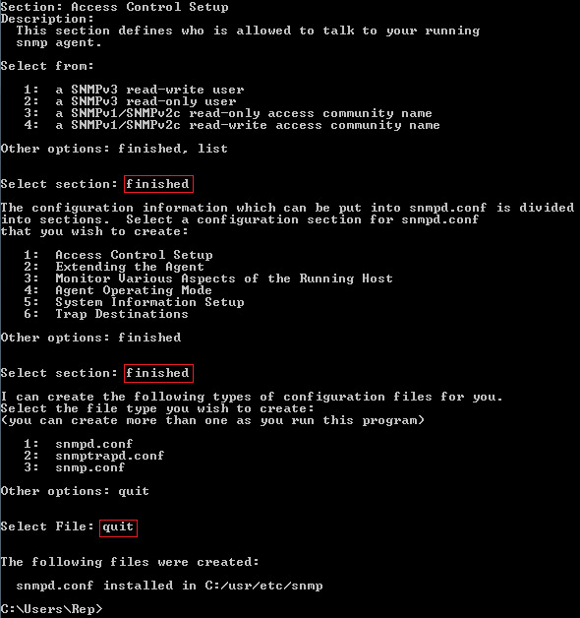
   10. Download the MIBs from the Juniper Web Portal and copy all MIB files (*.my) to the default MIB directory, which should be under **c:/usr/share/snmp/mibs**.
   11. Type the following lines in the **snmp.conf** file, which should be under **c:/usr/etc/snmp**:
   12. mibs +TRAPEZE-NETWORKS-AP-CONFIG-MIB
   13. mibs +TRAPEZE-NETWORKS-AP-IF-MIB
   14. mibs +TRAPEZE-NETWORKS-AP-STATUS-MIB
   15. mibs +TRAPEZE-NETWORKS-AP-TC
   16. mibs +TRAPEZE-NETWORKS-AP-UNCONFIGURED-MIB
   17. mibs +TRAPEZE-NETWORKS-BASIC-MIB
   18. mibs +TRAPEZE-NETWORKS-BASIC-TC
   19. mibs +TRAPEZE-NETWORKS-CLIENT-SESSION-MIB
   20. mibs +TRAPEZE-NETWORKS-CLIENT-SESSION-TC
   21. mibs +TRAPEZE-NETWORKS-CLUSTER-MIB
   22. mibs +TRAPEZE-NETWORKS-EXTERNAL-SERVER-MIB
   23. mibs +TRAPEZE-NETWORKS-INFO-RF-DETECT-MIB
   24. mibs +TRAPEZE-NETWORKS-LICENSE-FEATURE-TC-MIB
   25. mibs +TRAPEZE-NETWORKS-PORT-MIB
   26. mibs +TRAPEZE-NETWORKS-QOS-CONFIG-MIB
   27. mibs +TRAPEZE-NETWORKS-REGISTRATION-CHASSIS-MIB
   28. mibs +TRAPEZE-NETWORKS-REGISTRATION-DEVICES-MIB
   29. mibs +TRAPEZE-NETWORKS-RF-BLACKLIST-MIB
   30. mibs +TRAPEZE-NETWORKS-RF-DETECT-TC
   31. mibs +TRAPEZE-NETWORKS-RF-NOISE-TC-MIB
   32. mibs +TRAPEZE-NETWORKS-ROOT-MIB
   33. mibs +TRAPEZE-NETWORKS-SYSTEM-MIB
   34. mibs +TRAPEZE-NETWORKS-TRAP-MIB
   35. mibs +TRAPEZE-NETWORKS-TRAPLOG-MIB
3. Using local MIBs:
   1. Net-SNMP can translate numeric object identifies (OIDs) into textual object identifiers and vice versa (using the MIB description files):

> snmptranslate -On TRAPEZE-NETWORKS-PORT-MIB::trpzPortConfigTable

https://kb.juniper.net/library/CUSTOMERSERVICE/bk25949/bk25949-10.jpg

* 1. **snmpwalk** on a single OID will display a list of all results from the sub-tree of this OID:

snmpwalk -v 2c -c test 10.144.124.8 .1.3.6.1.4.1.14525.4.6.1.1.1

