**Curve fitting** is the process of constructing a [curve](https://en.wikipedia.org/wiki/Curve), or [mathematical function](https://en.wikipedia.org/wiki/Function_(mathematics)), that has the best fit to a series of [data points](https://en.wikipedia.org/wiki/Data_points), possibly subject to constraints.

 Curve fitting can involve either [interpolation](https://en.wikipedia.org/wiki/Interpolation), where an exact fit to the data is required, or [smoothing](https://en.wikipedia.org/wiki/Smoothing), in which a "smooth" function is constructed that approximately fits the data.

polyfit

Polynomial curve fitting

**Syntax**

p = polyfit(x,y,n)

[p,S] = polyfit(x,y,n)

[p,S,mu] = polyfit(x,y,n)

**Description**

[example](https://in.mathworks.com/help/matlab/ref/polyfit.html#bufeks8-1)

[p](https://in.mathworks.com/help/matlab/ref/polyfit.html?requestedDomain=de.mathworks.com#outputarg_p) = polyfit([x](https://in.mathworks.com/help/matlab/ref/polyfit.html?requestedDomain=de.mathworks.com" \l "inputarg_x),[y](https://in.mathworks.com/help/matlab/ref/polyfit.html?requestedDomain=de.mathworks.com#inputarg_y),[n](https://in.mathworks.com/help/matlab/ref/polyfit.html?requestedDomain=de.mathworks.com#inputarg_n)) returns the coefficients for a polynomial p(x) of degree n that is a best fit (in a least-squares sense) for the data in y. The coefficients in p are in descending powers, and the length of p is n+1

*p*(*x*)=*p*1*xn*+*p*2*xn*−1+...+*pnx*+*pn*+1.

[[p](https://in.mathworks.com/help/matlab/ref/polyfit.html?requestedDomain=de.mathworks.com" \l "outputarg_p),[S](https://in.mathworks.com/help/matlab/ref/polyfit.html?requestedDomain=de.mathworks.com#outputarg_S)] = polyfit([x](https://in.mathworks.com/help/matlab/ref/polyfit.html?requestedDomain=de.mathworks.com" \l "inputarg_x),[y](https://in.mathworks.com/help/matlab/ref/polyfit.html?requestedDomain=de.mathworks.com" \l "inputarg_y),[n](https://in.mathworks.com/help/matlab/ref/polyfit.html?requestedDomain=de.mathworks.com#inputarg_n)) also returns a structure S that can be used as an input to polyval to obtain error estimates.

[example](https://in.mathworks.com/help/matlab/ref/polyfit.html#bufcrts)

[[p](https://in.mathworks.com/help/matlab/ref/polyfit.html?requestedDomain=de.mathworks.com" \l "outputarg_p),[S](https://in.mathworks.com/help/matlab/ref/polyfit.html?requestedDomain=de.mathworks.com#outputarg_S),[mu](https://in.mathworks.com/help/matlab/ref/polyfit.html?requestedDomain=de.mathworks.com#outputarg_mu)] = polyfit([x](https://in.mathworks.com/help/matlab/ref/polyfit.html?requestedDomain=de.mathworks.com" \l "inputarg_x),[y](https://in.mathworks.com/help/matlab/ref/polyfit.html?requestedDomain=de.mathworks.com" \l "inputarg_y),[n](https://in.mathworks.com/help/matlab/ref/polyfit.html?requestedDomain=de.mathworks.com#inputarg_n)) also returns mu, which is a two-element vector with centering and scaling values. mu(1) is mean(x), and mu(2) is std(x). Using these values, polyfit centers x at zero and scales it to have unit standard deviation

ˆ*x*=*x*−‾*xσx* .

This centering and scaling transformation improves the numerical properties of both the polynomial and the fitting algorithm.

**Examples**

[collapse all](javascript:void(0);)

**Fit Polynomial to Trigonometric Function**

Try this Example

Generate 10 points equally spaced along a sine curve in the interval [0,4\*pi].

x = linspace(0,4\*pi,10);

y = sin(x);

Use polyfit to fit a 7th-degree polynomial to the points.

p = polyfit(x,y,7);

Evaluate the polynomial on a finer grid and plot the results.

x1 = linspace(0,4\*pi);

y1 = polyval(p,x1);

figure

plot(x,y,'o')

hold on

plot(x1,y1)

hold off

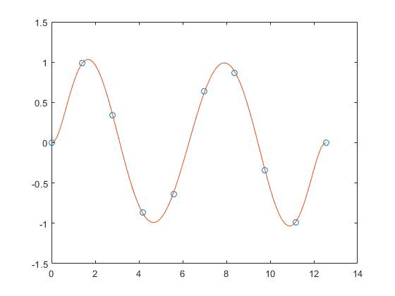

**Fit Polynomial to Set of Points**

Try this Example

Create a vector of 5 equally spaced points in the interval [0,1], and evaluate https://in.mathworks.com/help/examples/matlab/win64/FitPolynomialToSetOfPointsExample_01.png at those points.

x = linspace(0,1,5);

y = 1./(1+x);

Fit a polynomial of degree 4 to the 5 points. In general, for n points, you can fit a polynomial of degree n-1 to exactly pass through the points.

p = polyfit(x,y,4);

Evaluate the original function and the polynomial fit on a finer grid of points between 0 and 2.

x1 = linspace(0,2);

y1 = 1./(1+x1);

f1 = polyval(p,x1);

Plot the function values and the polynomial fit in the wider interval [0,2], with the points used to obtain the polynomial fit highlighted as circles. The polynomial fit is good in the original [0,1]interval, but quickly diverges from the fitted function outside of that interval.

figure

plot(x,y,'o')

hold on

plot(x1,y1)

plot(x1,f1,'r--')

legend('y','y1','f1')

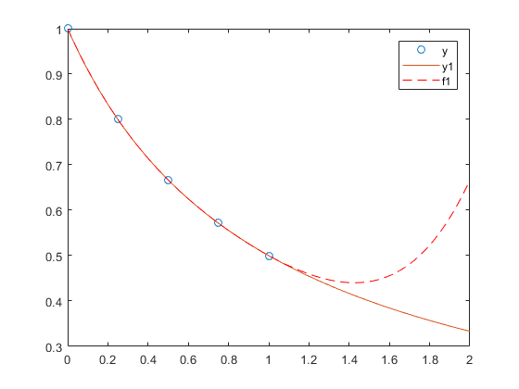

**Fit Polynomial to Error Function**

Try this Example

First generate a vector of x points, equally spaced in the interval [0,2.5], and then evaluate erf(x) at those points.

x = (0:0.1:2.5)';

y = erf(x);

Determine the coefficients of the approximating polynomial of degree 6.

p = polyfit(x,y,6)

p =

0.0084 -0.0983 0.4217 -0.7435 0.1471 1.1064 0.0004

To see how good the fit is, evaluate the polynomial at the data points and generate a table showing the data, fit, and error.

f = polyval(p,x);

T = table(x,y,f,y-f,'VariableNames',{'X','Y','Fit','FitError'})

T=*26x4 table*

X Y Fit FitError

\_\_\_ \_\_\_\_\_\_\_ \_\_\_\_\_\_\_\_\_\_ \_\_\_\_\_\_\_\_\_\_\_

0 0 0.00044117 -0.00044117

0.1 0.11246 0.11185 0.00060836

0.2 0.2227 0.22231 0.00039189

0.3 0.32863 0.32872 -9.7429e-05

0.4 0.42839 0.4288 -0.00040661

0.5 0.5205 0.52093 -0.00042568

0.6 0.60386 0.60408 -0.00022824

0.7 0.6778 0.67775 4.6383e-05

0.8 0.7421 0.74183 0.00026992

0.9 0.79691 0.79654 0.00036515

1 0.8427 0.84238 0.0003164

1.1 0.88021 0.88005 0.00015948

1.2 0.91031 0.91035 -3.9919e-05

1.3 0.93401 0.93422 -0.000211

1.4 0.95229 0.95258 -0.00029933

1.5 0.96611 0.96639 -0.00028097

In this interval, the interpolated values and the actual values agree fairly closely. Create a plot to show how outside this interval, the extrapolated values quickly diverge from the actual data.

x1 = (0:0.1:5)';

y1 = erf(x1);

f1 = polyval(p,x1);

figure

plot(x,y,'o')

hold on

plot(x1,y1,'-')

plot(x1,f1,'r--')

axis([0 5 0 2])

hold off

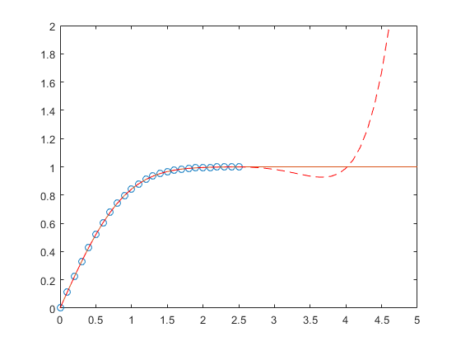

**Use Centering and Scaling to Improve Numerical Properties**

Try this Example

Create a table of population data for the years 1750 - 2000 and plot the data points.

year = (1750:25:2000)';

pop = 1e6\*[791 856 978 1050 1262 1544 1650 2532 6122 8170 11560]';

T = table(year, pop)

T=*11x2 table*

year pop

\_\_\_\_ \_\_\_\_\_\_\_\_\_

1750 7.91e+08

1775 8.56e+08

1800 9.78e+08

1825 1.05e+09

1850 1.262e+09

1875 1.544e+09

1900 1.65e+09

1925 2.532e+09

1950 6.122e+09

1975 8.17e+09

2000 1.156e+10

plot(year,pop,'o')

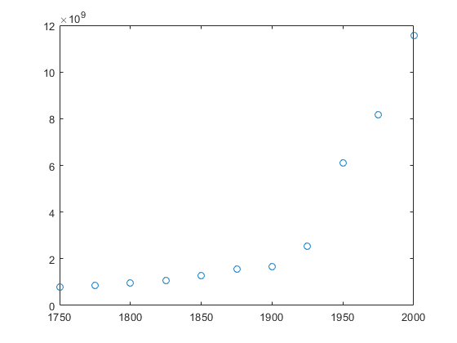

Use polyfit with three outputs to fit a 5th-degree polynomial using centering and scaling, which improves the numerical properties of the problem. polyfit centers the data in year at 0 and scales it to have a standard deviation of 1, which avoids an ill-conditioned Vandermonde matrix in the fit calculation.

[p,~,mu] = polyfit(T.year, T.pop, 5);

Use polyval with four inputs to evaluate p with the scaled years, (year-mu(1))/mu(2). Plot the results against the original years.

f = polyval(p,year,[],mu);

hold on

plot(year,f)

hold off

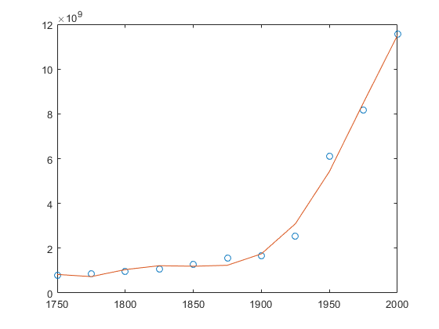

**Simple Linear Regression**

Try this Example

Fit a simple linear regression model to a set of discrete 2-D data points.

Create a few vectors of sample data points *(x,y)*. Fit a first degree polynomial to the data.

x = 1:50;

y = -0.3\*x + 2\*randn(1,50);

p = polyfit(x,y,1);

Evaluate the fitted polynomial p at the points in x. Plot the resulting linear regression model with the data.

f = polyval(p,x);

plot(x,y,'o',x,f,'-')

legend('data','linear fit')

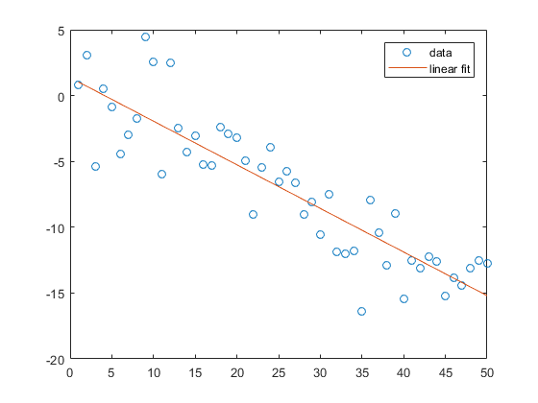

**Input Arguments**

[collapse all](javascript:void(0);)

**x — Query points  
vector**

Query points, specified as a vector. The points in x correspond to the fitted function values contained in y.

Warning messages result when x has repeated (or nearly repeated) points or if x might need centering and scaling.

**Data Types:**single | double  
**Complex Number Support:**Yes

**y — Fitted values at query points  
vector**

Fitted values at query points, specified as a vector. The values in y correspond to the query points contained in x.

**Data Types:**single | double  
**Complex Number Support:**Yes

**n — Degree of polynomial fit  
positive integer scalar**

Degree of polynomial fit, specified as a positive integer scalar. n specifies the polynomial power of the left-most coefficient in p.

**Output Arguments**

[collapse all](javascript:void(0);)

**p — Least-squares fit polynomial coefficients  
vector**

Least-squares fit polynomial coefficients, returned as a vector. p has length n+1 and contains the polynomial coefficients in descending powers, with the highest power being n. If either x or ycontain NaN values and n < length(x), then all elements in p are NaN.

Use polyval to evaluate p at query points.

**S — Error estimation structure  
structure**

Error estimation structure. This optional output structure is primarily used as an input to the polyval function to obtain error estimates. S contains the following fields:

| **Field** | **Description** |
| --- | --- |
| R | Triangular factor from a QR decomposition of the Vandermonde matrix of x |
| df | Degrees of freedom |
| normr | Norm of the residuals |

If the data in y is random, then an estimate of the covariance matrix of p is (Rinv\*Rinv')\*normr^2/df, where Rinv is the inverse of R.

If the errors in the data in y are independent and normal with constant variance, then [y,delta] = polyval(...) produces error bounds that contain at least 50% of the predictions. That is, y ± delta contains at least 50% of the predictions of future observations at x.

**mu — Centering and scaling values  
two element vector**

Centering and scaling values, returned as a two element vector. mu(1) is mean(x), and mu(2) is std(x). These values center the query points in x at zero with unit standard deviation.

Use mu as the fourth input to polyval to evaluate p at the scaled points, (x - mu(1))/mu(2).

**Limitations**

* In problems with many points, increasing the degree of the polynomial fit using polyfit does not always result in a better fit. High-order polynomials can be oscillatory between the data points, leading to a *poorer* fit to the data. In those cases, you might use a low-order polynomial fit (which tends to be smoother between points) or a different technique, depending on the problem.
* Polynomials are unbounded, oscillatory functions by nature. Therefore, they are not well-suited to extrapolating bounded data or monotonic (increasing or decreasing) data.

**Algorithms**

polyfit uses x to form Vandermonde matrix V with n+1 columns and m = length(x) rows, resulting in the linear system

0ΒΒΒΒΒ≅*xn*1*xn*2⋮*xnmxn*−11*xn*−12⋮*xn*−1*m*⋯⋯⋱⋯11⋮11ΧΧΧΧΧΑ0ΒΒΒΒΒ≅*p*1*p*2⋮*pn*1ΧΧΧΧΧΑ=0ΒΒΒΒΒ≅*y*1*y*2⋮*ym*1ΧΧΧΧΧΑ  ,

which polyfit solves with p = V\y. Since the columns in the Vandermonde matrix are powers of the vector x, the condition number of V is often large for high-order fits, resulting in a singular coefficient matrix. In those cases centering and scaling can improve the numerical properties of the system to produce a more reliable fit.