How to print scikit-learn version?

import sklearn
print(sklearn.__version__)

0.19.0

titanic_test.loc[titanic_test['Fare'].isnull(), 'Fare'] = 0

Because in fare column missing data is there
So to avoid NaN error replace missing data with mean value

#convert categorical features to one-hot encoded continuous features
features = ['Pclass', 'Sex', 'Embarked']
titanic_test1 = pd.get_dummies(titanic_test, columns=features)
print(titanic_test1.shape)

why we use get dummies?
To do one-hot encoding

pd.get_dummies is for create as dataframe

This is lifecycle deployment

dt_estimator = joblib.load('decision-tree-v1.pkl')
titanic_test1['Survived'] = dt_estimator.predict(titanic_test1)

Deployment Phase

joblib.dump(dt_estimator,'decision-tree-v1.pkl')

pickle format is like XML but pkl is specific for python

Model Serving

Integrate service to APP

before this just go through functions in python

def add1(a,b):
return a+b

Use indentation to identify body

def add2(a,b,c=20,d=30):
return a+b+c+d

Use named arguments to skip few arguments(like mention name see below)

Note: First letter as capital indicate Class in python

@indicates service

_name

To define private variable/function not visible to outside module

var_

To define alternative to use keywords as variables use above convention
Which def refers to function in python but forcefully you want to use it as variable name then use var_ (here var is variable name)

__name__

Special variables/keywords

Data Science life cycle

File Name: lifecycle1.py

Our titanic train data is in csv format so it consists columns of different type for that we need complex container i.e data frame

To use data frames import pandas package

import pandas as pd

import os
print(os.getcwd())

cwd - current working directory
E:\ramya_work\Algorithmica\DataScience

Use / (forward slash) instead of \ (backward slash) which is acceptable in both linux and windows

os.chdir('E:/ramya_work/Algorithmica/DataScience')

Read and explore titanic train data

titanic_train=pd.read_csv('titanic_train.csv')
titanic_train.shape
titanic_train.info()

Convert categorical features to continuous features for this we require one-hot encoding.
get_dummies used for one hot encoding

features=['Pclass','Sex','Embarked']
titanic_train1=pd.get_dummies(titanic_train,columns=features)
titanic_train1.shape

Drop features(columns) which are not useful for learning pattern(logic)

By default inplace=False which means after drop features will be existed and in data frame. If you dont want to see dropped columns use inplace=True

features_to_drop=['Name','PassengerId','Ticket','Cabin','Survived']
titanic_train1.drop(features_to_drop,axis=1,inplace=True)

Set featured columns and target column

X_train = titanic_train1
Y_train = titanic_train['Survived']

Create an instance of machine learning class

from sklearn import tree
dt_estimator=tree.DecisionTreeClassifier()

Build model(logic) by invoking fit method

dt_estimator.fit(X_train,Y_train)

To know our model is good or bad do model evaluation phase
Model evaluation phase

from sklearn import model_selection
scores = model_selection.cross_validate(dt_estimator, X_train, Y_train, cv=10)
scores.get('test_score').mean()
scores.get('train_score').mean()

By the above code we will get error like
ValueError: Input contains NaN

So include Age because Age column includes missing data

Model Deployment Phase

from sklearn.externals import joblib
joblib.dump(dt_estimator, "decision-tree-v1.pkl")

Local Test

Model Serving

Decision tree algorithm:

Decision tree learning is one of the most widely used techniques for classification.

Given a data table that contains attributes and class of the attributes,
we can measure all are same kind or different of the table based on the classes.
We say a table is pure if it contains only a single class.
If a data table contains several classes, then we say that the table is impure.
There are several indices to measure degree of impurity.

Impurity measures:

gini index
Entropy
Miss classification(classification error)

What is meant by impurity?
For this understanding of probability is necessary.
Includes impurity calculations. Once we need to go through probability then we will come back to impurity concept again.

Probability

In machine learning why we need probability

Business is random process, which is nothing but we don't know what is going to happen in future.

In a business generally we have train data/history data based on this we will do our predictions or plans to improve business.

And in data science we consider each column in train data as random column.

Like this probability and data science are related to each to other. And we will use probability in our data science.

What is probability?

Probability is the measure of the likelihood that an event will occur.
Always probability is in between 0 and 1,
where, 0 indicates impossibility and 1 indicates certainty.

Probability of an event happening = favorable outcomes/total experiments

Instead of writing something about experiment description we will use random variable.

What is a random variable in probability?

A random variable is a set of possible values from a random experiment.
Example:
Tossing a coin: we could get Heads or Tails.
Let's give them the values Heads=0 and Tails=1 (our choice you can give what ever you like)
and we have a Random Variable "X":
X = {0, 1}

In general will use capital letters for random variable like X.

Life is full of random events.

Let's go through cards in a deck. - Total 52 cards.

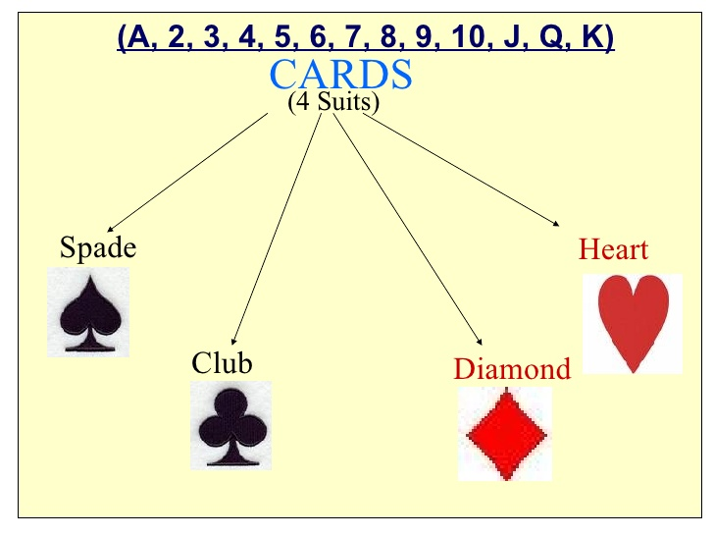

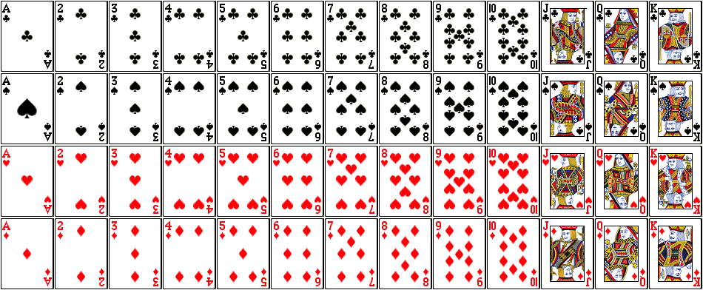

Events can be independent,dependent

Independent Events:
each event is not affected by other events.

Example:
Tossing a coin
What it did in the past will not affect the current toss

Dependent Events:
also called "Conditional", where an event is affected by other events.

Example: Drawing 2 cards from a deck

After taking one card from the deck there are less cards available, so the probabilities change.

Let's look at the chances of getting a King.

For the 1st card the chance of drawing a King is 4 out of 52

But for the 2nd card:

- If the 1st card was a King, then the 2nd card is less likely to be a King, as only 3 of the 51 cards left are Kings.
- If the 1st card was not a King, then the 2nd card is slightly more likely to be a King, as 4 of the 51 cards left are King.

Let's go in detail about dependent events.

Events can be "dependent" ... which means they can be affected by previous events ...

Example: Marbles in a bag

2 blue and 3 red marbles are in a bag.

What are the chances of getting a blue marble?

The chance is 2 in 5

But after taking one out the chances change!

So the next time:

if we got a red marble before, then the chance of a blue marble next is 2 in 4
if we got a blue marble before, then the chance of a blue marble next is 1 in 4

There is a 2/5 chance of pulling out a Blue marble, and a 3/5 chance for Red:

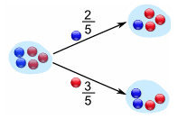

We can go one step further and see what happens when we pick a second marble:

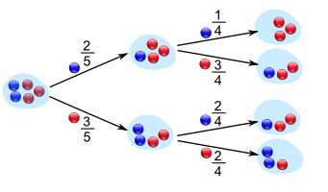

If a blue marble was selected first there is now a 1/4 chance of getting a blue marble and a 3/4 chance of getting a red marble.

If a red marble was selected first there is now a 2/4 chance of getting a blue marble and a 2/4 chance of getting a red marble.

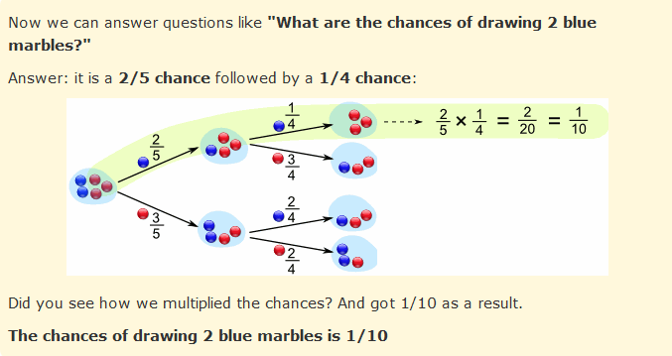

Generally we love notation in mathematics

P(A)=No. of favorable outcomes to A / Total number of outcomes.

P(A) means "Probability Of Event A"

In our marbles example Event A is "get a Blue Marble first" with a probability of 2/5:

P(A) = 2/5

And Event B is "get a Blue Marble second" ... but for that we have 2 choices:

If we got a Blue Marble first the chance is now 1/4
If we got a Red Marble first the chance is now 2/4
So we have to say which one we want, and use the symbol "|" to mean "given":

P(B|A) means "Event B given Event A"

In other words, event A has already happened, now what is the chance of event B?

P(B|A) is also called the "Conditional Probability" of B given A.

And in our case:

P(B|A) = 1/4

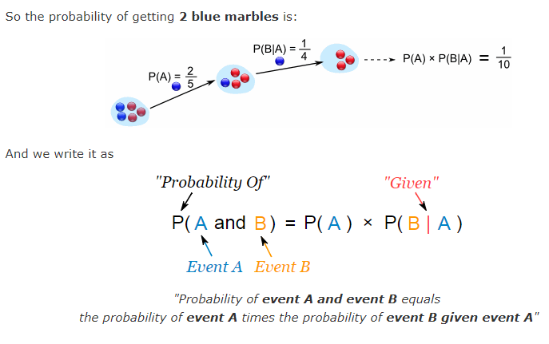

P(A and B) = P(A) x P(B|A)

P(B|A) = P(A and B) / P(A)

Let’s take another example.

Suppose you have a jar containing 6 marbles – 3 black and 3 white. What is the probability of getting a black given the first one was black too.

P (A) = getting a black marble in the first turn

P (B) = getting a black marble in the second turn

P (A) = 3/6

P (B) = 2/5

P (A and B) = 1/2*2/5 = 1/5

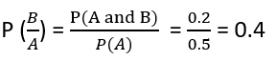

Reversing the condition

Example: Rahul’s favorite breakfast is bagels and his favorite lunch is pizza.
The probability of Rahul having bagels for breakfast is 0.6.
The probability of him having pizza for lunch is 0.5.
The probability of him, having a bagel for breakfast given that he eats a pizza for lunch is 0.7.

Let’s define event A as Rahul having a bagel for breakfast, Event B as Rahul having a pizza for lunch.

P (A) = 0.6

P (B) = 0.5

P(A|B) = 0.7

If we look at the numbers, the probability of having a bagel is different than the probability of having a bagel given he has a pizza for lunch.
This means that the probability of having a bagel is dependent on having a pizza for lunch.
Now what if we need to know the probability of having a pizza given you had a bagel for breakfast. i.e. we need to know P(B|A)
Bayes theorem now comes into the picture.

Bayes Theorem

The Bayes theorem describes the probability of an event based on the prior knowledge of the conditions that might be related to the event.
If we know the conditional probability P(A|B), we can use the bayes rule to find out the reverse probabilities P(B|A)

How can we do that?

P(A|B)=P(A and B)/P(B)
P(B|A)=P(A and B)/P(A)

P(A and B) = P(A|B)*P(B) = P(B|A)*P(A)

P(B|A) = P(A|B)*(P(B)/P(A))

The above statement is the general representation of the Bayes rule.

For the previous example –
if we now wish to calculate the probability of having a pizza for lunch provided you had a bagel for breakfast would be = 0.7 * 0.5/0.6.

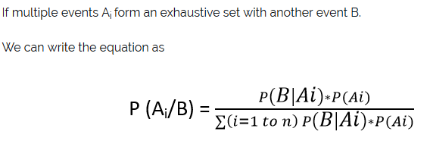

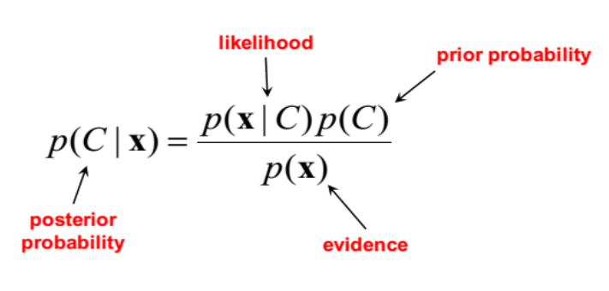

Go to PDF algorithmica pdf for cancer diagnosis problem

P(A|B) = P(B|A)/P(B) * P(A) (bayes's theorm)

A - cancer=yes
B - test=+ve

P(cancer=yes|test=+ve)=P(test=+ve|cancer=yes) / P(test=+ve) * P(cancer=yes)

Given,

P(cancer=yes) = 0.02 (2% given in problem)

-----------------------------------------------

P(test=+ve) = P(test=+ve&cancer=yes) + P(test=+ve&cancer=no)

P(test=+ve&cancer=yes) = P(cancer=yes) * P(test=+ve|cancer=yes)
= 0.02 * 0.9 (90% given)

P(test=+ve&cancer=no) = P(cancer=no) * P(test=+ve|cancer=no)
= 0.98 * 0.1 (10% given)

0.98 = 1-0.02

Go to PDF algorithmica pdf for double headed coin problem

Dh=double headed

P(coin=fair|toss=head) =
P(toss=head|coin=fair) / P(toss=head) * P(coin=fair)

P(toss=head) = P(toss=head &coin=fair) + P(toss=head &coin=dh)

P(toss=head &coin=fair) = P(coin=fair) * P(toss=head|coin=fair)
= 0.9 * 0.5

P(toss=head &coin=dh = P(coin=dh) * P(toss=head|coin=dh)
= 0.1 * 1

P(coin=fair) = 0.9 (given)

81%

2nd time also head it belief decreases to 68%

Coming back to decision tree for this consider below example:

Example:

Let’s say we have a sample of 30 students with three variables Gender (Boy/ Girl), Class( IX/ X) and Height (5 to 6 ft).
15 out of these 30 play cricket in leisure time.
Now, I want to create a model to predict who will play cricket during leisure period?
In this problem, we need to segregate students who play cricket in their leisure time based on highly significant input variable among all three.

How does a tree decide where to split?

The decision of making splits affects a tree’s accuracy.
The creation of sub-nodes increases the purity of sub-nodes. In other words, we can say that purity of the node increases with respect to the target variable.
Decision tree splits the nodes on all available variables and then selects the split which results in most pure sub-nodes.

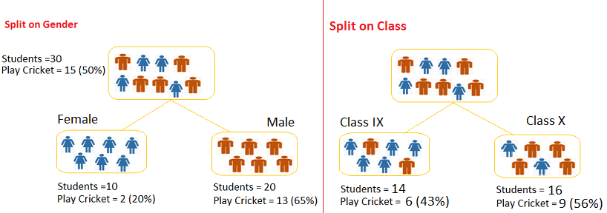

Split on Gender:

Calculate, Gini for sub-node Female = (0.2)*(0.2)+(0.8)*(0.8)=0.68
Gini for sub-node Male = (0.65)*(0.65)+(0.35)*(0.35)=0.55
Calculate weighted Gini for Split Gender = (10/30)*0.68+(20/30)*0.55 = 0.59
Similar for Split on Class:

Gini for sub-node Class IX = (0.43)*(0.43)+(0.57)*(0.57)=0.51
Gini for sub-node Class X = (0.56)*(0.56)+(0.44)*(0.44)=0.51
Calculate weighted Gini for Split Class = (14/30)*0.51+(16/30)*0.51 = 0.51

Above, you can see that Gini score for Split on Gender is higher than Split on Class, hence, the node split will take place on Gender.

Please look at the below example:

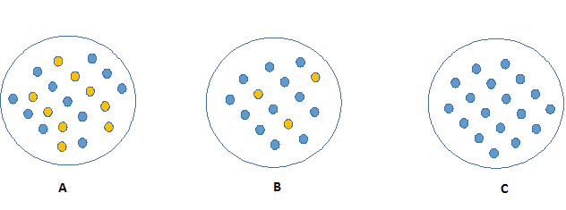

Look at the image below and think which node can be described easily.
I am sure, your answer is C because it requires less information as all values are similar.
On the other hand, B requires more information to describe it and A requires the maximum information.
In other words, we can say that C is a Pure node, B is less Impure and A is more impure.

Now, we can build a conclusion that less impure node requires less information to describe it. And, more impure node requires more information.
To define this degree of disorganization in a system known as Entropy.
If the sample is completely pure, then the entropy is zero and if the sample is an equally divided (50% – 50%), it has entropy of one.

Entropy can be calculated using formula:

It chooses the split which has lowest entropy

Steps to calculate entropy for a split:

- Calculate entropy of parent node

- Calculate entropy of each individual node of split and calculate weighted average of all sub-nodes available in split.

Example:
Let’s use this method to identify best split for student example.

Entropy for parent node = -(15/30) log2 (15/30) – (15/30) log2 (15/30) = 1. Here 1 shows that it is a impure node.

Entropy for Female node = -(2/10) log2 (2/10) – (8/10) log2 (8/10) = 0.72 and for male node, -(13/20) log2 (13/20) – (7/20) log2 (7/20) = 0.93

Entropy for split Gender = Weighted entropy of sub-nodes = (10/30)*0.72 + (20/30)*0.93 = 0.86

Entropy for Class IX node, -(6/14) log2 (6/14) – (8/14) log2 (8/14) = 0.99 and for Class X node, -(9/16) log2 (9/16) – (7/16) log2 (7/16) = 0.99.

Entropy for split Class = (14/30)*0.99 + (16/30)*0.99 = 0.99

Above, you can see that entropy for Split on Gender is the lowest among all, so the tree will split on Gender.

Why we need to control tree growth?

To avoid overfit for given data.

Overfitting:

Learning of irrelevant pattern
Why this overfitting will occur?

Due to noise in data
Not having enough data

Why over-fit or under-fit occurs?
It may occurs due to data only.

Why we need to control tree growth?

Why statistics necessary in ML?

Statistics is useful for EDA(Explorated data analysis)

EDA which is nothing but data understanding.

Why do we need to tune ML algorithms?

- ML algorithms tend to produce models under-fit or over-fit characteristics
nature. To avoid this we will use ML tuning concept
- To produce models in ideal region

How to tune ML algorithms?

In python we can tune algorithms in three different types

- Random tuning (selection done randomly)

- Bayesian tuning

- Grid tuning(Instead of random we can cover all possibilities using tuning)

Model Tuning:

https://github.com/algorithmica-repository/datascience/tree/master/2018-jan/8.parameter%20tuning

Jan 9th

Discrete probability distribution

P(A)=favorable out comes/total number of experiments

What is the probability to get 2 heads out of 5 coin tosses if it is a fair coin?

If it is a fair coin P(H)=P(T)=1/2

Note: No need to draw a curve to know about discrete variable

How we calculate this using normal probability i.e 5C2*(1/2)^5

H H T T T = (1/2)^5

Knowing distribution simplifies calculation for discrete variable too.

Discrete random process:

Here we will use discrete random variable

Binomial Distribution:

- N experiments which are independent of each other
- Each experiment is binary i.e Head or Tail
- And you know P(success)=1/2=P
P(Failure)=1/2=1-P

We can mention it as
B(n,k)=nCk p^k (1-P)^n-k

This is called binomial distribution

Here possible out comes is 2
And k is success out of n trails

Bernoulli Distribution:

- binary outcomes

P(success)=1/2=P
P(Failure)=1/2=1-P

- N is not given

Success represents =>1

P(y)=(p)^y (1-p)^1-y

P(failure)=(p)^0 (1-p)^1-0

P(success)=(p)^1 (1-p)^1-1

Multinomial Distribution:

- n-experiments available independent of each other
- Each experiment is binary and out comes is k

P(e1)P(e2).....P(ek)

P(n,e1=n1,e2=n2.....ek=nk)=(n!/n1!n2!...nk!) * p1^n1p2^n2.....pk^nk

Here n=n1+n2+....+nk

Naive Bayes algorithm

This is suitable for text analysis means text classification problems like spam email detection.

For structured data NB is not recommended

To know more about this go to text example:

Text | Target
........(text document) | 1(spam)
T1 T2 T3......... | 0(not spam)
 | 1
 | 1

If a word already exists don't create new column otherwise create new column
 | Term1 | Term2 | Term3 |  | Target
Document1 | Cell |  |  |  | 1
 |  |  |  |  | 0
 |  |  |  |  | 1
 |  |  |  |  | 1

Here first of all we consider, how to convert text to structure data. In deep learning this is automated but in ML we have do this.

Convert text to structured data we follow DTM(document term matrix)

Term
It consider how many adjacent words are included
It may be
Unigram
Bigram
Trigram(3 adjacent words)

Each cell may carries,
Binary
Term frequency(how frequent word exists)
Inverse document frequency

If cell is binary go for binomial/bernoulli distribution. Generally we will use binomial distribution.

In cell 2 times like 2 is mentioned(in the form Term Frequency) choose multinomial distribution

We know sk-learn is a module used for machine learning algorithms.
under sk-learn naive bayes exists refer below structure

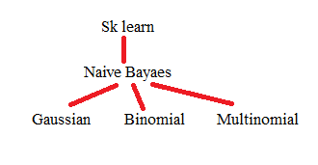
Note: if it is continuous variable and distribution is normal distribution go for gaussian distribution

Jan 10th

Classification Examples:

1.Spam email filter:
A particular email is spam or not

- Sentiment Analysis:
Positive sentiment or negative sentiment

We can understand by the example:

https://github.com/algorithmica-repository/datascience/blob/master/2018-jan/10.text%20classification/text-processing.py

Here the data set is related to sentiment analysis.

1 is positive sentiment
0 is negative sentiment

Predict column is sentiment

Extension : .tsv
Separator: tab
Delimiter: \t

First step is review column is text convert this to structure data then apply model building.

This text includes html tags
And also having useless words like as,this,and,have in english we can call these as stop words and also don't have weight-age to predict target column.

Also have dot,space,comma,\n

So we need to clean text data.

To do all this in python go for below basic understandings

nltk is a library for text processing
re is for regular expression
bs4 is used to remove html tags

Note: In regular expression ^ means except

Note: In pandas package data type object indicates string type.

Feature_extraction: extract from data
Count_vectorizer: this is useful for doing DTM
Tokenizer: splitting of data into pieces(called feature extraction)
Preprocessor: clean data before splitting

Jan 16th:

CART Vs C4.5

CART uses gini index for tree splitting
C4.5 uses entropy

CART uses binary tree which means a node has only two childs
C4.5 not uses binary tree which means a node has multiple childs

Note: Python uses CART with some changes in CART algorithm
I.e it doesn't uses post pruning

What is pre pruning?
While building tree we can control tree growth to build best model

What is post pruning?
After tree has built completely we can do changes in tree growth(decrease depth of tree ) for building best model

CART supports classification and regression(Classfication And Regression Tree)
C4.5 supports only classification and only best for small data sets.

Why model tends to overfit model?(Model Overfit)

Reasons:
- Noise data
- Not enough data
- Correlated featured

Note:
Correlated features is nothing but one column is more dependent on another which means value in first column increases then value in second column is also increases.

All the above reasons comes under data preprocessing and feature engineering.

What are the tasks that we need to do in data preprocessing?

To overcome the above reasons we need to follow below features.

- Missing data handling
- Scaling
- Dummy/Label encoding
- Box-Cox transformation
- Data transformations using joins and filters

The above features are the most common techniques for data preprocessing.

http://scikit-learn.org/stable/ (sklearn python documentation)
https://spark.apache.org/
https://docs.microsoft.com/en-us/azure/machine-learning/studio/create-experiment

Problem in using getdummies in pandas package?
While using getdummies, in test data we are facing an issue with dividing a column into multiple columns

Ex: Pclass_0 Pclass_1 Pclass_2

Instead of getting 3 columns we are getting only one column

To overcome this problem we need to follow one hot encoding with sklearn.

fit?
transform?
fit_transform?

Note:
- While we have test data apply only transform
- On train data will apply fit and transform

Why target Y is sometimes necessary?
Sometimes model expects target variable also in one hot encoding
Like survived_0, survived_1
Generally will get this scenario in neural networks

Why we use label encoding?
One hot encoding expects all columns in integer type(numeric)
So to convert string to integer we will use label encoding

Jan 17th:

Today we discuss about python containers specially array

Python containers:
List,tuple,dictionary (comes under core python containers)
Dataframe(pandas)
Array(numpy)
Series(pandas)

How to use numpy to work with arrays?

Array is nothing but container having elements of same type

What is the difference between dataframe and array?

Dataframe is accessed using index and names(elements of different type)
Array is accessed using index only

Machine learning expects all columns of same type that's why array is preferable.

Array is also useful in recommendations concept this we will see later.

By using array we can do operations like addition and multiplication.Dataframe doesn't support this.

To create array first of all we need to import numpy package.

https://github.com/algorithmica-repository/datascience/tree/master/2018-jan/1.python

Import numpy as np

Np.array

Here np is module name not an object. This is purely imperative style of coding.
To convert list to array is called as casting.
data type of numpy array is ndarray

Suppose output gives(3,) which indicates 3 elements with 1-dimension array.

In array in the arguments dtype exists which is not there for dataframe because array is same type and data frame is not.

By default dtype is float. If we don't pass this we can get float values in array.

Ex:np.one(15)

O/p: array([1.,1.,1. .........])

In python generally array is immutable.

2D arrays:

1D array is nothing but vector
2D array is nothing but matrix

In 2D array we can do matrix operations like addition and multiplication.

What is the significance of Dot Product?

In real life our shadow length in morning time varies from afternoon time.
Always person's shadow is down like 90 degrees and if we want to calculate shadow length then dot product concept arises.

How to calculate dot product?

[1 2 3] . [5 6 1]

(1*5) + (2*6) + (3*1)

By this we can calculate shadow length(projection length computation).

Note:
In matrix multiplication we take first row and first column etc. Consider row and column.

Jan 18th:

Follow preprocessing1.py

What is the goal of data preprocessing?

By this we can improve the performance of model
(Like in kaggle submission we can increase model performance 76% to some higher percentage)

Preprocessing techniques?

- Imputation(Missing data handling)
- Scaling
- Dummy encoding(one hot encoding)
- Label encoding
- Box-Cox transformation
- Data transformations using joins and filters

What is series container?

It is 1-D (dimensional)array.
Also known as single column data frame
We can use this by importing pandas package

What is the difference between [] and [[]]?

[]=series
[[]]=data frame

titanic_train['Age'] = >series
type(titanic_train['Age']) pandas.series

titanic_train[['Age'] ]=> Dataframe
type(titanic_train[['Age']]) pandas.Dataframe

Note:
Fit method is used to build model.
By Transform method we can fill values from fit model.
Will apply fit on train data which means learn on train data and apply the same model on test data.

Why we are not using get dummies and why we choose sklearn one hot encoding?

Suppose in your test data for Pclass you have only one column with value 1
So instead of creating 3 column(because you have 3 categories in Pclass) it creates only one column(test data has one category).

What is Imputation?

Nothing but filling missing values in a column.

Syntax:
Preprocessing.imputer

I don't want to do this imputing in test data and i want use this only in train data.

Imputer accepts only continuous numerical columns

Here NaN is replaced with strategy(mean/median/most frequent)

Label encoding on single column:

Label encoding is series will work on single column

Label encoding on multiple columns:

What we need to do if we apply label encoding on multiple columns?

First of all build pair of tuple for individual columns

What data frame mapper will do?
The responsibility of data frame mapper is to apply work on individual columns

categorical_feature=['Sex','Embarked']

dataFrameMapper(categorical_feature)

Column1 | Column2
Label encoding on Sex | Label encoding on Embarked

dataFrameMapper is responsible in doing this work parallely.

To use data frame mapper install sklearn_pandas using pip

Numerical imputer: it will work on continuous data or numerical columns
In numerical imputer strategy is mean/mode.

Categorical Imputer: it will work on categorical data
In categorical imputer strategy is most frequent.

What is difference between pipeline and data frame mapper?

Pipeline - combining multiple stages and work is done sequentially one after another.
Data frame mapper: Apply on multiple columns and work is done parallely.

What is the significance of n_values_?

To display output generated from model
And it gives distinct values only.

Note:
This kind of data preprocessing approach is recommended for train vs test data.

Scaling:

What is the use of scaling?

In scaling will convert 0-10 range to 0-1 this kind of scaling is called 0-1 scaler/scaling.

When this is useful(scaling)
When algorithm cares about values in columns then scaling is necessary
For example in decision tree it doesn't care about values in a column which takes some cut-off and do impurity calculation but in some algorithms like neural networks/PC algorithm/KNN cares about distance between values then scaling is important.

How to calculate scaling?

Age(ranges 0-85) X | Fare(ranges 0-800) X
10 Xmin | 10 Xmin
12 | 100
14 Xmax | 800 Xmax

To convert 0-1 scaling follow below formula:
(Xi-Xmin) / (Xmax-Xmin)

Z-score Scaling?

Also known as standard scaling.
Here most common range is -3 to +3
If data follows normal distribution then only use Z-score scaling.

Normal distribution?

When we plot a graph, the graph looks like bell curve called normal distribution.
And 99.8% data is in between the curve ranges from -3 to +3.

How to calculate Z-score?

Z-score formula:

Xi-U(mean) / sigma

