How to print scikit-learn version?

import sklearn
print(sklearn.__version__)

0.19.0

titanic_test.loc[titanic_test['Fare'].isnull(), 'Fare'] = 0

Because in fare column missing data is there
So to avoid NaN error replace missing data with mean value

#convert categorical features to one-hot encoded continuous features
features = ['Pclass', 'Sex', 'Embarked']
titanic_test1 = pd.get_dummies(titanic_test, columns=features)
print(titanic_test1.shape)

why we use get dummies?
To do one-hot encoding

pd.get_dummies is for create as dataframe

This is lifecycle deployment

dt_estimator = joblib.load('decision-tree-v1.pkl')
titanic_test1['Survived'] = dt_estimator.predict(titanic_test1)

Deployment Phase

joblib.dump(dt_estimator,'decision-tree-v1.pkl')

pickle format is like XML but pkl is specific for python

Model Serving

Integrate service to APP

before this just go through functions in python

def add1(a,b):
return a+b

Use indentation to identify body

def add2(a,b,c=20,d=30):
return a+b+c+d

Use named arguments to skip few arguments(like mention name see below)

Note: First letter as capital indicate Class in python

@indicates service

_name

To define private variable/function not visible to outside module

var_

To define alternative to use keywords as variables use above convention
Which def refers to function in python but forcefully you want to use it as variable name then use var_ (here var is variable name)

__name__

Special variables/keywords

Data Science life cycle

File Name: lifecycle1.py

Our titanic train data is in csv format so it consists columns of different type for that we need complex container i.e data frame

To use data frames import pandas package

import pandas as pd

import os
print(os.getcwd())

cwd - current working directory
E:\ramya_work\Algorithmica\DataScience

Use / (forward slash) instead of \ (backward slash) which is acceptable in both linux and windows

os.chdir('E:/ramya_work/Algorithmica/DataScience')

Read and explore titanic train data

titanic_train=pd.read_csv('titanic_train.csv')
titanic_train.shape
titanic_train.info()

Convert categorical features to continuous features for this we require one-hot encoding.
get_dummies used for one hot encoding

features=['Pclass','Sex','Embarked']
titanic_train1=pd.get_dummies(titanic_train,columns=features)
titanic_train1.shape

Drop features(columns) which are not useful for learning pattern(logic)

By default inplace=False which means after drop features will be existed and in data frame. If you dont want to see dropped columns use inplace=True

features_to_drop=['Name','PassengerId','Ticket','Cabin','Survived']
titanic_train1.drop(features_to_drop,axis=1,inplace=True)

Set featured columns and target column

X_train = titanic_train1
Y_train = titanic_train['Survived']

Create an instance of machine learning class

from sklearn import tree
dt_estimator=tree.DecisionTreeClassifier()

Build model(logic) by invoking fit method

dt_estimator.fit(X_train,Y_train)

To know our model is good or bad do model evaluation phase
Model evaluation phase

from sklearn import model_selection
scores = model_selection.cross_validate(dt_estimator, X_train, Y_train, cv=10)
scores.get('test_score').mean()
scores.get('train_score').mean()

By the above code we will get error like
ValueError: Input contains NaN

So include Age because Age column includes missing data

Model Deployment Phase

from sklearn.externals import joblib
joblib.dump(dt_estimator, "decision-tree-v1.pkl")

Local Test

Model Serving

What is meant by impurity?
For this understanding of probability is necessary.
Includes impurity calculations. Once we need to go through probability then we will come back to impurity concept again.

Probability

In machine learning why we need probability

Business is random process, which is nothing but we don't know what is going to happen in future.

In a business generally we have train data/history data based on this we will do our predictions or plans to improve business.

And in data science we consider each column in train data as random column.

Like this probability and data science are related to each to other. And we will use probability in our data science.

What is probability?

Probability is the measure of the likelihood that an event will occur.
Always probability is in between 0 and 1,
where, 0 indicates impossibility and 1 indicates certainty.

Probability of an event happening = favorable outcomes/total experiments

Instead of writing something about experiment description we will use random variable.

What is a random variable in probability?

A random variable is a set of possible values from a random experiment.
Example:
Tossing a coin: we could get Heads or Tails.
Let's give them the values Heads=0 and Tails=1 (our choice you can give what ever you like)
and we have a Random Variable "X":
X = {0, 1}

In general will use capital letters for random variable like X.

Life is full of random events.

Let's go through cards in a deck. - Total 52 cards.

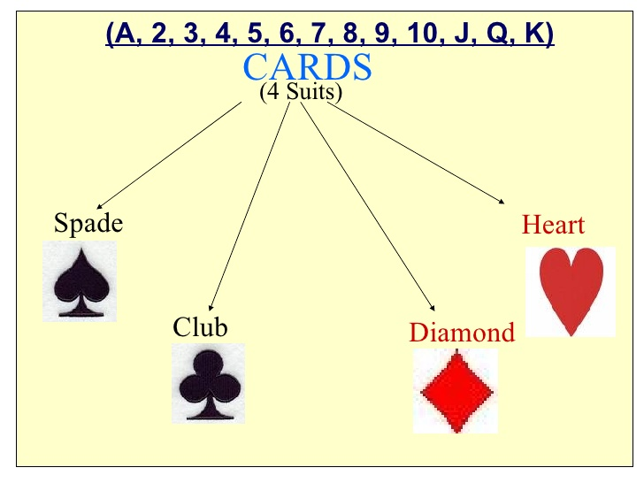

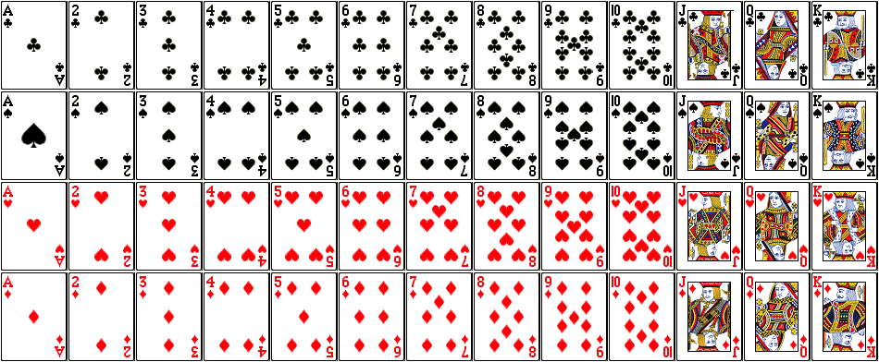

Events can be independent,dependent

Independent Events:
each event is not affected by other events.

Example:
Tossing a coin
What it did in the past will not affect the current toss

Dependent Events:
also called "Conditional", where an event is affected by other events.

Example: Drawing 2 cards from a deck

After taking one card from the deck there are less cards available, so the probabilities change.

Let's look at the chances of getting a King.

For the 1st card the chance of drawing a King is 4 out of 52

But for the 2nd card:

- If the 1st card was a King, then the 2nd card is less likely to be a King, as only 3 of the 51 cards left are Kings.
- If the 1st card was not a King, then the 2nd card is slightly more likely to be a King, as 4 of the 51 cards left are King.

Let's go in detail about dependent events.

Events can be "dependent" ... which means they can be affected by previous events ...

Example: Marbles in a bag

2 blue and 3 red marbles are in a bag.

What are the chances of getting a blue marble?

The chance is 2 in 5

But after taking one out the chances change!

So the next time:

if we got a red marble before, then the chance of a blue marble next is 2 in 4
if we got a blue marble before, then the chance of a blue marble next is 1 in 4

There is a 2/5 chance of pulling out a Blue marble, and a 3/5 chance for Red:

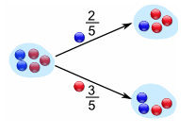

We can go one step further and see what happens when we pick a second marble:

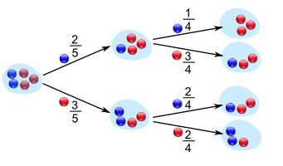

If a blue marble was selected first there is now a 1/4 chance of getting a blue marble and a 3/4 chance of getting a red marble.

If a red marble was selected first there is now a 2/4 chance of getting a blue marble and a 2/4 chance of getting a red marble.

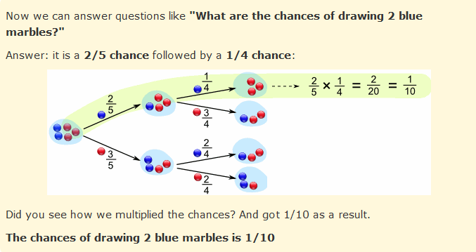

Generally we love notation in mathematics

P(A)=No. of favorable outcomes to A / Total number of outcomes.

P(A) means "Probability Of Event A"

In our marbles example Event A is "get a Blue Marble first" with a probability of 2/5:

P(A) = 2/5

And Event B is "get a Blue Marble second" ... but for that we have 2 choices:

If we got a Blue Marble first the chance is now 1/4
If we got a Red Marble first the chance is now 2/4
So we have to say which one we want, and use the symbol "|" to mean "given":

P(B|A) means "Event B given Event A"

In other words, event A has already happened, now what is the chance of event B?

P(B|A) is also called the "Conditional Probability" of B given A.

And in our case:

P(B|A) = 1/4

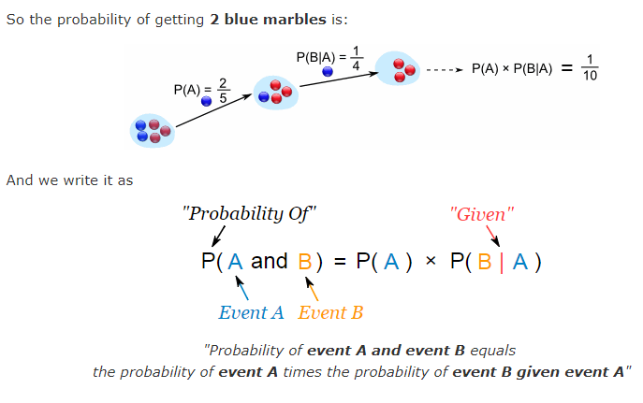

P(A and B) = P(A) x P(B|A)

P(B|A) = P(A and B) / P(A)

Let’s take another example.

Suppose you have a jar containing 6 marbles – 3 black and 3 white. What is the probability of getting a black given the first one was black too.

P (A) = getting a black marble in the first turn

P (B) = getting a black marble in the second turn

P (A) = 3/6

P (B) = 2/5

P (A and B) = 1/2*2/5 = 1/5

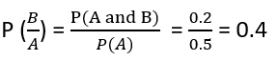

Reversing the condition

Example: Rahul’s favorite breakfast is bagels and his favorite lunch is pizza.
The probability of Rahul having bagels for breakfast is 0.6.
The probability of him having pizza for lunch is 0.5.
The probability of him, having a bagel for breakfast given that he eats a pizza for lunch is 0.7.

Let’s define event A as Rahul having a bagel for breakfast, Event B as Rahul having a pizza for lunch.

P (A) = 0.6

P (B) = 0.5

P(A|B) = 0.7

If we look at the numbers, the probability of having a bagel is different than the probability of having a bagel given he has a pizza for lunch.
This means that the probability of having a bagel is dependent on having a pizza for lunch.
Now what if we need to know the probability of having a pizza given you had a bagel for breakfast. i.e. we need to know P(B|A)
Bayes theorem now comes into the picture.

Bayes Theorem

The Bayes theorem describes the probability of an event based on the prior knowledge of the conditions that might be related to the event.
If we know the conditional probability P(A|B), we can use the bayes rule to find out the reverse probabilities P(B|A)

How can we do that?

P(A|B)=P(A and B)/P(B)
P(B|A)=P(A and B)/P(A)

P(A and B) = P(A|B)*P(B) = P(B|A)*P(A)

P(B|A) = P(A|B)*(P(B)/P(A))

The above statement is the general representation of the Bayes rule.

For the previous example –
if we now wish to calculate the probability of having a pizza for lunch provided you had a bagel for breakfast would be = 0.7 * 0.5/0.6.

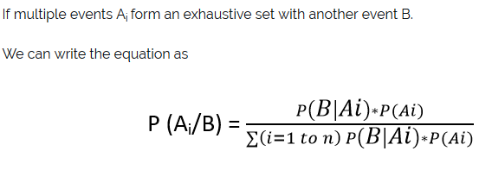

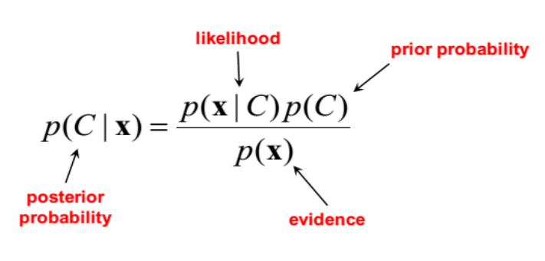

Go to PDF algorithmica pdf for cancer diagnosis problem

P(A|B) = P(B|A)/P(B) * P(A) (bayes's theorm)

A - cancer=yes
B - test=+ve

P(cancer=yes|test=+ve)=P(test=+ve|cancer=yes) / P(test=+ve) * P(cancer=yes)

Given,

P(cancer=yes) = 0.02 (2% given in problem)

-----------------------------------------------

P(test=+ve) = P(test=+ve&cancer=yes) + P(test=+ve&cancer=no)

P(test=+ve&cancer=yes) = P(cancer=yes) * P(test=+ve|cancer=yes)
= 0.02 * 0.9 (90% given)

P(test=+ve&cancer=no) = P(cancer=no) * P(test=+ve|cancer=no)
= 0.98 * 0.1 (10% given)

0.98 = 1-0.02

Go to PDF algorithmica pdf for double headed coin problem

Dh=double headed

P(coin=fair|toss=head) =
P(toss=head|coin=fair) / P(toss=head) * P(coin=fair)

P(toss=head) = P(toss=head &coin=fair) + P(toss=head &coin=dh)

P(toss=head &coin=fair) = P(coin=fair) * P(toss=head|coin=fair)
= 0.9 * 0.5

P(toss=head &coin=dh = P(coin=dh) * P(toss=head|coin=dh)
= 0.1 * 1

P(coin=fair) = 0.9 (given)

81%

2nd time also head it belief decreases to 68%

