Data Analytics/Science

Data Sources: Transactional data

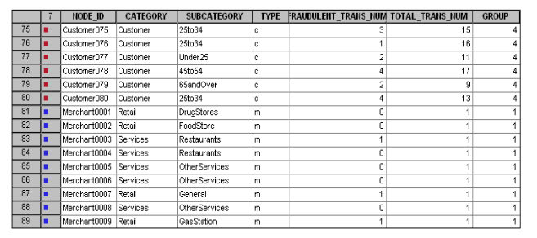

It includes

- Products purchased
- Customers and item details

Data Sources: Social Networks

- Posts in social media
- Pictures and videos posted online
- Instant and email messages
- Voice data

Data Sources: Mobiles

- GPS data
- Mobile apps data
- Voice data

Data Sources: server logs

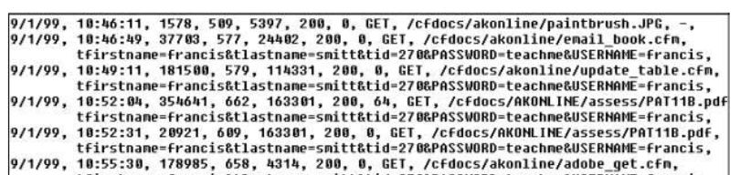

Data sources: IoT

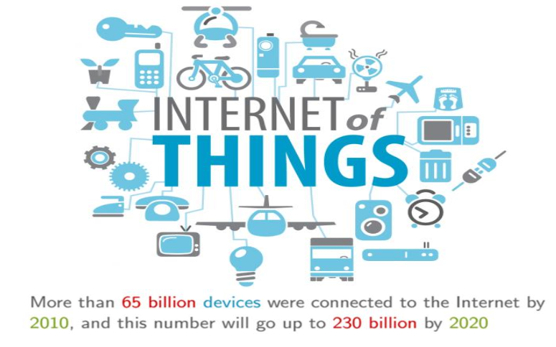

What kind of data generated by these sources?

1.Structured

Ex: transactional data

- Semi structured

Ex: log data, XML & JSON data, sensor data

3.Unstructured

Ex: images,voice,video & textdata(chats,emails,blogs,etc.,)

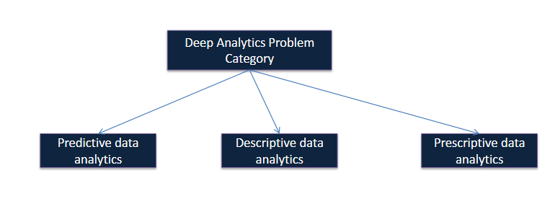

What is predictive data analytics?

Predictive analysis refers to using historical data to predict what will happen in the future.
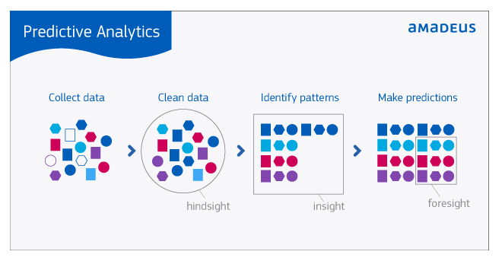

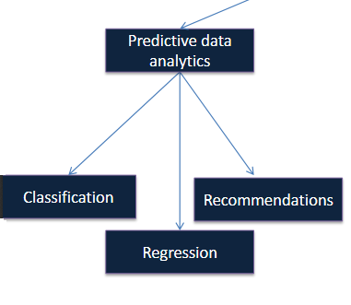
Classification

Predict the category of an unlabeled observation by analyzing the history of labeled observations

– Predicting whether new email is spam or not based on past labeled email history

– Predicting whether customer will be defaulter or not based on past labeled customer history

– Classifying an image is animal or not based on past labeled image history

Regression

Predict the numerical value of an unlabeled observation by analyzing the history of labeled observations

– Predicting the unknown stock price at any time based on history of labeled stock prices

– Predicting the rating of a non-rated product/movie based on history of labeled products/movies

– Predicting the value of real-estate property in future based on history of labeled real-estate properties

Recommenders

For an user, suggest a bunch of unpurchased items based on history of purchased items by that user

– Recommend set of unwatched movies based on history of movies watched by that user

Descriptive data analytics

• Descriptive analytics looks at data and analyzes past unlabeled events for insight as to how to approach the future.

• Unlike predictive models that focus on predicting a single customer behavior, descriptive models identify many different relationships between customers orproducts.

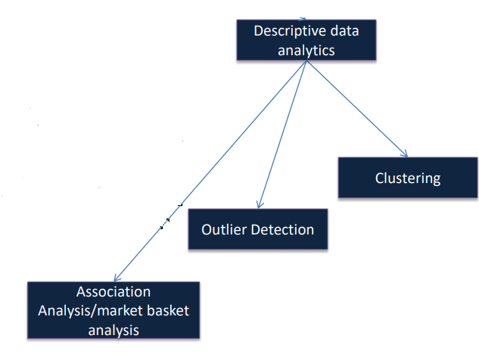

Clustering:

– Find the groups of related events from the history of unlabeled events

– Find the different groups of document clusters from unlabeled document collections

– Find the groups of similar search results from the entire unlabeled search results

– Find the different groups of telecom subscribers based on their call pattern and data usage

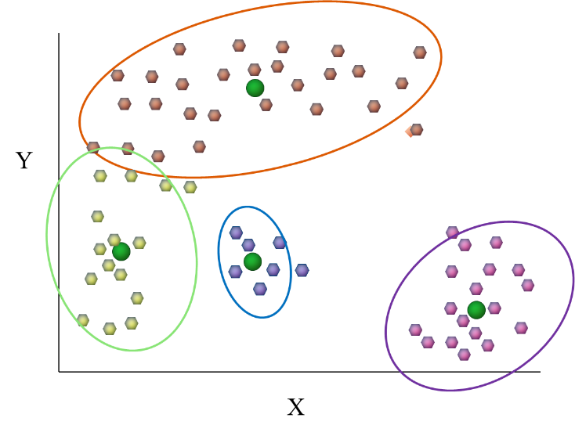

Association Analysis:

– For a customer, recommend the items that are frequently bought together with the current item by analyzing the transactions of customers who purchased that item

– Recommend the movies watched together with the one you are viewing/searching now based on past viewing history of that movie

– Suggest the items to place together in a store based on items purchased together by customers

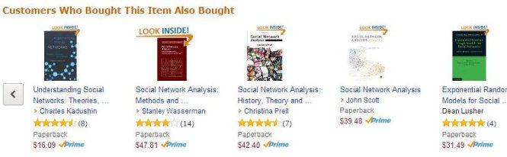

Prescriptive data analytics:

Prescriptive analytics goes beyond predicting future outcomes by also suggesting
actions to benefit from the predictions and showing the decision maker the implications of each decision option.

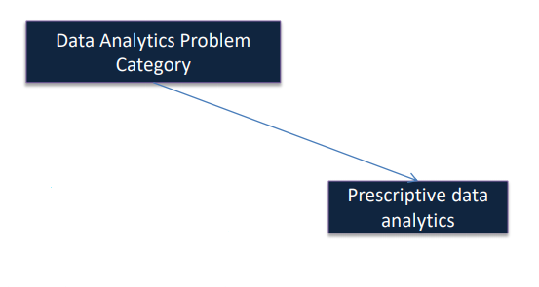

Always think about logic not syntax

What is the difference between ML(Machine Learning) developer and other developer?
ML developers get output as predictive suppose they get 80% output and trying to increase to 85% based on manager's/client's requirement
they should have an idea on algorithm and tune the algorithm and get results.

Python Distribution: Anaconda

It includes pip/conda - These are python package managers.

Here we are taking pip

https://repo.continuum.io/archive/

Prefer python 3.x compared to python 2.x

Python 3 code is readable compared to python 2.

Prefer spyder as IDE for writing python code which is available when we install Anaconda distribution.

Anaconda3-5.0.0-Windows-x86_64.exe

If you are using linux machine then instead of .exe use .sh file to install Anaconda.

Install Anaconda:

Destination Folder:
C:\Users\rallada.EVOKE\AppData\Local\Continuum\anaconda3

Choose to my path environment variable option

To check pip is existing or not?

Type pip in command prompt to check if it is existed or not. If exists then your installation is success.

Anaconda also includes jupyter it is also like IDE. For Python spyder(IDE) is recommended

JUPYTER:

JU - Julia Language
PY - Python
R - R language

This supports 3. But is like notebook kind of thing. So prefer Spyder.

In spyder you can find IPython console

IPython is nothing but Interactive python

Unlike other programming languages we can run few lines of code in a program file.

https://github.com/algorithmica-repository/datascience

Always how we learn a language in software like python/R/SAS
Because based on company a language can be changed but concept is same

Steps:
For Example consider Python

1.Why python?
2.Data containers
3.Control Statements
4.Functions
5.How do you do 3 styles of programming in python?
6.Packages in it.

Why Python why not R-language?
Python is maintained by Google. So having great level of support
R is maintained by Microsoft.

And Python is open-source and its license is apache license

Why python?
It supports 3 styles programming

1.Imperative(procedural) programming
2.Object oriented programming
3 Function style programming

Containers (or collections)

Data Containers in Python:

1.Basic Containers
2.Complex Containers

An important thing while learning data science is data analysis, which means how do you hold data?

Suppose you have excel data in that you can have different types of columns which means one column holds int data,another holds string data,float data,boolean etc.
In such cases you need to choose complex containers

Basic Containers:
int
float
boolean

Complex Containers:(7)
array
dataframe
matrix
dictionary
tuple
list
Series

How to print a variable value in Python?

C:\Users\rallada.EVOKE\datascience
datascience folder is created by me to save my all python files.

Comments in Python
#
Python file extension?
.py

basictype.py

x=10
print(x)

Output is 10 (select two lines then choose run current cell option and see output in console in spyder IDE and you can run single line by having cursor on the line and use run current line)

In python we will not define variable type before variable name
If you want to know the type of value you assigned then please see below

print(type(x))

O/p: int

y='evoke'
print(type(y))

O/p: str

How to print python version?

import platform
print(platform.python_version())

O/p: 3.6.2

Complex Containers:

A group of indexed elements
Here elements could be different types
It is also known as indexed container but it is not array because array is having elements of similar type.

[ ] indicates list

If python 2.x:

list=[10,12.6,'evoke',True]
print(list)

If python 3.x:
list2 = list([10,12.6,'evoke',True])
print(list2)

Access list elements by slicing

: is used for slicing

Print first element from list?
print(list1[0])
10

Print first 3 elements from list?
print(list1[0:3])
[10, 12.6, 'evoke']

Print starting from first element to last element in list?
print(list1[0:])
[10, 12.6, 'evoke', True]

Print starting from second element to last element in list?
print(list1[2:])
[12.6, 'evoke', True]

print(list1[2:3])
['evoke']

print(list1[-1])
True //starts from last element in list

print(len(list1))
4 //length of list

#method invocation

list1 = list([10,12.6,'evoke',True])
list1.append(60)
list1.append(5)
print(list1)

[10, 12.6, 'evoke', True, 60, 5]

list1.pop()
print(list1)

[10, 12.6, 'evoke', True, 60]

list1.reverse()
print(list1)

[60, True, 'evoke', 12.6, 10]

list4 = [[1,2,3], 10, 50]
print(list4)
print(list4[0])

[[1, 2, 3], 10, 50]
[1, 2, 3]

Tuple:
Immutable indexed container
Immutable - cannot change/modify

Py2.x - (1,2,3)
Py3.x - tuple(1,2,3)

tuple1 = (1,2,3,4,5)
print(tuple1)
(1, 2, 3, 4, 5)

print(tuple1[0:3])
(1, 2, 3)

print(tuple1[3:5])
(4, 5)

Python dataframes

Dataframe is a two dimensional container and here data is aligned in a tabluar fashion in rows and columns
Each column could be different type(In matrix columns are in same type like all integers)
Ex: An excel data

What is package?
Group of related functions and classes together is called package

Python packages?
NumPy - Numerical Python
is a library consisting of multidimensional array objects and a collection of routines for processing those arrays.
Using NumPy, mathematical and logical operations on arrays can be performed.

Pandas

To use dataframes we need pandas package

First of all we need to import pandas package to work with dataframes

import pandas as pd

How to read a csv file?

File path:
E:\ramya_work\Algorithmica\DataScience

Use / (forward slash) instead of \ (backward slash) which is acceptable in both linux and windows

data1=pd.read_csv('E:/ramya_work/Algorithmica/DataScience/train.csv')
print(data1)

Use can see dataframe using variable explorer in spyder IDE
Click on dataframe i.e data1 then you see data

data1.shape

Shape gives number of rows and columns in dataset

(891, 12)
Rows: 891
Columns:12

Basic format first rows then columns

data1.info()
Provides file memory usage like 100kb and data types for each column
Information about dataframe.

Access columns:

Access single column:

data1.Name

Or

data1['Pclass']

Access multiple columns

columns=['Name','Pclass']
print(data1[columns])

loc - label based
iloc - index based

data1.loc[0,columns]

Gives first row and consider column as Name and Pclass based on previous statement

data1.loc[0:,['PassengerId','Survived']]

Starts from first row to last because after : we didn't give anything

Only while using dataframes loc 0:3 prints 4 rows which means starts from 0 and 3 is also included not iloc

Print 4,5,6,7 columns and first 10 rows using index based

data1.iloc[0:10,3:7]

Print 3rd row 4th column

data1.iloc[2:3,3:4]
Heikkinen, Miss. Laina

Note: Only in pandas tab is slow to view functions from IDE

data = pd.read_csv('train.csv')
data.groupby(['Survived']).size()

Survived
0 549
1 342

data.groupby(['Sex','Survived']).size()

Sex Survived
female 0 81
1 233
male 0 468
1 109

titanic_test = pd.read_csv('test.csv')
titanic_test.shape
titanic_test.info()

In test data survived column is not there

Conditional checks on columns

# from group by data we can majority males not survived, females survived

titanic_test.loc[titanic_test.Sex=='female','Survived'] = 1
titanic_test.loc[titanic_test.Sex=='male','Survived'] = 0

#write in csv file, default python output provides index for rows so index=false to #remove that from csv file

titanic_test.to_csv('submission.csv',columns=['PassengerId','Survived'],index=False)

Try submitting your data in kaggle submission and check your percentage for your prediction. This is human discovery. See below.

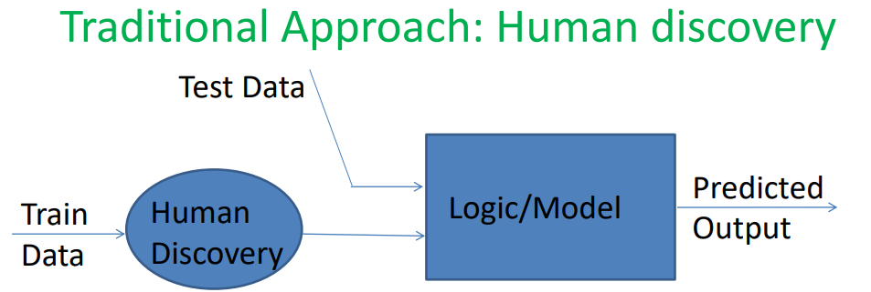

Issues:

• Human has to manually go through the train data to discover pattern or logic that can be applicable for test data.

• Hard-coded logic and needs to rediscover and update the logic whenever train data gets changed.

• Is it practical to discover the logic/pattern if train data is big?

So prefer machine discovery.

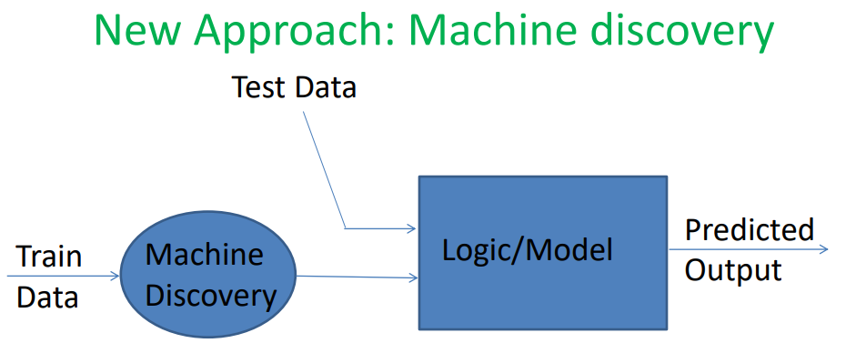

If machine could discover logic/pattern, its great!!

• No hardcoded logic

• Machine can rediscover logic if train data gets changed

• Machines can process big data sets(with more peers) as well.

• But How does machine discovers logic/pattern?

• Any thing in machine happens via software. So, we have to write programs that discovers logic automatically. We call it as Machine learning programming.

• Different Machine learning approaches discover logic/pattern in different ways. We have to find what approach is best for discovering logic in given train data.

titanic_train = pd.read_csv('titanic_train.csv')
titanic_train.shape
titanic_train.info()

titanic_train.groupby(['Sex','Survived']).size()
titanic_train.groupby(['Pclass','Survived']).size()
titanic_train.groupby(['Sex', 'Pclass','Survived']).size()
titanic_train.groupby([ 'Pclass', 'Sex','Survived']).size()
titanic_train.groupby(['Embarked','Survived']).size()
titanic_train.groupby(['Sex', 'Embarked','Survived']).size()

Try with above different approaches

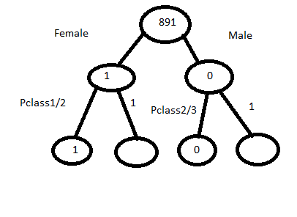

Machine learning algorithms

For ML algorithm there are 5 ways of learning

- Tree based learning
- Probability based learning
- Object based learning
- Lazy learning
- Ensemble learning

Tree based learning | Probability based learning | Object based learning | Lazy learning | Ensemble learning
CART | NB(name-based) | Logistic regression | KNN | Random forest
C4.5 |  | Linear regression |  | voting
C5.0 |  | SVM |  | stacking
 |  | Neural |  | Ada boosting
 |  |  |  | gradient boosting
 |  |  |  | Extreme gradient boosting

Dictionary Container

It is like map
A group of key-value pairs
like an associative array

how to identify dictionary in python
using {}
keys technically called as parameters

dict={'name':'Ram','age':10,'class':'first'}
print(dict['name'])

O/P - Ram

del dict['name']

O/P - {'age': 10, 'class': 'first'}

dict.clear() # remove all entries in dict

del dict # delete entire dictionary

dict.keys()
dict_keys(['age', 'class'])

dict.values()
dict_values([10, 'first'])

dict.items() #displays like tuples
dict_items([('age', 10), ('class', 'first')])

How to build own dataframe instead of data from excel

students={'student_id':[1,2,3],'student_name':['aa','bb','cc']}
students1=pd.DataFrame(students)
students1.shape

3X2

students={'student_id':[1,2,3],'student_name':['aa','bb']}

ValueError: arrays must all be same length

Add new column to the existing dataframe

students1['class']='first'

Another example:

#create dictionary
passengers={'passenger_id':[10,11,12],'fare':[10.6,11.6,12.6]}

#convert dictionary to data frame
df1=pd.DataFrame(passengers)

#access
df1['passenger_id']

O/P:

0 10
1 11
2 12
#access particular value
df1.loc[2,'fare']
12.6
#adding new column
df1['Pclass']=1;

First ML program

Create an instance of machine learning algorithm

from sklearn import tree

dt_estimator=tree.DecisionTreeClassifier()

Here tree is module

Separate features from target column

X_train -> features (input columns)
Y_train -> target column

Build a model by invoking fit method

dt_estimator.fit(X_train,Y_train)

features=['Pclass','sex','fare','Embarked']
X_train=titanic_train[features]
Y_train=titanic_train[['survived']]

To view decision tree which is returned from machine

Actually pydot is useful for providing visulization

import pydot
import io

First of all we need to install pydot through pip

pip install pydot

Install dot.exe software

#visualize the deciion tree
dot_data = io.StringIO()
tree.export_graphviz(dt_estimator, out_file = dot_data, feature_names = X_train.columns)
graph = pydot.graph_from_dot_data(dot_data.getvalue())[0]
graph.write_pdf("decision-tree.pdf")

titanic_test = pd.read_csv('titanic_test.csv')
titanic_test.shape
titanic_test.info()

X_test = titanic_test[features]
titanic_test['Survived'] = dt_estimator.predict(X_test)

X_train -> features (input columns)
Y_train -> target column

features=['Pclass','sex','fare','Embarked']
In this few column are not numeric and ML expects numeric

Data can be of two types:
Categorical(fixed set of values also known as qualitative/nominal)
Ex: Pclass,sex

Continuous(Infinite values)
Ex: fare,age

How do you transform categorical to continuous

For this we need to use one hot coding

Suppose pclass has 3 categories 1,2,3

Pclass | Pclass_1 | Pclass_2 | Pclass_3
2 | 0 | 1 | 0
3 | 0 | 0 | 1
1 | 1 | 0 | 0

After X_train in code

Pd.getdummies(titanic_train,column=features)
This gives dataframe . Above statement is one hot encoding

Instead of giving all column name drop columns which are not necessary

features_to_drop=['PassengerId','Name','age','ticket','cabin','survived']
titanic_train1.drop(features_to_drop,axis=1,inplace=True)
Due to inplace main data columns will not be removed

Axis = row/column
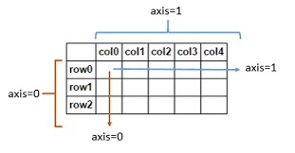

X_train=titanic_train1

How to know model/logic is good/bad

from sklearn import model_selection

#evaluate model

model_selection.cross_validate(dt_estimator,X_train,Y_train,cv=10)

Data Analytics life cycle:

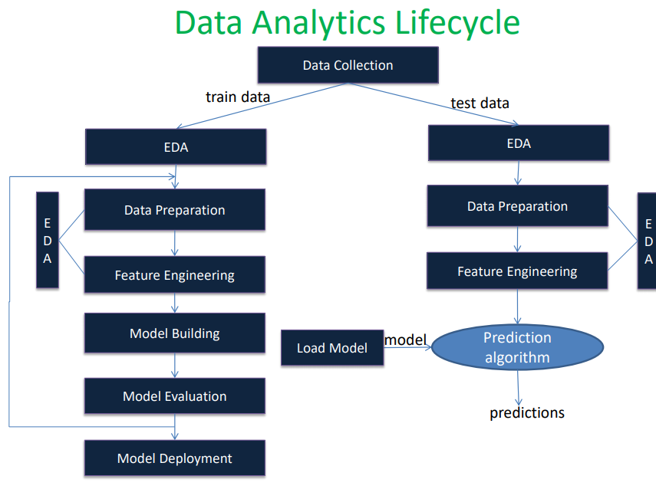

EDA is nothing but exploration of data

Note: train data should have all possible categorical values otherwise your prediction will be wrong. Which means in train data Pclass has 1,2,3 and f the next train data has category 4 for Pclass then our prediction will be wrong.

Model Evaluation Strategy:

Train data can be divided into train data and validation data

Model evaluation can be done by resampling technique

Resampling technique includes
- Repeated hold out
- Cross validation
- Bootstrapping

Re-substitution technique (train error)

Here we pass data and apply fit method evaluate model/logic

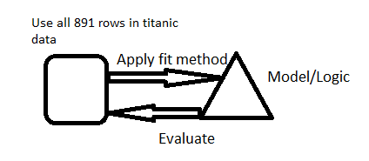

But the above approach is wrong because it may not give exact accuracy which means good logic because it applies on test data.

To evaluate model we need to go through hold out technique

Hold out(validation accuracy)

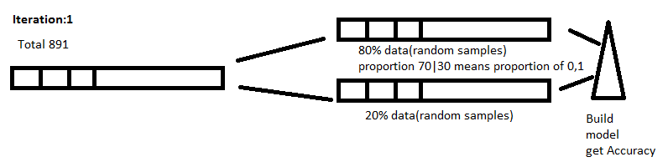

Here random division is done on samples

Don't go with one iteration because accuracy may change by taking other samples

So repeat this for example 10 times

And find out average of all 10 accuracies

Then this average accuracy is expected performance.

Final model is built on 891 data

But there are some issues with this hold out approach:

- May overlapping means same validation data may be there in iterations.And missing out some of samples.
- Cut-off selection is not good for small data sets.

To avoid the above mentioned problems we need to follow cross validation

Cross Validation(k-fold cross validation)

For example consider k=10

Here 891 data are divided as groups like folds

Suppose k=10

Then train data is 90% and validation data is 10%

F1 F2 F10
90-10 | 90-10 | ..... |  | 90-10

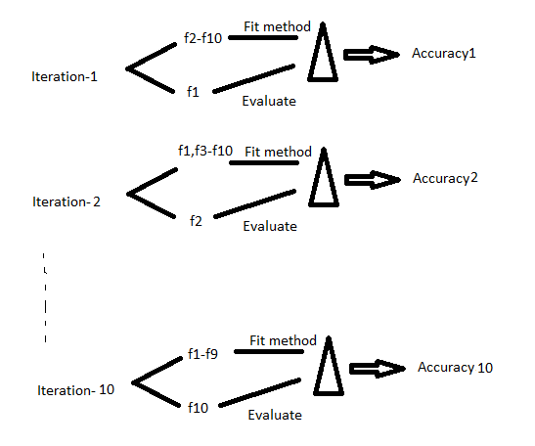

From above find average accuracy

Final model is built on 891 data

Suppose in your data 90% majority is there for a field then we can't approach this technique in such cases we need to go for outliers this can be explained later

Code explantion:

result_scores=model_selection.cross_validate(dt_estimator,X_train,Y_train,cv=10)

Here cv=10 is nothing but k

If you can observe output you will find test_score and train_score in dictionary
And get 10 outcomes in array

Here train_score is re-substitution scores
And test_score is regarding validation data

train_score contains values as 0.90,0.92...
And coming to test_score contains values as 0.83,0.82....

So test_score is good accuracy

Find average of these
result_scores.get('test_score').mean()
result_scores.get('train_score').mean()

Next step is model deployment phase

Model deployment phase

For example you are deploying EPF government site
Based user's previous history it will provide some suggestions like recommended govt. Schemes

Through database we can give what we have in database.

But now based users approach you need to provide some suggestions
Like suggestion at flip kart and amazon based on what particular user has purchased. The suggestion logic is developed by data science team.

App deployment(like java,php,mobile deployment) | Model deployment
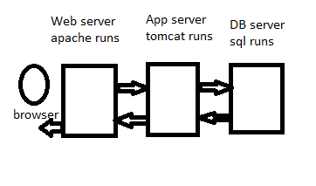 | 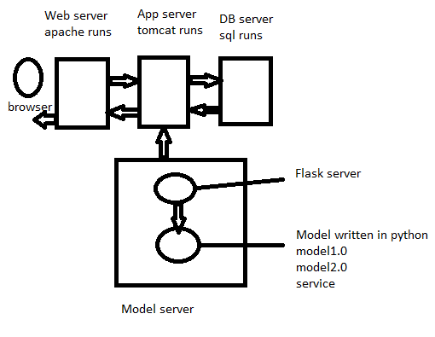

Model Evaluation Strategies

Why do we need to evaluate model?

• To estimate the predictive performance of our model on future (unseen) data.

• To fine-tune the model to increase its predictive performance

• To select the right machine learning algorithm that is best-suited for the problem at hand

Machine Learning(Model) Evaluation

• How do you evaluated machine learned model?

• Goal: Select the model that best performs on unseen(future) data i.e., best generalization capability.

Resubstitution Approach

• Use entire train data for learning as well as evaluation

• The accuracy returned by model on same training set used for learning is called as Resubstitutionaccuracy

• Does this approach makes sense???

Issues with Resubstitution Approach

Model may not have enough data to fully learn the concept (but on training data we don’t know this)

For noisy data, the model may overfit the training data

Hence, Resub error is always too optimistic i.e., under-estimates true error of model

Resampling Approach

Hold some observations from train-set, called as validation set

Use a validation set to estimate how well the model perform on new unseen data(out of sample)

Resampling methods try to “inject variation” in the system to approximate the model’s performance on future samples.

Resampling Approach

▪ Repeated Holdout*
▪ Cross Validation*
▪ Bootstrapping

*Stratified resampling is preferred

