Why we are using statistics?
Usually for describing data.
Statistics is also using data to predict unknown things.

Fundamentals of statistics?
Generally data is of two types
- Qualitative(Categorical)
- Quantitative
Categorical
Examples for categorical data:
- Model of a car
- Gender
- Yes/No or Pass/Fail
Quantitative
Suppose you have quantitative data
What is quantitative data?
Examples for quantitative data:
- Time to complete a task.
- Number of questions in a quiz.
This data can be either discrete or continuous
What is discrete data?
It has finite values which means you can count.
Number of questions in a quiz : 10

What is Continuous data?
It is in decimal format.
Time to complete a task : 170.68 seconds.
Few more examples for Discrete data:
- Number of students in a class
- Number of languages a person speaks
Few more examples for Continuous:
- Height of children
- Weight of cars

Describing the center of data:
When data are quantitative we need to summarize what is the middle or most typical value. We usually refer this as average.
But coming to statistics we need to be a bit more precise(accurate/correct) though as there are several averages : mean,median,mode etc.
The mean is the average of a data set.
The median is the middle of the set of numbers.
The mode is the most common number in a data set.
Suppose you have a data set
44, 19, 44, 44, 51, 78, 56, 86, 99, 99, 2
Step 1: Put the numbers in order.
2, 19, 44, 44, 44, 51, 56, 78, 86, 99, 99

Mode:
The mode is the number that appears the most often. In this case: 44, which appears three times.

Mean:
Sum: 2 +19 + 44 + 44 +44 + 51 + 56 + 78 + 86 + 99 + 99 = 622
Count: (2, 19, 44, 44, 44, 51, 56, 78, 86, 99, 99) = 11
622 / 11 = 56.5454545
Mean = 56.5454545

Median:
2, 19, 44, 44, 44, 51,56, 78, 86, 99, 99

Another Example :
1, 2, 5, 6, 7, 8, 12, 15, 16, 17
Median = 7.5
(7+8)/2 (add the two numbers together and divide by 2).

Formula:
9,5,4,3,2,1,7
Arrange series in ascending order
1,2,3,4,5,7,9
Count: 7
So odd formula is (n+1)/2 = 8/2 = 4th
Median = 4
For even series:
1,2,3,4,5,7,8,9
n/2 n/2+1
8/2 = 4
4+1 = 5
4th and 5th elements are = 4+5/2 = 9/2 = 4.5

The center of a distribution of data is helpful in telling you something about most common values but it doesn't tell you how spread out a group of data is. For this we need to consider describing the variability of data.
Range:
The difference between the min and max values is called the range, and this is one of the simplest ways to describe the variability.

The problem with the range is that it looks at the most extreme values in your data.
So the other way to describe the variability is Standard Deviation.
How to calculate standard deviation?
Step 1: Find the mean.
Step 2: For each data point, find the square of its distance to the mean.
Step 3: Sum the values from Step 2.
Step 4: Divide by the number of data points.
Step 5: Take the square root.

Ex: 6,2,3,1
Step 1: Find the mean μ
6+2+3+1 / 4 = 12 / 4 = 3
Step 2: Find the square of the distance from each data point to the mean
∣x−μ∣^2
∣6−3∣^2 = 3^2 = 9
∣2−3∣^2 = 1^2 = 1
∣3−3∣^2 = 0^2 = 0
∣1−3∣^2 = 2^2 = 4

Step 3,4 and 5:

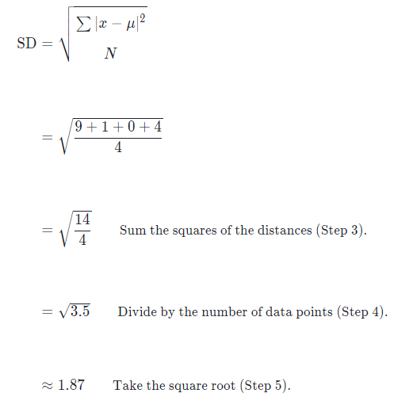

What is frequency of distribution?

Frequency distribution is a representation, either in a graphical or tabular format, that displays the number of observations within a given interval.
Example: A team has scored following number of goals in a game
2,3,1,2,1,3,2,3,4,5,4,2,2,3
Keep in order:
1,1,2,2,2,2,2,3,3,3,3,4,4,5

Score | Frequency
1 | 2
2 | 5
3 | 4
4 | 2
5 | 1

What is a histogram?
A histogram is a plot that lets you discover, and show, the frequency distribution (shape) of a set of continuous data.
To construct a histogram, first you need to split the data into intervals, called bins.

12 | 18 | 27 | 31 | 40 | 42
14 | 20 | 27 | 32 | 40 | 51
14 | 20 | 27 | 32 | 40 | 56
14 | 21 | 29 | 34 | 40 | 60
16 | 23 | 31 | 36 | 40 | 65

step 1: max-min
Range=65−12=53

step 2:53/6=8.8 = 9(approximately)

step 3:create groups
first number 12+9=21

12 – 21
21 – 30
30 – 39
39 – 48
48 – 57
57 – 66

step 4: find the frequency for each group

we want to count how many points are between 12 and 21 NOT INCLUDING 21.

12 – 21 8
21 – 30 6
30 – 39 6
39 – 48 6
48 – 57 2

57 – 66 2

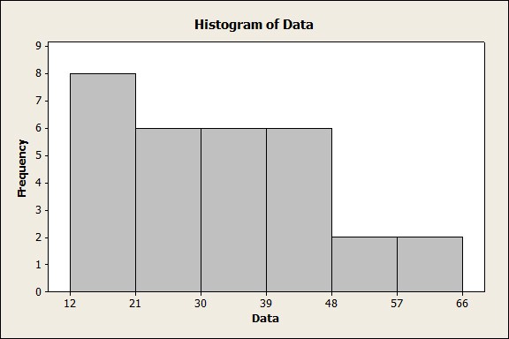

Example:
The histogram below shows the heights (in cm) distribution of 30 people.
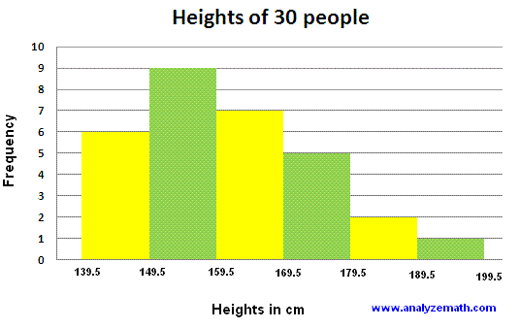

a) How many people have heights between 159.5 and 169.5 cm? 7 people
b) How many people have heights less than 159.5 cm? 9 + 6 = 15 people
c) How many people have heights more than 169.5 cm? 5 + 2 + 1 = 8 people
d) What percentage of people have heights between 149.5 and 179.5 cm?
(9 + 7 + 5)/30 = 0.7 = 70%

The goal of any graph is to summarize a data set.
Let's discuss about box plots(which are sometimes called box and whisker plots).
Like a histogram, box plots ignore information about each individual data value and instead show the overall pattern.

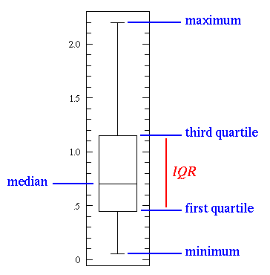
Below data set represents the salaries (in thousands) of a random sample of employees at a small company.

7 | 18 | 27 | 31 | 40 | 42
14 | 20 | 27 | 32 | 40 | 51
14 | 20 | 27 | 32 | 40 | 56
14 | 21 | 29 | 34 | 40 | 60
16 | 23 | 31 | 36 | 40 | 65

Keep in order:
7,14,14,14,16,18,20,20,21,23,27,27,27,29,31,31,32,32,34,36,40,40,40,40,40,42,51,56,60,65
n = 30
min = 7
max = 65
1st quartile = 20
3rd quartile = 40
median = 31
Median:
n/2 = 30/2 = 15th value
n/2+1 = 16th value
31+31/2 = 31
First Quartile:
1/4(n+1)
31/4 = 7.75 = 7th value and 8th value = 20+20/2 = 20
Third Quartile:
3/4(n+1) = 23.25 = 23rd and 24th = 40+40/2 = 40
the interquartile range(IQR) = Q3-Q1 = 40-20 = 20
Lower fence = Q1-1.5(IQR) = -10
Upper fence = Q3+1.5(IQR) = 70
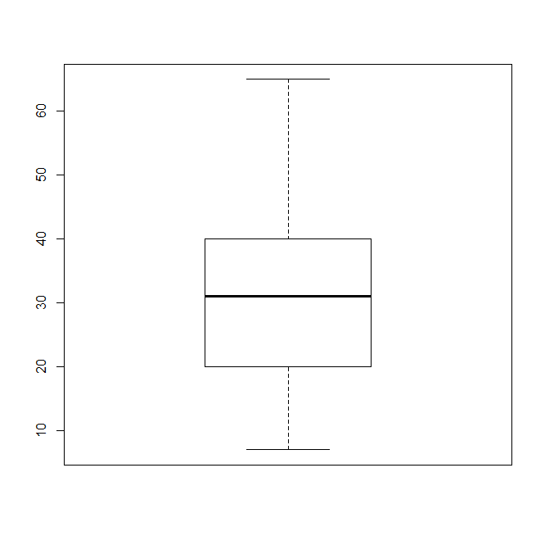
Outliers will be any points below lower fence or above upper fence.

Find the outliers, if any, for the following data set:
10.2, 14.1, 14.4, 14.4, 14.4, 14.5, 14.5, 14.6, 14.7, 14.7, 14.7, 14.9, 15.1, 15.9, 16.4
The outliers are at:
10.2, 15.9, and 16.4

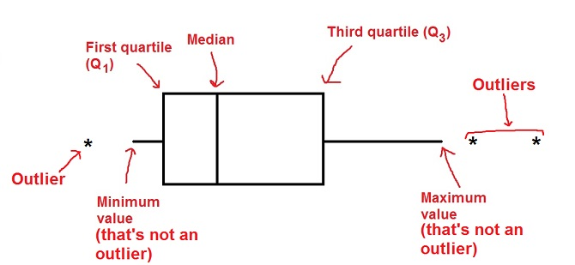

What is Normal Distribution?
Data can be "distributed" (spread out) in different ways.
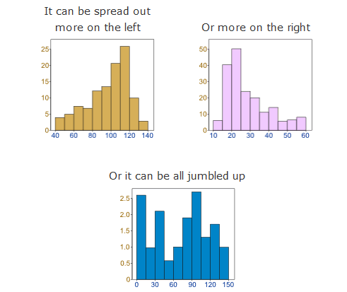

But there are many cases where the data tends to be around a central value with no bias left or right.
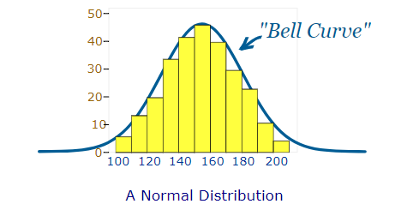
The "Bell Curve" is a Normal Distribution.

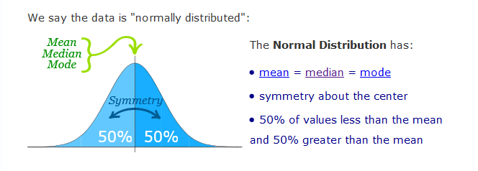

What is correlation?
When two data sets are strongly linked together we say they have a High Correlation.

Correlation is Positive when the values increase together, and
Correlation is Negative when one value decreases as the other increases

Correlation can have a value:

1 is a perfect positive correlation
0 is no correlation (the values don't seem linked at all)
-1 is a perfect negative correlation

Example: Ice Cream Sales
The local ice cream shop keeps track of how much ice cream they sell versus the temperature on that day,
here are their figures for the last 12 days:
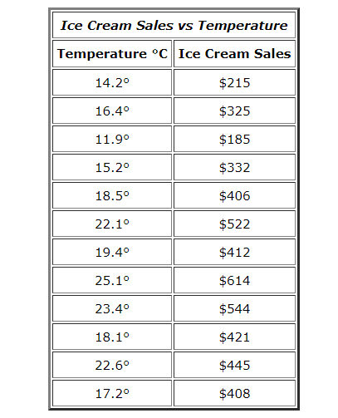
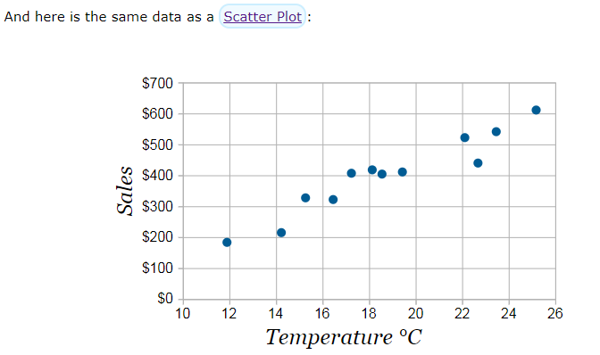

We can easily see that warmer weather and higher sales go together. The relationship is good but not perfect.
In fact the correlation is 0.9575
Calculation: CORREL() function in Excel

Let us call the two sets of data "x" and "y" (in our case Temperature is x and Ice Cream Sales is y):

Step 1: Find the mean of x, and the mean of y
Step 2: Subtract the mean of x from every x value (call them "a"), do the same for y (call them "b")
Step 3: Calculate: ab, a2 and b2 for every value
Step 4: Sum up ab, sum up a2 and sum up b2
Step 5: Divide the sum of ab by the square root of [(sum of a2) × (sum of b2)]
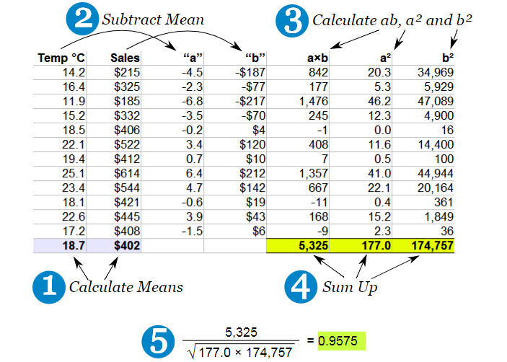

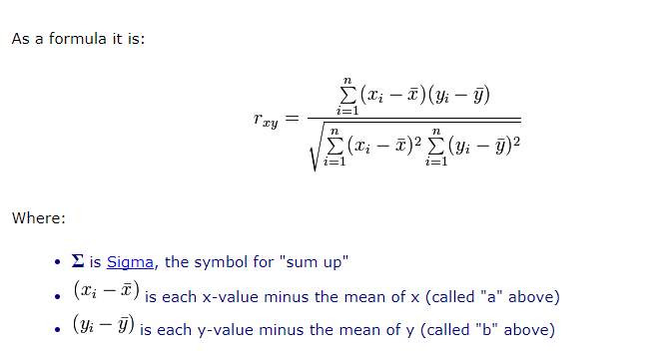

What is regression?
The process of determining the relationship between two variables is called as regression.
It is used to find the relationship between two variables.

What is Regression analysis?
Regression analysis is a set of statistical processes for estimating the relationships among variables.
Regression analysis is widely used for prediction and forecasting.
For example we predict scores on one variable from the scores of one or more variables.
The variable we are predicting is called the criterion variable.
The variable we are basing our predictions on is called the predictor variable.

Regression analysis helps one understand how the typical value of the dependent variable
(or 'criterion variable') changes when any one of the independent variables is varied, while the other independent variables are held fixed.

What is simple linear regression?
In simple linear regression, we predict scores on one variable from the scores on a second variable.
Y - criterion variable
X - predictor variable

When there is only one predictor variable, the prediction method is called simple regression.
In simple linear regression, the predictions of Y when plotted as a function of X form a straight line.

