Fundamentals of Statistics :: Discrete and Continuous

If you have quantitative data, like time to complete a task or number of questions correct on a quiz, then the data can be either continuous or discrete.
Discrete data have finite values, or buckets. You can count them.
Continuous data technically have an infinite number of steps, It is in decimal format.
The number of questions correct would be discrete -- there are a finite and countable number of questions.
Time to complete a task is continuous since it could take 178.8977687 seconds.
Time forms an interval from 0 to infinity.

Here are some examples of discrete and continuous data.

Discrete:
Number of children in a household
Number of languages a person speaks
Number of people sleeping in stats class

Continuous:
Height of children
Weight of cars
Time to wake up in the morning
Speed of the train

The sequence of terms to describe data : Nominal, Ordinal, Interval and Ratio
Nominal basically refers to categorically discrete data such as name of your school, type of car you drive or name of a book.
-------------------------------------------------------------------------------------------------------------
Ordinal refers to quantities that have a natural ordering. The ranking of favorite sports, the order of people's place in a line,
the order of runners finishing a race or more often the choice on a rating scale from 1 to 5.
With ordinal data you cannot state with certainty whether the intervals between each value are equal.
For example, On a 10 point scale,
the difference between a 9 and a 10 is not necessarily the same difference as the difference between a 6 and a 7.
This is also an easy one to remember, ordinal sounds like order.
-------------------------------------------------------------------------------------------------------------
Interval data: A interval variable is a measurement where the difference between two values is meaningful.
The difference between a temperature of 100 degrees and 90 degrees is the same difference as between 90 degrees and 80 degrees.
Ratio data is interval data with a natural zero point. For example, time is ratio since 0 time is meaningful.
Degrees Kelvin has a 0 point (absolute 0) and the steps in both these scales have the same degree of magnitude.

-------------------------------------------------------------------------------------------------------------

In summary, nominal variables are used to “name,” or label a series of values. Ordinal scales provide good information about the order of choices,
such as in a customer satisfaction survey. Interval scales give us the order of values + the ability to quantify the difference between each one.
Finally, Ratio scales give us the ultimate–order, interval values, plus the ability to calculate ratios since a “true zero” can be defined.

Describing the Center of Data:
When data are quantitative we often want to summarize the middle or most typical value. We usually refer to this as the average.
In statistics we need to be a bit more precises though as there are several averages: mean, median, mode etc.
The mean is the average of a data set.
The median is the middle of the set of numbers.
The mode is the most common number in a data set.

Step 1: Put the numbers in order so that you can clearly see patterns.
For example, lets say we have 2, 19, 44, 44, 44, 51, 56, 78, 86, 99, 99. The mode is the number that appears the most often. In this case: 44, which appears three times.

How to find the mean mode and median: MEAN
Step 2: Add the numbers up to get a total.
Example: 2 +19 + 44 + 44 +44 + 51 + 56 + 78 + 86 + 99 + 99 = 622. Set this number aside for a moment.

Step 3: Count the amount of numbers in the series.
In our example (2, 19, 44, 44, 44, 51, 56, 78, 86, 99, 99), we have 11 numbers.

Step 4: Divide the number you found in step 2 by the number you found in step 3.
In our example: 622 / 11 = 56.5454545. This is the mean, sometimes called the average.

Step 5: Find the number in the middle of the series.
This is the median. 2, 19, 44, 44, 44, 51,56, 78, 86, 99, 99.

Step 6: Find the middle two numbers.
For example, 1, 2, 5, 6, 7, 8, 12, 15, 16, 17. The median is the number that comes in the middle of those middle two numbers (7 and 8),
so that number would be 7.5 in this case. (To do this mathematically, add the two numbers together and divide by 2).

Describing the Variability of Data:
The center of a distribution of data is helpful in telling you something about the most common values,
but it doesn't tell you much about how spread out or variable the values are. To describe variability, we need an additional measure.

Range
An intuitive(using or based on what one feels to be true even without conscious reasoning) first start would be to provide the minimum and maximum values.
The difference between the min and max values is called the range, and this is one of the simplest ways to describe the variability.

The problem with the range is that it by definition looks at the most extreme values in your data.
What we want is some way of describing the average or typical distance each value is from the mean.

Standard Deviation
The Standard Deviation is a measure of how spread out numbers are.
Its symbol is σ (the greek letter sigma)
The formula is easy: it is the square root of the Variance. So now you ask, "What is the Variance?"

Variance
The Variance is defined as:
The average of the squared differences from the Mean.

To calculate the variance follow these steps:

Work out the Mean (the simple average of the numbers)
Then for each number: subtract the Mean and square the result (the squared difference).
Then work out the average of those squared differences. (Why Square?)

Example

You and your friends have just measured the heights of your dogs (in millimeters):
dogs on graph shoulder heights
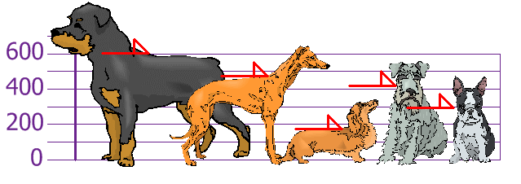

Find out the Mean, the Variance, and the Standard Deviation.
Your first step is to find the Mean:
Answer:
Mean = 600 + 470 + 170 + 430 + 300 = 1970/5 = 394
so the mean (average) height is 394 mm. Let's plot this on the chart:
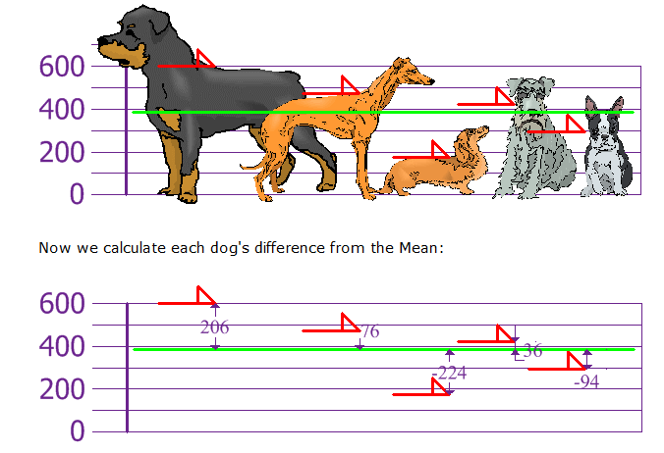
To calculate the Variance, take each difference, square it, and then average the result:
variance calc
So the Variance is 21,704

And the Standard Deviation is just the square root of Variance, so:
Standard Deviation

σ = √21,704
= 147.32...
= 147 (to the nearest mm)

And the good thing about the Standard Deviation is that it is useful. Now we can show which heights are within one Standard Deviation (147mm) of the Mean:
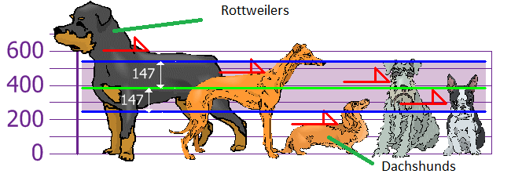
So, using the Standard Deviation we have a "standard" way of knowing what is normal, and what is extra large or extra small.
Rottweilers are tall dogs. And Dachshunds are a bit short ... but don't tell them!

