**Research:**

I am particularly interested in understanding molecular interactions between microbial communities and other members of the tissue microenvironment (e.g. epithelial, mesenchymal, and immune cells). And how these interactions establish and maintain normal tissue homeostasis. A proper understanding of these interactions will be helpful for the identification of the role of the microbiome in ***the overall growth performances, health***, and ***well-being*** of animals and humans.

My main goal is to contribute to the areas of a) microbiome-based diagnostics and therapeutics and b) personalized food and medicine to improve animal and human health by harnessing the power of multi-omics libraries and computational approaches. My expertise lies in the ***implementation of multi-omics data integration pipelines*** (microbial genomics, transcriptomics- bulk and single cell, whole genome sequencing, metagenomics) using novel computational methods.

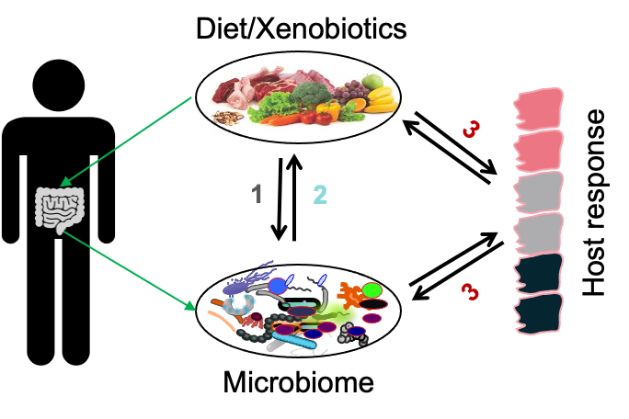

**Diet-microbiome-host interactions**

Overall research work can be divided in to the following aims:

**Aim 1**: ***Impact of diet/lifestyle, host genetics, and health status*** on microbiome composition, function, and interkingdom interactions in the gut.

**Aim 2: *Microbial metabolic capabilities*** to process various xenobiotics (dietary components and drug molecules) and regulation of host phenotype.

**Aim 3:** How these gut microbial compositional and functional and metabolic changes ***impact gene expression in Intestinal Epithelial Cells (IECs)***.

I am involved in the ***development and implementation of AI/machine learning and other data-driven approaches*** for a better understanding of these complex processes in animal and human models under diverse physiological conditions.