One is Roots, the other is Wings
At
- The value of knowledge that is based on our principles
- How to create stronger bonds with our roots
◻
- our community
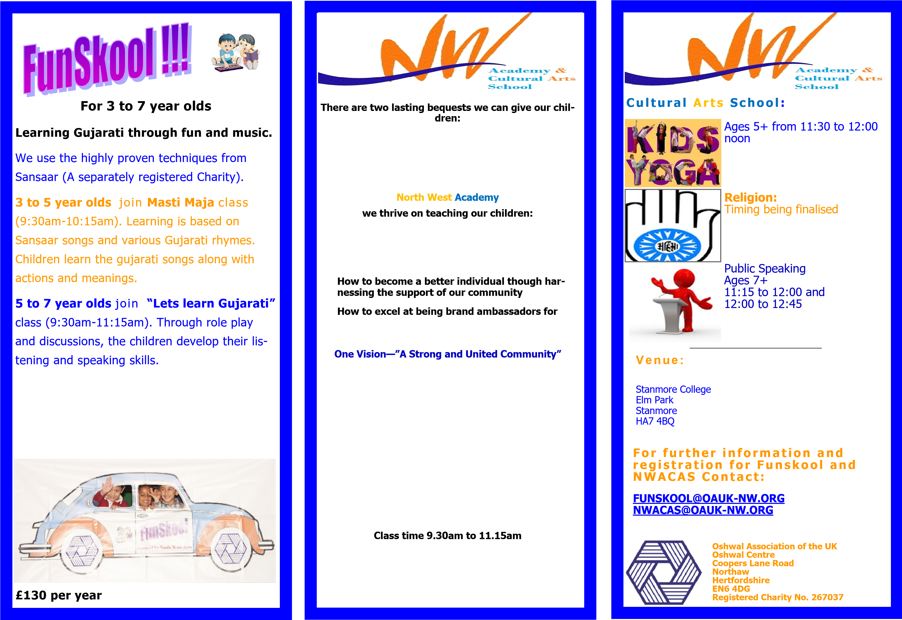

Our classes include:
- Learning Gujarati though role play
- Reading and writing skills
- Practical religion
- Projects—Geneology, ‘Maru Gaam’ etc
- Jain science - model and team work
- Pre-GCSE and GCSE classes.

