SKLPC Saturday School

Saturdays during term time at

Claremont High School, Kenton, Harrow

www.sklpc.com

Gujarati Classes

The SKLPC Gujarati School currently has over 230 pupils attending classes that cover curriculum study from beginners to GCSE level. Children start as early as 3.5 years and join the Bal mandir classes where they focus on listening and speaking through nursery rhymes and play. They then progress to learn the alphabet and vowels signs. This is preparation for the students so that they can pick up skills of reading and writing. This then sets a firm foundation for these vital skills needed for the final GCSE exam.
Staff at the Gujarati school cover the OCR syllabus provided by the examining body and are qualified and fully trained for the position they hold. As with other GCSE examinations the Gujarati GCSE is a two year course.
Balmandir classes start at the age of 3.5 up to 5 years old. These classes place more emphasis on oral teaching techniques accompanied with practical and fun work to keep the children interested.
Beginner’s classes range from age 6 to 15 and set the foundation for students with alphabet, sounds and introduction of simple vocabulary.
GCSE & Pre GCSE classes are aimed to prepare students for passing their GCSE by practising past papers and oral questions. We also promote students sitting their GCSE exams at the age of 14 and 15 if they are ready.

Why send your children to learn

Gujarati?
Educators have found that:
~ Children who come to school with a solid foundation in their mother tongue develop stronger literacy abilities in the school language and succeed educationally.
~ Both languages nurture each other when the educational environment permits children access to both languages.
~ Encouraging young children to learn their mother tongue would help them to develop confidence, self-esteem and their unique identity within a multicultural society.
~ Bilingualism assists the child’s general intellectual and conceptual development.
~ Your children will learn English much more effectively if they continue to develop their first language at the same time.
~ To reduce the extent of language loss, parents should establish a strong home language policy and provide ample opportunities for children to expand the functions for which they use their mother tongue (e.g. reading and writing) and contexts in which they can use it.

Learn Gujarati
“Learn Gujarati” is a series of workbooks that can be used by parents teaching their children or by teachers in schools to teach Gujarati to beginners. The material within is aimed at both children and adults and has been developed to ensure learning is easy and effective.

LEVEL 1
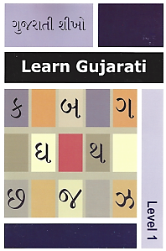
The Level 1 Workbook will teach students to read, write, understand and speak simple Gujarati sentences.
Book Features:
~ Teachers & parents guide in English
~ Beginners book with emphasis on on written Gujarati
~ Covers the Gujarati alphabet, number & vowels
~ Covers Gujarati vocabulary
~ Combined worksheets with reading materials (comprehension)
~ Gujarati cultural illustrations
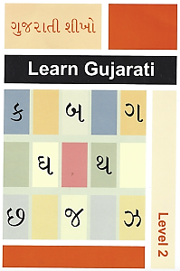
LEVEL 2
The Level 2 Workbook enables students to read, write, understand and speak Gujarati to an intermediate level.
Book Features:
~ Teachers & parents guide in English
~ Building on the key components > Listening and Speaking
~ Combined worksheets with reading material (comprehension)
~ Covers all vowels
~ Topics covering everyday vocabulary
~ Gujarati cultural illustrations

—- More Information —-
For further information or to place an order please contact please contact the Saturday School team.
Alternatively come and visit us on Saturday mornings at Claremont High School during term time.
ANSWER BOOKS FOR OUR GUJARATI BOOKS ARE AVAILABLE ON REQUEST.

