

**Airbnb Price Predictor**

**Project Description:**

The Airbnb Price Predictor project is a creative effort that aims to create an advanced prediction model for estimating Airbnb listing prices. This project aims to identify the complex elements affecting rental costs on the Airbnb platform by employing a large and varied dataset. It delivers precise and dependable price forecasts for Airbnb rentals by incorporating a variety of features, such as location attributes, property categories, host information, and historical booking data.

**Goals and Objectives:**

**Motivation:**

The increasing demand for a precise instrument that can precisely forecast rental costs has been brought about by the rise in demand of Airbnb as a substitute for conventional accommodation alternatives. In a market where prices vary according to a multitude of criteria, such as property attributes and geographical specifics, such a tool is important. The "Airbnb Price Predictor" project's goal is to use machine learning and data analytics to make Airbnb pricing more transparent and predictable for the advantage of hosts and guests inside the network's ecosystem.

**Significance:**

The project is highly valuable in a number of important areas:

* For Visitors: It assists in selecting economical and well-informed hotel options.
* Hosts: It helps them choose affordable and trustworthy marketing prices.
* For Industry Researchers: It offers valuable information about factors influencing lease expenses and pricing trends, which is essential for prediction and evaluating the market.
* Regarding the Collective Economy: It advances our knowledge of the mechanics of pricing in collaborative activity networks.

**Objectives:**

To create a trustworthy predictive model based on a variety of factors that can reliably anticipate Airbnb rental pricing. Examine the ways in which various elements—like property type, location, host details, and booking history—affect rental pricing. Offer a user-friendly tool that hosts can use to optimize prices and prospective tenants may use to estimate prices. Add to the corpus of knowledge about statistical analysis and modeling predictions in a collaborative market.

**Features:**

1. Based on data Insights: Deriving valuable insights regarding pricing from an extensive dataset.
2. Multi-Factor Analysis: Taking into account a wide range of factors, such as neighborhood, host verification status, property type, and geographic location.
3. Advanced Predictive Models: Applying and assessing different machine learning models for price estimation, such as decision trees Regression and linear regression.
4. Focused on users Approach: Emphasizing the model's useful implementation for Airbnb guests as well as hosts.
5. Industry Pattern Evaluation: This helps those in the real estate and hospitality sectors make strategic decisions by giving a broad picture of pricing patterns in the Airbnb industry.

**Related Work (Background):**

The research and advancements in the domains of housing market evaluation, machine learning, and modeling for prediction serve as a solid foundation for this project. This background section examines pertinent research, developments in technology, and the growth approaches that have shaped this initiative's evolution.

**Estimation of Prices Problems in Machine Learning:** With significant benefits, machine learning has been used more and more in price prediction tasks. Prices in different industries have been forecasted using a variety of techniques, from straightforward linear regression to intricate ensemble methods. With regard to Airbnb, these techniques are especially useful because of the platform's pricing system, which is impacted by a variety of variable fluctuations.

**Research of Airbnb Market Behavior:** A number of investigations have examined the variables, including location popularity, seasonal trends, and host credibility, that influence Airbnb price. These observations are beneficial to this project since they can be included into a more comprehensive model that takes into consideration both the peculiarities of the Airbnb industry and conventional real estate aspects.

**Past Prediction Pricing Methods for Airbnb Listing:** Earlier attempts were made to develop predictive pricing algorithms especially for Airbnb listings. By finding important predictive characteristics and proving that machine learning can be used to anticipate prices in this market, these models have set the foundation for future research. With the use of a large dataset and cutting-edge methodologies, the "Airbnb Price Predictor" project seeks to improve and expand these models' reliability and usability.

**Dataset:**

This project makes use of an extensive Airbnb dataset that was obtained from Kaggle. The dataset offers extensive knowledge into the variables affecting rental costs and is specifically made to support the creation of predictive models for Airbnb pricing.

The following are the main characteristics of the dataset:

* ID : An individual identifying number that is given to every dataset element.
* NAME: The name or title assigned to the real estate listing.
* Host ID: The property's host's unique identification.
* Host identification Verified: Returns a "Yes" or "No" depending on whether the host's identification has been confirmed.
* Name of the person or organization that is hosting the property is the host name.
* Neighborhood Group: The neighborhood of the property is categorized or classified.
* Neighborhood: The precise location of the property inside a locale.
* Latitude: The property's geographical latitude coordinate.
* Longitude: The property's geographical longitude coordinate.
* Country: The nation in which the asset is located.
* Country Code: The country code that corresponds to the location of the property.

**Detail design of Features**

ID acts as a distinct identifier for every dataset listing. mostly employed to maintain and track data, guaranteeing its integrity. used to identify listings apart in a unique way, guaranteeing correct reference and the absence of duplicates in the dataset.

NAME is a textual descriptor that gives the listing a title and a succinct explanation. Using text analysis, this feature can extract sentiment or theme information that could be related to pricing strategies.

Another distinct numerical identity, the host ID refers to the individual hosting the listing. enables the inclusion of host-specific characteristics in the model, such as a host's possible influence.

A category variable called "Host Identity Verified" indicates whether or not the host's identification has been confirmed. Pricing may be impacted by this binary characteristic (Yes/No), since verified hosts may charge more because of a greater trust factor.

The host's name may be utilized for secondary analysis or to personalize data, but it is not directly used for price prediction.

The neighborhood feature improves the dataset's based on location resolution and makes hyper-local market price analysis possible.

**Analysis:**

The goal of the Airbnb Price Predictor project is to find patterns, trends, and connections between different attributes and listing prices by methodically going over the dataset. This is accomplished by combining inferential statistics, visual research, and statistical analysis, all of which provide information for the ensuing modeling procedure.

Summary Evaluation: Determine the mean, median, mode, standard deviation, and variation for numerical characteristics such as cost, minimum number of nights, and reviews.

Distributed Analysis: Examine the statistical patterns of significant factors to determine the skewness, spread, and existence of outliers. For instance, looking at the price range might show whether there are extreme values or whether the majority of listings are concentrated inside a particular price range.

Heatmaps for Correlation: Make heatmaps to illustrate the relationship among numerical features. This makes it easier to determine whether variables are strongly or weakly correlated with the price.

Geographic Maps: To find geographic trends and pricing hotspots, plot items on a map utilizing latitude and longitude information.

Regression Analyses: While accounting for a variety of factors, use regression models to measure the link between price and other variables.

Model Efficiency Metrics: R-squared, RMSE, and MAE are a few examples of metrics that can be used to assess how well different predictive models perform. To choose the model that predicts prices most accurately, compare them.

**Implementation:**

The portion of the Airbnb Price Prediction project when statistical findings are converted into a useful model for prediction is called the Implementation phase. Preparing the data, choosing the model, training, and testing are all involved.

**Exploratory Data Analysis:**

Below is statistical analysis of mean, std, min and max by using describe() function.

The diagram shows a summary of a pandas Data Frame used for Airbnb listing analysis, with 102,599 items and 26 columns. Each column's non-null values and data types are displayed.

This image shows the result of applying the isnull().sum() method to a pandas DataFrame; it shows how many values in every column of the Airbnb listings dataset are missing.

Below code that removes particular columns from a panda DataFrame, bringing the total number of columns down to 20, and fills in the blanks in the 'house_rules' column with the text "Not stated."

The program below transforms the columns labeled "price" and "service fee" into strings, eliminates leading individuals, eliminates whitespace, removes commas, and then converts it back to numerical values. It handles mistakes by forcing erroneous parsing to result in NaN.

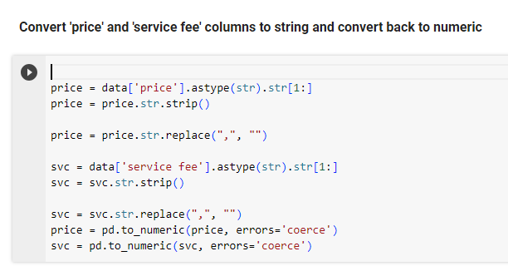

**Data Cleaning -** The section of code cleans the data by assigning zeros to NaN values in a number of columns and transforming them to the proper data types.

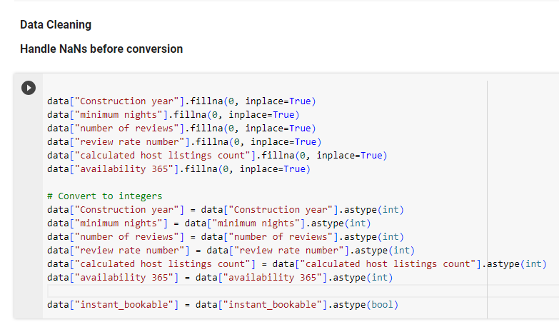

**Data Visualization:**

The below heatmap shows the link strengths between pairs of features from an Airbnb dataset, such as "minimum nights," "number of reviews," "estimated host listings count," "price," and "service fee." It is a heatmap of a relationship matrix.

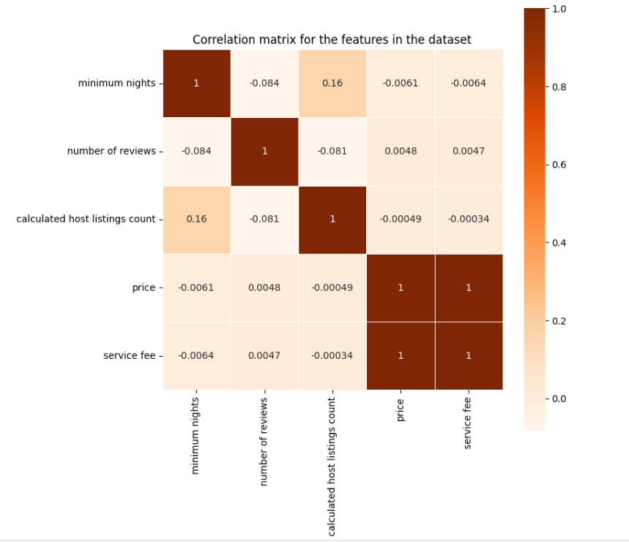

The below two bar graphs are displayed as one demonstrates the breakdown of Airbnb listings by neighborhood group, with Brooklyn and Manhattan getting the greatest counts; the other demonstrates the number of different room types accessible, with the most prevalent types being "Entire home/apt" and "Private room."

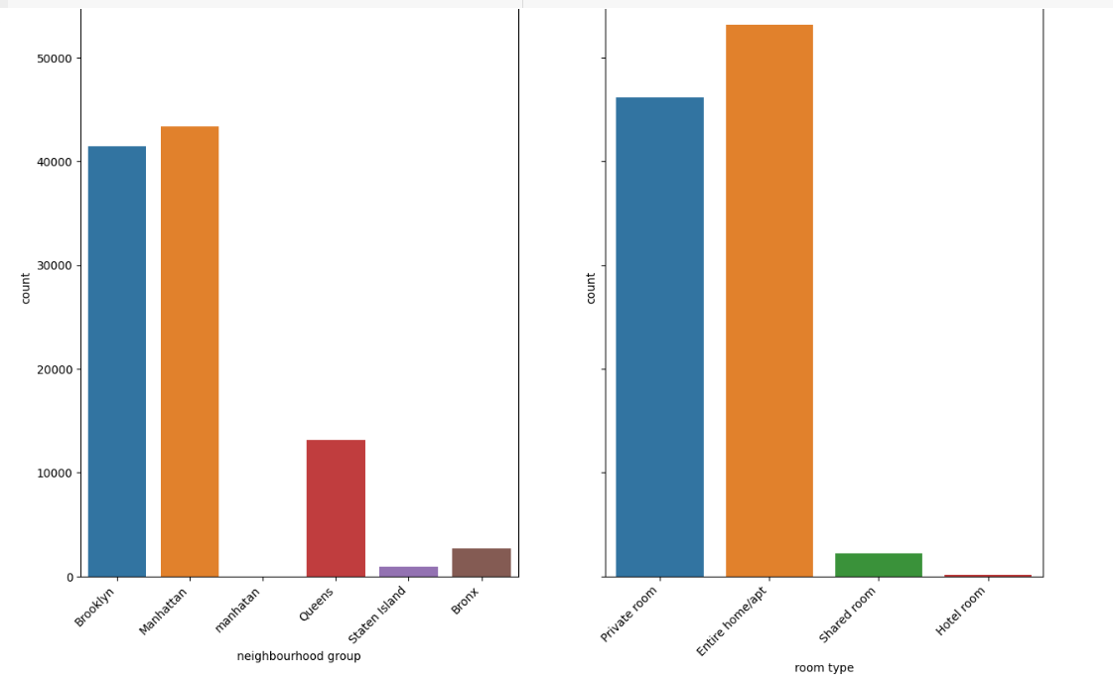

Another way of representation, the graph, which is a bar chart, displays the quantity of Airbnb listings broken down by kind of room. The most popular category is "Entire home/apt," which follows by "Private room," "Shared room," & "Hotel room."  
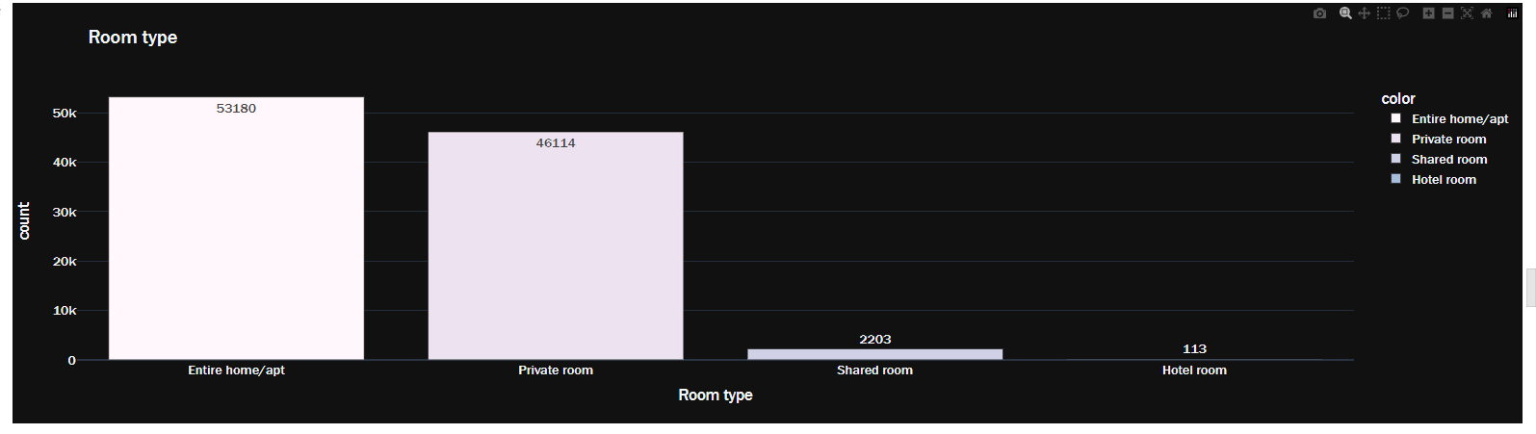

The image below creates a word cloud using a dataset's 'NAME' column to show the most frequently occurring terms in Airbnb listing names.

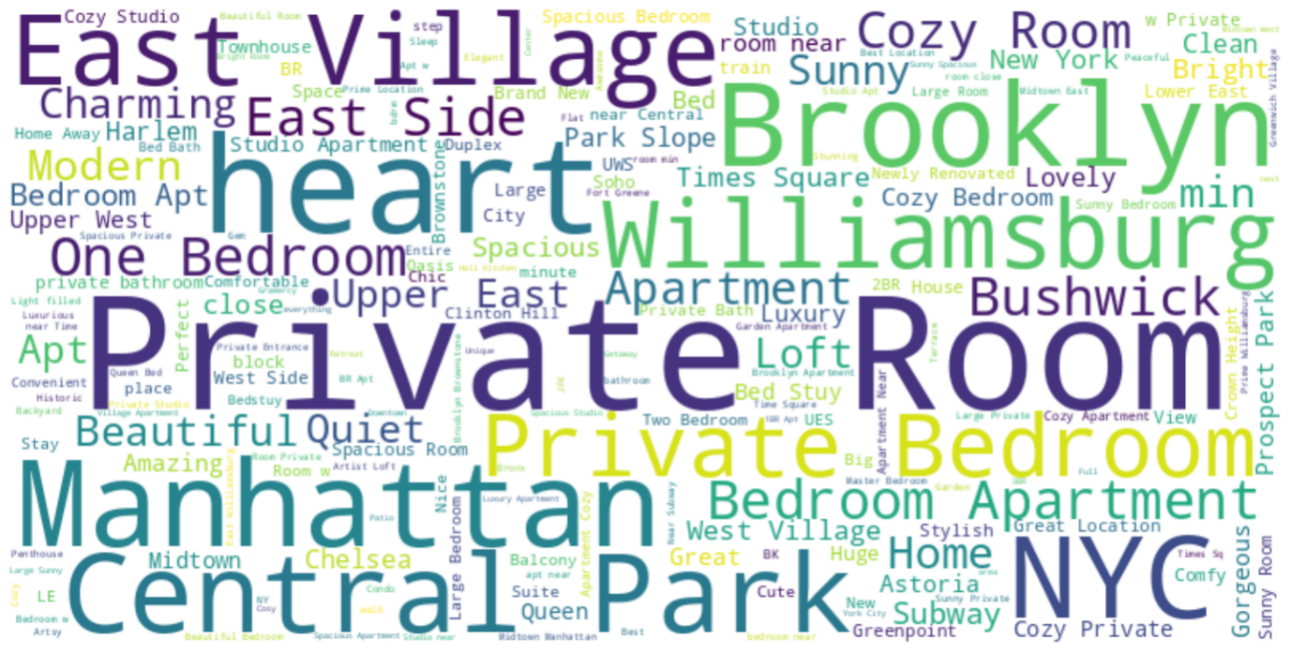

**Feature Engineering**

By assigning numerical values to categorical variables (neighborhood group, room type, and cancelation policy) in a DataFrame, which illustrates feature engineering.

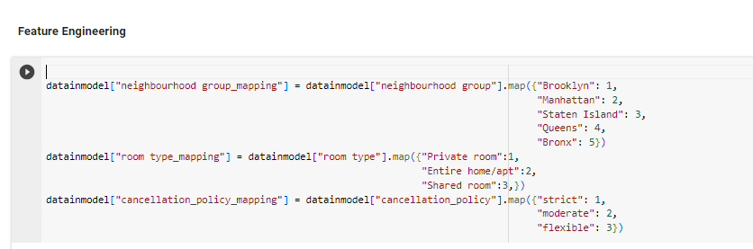

**Splitting the data**

The dataset was divided into training and test sets utilizing the scikit-learn train test split function, with 20% set aside for testing and a random state specified for repeatability.

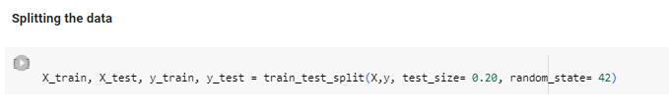

**Model Building**

Linear Regression:

The statistical technique known as linear regression involves fitting an equation with observed data in order to model the connection between the dependent variable and one or more variables that are independent. The main objective is to identify the line of equality that fits the data point the best and minimizes the sum of the squared discrepancies between the line's anticipated values and the actual values.

Uses the scikit-learn module to initialize a Linear Regression model, fit it to the training set of data, and provide predictions for the test set of data.

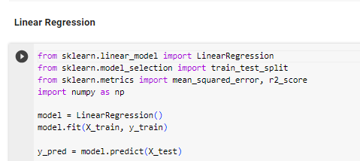

Decision Tree:

A non-linear predictive modeling method called a decision tree model divides the information into groups recursively according to the feature input values. The information is divided into branches at decision nodes, which stand for options. Leaf nodes with anticipated output values are located at the terminus of these branches. Although this model is simple to understand and visualize, if it is not adjusted properly, it may become overfit.

Decision Tree is imported the scikit-learning regression model trains on training data, produces prediction on test data, and then resets to a random state for consistency.

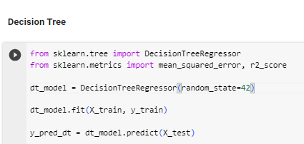

**Preliminary Results:**

**Model Evaluation**

A linear regression model's performance measures are displayed in its assessment output. Measuring the variation between that the model predicts and the values, the Mean Squared Error (MSE) is a metric that takes the average of the squares of the mistakes. The mean square error (MSE) in this instance is around 2.02, indicating that the model's predictions are, on average, 2.02 units off from the true values.

A more concrete understanding of the model's prediction error is provided by the RMSE 1.42, which indicates that the model's predictions are, on average, 1.42 units off from the actual values. Since it shows greater model performance with less variance from the observed data, a lower RMSE is usually preferred. A model's ability to explain almost all of the variance in the dependent variable is shown by an R-squared value that is extremely close to 1, precisely around 0.9999. This indicates an excellent fit between the model and the data. But with an R2 value so near to ideal, it's equally critical to exercise caution to avoid overfitting.

Here the preliminary results for the decision tree model, The mean squared variance between the actual results that were observed and the outcomes that the model anticipated is indicated by the Mean Squared Error (MSE), which is roughly 2.79. Root Mean Squared Error (RMSE) is the average difference between the expected and actual values is represented by the square root of the mean square error (MSE), which is around 1.67. The statistical measure of how well the data match the fitted regression line is called R-squared, with 1.0 denoting a perfect fit. R² is roughly 0.9999. According to these measures, the Decision Tree model's predictive accuracy on the provided test data is extremely high. On the other hand, an R2 value this close to 1 may suggest possible overfitting to the training set, much like in the evaluation of the linear regression model. This ought to be further examined using extra verification methods like cross-validation.

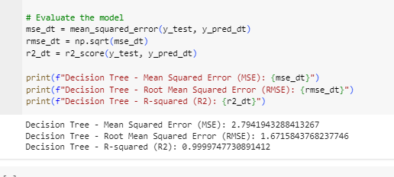

**Project Management:**

**Work Completed:**

Data Preprocessing: data cleaning, missing value handling, and feature normalization/standardization.

Exploratory Data Analysis: Recognizing outliers, visualizing data distributions, and comprehending feature associations.

Feature Engineering: feature selection, feature generation, and categorical variable encoding.

Model Building & Evaluation: Applying decision tree and linear regression algorithms, as well as measuring model performance with R-squared, RMSE, and MSE metrics.

Documentation: Prepare a documentation for all methods, codes, and results into an official report.

**Work to be completed:**

More fine-tuning of the current models to improve their fit and ability to generalize to new data. This could entail experimenting with different algorithms, regularizing data, and modifying hyperparameters.

Apply two more models of machine learning, i.e. Random Forest and Support Vector Machines, should be investigated and used in order to expand our forecasting strategies and maybe increase accuracy.

Using cross-validation techniques to verify the consistency and stability of each model, reducing overfitting and increasing forecast reliability.

Analyzing all of the model faults in-depth in order to find recurring problems or particular situations when models are unable to make accurate predictions.

Interacting with the information in the science field to conduct peer reviews and incorporate their suggestions for further model improvement.

**References:**

Airbnb dataset refer from,

<https://www.kaggle.com/datasets/arianazmoudeh/airbnbopendata/data>

James, G., Tibshirani, R., Witten, D., and Hastie, T. (2013). An Overview of Statistical Education.

Sprout.

Proserpio, D., Zervas, G., and Byers, J. W. (2017). The Sharing Economy is Growing: Measuring

Airbnb's Effect on the Hotel Sector.

Pedregosa and associates (2011). Scikit-learn: Python for Machine Learning, JMLR 12