Assignment 1

# Q1: Install Jupyter notebook and run the first program and share the screenshot of the output.

# Answer:

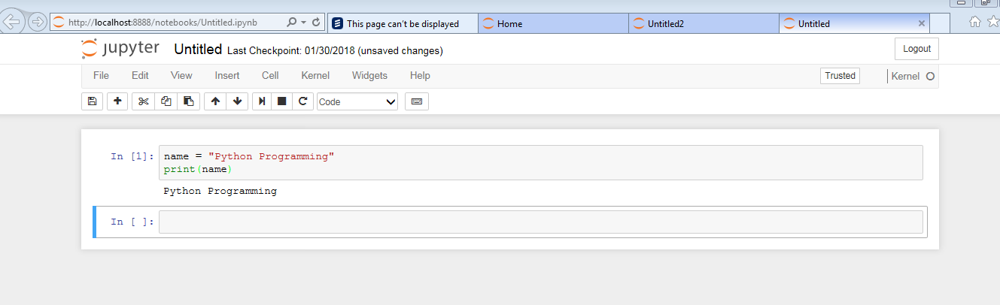

# Q2: Write a program which will find all such numbers which are divisible by 7 but are not a multiple of 5, between 2000 and 3200 (both included). The numbers obtained should be printed in a comma-separated sequence on a single line.

# Answer:

output = filter(lambda x: x%7—0 and x % 5 !=0 , list(range(2000,3201)))

Print(list(output))

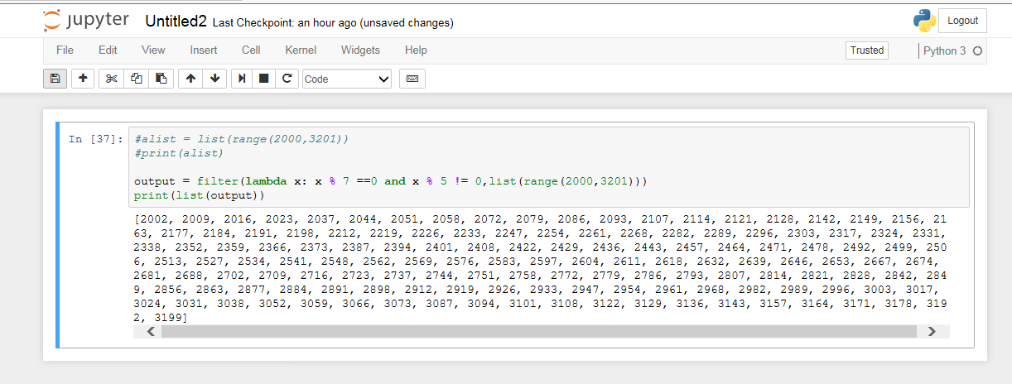

# Q3: Write a Python program to accept the user's first and last name and then getting them printed in the reverse order with a space between first name and last name.

# Answer:

fname = input("Enter your first name : ")

lname = input("Enter your last name : ")

print(lname+ " "+fname)

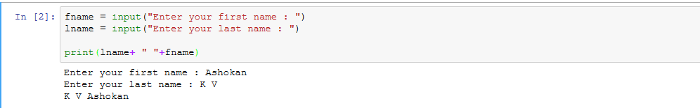

# Q4: Write a Python program to find the volume of a sphere with diameter 12 cm.

Formula: V=4/3 * π * r 3

# Answer:

π = 3.14

r = float(input("enter the radius :"))

result = (4/3)*π*r*r*r

print(result)

