**Assignment 16**

# Problem Statement 1:

**A test is conducted which is consisting of 20 MCQs (multiple choices questions) with**

**every MCQ having its four options out of which only one is correct. Determine the**

**probability that a person undertaking that test has answered exactly 5 questions wrong.**

Answer :

Here, n = 20, n - k = 5, k = 20 - 5 = 15

Here the probability of success = probability of giving a right answer = s = 1/4

Hence, the probability of failure = probability of giving a wrong answer = 1 - s

= 1 – 1/4= 3/4

When we substitute these values in the formula for Binomial distribution we get,

So, P (exactly 5 out of 20 answers incorrect) = C (20, 5) * (1/4) 15 * (3/4) 5

→ P (5 out of 20) =( (20*19*18*17*16) /(5*4*3*2*1))* (1/4) 15 * (3/4) 5

= 3.426E-06 (approximately)

Using Python code –

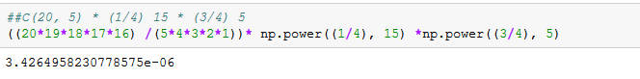

Using Python Binomial distribution code-

*n=20 # No. of total MCQ*

*p=1/4 # probability of chooing wrong answer out of 4 choice*

*x=15*

*binom.pmf(x,n,p)*

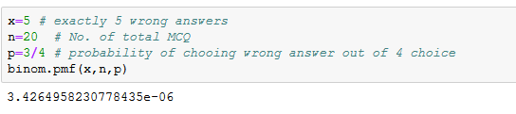

# Problem Statement 2:

**A die marked A to E is rolled 50 times. Find the probability of getting a “D” exactly 5**

**times.**

Answer :

Here, n = 50, k = 5, n - k = 45.

The probability of success = probability of getting a “D”= s = 1/5

Hence, the probability of failure = probability of not getting a “D” = 1 - s = 4/5

.

C (50, 5) * (1/5) 5 * (4/5)45 = 0.0295 times approx.

Using Python code –



Using Python Binomial code-

*n=50 # Total no. of times die rolled*

*p=1/5 # probability of gettind 'D'*

*x=5 # Getting 'D' exactly 5 times*

*binom.pmf(x,n,p)*

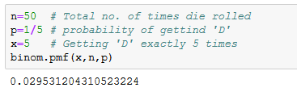

# Problem Statement 3:

**Two balls are drawn at random in succession without replacement from an urn**

**containing 4 red balls and 6 black balls.**

**Find the probabilities of all the possible outcomes.**

Answer :

Given the total number of black balls = 6 and total number of red balls = 4.

Calculating all Possible combinations:

1.Probability of drawing two red out of 10 = P(4/10)*P(3/9) = 0.133

2. Probability of drawing two black out of 10 = P(6/10)*P(5/9)=0.333

3.Probability of drawing one red and one black = P(4/10)*P(6/9)=0.266 ( same as below)

4.Probability of drawing one black and one red=P(6/10)*P(4/9)=0.266 (same as above)

All possible outcomes for two red + two black + two(red and black) = (0.133 +0.333+0.266) = 0.733

Using Python code:

