Assignment 2

## Q1: Write a program which accepts a sequence of comma-separated numbers from console and generate a list.

## Answer :

nlist = input("Input some comma seprated numbers : ")

flist = nlist.split(",")

print('List : ',flist)

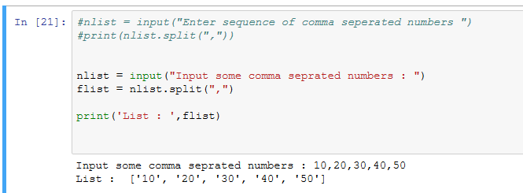

## Q2: Create the below pattern using nested for loop in Python.

*

* *

* * *

* * * *

* * * * *

* * * *

* * *

* *

*

## Answer :

for i in range(1,5):

for j in range(i):

print ('* ', end="")

print('')

for i in range(5,0,-1):

for j in range(i):

print('* ', end="")

print('')

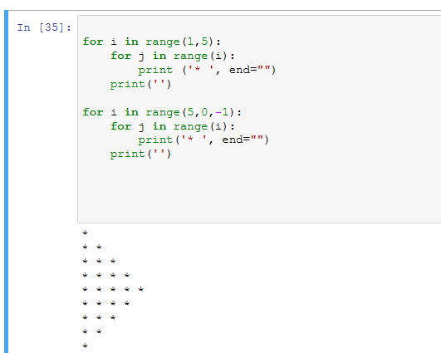

## Q3: Write a Python program to reverse a word after accepting the input from the user.

## Sample Output:

Input word: AcadGild

Output: dilGdacA

## Answer :

name = input("Enter text : ")

for i in range(len(name),0,-1):

print(name[i-1],end="")

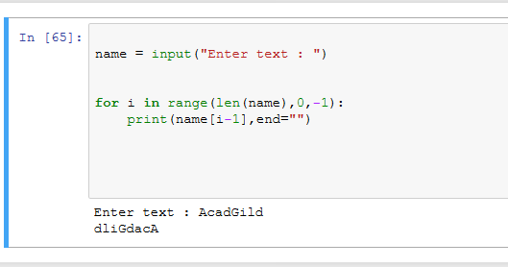

## Q4: Write a Python Program to print the given string in the format specified in the sample

output.

WE, THE PEOPLE OF INDIA, having solemnly resolved to constitute India into a SOVEREIGN, SOCIALIST, SECULAR, DEMOCRATIC REPUBLIC and to secure to all its citizens

Sample Output:

WE, THE PEOPLE OF INDIA,

having solemnly resolved to constitute India into a SOVEREIGN,!

SOCIALIST, SECULAR, DEMOCRATIC REPUBLIC

and to secure to all its citizens

## Answer:

print("WE, THE PEOPLE OF INDIA,\n\thaving solemnly resolved to constitute India into a SOVEREIGN,! \n\t\t SOCIALIST, SECULAR, DEMOCRATIC REPUBLIC \n\t\t and to secure to all its citizens")

