Assignment 4

# Q1.1: Write a Python Program(with class concepts) to find the area of the triangle using the below formula.

area = (s*(s-a)*(s-b)*(s-c)) ** 0.5

Function to take the length of the sides of triangle from user should be defined in the parent

class and function to calculate the area should be defined in subclass.

# Answer :

class TriangleInput:

def __init__(self):

self.sides=[]

a=input("Enter Side 1 :")

b=input("Enter Side 2 :")

c=input("Enter Side 3 :")

self.sides.append(float(a))

self.sides.append(float(b))

self.sides.append(float(c))

#print(self.sides)

class AreaTriangle(TriangleInput):

def __init__(self):

TriangleInput.__init__(self)

def findArea(self):

a, b, c = self.sides

# calculate the semi-perimeter

s = (a + b + c) / 2

area = (s*(s-a)*(s-b)*(s-c)) ** 0.5

print('The area of the triangle is %0.2f' %area)

t = AreaTriangle()

t.findArea()

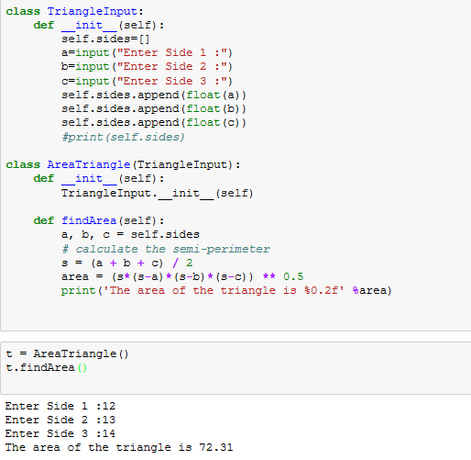

# Q1.2: Write a function filter_long_words() that takes a list of words and an integer n and returns the list of words that are longer than n.

# Answer :

def words_longer(lista,n):

words=list(filter(lambda word : len(word)>n, lista))

return words

lword = []

while True:

word= input('enter the word : ')

if word == 'break':

break

else:

lword.append(word)

num=int(input('Enter the number :'))

print(words_longer(lword,num))

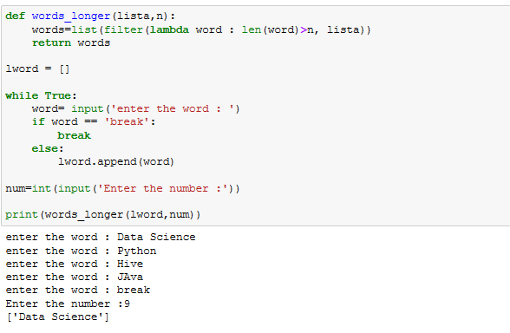

# Q2.1: Write a Python program using function concept that maps list of words into a list of integers representing the lengths of the corresponding words .

Hint: If a list [ ab,cde,erty] is passed on to the python function output should come as [2,3,4]

# Answer :

list_ap=['Java', 'C++', 'Python','Data Science']

print(list(map(lambda words : len(words), list_ap)))

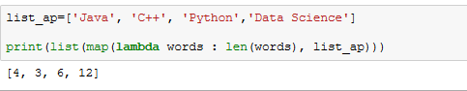

# Q2.2: Write a Python function which takes a character (i.e. a string of length 1) and returns True if it is a vowel, False otherwise.

# Answer :

vowels='aeiouAEIOU'

while True:

v = input('Enter a character : ')

if v in vowels:

print('True')

break

else:

print('False')

