Assignment 5

# Q1: Write a function to compute 5/0 and use try/except to catch the exceptions.

# Answer :

def mdiv():

try:

val = 5/0

except ZeroDivisionError:

print("unable to divide a number by zero")

except TypeError:

print("invalid input")

except ValueError:

print("invalid operation")

mdiv()

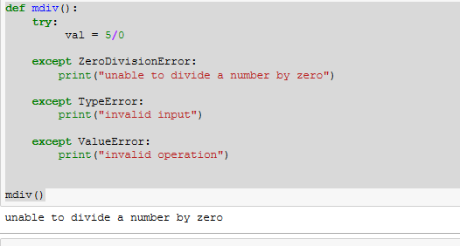

# Q2: Implement a Python program to generate all sentences where subject is in

["Americans", "Indians"] and verb is in ["Play", "watch"] and the object is in

["Baseball","cricket"].

Hint: Subject,Verb and Object should be declared in the program as shown below.

subjects=["Americans ","Indians"]

verbs=["play","watch"]

objects=["Baseball","Cricket"]

Output should come as below:

Americans play Baseball.

Americans play Cricket.

Americans watch Baseball.

Americans watch Cricket.

Indians play Baseball.

Indians play Cricket.

Indians watch Baseball.

Indians watch Cricket.

# Answer:

subjects=["Americans ","Indians"]

verbs=["play","watch"]

objects=["Baseball","Cricket"]

for i in subjects :

for j in verbs :

for k in objects :

print(i," ",j," ",k)

