Assignment 10.1

Q1. Delete unnamed columns

Answer:

import pandas as pd

df=pd.read_csv('https://raw.githubusercontent.com/guipsamora/pandas_exercises/master/06_Stats/US_Baby_Names/US_Baby_Names_right.csv')

df.drop('Unnamed: 0',axis=1,inplace=True)

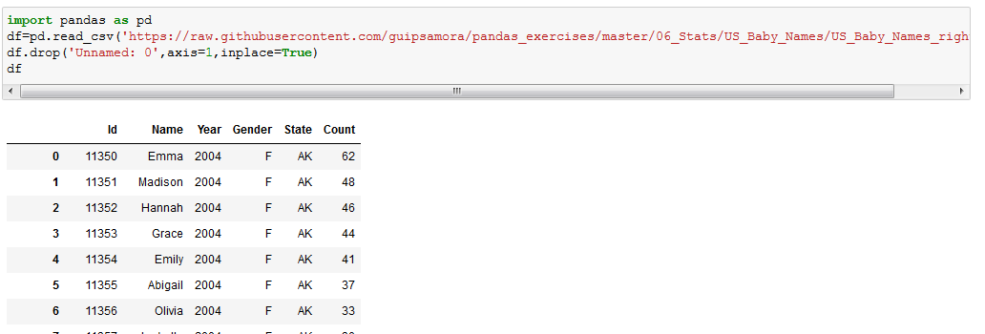

Q2. Show the distribution of male and female

Answer:

1. df.groupby('Gender').describe()

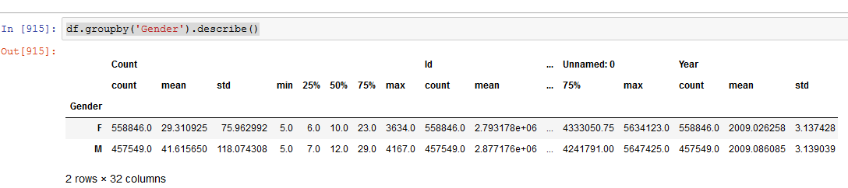

1. dist=pd.Categorical(df.Gender)

dist=dist.rename_categories(['Female','Male'])

dist.describe()

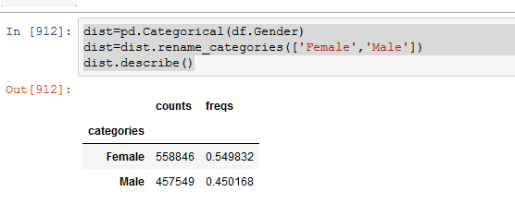

Q3. Show the top 5 most preferred names

Answer :

df[["Name", "Count"]].sort_values('Count',ascending=False).head(5)

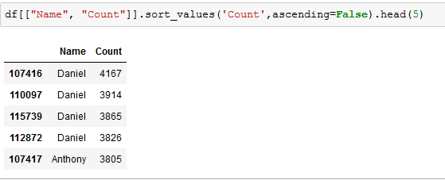

Q4. What is the median name occurrence in the dataset

Answer:

df["Name"][df.Count.median()]

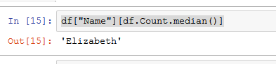

5. Distribution of male and female born count by states

Answer:

df.groupby(['Gender','State']).describe()

