Assignment 11.1

Q1. Create a pie chart presenting the male/female proportion

Answer:

import matplotlib as mpl

import matplotlib.pyplot as plt

url='https://raw.githubusercontent.com/Geoyi/Cleaning-Titanic-Data/master/titanic_original.csv'

titanic = pd.read_csv(url)

sdis=scatg.describe().counts

scatg=pd.Categorical(titanic.sex).dropna()

label=scatg.unique()

plt.pie(sdis,labels=label,startangle=90, autopct='%.1f%%')

plt.title('Male/Female proportion')

plt.show()

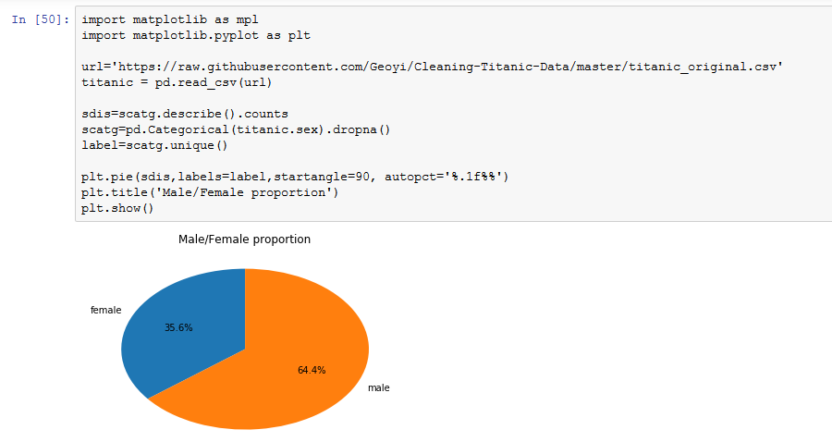

Q2. Create a scatterplot with the Fare paid and the Age, differ the plot color by gender

Answer:

x=titanic['fare']

y=titanic['age']

#z=titanic['sex']

z=np.array(titanic.sex.dropna(axis=0).unique())

colors = np.where(titanic['sex']=='female','r','g')

fig = plt.figure()

ax = fig.add_subplot(1, 1, 1)

ax.scatter(x,y,s=30,alpha=0.5,edgecolors='none',c=colors,label=z)

plt.title('Scatter Plot')

plt.xlabel('Fare')

plt.ylabel('Age')

plt.show()

