Assignment3.1

Q1: Write a Python Program to implement your own myreduce() function which works exactly

like Python's built-in function reduce()

Answer :

def myreduce(a, b):

mred = b[0]

for next in b[1:]:

mred = a(mred, next)

return mred

myreduce( (lambda x, y: x \* y), [1, 2, 3, 4])

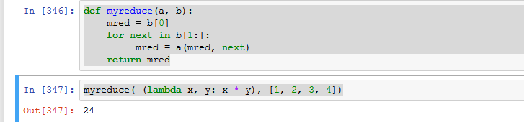

Q2: Write a Python program to implement your own myfilter() function which works exactly

like Python's built-in function filter()

Answer :

alist = [1,2,3,4,5]

def myfilter(x):

if (x%2)== 0 :

return x;

myfiltered = map(myfilter, alist)

for element in myfiltered:

if element != None:

print(element)

