Assignment 4.1

Q1: area = (s*(s-a)*(s-b)*(s-c)) ** 0.5

Function to take the length of the sides of triangle from user should be defined in the parent

class and function to calculate the area should be defined in subclass.

Answer :

class TriangleInput:

def __init__(self):

self.sides=[]

a=input("Enter Side 1 :")

b=input("Enter Side 2 :")

c=input("Enter Side 3 :")

self.sides.append(float(a))

self.sides.append(float(b))

self.sides.append(float(c))

#print(self.sides)

class AreaTriangle(TriangleInput):

def __init__(self):

TriangleInput.__init__(self)

def findArea(self):

a, b, c = self.sides

# calculate the semi-perimeter

s = (a + b + c) / 2

area = (s*(s-a)*(s-b)*(s-c)) ** 0.5

print('The area of the triangle is %0.2f' %area)

t = AreaTriangle()

t.findArea()

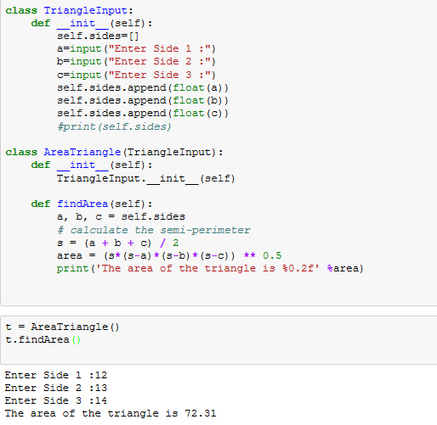

Q2: Write a function filter_long_words() that takes a list of words and an integer n and returns the list

of words that are longer than n.

Answer :

def words_longer(lista,n):

words=list(filter(lambda word : len(word)>n, lista))

return words

lword = []

while True:

word= input('enter the word : ')

if word == 'break':

break

else:

lword.append(word)

num=int(input('Enter the number :'))

print(words_longer(lword,num))

