Assignment 4.2

Q1: Write a Python program using function concept that maps list of words into a list of integers

representing the lengths of the corresponding words .

Hint: If a list [ ab,cde,erty] is passed on to the python function output should come as [2,3,4]

Answer :

list_ap=['Java', 'C++', 'Python','Data Science']

print(list(map(lambda words : len(words), list_ap)))

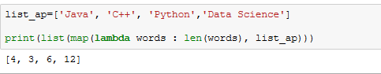

Q2: Write a Python function which takes a character (i.e. a string of length 1) and returns True if it is

a vowel, False otherwise.

Answer :

vowels='aeiouAEIOU'

while True:

v = input('Enter a character : ')

if v in vowels:

print('True')

break

else:

print('False')

