 AUTOMATIC GUIDED VECHILE 

**SYNCHRONOUS AND ASYNCHRONOUS MACHINES**

A PROJECT REPORT

Submitted By

**ASHOK G 6176AC22UEE005**

**SUDALAI MUTHU M 6176AC22UEE035**

**VIJAYAN S 6176AC22UEE044**

In partial fulfilment for the award of the degree *Of*

**BACHELOR OF ENGINEERING**

*In*

**ELECTRICAL AND ELECTRONICS ENGINEERING ADHIYAMAAN COLLEGE OF ENGINEERING [AUTONOMOUS] Dr. M.G.R NAGAR, HOSUR -**

**635130, TAMILNADU.**

**(Accredited by NBA & NAAC ’A’ Grade) HOSUR – 635 109**

**ANNA UNIVERSITY: CHENNAI – 600025**

**NOVEMBER 2024**

**ABSTRACT**

Wi-fi is controlled by using a Blynk android application instead joystick

method. Here only needs to move the joystick in Blynk android application to control the car in forward, backward, left and right directions. So here Blynk android application is used as a transmitting device and indult wi-fi module placed in the car is used as a receiver. Blynk android application will transmit command using wi-fi to the car so that it can move in the required direction like moving forward, reverse, turning left, turning right and stop.

**INTRODUCTION**

Robotic evolution starts with some basic ideas. It minimizes the human efforts and it can be deployed in a lot of fields like military, surveillance application, Industrial Pick and Place Robots latest Humanoid robots are developed in the modern world. Now a day’s robotic cars are developed by using Wireless technology. Wireless technology in Robotics starts with Bluetooth, WI-FI, and Zigbee Communication. Based on the Requirement and Application they deployed the communication in Projects. And we have numerous android Applications in Play store to control a Robot car. Blynk is a Popular App used in this Project it has a lot of Features like buttons, gauges, Sliders and Plotting Features also. By using Wi-Fitechnologywe can connect a greater number of Robotic Car to control it very useful for surveillance application. Now a day’s Indoor localization Technologies are developed on that case also we can deploy this type of Wi-Fi-controlled Robotic Car.

**Overview:**

A Wi-Fi controlled car is a vehicle that can be operated remotely using a Wi-Fi connection. The car uses a Node MCU board to connect to a Wi-Fi network, and then the user can control the car’s movements via a website or app. The car’s motors rotate based on the commands sent to the Node MCU board from the user’s device.

# Key Components:

* **Arduino Uno:**

The NodeMCU (Node MicroController Unit) is an open-source software and hardware development environment built around an inexpensive System-on-a- Chip (SoC) called the ESP8266.

# Stepper Motor:

Provides precise control of movement, making it ideal for applications requiring detailed positioning and speed regulation.

# L298N Motor driver:

The L298N is a dual H-Bridge motor driver which allows speed and direction control of two DC motors at the same time. The module can drive DC motors that have voltages between 5 and 35V, with a peak current up to 2A.

**Functionality:**

**A Wi-Fi controlled car can be operated remotely**

**from anywhere with an internet connection. It can be used for a variety of purposes, including:**

**Remote control:**

The car can be controlled remotely using a mobile device or computer.

# Surveillance:

A Wi-Fi controlled car with a mobile camera can be used for surveillance, allowing users to control the movement of the vehicle and stream live video.

# IoT demonstration:

A Wi-Fi controlled car can demonstrate the capabilities of the Internet of Things (IoT) in remote control and automation.

**OBJECTIVE**

The objectives of a Wi-Fi controlled car include:

# Remote control:

A Wi-Fi controlled car can be controlled remotely using a smartphone or other device with internet connectivity.

# Obstacle avoidance:

The car can use sensors to detect and avoid obstacles.

# Real-time data:

The car can provide real-time data, such as sensor readings and camera feed, to the remote device or computer.

# Demonstrate IoT:

The car can demonstrate the practical application of the Internet of Things (IoT) in daily life.

Revolutionize device interaction:

The car can showcase the potential of IoT to revolutionize how devices are controlled and interacted with.

# Make work easier:

The car can make work easier by allowing the user to control it with a single movement on a mobile phone or computer.

**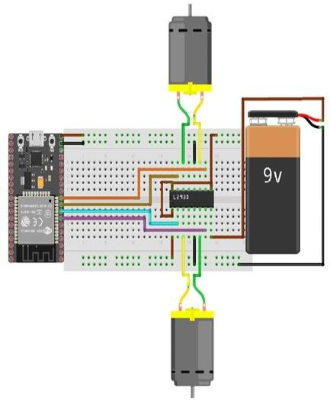****CIRCUIT DIAGRAM**

**CIRCUIT DIAGRAM DESCRIPTION**

In this project, a wifi controlled car using an Arduino NodeMCU ESP8266,L298N motor driver and a stepper motor. The core of the system is the Arduino NodeMCU, which reads the analog input from the stepper motor controlled by black application. As the user controls the stepper motor using black application, it changes the speed and direction (RIGHT, LEFT, FORWARD,BACKWARD). This analog signal is then converted into a digital value that the Arduino uses to determine the appropriate control for the stepper motor. The Arduino sends precise control signals to the motor driver, which in turn adjusts the power supplied to the stepper motor, effectively controlling its speed. This setup offers a simple yet effective way to manage motor speed, making it highly useful for applications in robotics, automation, and educational projects. The real-time responsiveness and ease of use provided by the black application make this system an accessible solution for precise motor control, showcasing the practical benefits of combining basic electronic components with microcontroller programming.

**HARDWARE REQUIREMENTS AND SPECIFICATIONS** **ARDUINO UNO**

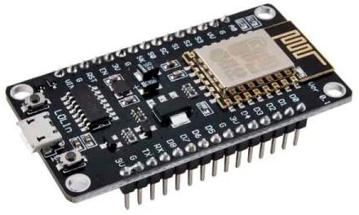Based on the ESP8266 Wi-Fi transceiver module and the CH340 USB converter chip, this compact (Open Source) development and prototyping board is ideal for IoT applications.

The Wi-Fi module is compatible with the 802.11 b/g/n standard at 2.4 GHz, has an integrated TCP/IP stack,

19.5 dBm output power, data interface (UART / HSPI

/ I2C / I2S / Ir Remote Control GPIO / PWM) and PCB antenna.

It also has a micro USB connector and reset button. Programmable with Arduino IDE, it includes interpreters for processing commands for languages such as LUA..

.

**STEPPER MOTOR**

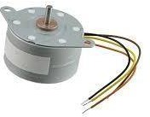The stepper motor is an essential component used in various applications for its precise control over rotational movement. Typically, a stepper motor, such as the PM35L-048-HPH7, is a brushless DC motor that divides a full rotation into a number of equal steps. Unlike regular DC motors, which rotate continuously when power is applied, stepper motors move incrementally, which allows for precise control of

angular position. The PM35L-048-HPH7 stepper motor is a type of hybrid stepper motor known for its reliability and accuracy. It features a 48-step per revolution

design, which translates to a step angle of 7.5 degrees. This motor usually has four or six wires, depending on its internal configuration (unipolar or bipolar), and it operates on a specified voltage and current, ensuring consistent performance. Each wire corresponds to a phase coil, and energizing these coils in a specific sequence causes the motor to move in discrete steps. In practical applications, stepper motors like the PM35L-048-HPH7 are used in 3D printers, CNC machines, robotics, and other devices where precise positioning and repeatability are crucial. The combination of accuracy, reliability, and control makes stepper motors a preferred choice for engineers and hobbyists alike.

**POTENTIOMETER**

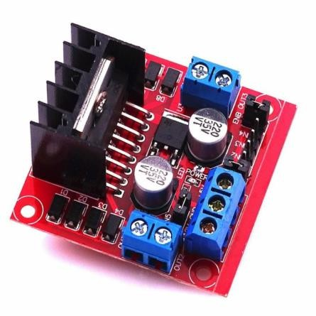The L298N Motor Driver module consists of an L298 Motor Driver IC, 78M05 Voltage Regulator, resistors, capacitor, Power LED, 5V jumper in an integrated circuit.78M05 Voltage regulator will be enabled only when the jumper is placed. When the power supply is less than or equal to 12V, then the internal circuitry will be powered by the voltage regulator and the 5V pin can be used as an output pin to power the microcontroller. The jumper should not be placed when the power supply is greater than 12V and separate 5V should be given through 5V terminal to power the internal

circuitry.ENA & ENB pins are speed control pins for Motor A and Motor B while IN1& IN2 and IN3 & IN4 are direction control pins for Motor A and Motor B.

**COMPONENT DETAILS**

|  |  |
| --- | --- |
| **Name of Component** | **Cost of The Product** |
| Stepper Motor | 280x2=560 |
| Arduino NodeMCU ESP8266 | 236 |
| L298N motor driver | 89 |
| Jumper Wire | 15 |
| Total | 900 |

**APPLICATION**

1. Surveillance
2. Tracking
3. Emergency services
4. Hobby, education, and research
5. Autonomous driving

**HARDWARE KIT**

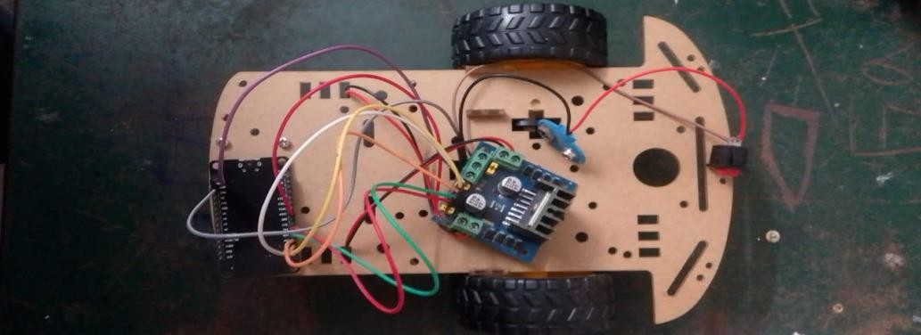

**CONCLUSION**

A WiFi-controlled car is a versatile and innovative project that combines technology, engineering, and programming to create a remote-controlled vehicle that can be operated wirelessly using a smartphone, laptop, or other WiFi-enabled devices.This project provides hands-on experience with various technologies like microcontrollers, WiFi modules, sensors, and motors, enhancing technical skills in electronics and programming.WiFi-controlled cars can be built with affordable components, making them accessible for educational purposes and DIY enthusiasts.These vehicles can be equipped with additional features such as cameras, sensors, and AI capabilities, enabling them to perform tasks like surveillance, obstacle avoidance, and real-time data collection.WiFi-controlled cars can be utilized in diverse fields such as robotics research, home automation, search and rescue missions, and entertainment.The project demonstrates the potential of IoT (Internet of Things) by integrating wireless communication into everyday devices, paving the way for further innovations.