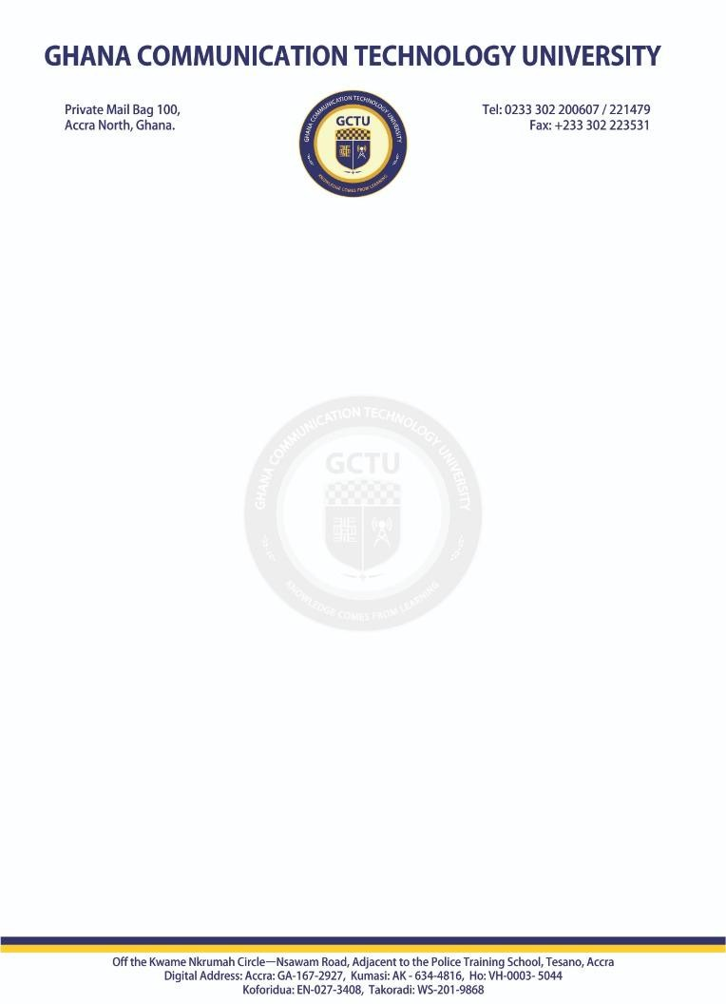


21st July,2025

To WHOM IT MAY CONCERN

Dear Sir/Madam,
FOR INDUSTRIAL ATTACHMENT
I write to formally introduce to you Mr. Ashong Abdallah. Mr. Ashong is a level 300 student at the Ghana Communication Technology University (GCTU), offering a Bachelor of Science Programme in Information Technology and has expressed interest for an opportunity to undergo his industrial attachment in your organization.

As part of the requirements for the award of the degree, students are encouraged to undertake an attachment during vacations with well-established organizations either in or outside the country for a period of two to three months.
This attachment program is to enable students gain professional work experiences, develop and refine new skills, and to serve as a bridge between academia and industry in developing programs to meet the needs and demands of the industry.
I would be grateful if you could kindly offer Mr. Ashong Abdallah the opportunity to enable him serve and prepare for the job market.
Please contact Mr. Ashong on 055 535 9339.
For further information, kindly contact the Industrial Liaison Department at ild@gctu.edu.gh

Thank you Sincerely,

Sandra Emefa Seke (Ms.)
For: Head, Industrial Liaison Department

