Dream Designer Manual
Revision 1.3
Copyright © 1997 – 1999 Dream Company

TABLE OF CONTENT

Introduction 2
Quick Start 3
Which Designer Is Right For You 3
Specifying the Designed Object 4
Designing Forms 4
Designing Data modules 4
Designing a part of the form 4
Switching between design and run time 5
With Hot Keys 5
With Caption Button 5
By Modifying Active Property 6
Taking Some Actions When The User Switches Between Design And Run Time 6
Updating Controls When The Switch Is Performed 7
NeedRecreateWnd property 7
UpdateDisabledControls procedure 7
Storing Changes 7
Automatic Changes Storing 8
Storing In A Custom Storage (2.56B3 and later) 8
TDCChangesStore component 9
TDCPropStore component 10
Appearance at Design Time 10
Grid 10
Enabling And Disabling Grid 10
Grid Step 10
Automatic Alignment To Grid 11
Component Captions 11
Component Palette 11
Object Inspector 11
Alignment Palette 12
Popup Menu 13
Limits and Security 13
Component Level Limits 13
Action Limits. Enabling and Disabling Actions. 13
Preventing Users From Modifying Properties 14
Specifying Read-only Properties 14
Specifying Hidden Properties 15
Global Limits 16
Insert and Delete limitations 16
Handling actions events 16
Locking controls 17
How to specify parameters that will be common for all designed components 17
Securing Name Property 17
Common methods 18
Loading and Saving Forms 18
With TDreamDesigner (2.56B3 and later) 18
With TCompFiler 18
Loading and Saving Form Sections 19
With TDreamDesigner (2.56B3 and later) 19
With earlier versions of Dream Designer 20
Working with Clipboard 20
Undo/Redo 21
Managing Components’ Appearance At Design Time 21
Standard Designing Methods 21
Standard Designing Dialogs 21
Align Dialog 22
Size dialog 23
Scale Dialog 24
Tab Order 25
Creation Order 25
Using Custom Components In Designer 26
Registering VCL and Dream Components 26
Registering Components Manually 27
Components’ Icons On The Palette 27
Custom Menu Items In Popup Menu 28
Using Delphi and C++ Builder Packages 29
Component Palette 31
Designer events 32
Integration with other Dream products 33
Integration with Dream Scripter 33
Integration with Dream Inspector 33
Integration With Dream Tree 33
Advanced Designers 34
Integration Example 35

Introduction

Dream Designer is a pack of powerful components that allows you to modify forms, reports and data modules at run-time. No recompilation or extra coding is required – all you have to do is to put a TDreamDesigner component on the form and run the application. Then you will be able to switch to design time by pressing a hot key and make changes to a form or report and to the components, placed there. The changes can be saved so that the next time you run the application, designed form will look the same as you left it at the previous time.

Dream Designer does not require any additional tools or applications to switch between run and design time and to modify forms, reports and data modules. End users do not need Delphi or C++ Builder installed on their computers, or any extra DLLs to use Dream Designer. It means that Dream Designer has its own design mode that has all designing features of standard Delphi Designer. Moreover, Dream Designer is capable of working with ActiveX controls – as easy as with usual ones!

Dream Designer can be used independently, but its abilities become much more powerful, if it is used with Dream Scripter, Dream Inspector, Dream Memo and Dream Tree. In this case you will be able not only to change the forms and reports, but also to modify their behavior at run-time by changing code of event handlers.

Dream Designer pack includes Dream Common Library that contains a lot of powerful components and controls and the number of useful classes, types, procedures and functions that can be used in your applications.

The best way to feel the strength of different Dream products is to run our demo application – Instant Report that is created only with standard Delphi and Dream components (you can find Instant Report in the \INSTANT folder of your installation).

Quick Start

Now we are ready to create the first application with Dream Designer. Put a TDreamDesigner component on the main form and run the application. Then, at run-time press Ctrl-F12 key and the main form will go to design mode. Now you have all designing tools that can be found in Delphi IDE. You will be able to modify any components and controls, placed on the form. After you have finished designing you can switch back to run-time. To do so simply press the hot key – Ctrl-F12 (this is the default hot key that can be changed). In this way your users will be able to customize any form, data module or report in your application.

That was only a simple example that lets you to feel the power of Dream Designer. After getting acquainted with Designer you have to understand how it works, to learn its properties and methods. So, we are going to explore Dream Designer step by step.

Which Designer Is Right For You

Dream Designer pack includes two types of designers – full (TDreamDesigner, TDCScriptDesigner, TDCMemoScrDesigner) and light versions (TDCLiteDesigner, TDCLiteScriptDsgn, TDCLiteMemoScrDsgn). Both versions are very similar and have the same functionality. All tasks can be solved with full designers as well as with light ones. But there are several differences between them. Here are they:

- Full designers (TDreamDesigner, TDCScriptDesigner, TDCMemoScrDesigner) automatically use units where standard VCL and Dream components are registered (so that they become available at design time and appear on the component palette);
- Full designers automatically use Dream Inspector, but when working with light versions you have to link it up manually;

Please note that executables become rather large if VCL components are linked. But sometimes it is not necessary to use all the components, so you may wish to register only some of them. In this case you should use light versions of Designer that do not register any components. It means that you have to register components, component and property editors, which you are going to use at design time by yourself (please refer to Using Custom Components In Designer chapter for the detailed information).

Important: this manual contains a number of different examples that describe the most significant points. Mainly TDreamDesigner is used in these examples. Yet they also concern any other designers (full and light versions), if opposite is not specified.

Specifying the Designed Object

Designing Forms

By default Dream Designer works with the form or data module where it is placed. You can change the form that will be designed using DesignedComponent property. Please note, that Delphi does not allow specifying a form in this property at design time. Therefore if you need to design another form put there any component and specify it in the DesignedComponent property. This limit concerns only working at design time – at run time it is possible to specify a form in the DesignedComponent property.

For example, put a TDreamDesigner component on one form, create another form and place there a button. Specify this control in DesignedComponent property – now designer will work with the second form. And don’t forget to go to File | Use Unit in the main menu and select there a unit where the designed form is declared (so that Designer will be able to access another form).

Designing Data modules

Dream Designer can also design data modules and components, placed there (although data module is not a visual form). Create a data module and put there TDreamDesigner component. As you know if no component is specified in the DesignedComponent, then designer works with the module, where it is placed. But, data module is not a visual form therefore you will not be able to start designing it by pressing a hot key. You’ll need to assign True to the Active property of designer manually. Besides that you can put a Designer on a visual form and use DesignedComponent property to specify there any component from the data module. In this case you will be able to use the hot keys to switch between design and run time.

Designing a part of the form

Sometimes it is necessary to define controls that cannot be modified at design time. So you can limit designing to the interior of some control, for example, to a panel (TPanel). If such control is defined in LimitControl property, then the users will be able to modify only those components that are placed on it. Other controls that are situated outside the limit control will not be editable.
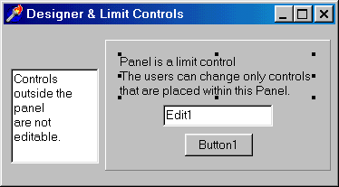
So, place a TPanel control on the form and make sure that controls that can be edited by the users are situated within this Panel. Then specify it in the LimitControl property of TDreamDesigner. That’s all you have to do to restrict the controls that can be modified at design time.

Please note that you cannot limit changing of components in the way described above, because components do not have a parent control. But the solution for the components also exists – assign False to the ShowComponents property of Designer if you do not want components to be shown at design time. You may also use LimitInfos property of Designer that is discussed in Limits And Security chapter.

Switching between design and run time

With Hot Keys

As mentioned above, users can switch to design time by pressing a hot key. The default hot key is Ctrl-F12 but you can customize it, using StartHotKey and StopHotKey properties of Dream Designer. The StartHotKey determines the hot key that will be used to go to the design time, StopHotKey – back to run time. Of course you can disable entering design mode by hot key – just assign None to StartHotKey property.

With Caption Button

Users can also use Caption Button to switch between run time and design time. Caption Button is a small button situated on the caption bar of the windows near standard Minimize, Maximize and Close buttons. It “works” both at design and at run time allowing to switch easily between two designer modes. To turn Caption Button on assign True to UseCaptionButton property.

The glyph that is displayed on the Caption Button can be changed. To specify it use CaptionGlyph property.

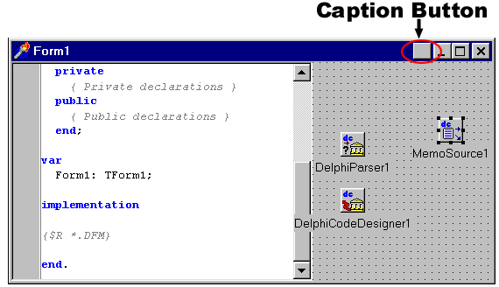

By Modifying Active Property

You can switch to design time also using Active property of TDreamDesigner. Assign True to Active property of TDreamDesigner to go to design time and False to go back to run time:

procedure TForm1.Button2Click(Sender: TObject);
begin
DreamDesigner1.Active := True;
end;

So, you can create a button (something like “Switch to design time”) and use the above method to handle its OnClick event. You can also use Active property to determine the current mode of Designer.

Taking Some Actions When The User Switches Between Design And Run Time

Sometimes it is necessary to take some actions when the user goes from design to run time and back. You may react on that by handling OnActiveChanged event that is fired when Designer changes its mode. Here is an example of an event handler:

procedure TForm1.DreamDesigner1ActiveChanged(Sender: TObject);
begin
If DreamDesigner1.Active then
ShowMessage('You have switched to design time.')
else
ShowMessage('You have switched to run time.');
end;

This procedure displays a Message Dialog when the user switches between design and run time. As you see, Active property is used to determine the current mode of Designer.

Updating Controls When The Switch Is Performed

When the user switches from run time to design time controls placed on the designed form need to be updated. For example, some controls can be invisible at run time (their Visible property is False) but certainly they have to become visible at design time (otherwise users would not be able to modify them). Disabled controls have also to be updated when the user goes to design time.

NeedRecreateWnd property

This property determines whether controls are updated when the designer mode is changed. By default this property is True. In this case the designed form is recreated.
But if there are lots of controls placed on the designed form then it may flicker during updating. In this case you may assign False to NeedRecreateWnd property and use the next procedure.

UpdateDisabledControls procedure

Call this procedure to update all disabled controls (which Enabled property is False) placed on the designed form. It is recommended to call UpdateDisabledControls when you need to change only the state of disabled controls. You should use this procedure only when NeedRecreateWnd is False.

Here is an example how to update disabled controls when the form goes to design time:

procedure TForm1.DreamDesigner1ActiveChanged(Sender: TObject);
begin
with DreamDesigner1 do
if not NeedRecreateWnd then
UpdateDisabledControls(Self);
end;

Please note that UpdateDisabledControls procedure is declared in dcgen unit, so you have to add it to the uses section of the unit, where this procedure is called.

Storing Changes

Go to design time, make changes to a form, then go back to run time and close the application. You certainly expect that the next time you run this application the designed form will look like you “left” it, and all the modifications you have done will not be lost.

There are several ways to “remember” changes that users make to a form. It is possible to store the changes of a whole form, or of its part. You may change the storage type (e.g. registry, disk file system or database fields), implement custom storing methods, etc. These questions will be discussed in the following chapters.

Automatic Changes Storing

In order to make Designer store changes you have to assign True to its StoreChanges property. In this case changes data will be stored in the system registry with the registry key, specified in ChangesKey property (if the registry key is not specified then the information is saved with an automatically generated one).

If StoreChanges is False then modifications that users make to the form will not be saved when the application is closed.

Storing In A Custom Storage (2.56B3 and later)

Changes can be saved and loaded not only from the registry, but also from files, streams, or, for example, from database fields. To change the type of storage you have to handle OnSaveChanges and OnLoadChanges events of Designer. Here is an example, how to store and retrieve changes from the disk file:

procedure TForm1.DreamDesigner1SaveChanges(Sender: TObject;
var processed: Boolean);
begin
DreamDesigner1.Changes.SaveToFile('changes.dat');
processed := True;
end;

procedure TForm1.DreamDesigner1LoadChanges(Sender: TObject;
var processed: Boolean);
begin
DreamDesigner1.Changes.ApplyFromFile(Form1, 'changes.dat');
processed := True;
end;

ApplyFormFile method loads the form, specified by the first parameter, from the file, specified in the second one. Do not forget to assign True to Processed flag, if you perform saving or loading. Otherwise data will be loaded or saved to its default storage – to the system registry. To allow default processing set Processed flag to False.

Here is another example that shows how to load and save information about form changes to a stream:

procedure TForm1.DreamDesigner1LoadChanges(Sender: TObject;
var processed: Boolean);
var MyStream : TFileStream;
begin
MyStream := TFileStream.Create('c:\changes.dat', fmOpenRead);
try
DreamDesigner1.Changes.ApplyFromStream(Form1, MyStream);
finally
MyStream.Free;
end;
processed := True;
end;

procedure TForm1.DreamDesigner1SaveChanges(Sender: TObject;
var processed: Boolean);
var MyStream : TFileStream;
begin
MyStream := TFileStream.Create('c:\changes.dat', fmCreate);
try
DreamDesigner1.Changes.SaveToStream(MyStream);
finally
MyStream.Free;
end;
processed := True;
end;

In this example we’ve used ApplyFromStream and SaveToStream procedures to operate with streams.

TDCChangesStore component

This component comes with Dream Designer pack. It allows to save and to restore the state of the form and components placed on it. No coding is required to use TDCChangesStore. You only have to put it on the form and all changes will be automatically saved to the registry or custom storage.

For example, the user can change the size of position of a form or, for example, type some text in the memo. When the form with TDCChangesStore is closed then the changes are saved in the storage. And the next time when the user runs the program the form and all its components will be in the same state as they were at the previous time (including size, position, text in memo and other properties).

TDCChangesStore can be very useful when working with Delphi 4 and C++ Builder 4 toolbars (that have docking feature). Unfortunately Delphi does not provide any tools to save the position and state of such toolbars. TDCChangesStore component successfully solves this problem. It “remembers” everything about the forms including the information about toolbars position and their docking state.

Please note that TDCChangesStore does not require Designer component placed on the form. It means that in order to use it you do not need to put, for example, TDreamDesigner on your form.

Important: TDCChangesStore component as well as Designer store not the whole form but only the difference between its initial and ending states. Therefore the size of the stored information is quite small.

TDCPropStore component

This component allows specifying properties that are to be saved in the registry. It works in the similar way to TDCChangesStore component but programmers can choose which properties of which components have to be saved. You can specify these properties at design time using a handy editor (right click on the TDCPropStore component and select Edit Property List menu item).

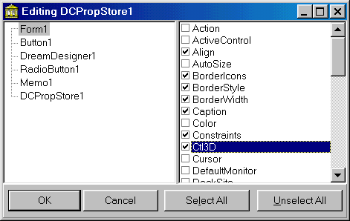

Appearance at Design Time

Dream Designer supports all features of standard Delphi Designer. Users can modify forms and components like they would do that in Delphi. Dream Designer can show component palette, alignment palette, different designing dialogs, object inspector, grid, etc. in the same way as Delphi IDE does it. Let’s explore how to customize designer appearance.

Grid

Enabling And Disabling Grid

ShowGrid property determines, whether the grid will be shown at design time. The default value of this property is True, but if you do not want the grid to be displayed on the designed form, assign False to this property.

Grid Step

You can modify the grid step – the space between the next dots. Horizontal grid step is stored in the GridStepX property, the vertical one – in the GridStepY. The default value of the both grid steps is 8. They can be changed from 2 to 127.

Automatic Alignment To Grid

SnapToGrid property determines whether the components placed on the form are automatically aligned to the grid (when moved/resized by the mouse or inserted into the form). By default this property is True. But if you want to disable this feature you may assign False to SnapToGrid property.

Component Captions

Normally, captions of components, placed on the form, are displayed at design time. However you can hide them, setting ShowCaptions property to false.

Component Palette

By default at design time Dream Designer shows the component palette (like in Delphi) with all registered components. This feature is disabled, if ShowPalette property is False.

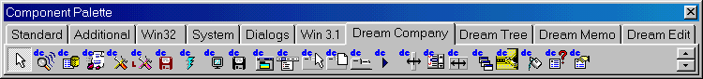

Please note that by default TDCLiteDesigner does not display any components on the component palette. In order to make components visible on the palette you need to register them. Please refer to Using Custom Components In Designer chapter for the registration process description.

Object Inspector

Dream Designer is capable of working with Object Inspector at design time. We offer a convenient and professionally designed Object Inspector – Dream Inspector. No extra coding is required to use Dream Inspector together with Dream Designer (see Integration With Other Dream Products chapter for more detailed information).

Please note that you have to add inspunit to your project in order to use Dream Inspector form with TDCLiteDesigner.
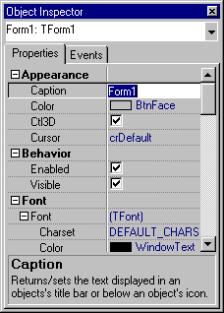

ShowInspector property determines whether the Object Inspector is displayed at design time. By default it is True, but if you want to disable usage of Object Inspector assign False to this property.

Despite Dream Company provides an Object Inspector form (it comes with Dream Designer package) you may wish to develop custom Object Inspector form and use it with Dream Designer. To do so you have to add custom Object Inspector form to your project and implement the following handler for the OnSelectionChanged event of Designer component:

procedure TForm1.DreamDesigner1SelectionChanged(Sender: TObject);
begin
OIForm.ObjectInspector1.CurrentControls:= DreamDesigner1.Designer.SelectedComponents;
end;

Alignment Palette
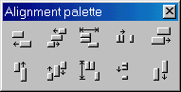
Alignment palette (similar to one that can be found in Delphi) can be displayed at design time. To make it visible, assign True to the ShowAlignPalette property of Designer. The default value of this property is False, so alignment palette is not shown.
To add alignment palette to a project that uses TDCLiteDesigner you have to add aligunit to your uses section.

Putting Tools Windows On Top

If you want Object Inspector, Component Palette and Alignment Palette windows to be displayed over the designed form and other windows (on the top) then assign True to the ToolsOnTop property of designer. By default this property is False.

Popup Menu

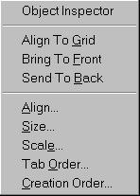By default Dream Designer can display a popup menu at design time (as in Delphi). It allows performing the most commonly used operations with the components placed on the designed form. If you have worked with standard Delphi designer you can see that the Dream Designer popup menu features are almost the same as the Delphi ones.

You can use your own popup menu that has to be specified in the PopupMenu property of Dream Designer. If UseDefaultMenu property is True then custom popup menu is merged with the standard one. But if UseDefaultMenu property is False then Designer displays only custom popup menu (of course, if it is specified in the PopupMenu property). Moreover, Popup menu includes items that are used to activate registered Component Editors.

Limits and Security

In this section we will discuss how to prevent users from modifying forms, components and controls, how to disable some commonly used actions, etc. Limits and Security section will help you to organize your application in the most effective and safe way, so that the end users will not be able to do some unwanted operations.

Component Level Limits

Component level limits can be specified with LimitInfos property of Designer. This property contains a collection which elements store limits for components and controls placed on the designed form. The component for which the limits are applied is defined in the Component property of the LimitInfos items (you can add, delete and move items in collection editor).

Note: despite Delphi 2 and C++ Builder 1 do not provide any collection editor, you can use one that comes with Dream Tree. But you also need Dream Inspector to work with Dream collection editor.

Action Limits. Enabling and Disabling Actions.

Actions are the frequently used operations that can be performed with a component at design time. The table listed below contains the list of possible actions. You can disable one or several actions from this list assigning False to the elements of AllowedAction property.

Action Type | Meaning
atSelect | user selects a component
atDelete | user deletes a component
atInsertInto | user inserts a component
atMove | user moves a component
atResize | users changes component’s size
atShow | component is shown at design time
atEdit | user is about to change the properties of a component

Take a look at the following example. If such code is implemented then the users of your application will not be able to delete the Button1 control from the designed form:

var Item : TLimitInfoItem;
begin
Item := TLimitInfoItem (DreamDesigner1.LimitInfos.Add);
with Item do
begin
Component := Button1;
AllowedActions := AllowedActions - [atDelete];
end;
end;

In such way you can disable or enable other actions.

Preventing Users From Modifying Properties

Dream Designer is a powerful tool that can change visualization and behavior of the forms. Therefore, you may need to disable changing of some properties of important components (such as DataSets, for example) to keep them away from changes that users can make. There are several solutions for this task. One of them is to use the LimitInfos property of Designer, the second one – to handle its OnAction event. Perhaps the first way is easier, because it requires no coding. We will discuss both of them.

Specifying Read-only Properties

Take a look at ReadOnlyProps property of LimitInfos items. It stores the TStrings object that contains the names of the properties that cannot be modified in Object Inspector. You can access this property both at design and at run time and operate with it as with usual TStrings object.

Follow these steps to specify read-only properties:

- Add an item to the LimitInfos property of TDreamDesigner;
- In the Component property specify the modified component (in this example Button1);
- Press ellipsis button – you’ll get to the String list editor;
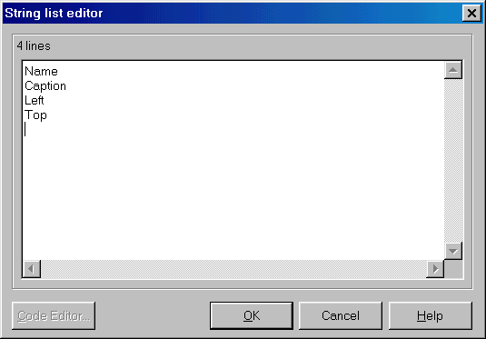
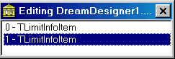
- 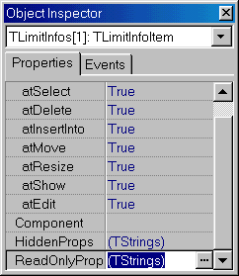Add there the names of the properties that you want to be read-only;

In this example we have assigned read-only status to the Name, Caption, Left and Top properties of the Button1.

You can also handle OnEditProperty event to prevent users from changing of some properties in Object Inspector.

Example:

procedure TForm1.DreamDesigner1EditProperty(Sender, Instance: TObject;
const PropName: String; var AllowEdit: Boolean);
begin
if (Instance is TButton) and (PropName = 'Caption') then
AllowEdit := False;
end;

You may implement this code if you do not want to give the users an ability to change Caption property of the Buttons (TButton) that are placed on the form..

Note, in this event handler you can implement some algorithm that determines which properties of which components can be edited.

Specifying Hidden Properties

You can specify properties that will not be shown in Object Inspector at all. There are two ways to do that – one of them is to modify HiddenProps property and another one is to handle OnShowProperty event. After you have got familiar with making properties read-only it will not be difficult to make them hidden, because these routines are almost the same.

So, find HiddenProps property of a LimitInfos item. It stores a TStrings object that contains the names of the hidden properties – one in each line. Specifying hidden properties is not different from specifying read-only properties – use strings editor at design time or work with HiddenProps as with usual TStrings object at run time.

Handling OnShowProperty event can also solve the same task. You may process it if you do not want some properties to be displayed in Object Inspector.

procedure TForm1.DreamDesigner1ShowProperty(Sender, Instance: TObject;
const PropName: String; var AllowShow: Boolean);
begin
if PropName = 'Caption' then
AllowShow := False;
end;

If you will use this procedure to handle OnShowProperty event then Caption property will not be displayed in Object Inspector.
Global Limits

Dream Designer offers several ways to limit changing of all components and controls placed on the form. This section describes how to specify such global limits.

Insert and Delete limitations

You can prohibit inserting or deleting components from the form or report using Options property. If fdAllowDelete is False, then the users will not be able to delete components and controls. If fdAllowInsert is False, then no new component can be placed on the form. As you see, if both of the mentioned elements are set to False, then components can be neither inserted nor deleted.

Handling actions events

Dream Designer has OnAction event, which is fired when some action is being performed with a component or control. You may handle it to disable or enable some of these actions or to implement some other reaction.
Please note that if an action is applied to several components together then OnAction event is fired for each one.

procedure TForm1.DreamDesigner1Action(Sender: TObject; Instance: TPersistent; Action: TActionType; var Allow: Boolean);

Handling procedure has four parameters:

- Sender – Designer that called event;
- Instance is a component for which the action is applied;
- ActionType defines what type of action is going to be applied to a component (meaning of the ActionType parameter is described in the table, mentioned above);
- Allow is used to return the permission to apply the action of the specified ActionType. Assign False to this parameter if you want to disable the action.

See the following example to understand better how to handle OnActionEvent:

procedure TForm1.DreamDesigner1Action(Sender: TObject;
Instance: TPersistent; Action: TActionType; var Allow: Boolean);
begin
Allow := not (Action in [atDelete, atResize, atInsertInto]);
end;

This handling procedure prevents users from deleting and resizing of the existing components and from inserting the new ones.

Please note that if ActionType is atInsertInto (component is inserted) then Instance parameter contains the control where the component is inserted (for example, a Panel). So you can disable to insert component in the certain control.

For example:

procedure TForm1.DreamDesigner1Action(Sender: TObject;
Instance: TPersistent; Action: TActionType; var Allow: Boolean);
begin
if (Instance=Panel1) and (Action=atInsertInto) then
Allow := False;
end;

If this code is implemented then the user won’t be able to insert any controls to the Panel1.

Note that if atEdit action is disabled then the users will not able to modify any properties of this component. But still it can be deleted.

Locking controls

LockControls property can be used to secure all components on the designed form in their current position. If LockControls property is True then no component can be neither moved nor resized with the mouse. But if Left, Top, Width or Height properties are changed manually (e.g. in Object Inspector), then the corresponding component changes its appearance.

How to specify parameters that will be common for all designed components

Sometimes you need to specify limits that will be used for all components and controls that are placed on the designed form. You can assign the common list of the same allowed actions, hidden and read-only properties To do that you can use AllowedActions, HiddenProps and ReadOnlyProps properties of DreamDesigner.

For example:

DreamDesigner1.AllowedActions := DreamDesigner1.AllowedActions –[atResize];

If this code is implemented then the users will not be able to resize controls on the designed form.

Securing Name Property

Quite often it is necessary to prevent users from changing Name property of the components and controls. Certainly, you can prevent it from modifying with one of the ways described above. But there is a handy property that can be used to make Name property read-only.

So, assign True to NameIsReadOnly property of Designer and the users will not be able to change the Name property of any component or control placed on the designed form.

Common methods

There are several methods designed to perform some common actions with the components (such as working with ClipBoard). They can be used in your applications that work with Dream Designer. So let’s talk about them and understand how and when they are to be called.

Loading and Saving Forms

Dream Designer can save and load forms. Moreover, it uses standard Delphi and C++ Builder format – DFM that allows exchanging forms between Dream Designer and these Inprise applications.

With TDreamDesigner (2.56B3 and later)

You can use

- LoadFromFile to load form or datamodule from the file;
- LoadFromStream to load form or datamodule from the stream;
- CreateFromFile creates form or datamodule from the file;
- CreateFromStream creates form or datamodule from the stream;
- SaveToFile to save form or datamodule to the file;
- SaveToStream to save form or datamodule to the stream.

For example:

DreamDesigner1.SaveToFile(‘myform.dfm’);

This call saves the currently designed form to the ‘myform.dfm’ file.

MyForm := DreamDesigner1.CreateFromFile(‘myform.dfm’, TForm);

This call creates a form from the ‘myform.dfm’ file. You can access it trough MyForm variable.

With TCompFiler

In earlier versions of Dream Designer (before 2.56B3) there were no such methods for saving and loading form as described above. However if you have an earlier version of Dream Designer then you can use TCompFiler to perform the same loading/saving operations. The following example (it can be found in the \COMPFILER folder) shows how to load and save forms through TCompFiler:

DreamDesigner1.Designer.CompFiler.LoadFromFile('myform.dfm', Form2);

Loads Form2 from ‘Test.dfm’ file.

DreamDesigner1.Designer.CompFiler.SaveToFile(''myform.dfm', Form2);

Saves Form2 to ‘Test.dfm’ file.

You can also use the following methods of TCompFiler to load and save forms:

- LoadFromStream to load form or datamodule from the stream;
- CreateFromFile creates form or datamodule from the file;
- CreateFromStream creates form or datamodule from the stream;
- SaveToStream to save form or datamodule to the stream.

Loading and Saving Form Sections

You can also load and save parts of the forms. For example you can save a panel with all controls placed within it.

With TDreamDesigner (2.56B3 and later)

Beginning from version 2.56B3 you can use the following methods:

- LoadComponentFromFile loads a component from file;
- SaveComponentToFile saves a component to file;
- LoadComponentFromStream loads a component from stream;
- SaveComponentToStream saves a component to stream.

Here is an example of loading and saving routines:

procedure TForm1.ButtonSaveClick(Sender: TObject);
begin
if SaveDialog1.Execute then
DreamDesigner1.SaveComponentToFile(Panel1, SaveDialog1.FileName);
end;

procedure TForm1.ButtonLoadClick(Sender: TObject);
begin
if OpenDialog1.Execute then
DreamDesigner1.LoadComponentFromFile(Panel1, OpenDialog1.FileName);

end;

These procedures display Open or Save dialogs respectively and load or save Panel1 and all controls within it to the chosen file.

With earlier versions of Dream Designer

If you have an earlier version of Dream Designer then you can use loading and saving procedures, which are implemented in the example that can be found in the \COMPONENTSAVE folder.

Working with Clipboard

Dream Designer uses the same format for the components being placed and pasted from the clipboard as Delphi and C++ Builder (text format). It means that you can copy components from a form, designed with Delphi Designer, to one, designed with Dream Designer and vice versa through the clipboard. For example go to design time with Dream Designer, select a component, copy it to the clipboard, then switch to Delphi and paste it – the component will appear on the form, designed in Delphi.

You can use

- ClipboardCut to cut the selected component(s) to the clipboard;
- ClipboardPaste to paste component(s) from the clipboard to the designed form;
- ClipboardCopy to copy the selected component(s) to the clipboard;
- DeleteSelectedComponents to delete all selected components.

There are several functions that can be called when determining Enabled state of menu items (from Edit section):

- CanCopy returns True if the component(s) can be copied to the clipboard;
- CanCut returns True if the component(s) can be cut to clipboard;
- CanPaste returns True if the component(s) can be pasted from the clipboard to a form or datamodule.

The following example demonstrates how to work with clipboard:

with DreamDesigner1 do
if Active and CanCopy then
Designer.ClipboardCopy;

This code checks whether Designer is at design mode. If it is, then the selected components are copied to the clipboard. If no component is selected then mentioned methods do nothing.

Undo/Redo

Dream Designer allows to perform the unlimited number of undo/redo operations at design time. Users can make undo/redo simply by pressing the hot key – Alt-BackSpace for undo and Shift-Alt-Backspace for redo.

Please note that you have to assign True to AllowUndo property of designer component in order to enable undo/redo operations.

You can also manage undo/redo from the code by using Undo and Redo methods as it is shown below:

DreamDesigner1.Designer.Undo; //undoes the last operation
DreamDesigner1.Designer.Redo; //redoes the last operation
DreamDesigner1.Designer.UndoAll; //undoes all operations

Managing Components’ Appearance At Design Time

Standard Designing Methods

You can customize the appearance of components using the following methods:

- BringToFront brings the selected component(s) to front;
- SendToBack sends the selected component(s) to back;
- AlignToGrid aligns the selected component(s) to the form’s grid;
- SelectAll selects all the components placed on the designed form;
- Scale scales all controls placed on the form by the specified factor.

For example:

if DreamDesigner1.Active then
DreamDesigner1.Designer.AlignToGrid;

This code checks whether Designer is at design mode. If it is, then the selected components are aligned to the grid.

if DreamDesigner1.Active then
DreamDesigner1.Designer.Scale(2);

This code increases the size of all controls placed on the designed form twice.

Standard Designing Dialogs

Dream Designer includes all standard designing dialogs that can be found in Delphi or C++ Builder IDE (such as Align, Tab Order, Creation Order, etc.). Although these dialogs are automatically included to the Designer’s popup menu they can be called directly from code.

Align Dialog

This dialog allows users to specify components alignment at design time.

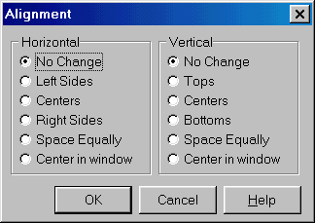

To use it add dcsystem and dalign units to the uses section (dcsystem contains several types that will be used and dalign contains the Align Dialog form).

You may implement the following code to execute Align dialog:

procedure TForm1.Button1Click(Sender: TObject);
Var
HorAlign,VertAlign:TAlignControls;
begin
If DreamDesigner1.Active then
If AlignWasChanged(HorAlign,VertAlign) then
DreamDesigner1.AlignSelected(HorAlign,VertAlign);
//….
end;

This code checks whether Designer is at design mode and, if so, calls AlignWasChanged function, which shows Alignment dialog. Two parameters are passed to it, they are used to return alignment parameters:

- HorAlign will contain horizontal alignment for the component(s);
- VertAlign will contain vertical alignment for the component(s).

If the user presses Ok button then alignment is applied to the selected component or control.

Here is the table that describes the possible values of HorAlign and VertAlign parameters.

Value | Meaning
AcNoChange | No changes to alignment is selected by the user
AcLefts | Alignment by the left side is selected
AcTops | Alignment by the top is selected
AcCenters | Alignment by the center is selected
AcRights | Alignment by the right side is selected
acBottoms | Alignment by the bottom is selected
acSpaceEqually | Alignment by equal spaces is selected
acCenterInWindow | Alignment by the center of window is selected

AlignWasChanged function returns True if the user presses OK button; otherwise it returns False.

Size dialog

You can call Size dialog to allow the user to adjust size of different components quickly and easily. To use this dialog you have to add dcsystem and dsize units to the uses section.

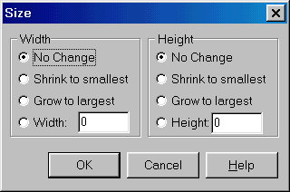

Here is an example of how to execute Size dialog:

procedure TForm1.Button1Click(Sender: TObject);
Var
xsizechange, ysizechange:Integer;
begin
if Dreamdesigner1.Active then
If SizeWasChanged(xsizechange, ysizechange) then
DreamDesigner1.SizeSelected(xsizechange, ysizechange);
// …

end;

XSizeChange and YSizeChange are used to determine what the user selected in the dialog. The possible values of these parameters are:

Value | Meaning
scNoChange | No changes are selected
scShrinkToSmallest | The control is to shrink to the size of the smallest control placed on the designed form
scGrowToLargest | The control is to grow to the size of the largest control placed on the designed form
any other positive values | Width and Height values, entered in the corresponding fields

SizeWasChanged returns True, if the users presses OK button; otherwise it returns False.

Scale Dialog

Scale dialog allows users to modify size of different controls at design time.

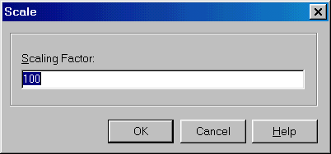

To use Scale dialog you have to add dcsystem and dcinpfrm units to the uses section and implement the code that executes the dialog.

Here is an example of such code:

procedure TForm1.Button1Click(Sender: TObject);
Var
Factor:Extended;
begin
if Dreamdesigner1.Active then
If ReadScaleFactor(Factor) then
GetActiveDesigner.Scale(Factor);
// ...
end;

This code checks the Designer’s mode. If it is a design time then Scale dialog is executed. Factor parameter is used to return data – it specifies the scaling rate. Please note that if the users enters, for instance, 200, then Factor will be equal to 2 and so on. I.e. Factor value is 100 times smaller than the value entered by the user in the Scale dialog.

Tab Order

This dialog allows the user to change the tab order of the controls at design time.

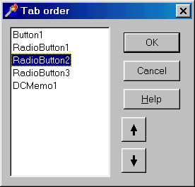

To call it you can use the following code:

if DreamDesigner1.Active then
ChangeTabOrder (DreamDesigner1.Designer.GetTabOrderControl);

This code executes ChangetabOrder form if Dream Designer is at design mode.

Important: Tab Order and Creation Order forms come with Dream Tree. So you will not be able to use it if you do not have Dream Tree installed. In order to use Tab Order and Creation Order dialogs you should add treemod unit (it contains these forms) to the uses section.

Creation Order

This dialog allows the user to change the creation order of the components at design time.

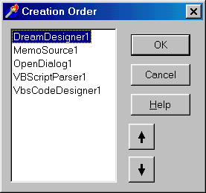

To call it you can use the following code:

if Dreamdesigner1.Active then
ChangeCreationOrder(DreamDesigner1.Designer.OwnerControl);

This code executes ChangetabOrder form if Dream Designer is at design mode.

Important: Tab Order and Creation Order forms come with Dream Tree. So you will not be able to use it if you do not have Dream Tree installed. In order to use Tab Order and Creation Order dialogs you should add treemod unit (it contains these forms) to the uses section.

Using Custom Components In Designer

If you want to use different VCL and custom components with Dream Designer you have to register them. All registered components will be displayed in the Component Palette.

Registering VCL and Dream Components

If you are using TDreamDesigner then you do not have to register standard VCL and Dream Controls by yourself. TDreamDesigner uses vclstdreg and dcreg units, which automatically register these components. TDCLiteDesigner does not register any components (that’s why Component Palette is empty when working with TDCLiteDesigner). However, you can add vclstdreg unit to your project and standard VCL components will be registered.

Dream Designer pack includes several units that automatically register different components, component and property editors. Here is the table that explains which components are registered in which unit:

Folder | Unit | Components
\units | vclstdreg | VCL
\units | vcldbreg | Data Access, Data Controls
\units | vclqrreg | Quick Report
\vclreg | vcldssreg | Decision Cube
\vclreg | vclteereg | Tee Chart
\units | dcconfig | Dream, VCL, Quick Report, Client-Server, DataBase
\units | dcreg | Dream And VCL

Please note that almost all component and property editors that can be found in Delphi are implemented in Dream Tree.

For example, you need to use VCL, Dream and Quick Report components with TDCLiteDesigner. In this case you have to add to your project the following units:

- vclstdreg;
- vclqrreg;
- dcreg.

Registering Components Manually

Of course it is very convenient to use regsitration units. They allow to register frequently used components quickly and easily. But sometimes you need to allow the user to use only few components, or may be, some custom components. In this case you have to register components manually. Registration routine is quite simple and does not differ from the one used in Delphi.

First of all you have to include units where the components are declared to the unit where the registration is performed. Then you may call RegisterComponents procedure like it is shown below:

RegisterComponents('Sample Page', [TDCScripter, TMemo, TButton]);

This call creates a ‘Sample Page’ sheet on the component palette and registers TDCScripter, TMemo and TButton components there. In such way you can register other components and controls. You can also use another registration procedures with Dream Designer, such as RegisterNoIcon (that registers components but does not add them to the component palette).

It is recommended to call registration methods in the initialization section of your main unit.

Components’ Icons On The Palette

If you register components manually then you have to specify icons that will be displayed on the component palette. To do that you have to include a Delphi Resource file (DCR) with the icons to your project.

Dream Designer pack includes several DCR files that contain icons for Dream components and standard Delphi ones. Here is the list of DCR files with different icons:

Folder | Filename | Content
\units | Dcregbmp.dcr | Dream Components
\units | Vclstdbmp.dcr | Standard Components
\units | Vcldbdbmp.dcr | DB Components
\units | Vclqrbmp.dcr | Quick Report Components
\Vclreg | vcldssbmp.dcr | Decision Cube Components
\vclreg | vclteebmp.dcr | Tee Chart Components
\units | vclwinbmp.dcr | Win32 Components
\units | vclsysbmp.dcr | System Components

To include DCR file to your project add the following line to your main unit:

{$R dcregbmp.dcr}

This adds all icons of Dream Controls to the project.

{$R dcstdreg.dcr}

This adds all icons of Standard components to the project.

Custom Menu Items In Popup Menu

As you know from the PopupMenu chapter Dream Designer has popup menu, which is displayed, when the users clicks the right mouse button at design time. You may register component editors for different components and the corresponding elements will be added to the popup menu. To register component editors you can use standard Delphi procedure RegisterComponentEditor.

You may use the following procedures to register different component and property editors:

- RegisterPropertyEditor (Delphi Standard) allows a component to bring up a custom property editor from the Object Inspector;
- RegisterComponentEditor (Delphi Standard) registers an editor so that it is available at design time;
- RegisterVisualProperty registers additional popup menu item which appears when user right clicks on designed form;
- RegisterComponentAction registers an action for the specified component.

Here is an example how to use RegisterComponentAction:

procedure ShowMsg(Comp : TPersistent);
begin
ShowMessage('Right click on the button.');
end;

procedure TForm1.Button1Click(Sender: TObject);
begin
RegisterComponentAction('Show Message', TButton, ShowMsg);
end;

ShowMsg procedure is registered for TButton control. Now when the user right clicks on the TButton control, then popup menu with ‘Show Message’ item appears. If it is selected then ShowMsg procedure will be called.

Using Delphi and C++ Builder Packages

Packages usage is very convenient when dividing a big application into smaller modules. Really, when distributing applications it is often necessary to give different modules to different users, to produce add-ons, updates, etc. to the existing programs. Such task can be solved in different ways. One of them is to place separate modules into DLL files and to work out complicated interfaces between them and the main application. But why do we need to create DLL files? Why shouldn’t we use Delphi’s native packages?

Yes, there’s no reason not to use packages. Therefore, Dream Company has developed a powerful and easy to use TDCPackageLoader component that allows managing Delphi and C++ Builder packages.

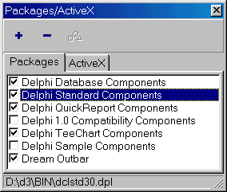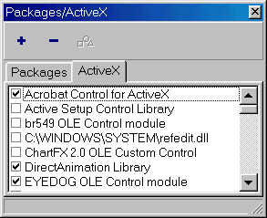

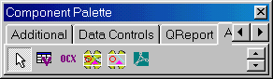

And now let’s explore TDCPackageLoader component. Place TDreamDesigner and TDCPackageLoader components on your form and handle OnActiveChanged event of Designer in the following way:

procedure TForm1.DCLiteDesigner1ActiveChanged(Sender: TObject);
begin
if DreamDesigner1.Active then
ShowPackagesConfig;
end;

If such handler is implemented then Packages/ActiveX form will appear when the user goes to design time and users will be able to add/remove packages and ActiveX controls. All components contained in the added packages will be available on the component palette.

Please note that ShowPackagesConfig procedure is declared in packcfg unit. Therefore you have to add it to the uses section.

There are several methods designed to manage packages that you can use in your code.

First of all you have to register packages you are going to use. To do that you need to call RegisterPackage method of TDCPackageLoader. You have to pass two parameters:

- PackName specifies the name of the package file (with full path);
- ALoad specifies whether the package is loaded or only registered. So, if it is True then package is loaded.

The difference between registered and loaded packages can be understood from the packages form, figured above:

- All packages that are shown in this form are registered;
- Checked packages are loaded.

Function returns the package index if operation is successful; otherwise INVALID_HANDLE_VALUE is returned.

For example:

if DCPackageLoader1.RegisterPackage('c:\mypackage.bpl',True) <> INVALID_HANDLE_VALUE
then ShowMessage('Package registered successfully');

This code registers and loads mypackage.bpl package. If operation is successful then the message box is shown.

To load or unload packages use PackageLoaded indexed property. It contains Boolean values that correspond to the different loaded packages. For example, to unload the package #3 you can use the next code:

DCPackageLoader1.PackageLoaded[3] := False;

The following code loads the package #1:

DCPackageLoader1.PackageLoaded[1] := True;

To unregister package use UnRegisterPackage procedure, specifying the package index (don’t mix up package index with package handle).

For example:

DCPackageLoader1.UnRegisterPackage(1);

Package with index 1 is unregistered.

You can also use UnRegisterPackages procedure that unregisters and unloads all packages. This procedure requires no parameters.

Please note that Package Loader can be used only if application is compiled with run time packages. Please follow the listed below instructions to turn on run time packages:

- Go to Delphi or C++ Builder;
- Select Component | Install Packages from the main menu;
- Mark Build with runtime packages checkbox;
- Make sure that at least VCL40 (VCL30 for Delphi 3, etc.) is specified in the edit control.

Important: TDCPackageLoader cannot be used with Delphi 2 or C++ Builder 1, because these versions do not support packages.

Component Palette

Dream Designer pack includes TDCCompPalette control that provides the component palette. You can put it on your form and all registered components will appear on it automatically. TDCCompPalette is highly customizable – you can easily manage the order of pages, move components from one page to another, manually specify visible and hidden components, make new pages, etc.

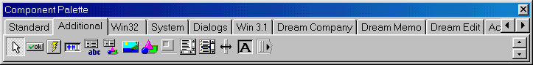

Let’s talk about the main features of TDCCompPalette. Put this control on your form and find OnlyDefinedItems property. If it is True then Component Palette will display only those pages and components that are specified in PredefinedPages property. If it is False then Component Palette will contain both standard pages and those defined in PredefinedPages property.
And now let’s turn directly to PredefinedPages property. It contains the TStrings object with the names of palette pages in each line. If you delete some of these lines then the corresponding pages don’t appear on the palette. Moreover, you can specify which components are placed in which tabs and define new tabs. To do that you need to modify Predefined Pages like it is shown on this picture:

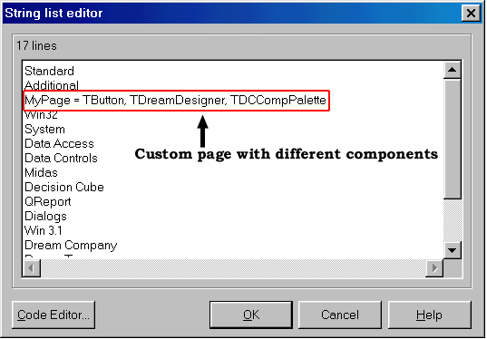

In this case Component Palette will look like:

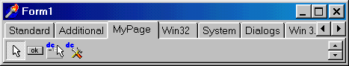

Designer events

OnAfterInsertComponent event is fired after the component was inserted to the form. You can handle this event to take some actions immediately after the component was inserted. For example, you can use this event when implementing a custom component palette to change its status after the component is inserted. Or you can automatically assign “default” values to some properties of the components, when they are inserted.
This small sample will help you to understand better how to handle OnAfterInsertComponent:

procedure TForm1.DreamDesigner1AfterInsertComponent(Sender: TObject;
AControl: TComponent);
begin
if AControl is TLabel then
TLabel (AControl).Font.Size := 12;
end;

This handler checks whether the inserted component is TLabel. In this case it changes Label’s font size, assigning 12 to it. As you see, AControl parameter contains the inserted component.

OnDeleteComponent event is fired when the component is deleted from the form. AControl parameter that is passed to the handler contains the deleted component. Its handling is similar to the OnAfterInsert event’s one.

Integration with other Dream products

As noticed above you can use Dream Designer together with Dream Scripter, Dream Inspector and Dream Tree. So, let’s discuss in details how to integrate different Dream products and how to develop a sample application.

Integration with Dream Scripter

Dream Scripter is a product that allows using Delphi Script, VBScript, JScript, Perl and Python scripting languages in your application. For example, you will be able to write event handlers in JScript, and all Delphi components will be accessible. Moreover, all methods, variables and constants, declared in the main program will be available in the script.

No extra coding is required to use Dream Designer and Dream Scripter. You only have to place both of these components (TDreamDesigner and TDCScripter) and specify the Scripter in the Scripter property of Designer. See the detailed example on how to integrate Dream Designer with Dream Scripter in the Integration Example chapter.

Integration with Dream Inspector

Dream Inspector is a powerful and convenient Object Inspector that can be used together with Dream Designer. It allows editing properties of the components and specify event handlers at design time. No coding is required to use Dream Inspector together with Dream Designer.

Please note that to use Dream Inspector with TDCLiteDesigner you have to add inspunit to your project. TDreamDesigner adds this unit automatically.

Integration With Dream Tree

Dream Tree provides a lot of component and property editors, used in Dream Designer. Among them are ListView items editor, TreeView items editor, ImageList editor, Menu designer, Table and Query fields editors, Query parameters editor, Grid columns editor and more. Besides that property editors for the above-named components are also available. Moreover, Tab Order and Creation Order dialogs come with Dream Tree too. Therefore it is highly recommended to use Dream Designer with Dream Tree.

Advanced Designers

Dream Designer pack includes several advanced designers that combine the functionality of several Dream products in one component. For example, TDCScriptDesigner component integrates Designer and Scripter, TDCMemoScrDesigner – integrates Designer, Scripter and Memo. Light versions of advanced designers are also provided.

So, let’s talk about TDCMemoScrDesigner. This component combines the functionality of Dream Designer, Dream Scripter and Dream Memo. It means that actually you need only one component to implement fully functional IDE environment. To try TDCMemoScrDesigner put it on your form and run the application. Then switch to design time (by pressing the hot key – Ctrl-F12 by default). You will be able to design form, place and delete different components and controls, modify form’s behavior by implementing new event handlers, etc. Memo control that appears when the user switches to design time displays the code implemented for the event handlers. Memo text is highlighted (parser is selected automatically depending on the scripting language that is specified in the Language property of TDCMemoScrDesigner or TDCLiteMemoScrDsgn component) and Code Designers are used to design script code.
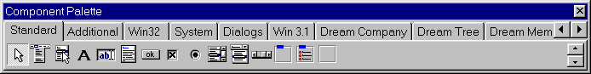
Here is a screenshot that shows the form that is designed by TDCMemoScrDesigner:
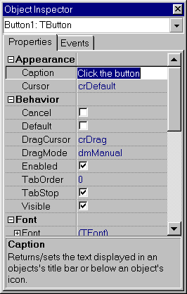
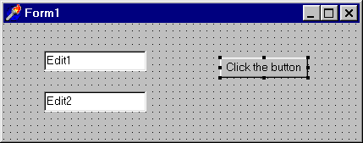
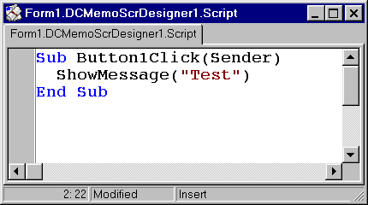

Integration Example

Now we will create a sample application that illustrates how to use Dream Designer together with Dream Scripter, Dream Inspector and Dream Tree. Users will be able to go to design time (no Delphi or C++ Builder is required), modify the form and implement event handlers (using one of the available script languages). In this example we will not use any of advanced designers – so that you will better understand how Dream Designer works together with other Dream products.

Please note that you can find this integration example in the \INTEGRSAMPLE folder.

- Create a new form (Form1) and put there the following components:
- Dream Designer (DreamDesigner1);
- Dream Scripter (DCScripter1);
- VBScript Code Designer (VbsCodeDesigner1).
- Select the Designer (DreamDesigner1) component.
- In Object Inspector find CodeDesigner property and specify the VbsCodeDesigner1 there.
- In the Scripter property specify DCScripter1.
- Then select Dream Scripter (DCScripter1) and specify the script language in the Language property (in our sample, it will be VBScript).
- Create a new form (Form2) and place there a memo control (Memo1).
- In order to make Memo1 accessible from the unit1 (for Code Designer) go to File | Use Unit and add there unit2;
- Select VB Script Code Designer (VbsCodeDesigner1) and modify its properties in the following way:
- Choose a memo form the Form2 in the Link property;
- Select Lines in the PropName property.

After that Code Designer is connected with the Memo control, where the users will be able to enter code.

Now you have to handle two events to secure correct data exchange between the Memo and Scripter. Here are these event handlers:

procedure TForm1.DreamDesigner1ActiveChanging(Sender: TObject;
var AllowChange: Boolean);
begin
if not DreamDesigner1.Active then
begin
Form2.DCMemo1.Lines := DCScripter1.Script;
Form2.Show
end else
begin
DCScripter1.Script := Form2.DCMemo1.Lines;
Form2.Hide;
end;
AllowChange := True;
end;

OnActiveChanging event is called right before designer is goes either to design or run time.

Script code is stored in the Script property of DCScripter1. So, when Designer goes to design time you have to copy the script source to the memo, where it is displayed, and show the form (Form2.Show) with this memo. When Designer goes back to run time, you have to “remember” the script (that could be modified by the user) by copying it from Memo1.Lines to DCScripter1.Script property.

procedure TForm1.VbsCodeDesigner1ShowSource(Sender: TObject; x,
y: Integer);
begin
Form2.Show;
end;

OnShowSource event of Code Designer is fired when designer has to show the script source, for example, when the users double click on some control (a memo with the script has to appear so that the user can implement the handling method there). You have to handle this event to show the form that displays script source code.

Find USES section in the code of your main unit and add the vclimp unit that can found in the IMPORTED directory of Dream Controls. This unit is used to register VCL classes with Scripter, so that VCL will be accessible in scripts.

Place any control on the main form (Form1), for example a TButton. And now we are ready to run the application. Do that and switch to design time (by pressing the hot key, for example). You should see the Form1 with the button and the Form2 with an empty memo. Double click on the button and you will get to the memo, where the handling method is already declared. So you can handle OnClick event of the button in VB Script language. As an example, implement the following code:

Sub Button1Click(Sender)
ShowMessage("Button1 Clicked.")
End Sub

… and go back to run-time. Now click the button and see a message box – just like it had to be.

In such style you can use not only VB Script, but also several other script languages, including JScript, Delphi Script and Perl.

Please note that if you are using Delphi Scripting (with Delphi Code Designer) than you have to assign ModuleOwner property of Code Designer to the designed module.

In the example that was discussed above we have used standard TMemo control. It is recommended to use Dream Memo instead of it. In this case you will be able to use syntax highlighting for different programming languages (as well as other advantages of this really good and convenient memo control). That will make your applications more powerful and attractive for the customers.

