Dream OutBar

Revision 1.5
Copyright © 1998,1999 Dream Company

Introduction 1

TDCOutbar 2

TDCVertListView 4

TDCGroupBar 5

TDCOutHeader 6

TDCHeaderPanel 6

TDCSplitterPanel 6

TDCTranspScrollBar 7

TDCScrollButton 7

Introduction

Have you ever thought what makes customers to buy and to use software? Do you know what makes applications attractive for the users? Yes, great functionality, high productivity, etc… But don’t forget about one very important reason – about nice and user-friendly interface. Really, applications with bad interface will not win the hearts of the customers. Therefore, one of the main tasks that need to be solved by the programmer is to develop a good interface.

Microsoft Outlook is a good example of a good interface. Look at Outlook bar – it is very convenient and easy to use. Maybe the secret of Microsoft Outlook’s popularity is here? Who knows… but there is one thing we are certain in – a lot of programmers dream about a control like Outlook Bar. OK, Dream Company has got something for you.

Dream Outbar is a pack of eight powerful controls that give you new exciting possibilities for creating highly customizable applications with user friendly interface. Product includes the following components:

- TDCOutbar implements functionality of Outlook Bar used in Microsoft Outlook, Microsoft Frontpage and Microsoft Office 2000. It has the same interface and features;
- TDCGroupBar can be considered as an advanced page control with Outlook Bar interface;
- TDCVertListView is a list view with real hottrack and vertically ordered items. TDCTranspScrollBar is a scroll bar that can be transparent and has the hidden thumb;
- TDCScrollButton is a scroll button that can be placed on the form and used without a scroll bar. Different standard Windows glyphs can be displayed in this control;
- TDCOutHeader is a control that implements functionality of the MS Outlook Header;
- TDCHeaderControl allows you to create nice MS Outlook style headers with highly customizable parameters;
- TDCSplitterPanel provides an easy in use horizontal and vertical splitter panels.

With these controls you will be able to create better programs faster and easier! So, let’s explore Dream Outbar step-by-step.

After you have installed Dream Outbar pack you will find a new tab on Delphi component palette – Dream Outbar.

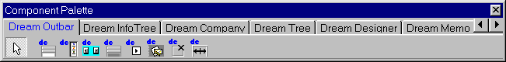

As mentioned above eight new controls will appear there. Among them there is TDCOutbar – an exciting powerful component with interface similar to Outlook Bar. We are going to discuss it now.

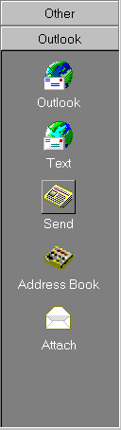
TDCOutbar

To start working with TDCOutbar please follow the next instructions:

- Place TDCOutbar on your form;
- Click the right mouse button on it and select “New group” from the pop-up menu. This will add a new group to the control;
- Add several other groups and run the application.

Now you can taste some features of TDCOutbar. Select different groups and enjoy the smooth movement of their tags. To switch between different groups at design time you can use Next Group and Previous Group menu items from the pop-up menu.

The movement speed can be easily changed. To do this:

- Switch to design time;
- Select TDCOutbar control;
- Find and change Frequency property in the Object Inspector.

The greater value is assigned to this property the slower the tag moves. The minimal value is 0 (groups change immediately), the maximal is 50 (groups change very smoothly).

Captions of the groups can be easily changed. There are several ways to do this. At design time select a TDCOutbarVertListView and press ESC key. This will select a group from TDCOutbar control. Now find Caption property in Object Inspector and change its content.

You can also modify the caption of a group at run-time by accessing directly the Caption property of a group as it is shown below:

DCOutbar1.Groups[0].Caption := 'New Caption';

Use Groups property of TDCOutbar to access a specific group. This is a zero-based array of TDCOutBarGroup objects.
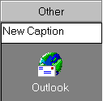

If you want to give the users a possibility to enter groups’ captions manually use EditGroupCaption or EditActiveGroupCaption methods. Both of them display a handy edit control that allows the users to enter new captions for the group at run time. The difference between these two methods is that you have to provide the index of group being edited in the EditGroupCaption and EditActiveGroupCaption modifies the caption of the currently active group.

Most modern applications support hottrack feature. TDCOutbar also has it – the group that is currently pointed by mouse cursor is automatically selected. To turn on hottrack assign True to HotTrack property. The caption of the pointed group may be displayed using the different color. To specify the hottrack color use HotColor property. The color and the space between the group tags can also be changed – use ButtonSpaceColor and ButtonSpace properties.

To add a group at run-time call AddNewGroup method. To delete a group at run-time use RemoveGroup method.

To delete a group at design-time:

- Select the group;
- Press Del key – the selected group will be deleted.

There is a second way to delete a group from the Outbar control:

- At design time select the TDCOutbar control;
- Click the right mouse button and select Delete Group menu item from the popup menu.

TDCVertListView

Now, let’s add items to TDCOutbar. To do that we have to get familiar with TDCVertListView control that is used by TDCOutbar. This control is similar to standard TListView but it has several extra features. First of all, TDCVertListView control uses transparent scroll bar – only scroll buttons are displayed (like in Microsoft Outlook). Besides that, all items are shown vertically. Drag and drop operations are also supported automatically. You can drag items, change their order and even move them from one group to another. Moreover, TDCVertListView can use different background images instead of dull monotonous color!

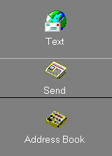

The real hottrack is implemented! The item, currently pointed by the mouse, is drawn on the raised square (not just underlined like in TListView). It looks very cool. Moreover, you can select two types of selection – standard and expanded. Both of them are shown on the screenshots. To choose the selection style use SelectionType property. You can modify this property both at design time and at run time.

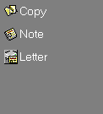Follow next instructions to add items to the TDCVertListView:
- Put two TImageList objects on your form;
- In the first one set Width and Height properties to 16, in the second one – assign 32 to them;
- Add images (at design time select a TImageList object, press the right mouse key and select ImageListEditor item) that will be shown when the view style is “list” to the first ImageList;
- Add images that will be shown when the view style is “icon” to the second ImageList;
- Select TDCOutbar control and find SmallImages and LargeImages properties in Object Inspector;
- Choose the first ImageList (which Width and Height are 16) in the SmallImages property and the second ImageList in the LargeImages.

Images, stored in the LargeImages property will be shown when view style is “icon”, and the small ones – when the view style is “list”. To switch between different supported view styles use ViewStyle property. Note that if you are going to use only one view style (for example “icon”) then you can use only one ImageList and specify it in the corresponding property (for example LargeImages), leaving the second one (SmallImages) empty.

TDCVertListView can use different backgrounds. To specify the background, please refer to BackGround property, that stores the TBitmap object. Background can be displayed in several modes: at the center of listview, stretched to the whole client area of list view and in the tiled mode. To choose the display mode use BackGroundMode property of the TDCOutbarListView. You can modify it both at run time and at design time.

Now you can run the application and see the powerful abilities of TDCOutbar. Looks like Microsoft Outlook, doesn’t it? Yeah, you’ve really got it all.

To determine which item was clicked by the user handle OnButtonClick. Here is an example that shows the caption of the chosen item:

procedure DCOutBarVertListView.OnButtonClick(Sender: TObject;

Item: TListItem);

var s: string;

begin

s := '"'+Item.Caption+'" Clicked';

ShowMessage(s);

end;

Besides that you can make the active item to be shown in the sunken square like in Microsoft Frontpage 98. To do this assign True to the SunkSelected property of the TDCOutbarVertListView.

TDCVertListView controls, placed on the Outbar groups can use different options, but sometimes it is necessary to assign the same options to all VertList views of the TDCOutBar control.

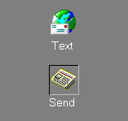For example, you want all list views of the TDCOutbar control to use the same background. Certainly you can specify this background in Background property of the each list view (as described above). But the better and faster way to solve this task is to specify this background in the BackGround property of the TDCOutbar control. After that all you have to do is to assign True to ParentBackGround property of those TDCOutbarVertListViews, that are to use the same background. In such way you can assign several other properties to the vertical list views of the Outbar control.

TDCOutBar can be considered as a control that is designed to look as Outlook Bar. You can put it on the form and use it almost immediately after that. In the five minutes after you started to develop an application you can have the powerful Outlook Bar. But there are some limits you can meet. For example, items in TDCVertListView (TDCOutbar contains TDCVerListView inside) are situated vertically and you can not change this order. So, sometimes you need more powerful and more customizable control… just like TDCGroupBar.

TDCGroupBar

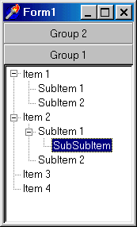
At first sight this control does not differ much from the TDCOutbar. The same smooth group movement, the same hottacking. But there is no control inside the groups. It is the main difference between TDCGroupBar and TDCOutBar. It means that you can put any control inside the group. And not only one control – you may put as many controls as you need in every group. For example, place a TDCVertListView control in the one group and standard TListView or TTreeView in the other. Possibilities that are open for you now are really unlimited! TDCGroupBar is a control for the real programmers!

Note: controls that are placed to TCDGroupBar may look better if you turn off their border (assign bsNone to the BorderStyle property).

TDCOutHeader

TDCOutHeader is the control that has the functionality of MS Outlook Header. Using this control you will be able to create highly customizable Outlook-style headers and integrate them in your applications with other controls from the Dream Outbar pack.

We suggest you to use this control together with TDCOutHeader. This will allow you to create really powerful applications with convenient user-friendly interface. All you have to do to connect TDCOutHeader with TDCHeaderPanel is to specify an instance of TDCHeaderPanel in the HeaderPanel property of TDCOutHeader.

TDCHeaderPanel

TDCHeaderPanel implement the Outlook-style header panel that can be found in many Microsoft products (among them are MS Outlook, MS FrontPage, MS Office 2000, etc.).

TDCSplitterPanel

This is a splitter control. It allows users to change the sizes of different controls at run-time. Just place TDCSplitterPanel control on your form and split it in several regions. Each region can be easily resized by the users at run-time by the mouse.

Here is the screen shot that shows the integration of Dream OutBar controls:

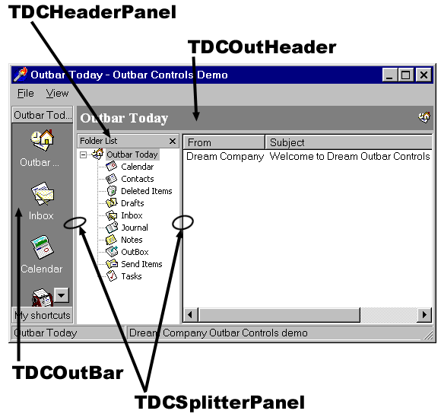

TDCTranspScrollBar

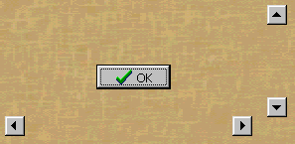

OK, when we have got acquainted with main controls in Dream Outbar pack, let’s talk a bit about the scroll bars. I mean, about the transparent scroll bars. Yes, TDCTransScrollBar is a usual scroll bar, but it can be transparent and it does not have a thumb. Put this control on the form and find Transparent property. Change its value and have a cool scroll bar! However, if you want the scroll bar not to be transparent, simply assign False to the Transparent property. By the way, you can change the Frequency – it is a time delay that will determine the speed of scrolling.

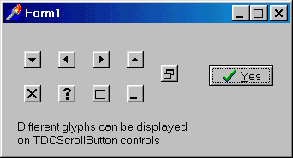
TDCScrollButton

This control is a separate scroll button without a scroll bar. Actually it can be considered as a speed button that is used as a scroll button. TDCScrollButton can display several standard Windows buttons glyphs: Scroll Left, Scroll Down, Window Close, Window Maximize, etc. Use ButtonStyle property to choose a glyph. As you can see, this control is very useful when developing user friendly applications.

