Dream InfoTree Manual
Revision 1.1
Copyright © 1999 Dream Company

TABLE OF CONTENT

Introduction 2
Dream Tree 2
Enhanced Tree Views 2
Features Table 3
Multi Select 3
Select Only Siblings 4
CheckBoxes and RadioButtons 5
Grayed CheckBoxes 5
Nodes Auto Expand On Drag 7
Nodes Auto Expand On Selection 7
Node Text Style 7
AutoScroll On Drag And Select 8
Custom Drawing 8
Optional Tool Tips 9
Hottrack 9
Enhanced List View 9
Features Table 9
Check Boxes 10
Grid Lines 11
Flat Scroll Bars 11
Hot Track 11
Full Drag 12
Transparency 12
Dream InfoTree 12
Dream InfoTree Main Concepts 12
DB Relation InfoSet 14
Multi InfoSet 16
TDCInfoTree control 17
TDCInfoListView control 18
InfoTree Usage Examples 19
Master/Detail Example 19
Extended Mater/Detail Example 22
Grouping Example 25
Query Example 28
Self-Reference Example 30
Multi InfoSet Example 33
Multi Tables Example 35
Drag And Drop Example 37
“Bill of Materials” Example 38

Introduction

Dream InfoTree is a pack of several powerful components and controls that can be used in applications that give users ability to view and operate with hierarchically organized data. TDCDrawTreeView and TDCMSTreeView have a lot of powerful features such as hottrack, multi-select, customizable node text styles, checkboxes and radio buttons, etc. TDCDrawListView is an advanced list view control that perfectly works under Delphi 4/C++Builder 4 and under older versions of Delphi/C++ Builder (as well as TDCDrawTreeView and TDCMSTreeView) without loosing of any functionality. TDCInfoTree and TDCInfoListView are Tree/List view controls designed to display different data including data from master/detail, self-referenced or any other datasets with custom structure.
Dream Tree

Enhanced Tree Views

TDCDrawTreeView and TDCMSTreeView controls can be considered as advanced versions of TTreeView control that comes with Delphi and C++ Builder. Having all features of Delphi 4 TTreeView, Dream Trees provide many new possibilities for developers. As all other Dream products, Dream InfoTree can be used under Delphi 2, Delphi 3, Delphi 4 and C++ Builder 1, C++ Builder 3, C++ Builder 4. It means, that Dream Tree brings all the power of the TTreeView from Delphi 4/C++ Builder 4 (as well as many other great features) to older versions of Delphi and C++ Builder. You should not notice any difference between using Dream Tree controls under any versions of Delphi or C++ Builder.

TDCDrawTreeView is a Tree View control that supports radio buttons and check boxes, drag and drop, hot tracking, different styles for the fonts that are used to display nodes in the tree, etc. It can be used as a base Tree View control in applications where nice representation of hierarchically organized data is needed.
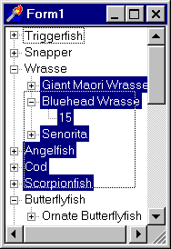
TDCMSTreeView is derived from TDCDrawTreeView. The main advantage of this control is multiselect and multidrag support. It means that users are able to select several items and operate with them together. Items can be selected with mouse (rectangular selection), with keyboard or together with mouse and keyboard. Thus users can operate with selected items as with one, including drag-and-drop, deleting, etc.
In this chapter we’ll discuss how to manage TDCMSTreeView and TDCDrawTreeView controls. Please note that TDCMSTreeView has all the features of TDCDrawTreeView, therefore it’s a good idea to talk about these controls together mentioning the differences between them.

Features Table

Table below shows the difference between Dream Tree controls and the standard Tree View controls included with different versions of Delphi and C++ Builder.
Feature | Dream Tree  (Works under D2, D3, D4, CPB1, CPB3 and CPB4) | Standard Tree View
Feature | Dream Tree  (Works under D2, D3, D4, CPB1, CPB3 and CPB4) | Delphi 4/  C++ Builder 4 | Delphi 3/  C++ Builder 3 | Delphi 2/  C++ Builder 1
Multi Select and Multi Drag | √ | ❒ | ❒ | ❒
Select only Siblings | √ | ❒ | ❒ | ❒
Auto Expand On Drag | √ | ❒ | ❒ | ❒
Auto Expand on Select | √ | √ | ❒ | ❒
Auto Scroll On Drag And Select | √ | ❒ | ❒ | ❒
Check Boxes | √ | ❒ | ❒ | ❒
Grayed Checkboxes | √ | ❒ | ❒ | ❒
Radio Buttons | √ | ❒ | ❒ | ❒
Hot Tracking | √ | √ | ❒ | ❒
Right Click Select | √ | √ | √ | ❒
Row Select | √ | √ | ❒ | ❒
Custom Drawing | √ | √ | ❒ | ❒
Node Text Styles (FontColor, FontStyle) | √ | ❒ | ❒ | ❒
Delayed OnSelectChange events | √ | √ | ❒ | ❒
Optional Tool Tips | √ | √ | ❒ | ❒

Multi Select

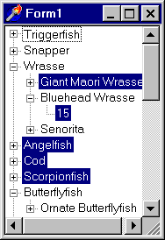
TDCMSTreeView control supports multi select feature. It means that the users can select several tree nodes simultaneously. Selection can be made by the mouse, keyboard or together by the mouse and keyboard with modifying keys (Shift, Ctrl). So, assign True to the Multiselect property of TDCMSTreeView to turn this feature on.
TDCMSTreeView supports drag-and-drop operations with multiple items. However, you can disable this feature by assigning False to the Multidrag property.
To determine what elements are selected you can use ItemsSelected property that contains the list of selected nodes. You can either read or write to this property and operate with it as with standard TList object. Here is an example that shows the box with the number of selected items:
procedure TForm1.Button2Click(Sender: TObject);
var n: integer;
begin
n := DCMSTreeView1.ItemsSelected.Count;
ShowMessage(IntToStr(n) + ' items selected.');
end;

Please pay attention to the SelectDelay property. It determines the time delay between the moment when the tree node is selected and when the OnSelectionChange event is fired. So if user selects several nodes during interval specified by SelectDelay property OnSelectionChange event is fired only for the last selected node (as if the user changed selection only once). Default SelectDelay value is 100 milliseconds (like in Explorer). If its value is zero then the OnSelectionChange event is fired immediately after the selected node is changed.
Note that TDCDrawListView has the same property and event (SelectDelay, OnSelectionChange) with the same meaning.

Select Only Siblings

SelectOnlySiblings determines whether the user can select tree elements that have different parent node. By default its value is False that means that no limits are set for selections.
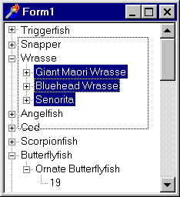
Given picture shows the Tree View control when its SelectOnlySiblings property is True. As you can see the user makes a rectangular selection by the mouse here. But only siblings of the currently focused node are selected.
Please note that this property is ignored when MultiSelect is False.

CheckBoxes and RadioButtons

Both TDCDrawTreeView and TDCMSTreeView can display checkboxes and radio buttons next to tree nodes. To enable this feature, assign True to the CheckBoxes property of the tree control.
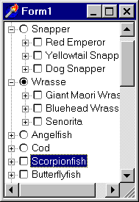
You can choose whether checkbox or radio button is displayed near the tree node. By default, checkbox is shown, but you can switch to radio button by assigning True to the RadioItem property of the node. For example like in the code below:
procedure TForm1.Button1Click(Sender: TObject);
var
Node : TTreeNode;
begin
with DCMSTreeView1, Items do
begin
Node := GetFirstNode;
TDrawNode(Node).RadioItem := true;
end;
end;

This example shows how to assign Radio Button style to the first node of the tree.

Grayed CheckBoxes

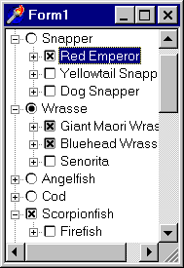
Dream Tree supports grayed checkboxes. By default checkboxes do not have grayed state. In order to enable it, set True to AllowGrayed property of the tree view control.
To determine the current state of the node’s check box you can use the following code:
procedure TForm1.Button1Click(Sender: TObject);
var
Node : TTreeNode;
begin
with DCMSTreeView1, Items do
begin
Node := GetFirstNode;
case TDrawNode(Node).CheckState of
csUnchecked: ShowMessage('Check box is not checked.');
csChecked: ShowMessage('Check box is checked.');
csGrayed: ShowMessage('Check box is grayed.');
end;
end;
end;

In this example GetFirstNode function is used to determine the first node of the tree. Then the Check State (of the first node) is verified and the message is displayed according to its state. Here is the table that describes the possible check states:

Value | Meaning
csUnchecked | Check box is not checked.
csChecked | Check box is checked.
csGrayed | Check box is grayed.

OnClickCheck event is fired when the user clicks on the checkbox or on the radio button. You may handle this event to perform some actions when the button’s state is modified:
procedure TForm1.DCMSTreeView1ClickCheck(Sender: TObject; Node: TTreeNode);
begin
If TDrawNode (Node).RadioItem then
ShowMessage('The user clicked on a radio button.')
else
ShowMessage('The user clicked on a check box.')
end;
This example checks whether the clicked item has RadioButton and displays a message when the user clicks on it. Node parameter that is passed to the handler contains the clicked node.

Nodes Auto Expand On Drag

Dream Tree can automatically expand tree nodes when the user drags items there. To enable this feature you have to assign True to ExpandOnDrag property.
Besides that you can use DragExpandDelay property to define the expand delay in milliseconds. Default value of this parameter is 100 (which is the same as in Explorer).

Nodes Auto Expand On Selection

Don’t miss AutoExpand property that specifies whether the nodes in the tree view automatically expand and collapse depending on the selection. If this property is True then the node automatically expands when it is selected.

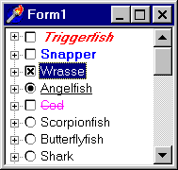
Node Text Style

TDCDrawTreeView and TDCMSTreeView allow you to specify different text styles for the different nodes. To do that you have to work directly with nodes, modifying their FontStyle and FontColor properties at run-time or to use handy design-time editor.

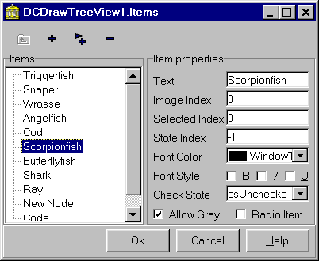

Here is an example that illustrates how to set different font styles and colors at run-time:
procedure TForm1.Button1Click(Sender: TObject);
var Node: TTreeNode;
begin
with DCDrawTree1, Items do
begin
Node := GetFirstNode;
TDrawNode (Node).FontStyle := [fsBold, fsItalic];
TDrawNode (Node).FontColor := clRed;
end;
end;

This code modifies the appearance of the first node, making its font bold and italic and changing its color to red.

AutoScroll On Drag And Select

Dream InfoTree supports AutoScroll feature – when the user drags item(s) or selects several ones (in TDCMSTreeView) and moves mouse pointer to the boundaries of the tree view control, the tree window is automatically scrolled. By default AutoScroll is disabled, so you have to assign True to the AutoScroll property of the tree to enable it.

Custom Drawing

Sometimes you need to implement custom drawing of the whole tree or of its single element. To do that you can handle OnCustomDraw and OnCustomDrawItem events and use Canvas property of the tree. Let’s examine these events in details.
OnCustomDraw event is fired when the tree needs to be painted. Here is an event type of OnCustomDraw handlers:
type TTVCustomDrawItemEvent = procedure(Sender: TCustomTreeView; ARect: TRect; var DefaultDraw: Boolean) of object;

As you can see, three parameters are passed to the handler:
- Sender is the tree-view control that needs to be painted;
- ARect is the rectangle that defines the boundaries of the tree-view control;
- DefaultDraw is used to “tell” the tree view whether it has to paint itself. So, assign False to this parameter in your handler if you do not want to allow default paint operation.
OnCustomDrawItem is fired when the single tree element is about to be painted.
Here is the event type declaration for the OnCustomDrawItem event:
type TTVCustomDrawItemEvent = procedure(Sender: TCustomTreeView; Node: TTreeNode; State: TCustomDrawState; var DefaultDraw: Boolean) of object;

Four parameters are required:
- Sender is the tree-view control which item is about to be painted;
- Node is the item that is about to be painted;
- State is the item's current state. Here are the possible values of this parameter: dsSelected, dsGrayed, dsDisabled, dsChecked, dsFocused, dsDefault, dsHot, dsMarked, dsIndeterminate;
- DefaultDraw specifies whether the control should paint the item or it is already painted in the event handler.

Optional Tool Tips

TDCDrawTreeView and TDCMSTreeView as well as standard Delphi 4 TTreeView support tool tips. By default tool tips are enabled but if you wish to disable them assign False to the ToolTips property. On the picture below TDCDrawTreeView with tool tips is shown:
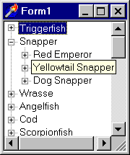
Hottrack

HotTrack property indicates whether nodes in the tree view control are highlighted as mouse pointer passes over them. Set HotTrack property to true if the tree view control provides feedback to the user by highlighting the node when mouse pointer is positioned over it; otherwise, set HotTrack to false. The default value is false.

Enhanced List View

TDCDrawListView can be used when developing applications with different List Views. This control has all features of the standard TListView from Delphi 4/C++ Builder 4 but it also works under earlier versions of Delphi and C++ Builder preserving all functionality. Besides that TDCDrawListView has several additional features that will be discussed below.

Features Table

Table below shows the difference between Dream List View control and the standard List View control included with different versions of Delphi and C++ Builder.

Feature | Dream List View  (Works under D2, D3, D4, CPB1, CPB3 and CPB4) | Standard List View
Feature |  | Delphi 4/  C++  Builder 4 | Delphi 3/  C++ Builder 3 | Delphi 2/  C++ Builder 1
Check boxes | √ | √ | √ | ❒
Delayed OnSelectChange | √ | ❒ | ❒ | ❒
Flat Scroll Bars | √ | √ | ❒ | ❒
Full Drag | √ | √ | ❒ | ❒
Grid Lines | √ | √ | √ | ❒
HotTrack | √ | √ | √ | ❒
HotTrack styles | √ | √ | ❒ | ❒
Row Select | √ | √ | √ | ❒
Transparency | √ | ❒ | ❒ | ❒

Check Boxes

TDCDrawListView can display check boxes near its items (works only in vsList view style). Assign True to the Checkboxes property of TDCDrawListView control to enable this feature.
Now let’s determine how many items are checked in List View. To do that you may use the code from the following example:
procedure TForm1.Button1Click(Sender: TObject);
var i: integer;
Number : integer;
begin
Number := 0;
for i := 0 to DCDrawListView1.Items.Count -1 do
if DCDrawListView1.Items[i].Checked then
Number := Number + 1;
ShowMessage(IntToStr(Number) + ' items checked.');
end;

If you implement above method and assign it to button’s OnClick event, a message box with the number of checked items would be shown when the user clicks the button.

Grid Lines

Dream List View is capable of displaying grid lines (when the viewing style is “vsReport”). To enable this features assign True to the GridLines property.

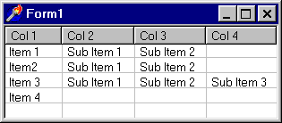

Flat Scroll Bars

You can change the appearance of the TDCDrawListView scroll bars by modifying its FlatScrollBars property. Be default this property is False, but if you assign True to it then the scroll bar will be displayed in the “Mac” style.

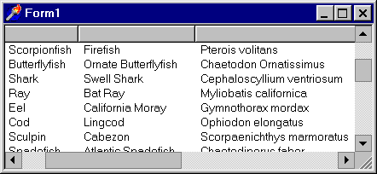

Hot Track

TDCDrawListView supports hot tracking with customizable hot tracking styles. To turn on hot tracking assign True to HotTrack property of the TDCDrawListView control. You may change the hot tracking style by modifying HotTrackStyle property. Here is the table that explains the meaning of different styles:

Value | Meaning
htHandPoint | The mouse cursor turns into a hand.
htUnderlineCold | An underline is displayed under all untracked items.
htUnderlineHot | An underline is displayed under the tracked item.

Full Drag

If this property is True then users are able to drag column headers at run-time thus changing columns order. Standard TListView supports this feature only beginning from the 4-th version of Delphi, but with TDCDrawListView you can use full drag in the earlier versions of Delphi and C++ Builder.

Transparency

If the viewing style is “vsIcon” then you can make TDCDrawListView to display its items transparently (so you will be able to show it transparently over Bitmap). To do that assign True to Regional property of TDCDrawListView control.

Dream InfoTree

Dream InfoTree Main Concepts

Internal architecture of Dream InfoTree is based on a new concept of InfoSet that changes the usual style of working with hierarchically organized data.

When working with standard Delphi Tree/List View programmers need to implement, in fact, different visual controls (tree and list views) for processing data from different sources (e.g. databases, files, etc.). Now these problems are gone. The main advantage of InfoTree architecture is that there is the clear distinction between data acquiring and data visualization.

Relationships between Dream InfoTree components and controls are like those between Data Access and Data Controls components. InfoSet processes data InfoTree and InfoListView controls display it. Thus when working with custom data you do not need to implement new visual controls. Instead of doing this you only have to make a new InfoSet.

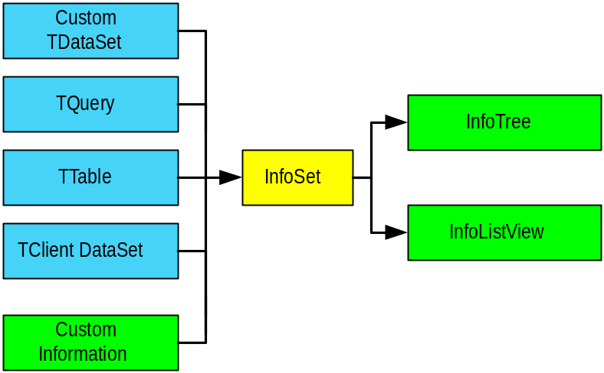

As you can see InfoTree and InfoListView controls can be linked directly to InfoSet. Besides this InfoListView can be linked to InfoTree or to another InfoListView controls so that it will show the sublevel of currently selected item.

Note that one InfoSet is capable of working with unlimited number of info-aware controls. It means that data will be synchronized and you will be able to browse it with different visual controls.

So, let’s discuss in details how info-aware components and controls work together. The root dataset is determined from the RootDataSet property of the TDCDBRelInfoSet. Then it is necessary to determine relationships between different tables and their records. Relations are stored in the Relations property of the TDCDBRelInfoSet. This property contains the collection of TDataRelation items each of them defines one relation.

Links are established on the basis of properties of TDataRelation items. Each item has MasterDataSet and DetailDataSet properties. Master and detail datasets are determined from them. MasterFields and DetailFields properties contain the fields that are used to set the connection (certainly these fields have to be of the same type).

Hierarchical structure is built beginning from the root dataset. The dataset, specified in the RootDataSet property, is filtered with the value, specified in Filter property, and then compared to the MasterDataSet property of TDataRelation items from the Relations collection. Please note that if Active property of the relation item has to be True otherwise it will not be taken into account when the hierarchical structure is built.

If a dataset same to the one, specified in MasterDataSet, is found then its records can be placed on the sub-level of the hierarchical structure. Searching of the detailed datasets is repeated recursively. In this way hierarchical structure is being built.

Please note that when working with self-referenced tables recursive operations may cause the unlimited expand of the tree structure. To prevent tree from this use ActiveOnLevel property that defines the level, where the relation is active.

DB Relation InfoSet

TDCDBRelInfoSet is an InfoSet designed to work with data from datasets. Info-aware visual controls can be connected with datasets through TDCDBRelInfoSet. Using TDCDBRelInfoSet you will be able to represent different data structures (master/detail, self-referenced tables or any other datasets configuration) in info-aware controls.

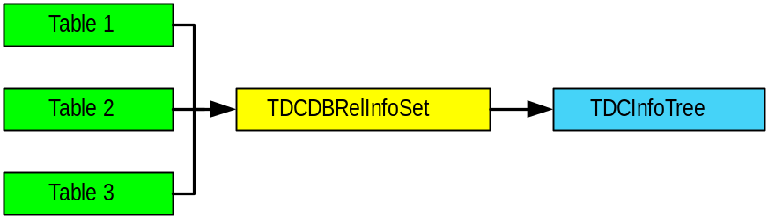

Specifying Root DataSet

First of all you need to specify the dataset which records are placed on the root level of the hierarchically organized data structure. This dataset is specified in the RootDataSet property of TDCDBRelInfoSet component.

Filtering Data

Sometimes you need to specify the filter that will be applied to the records of the Root DataSet. Imagine, for example, that you have to show information about some international companies filtering those that come from USA. In this case you can apply a filter to the DataSet using Filter property of TDCDBRelInfoSet:

DCDBRelInfoSet1.Filter := ‘Country = ’’USA’’ ’;

If such filter is applied then the TDCDBRelInfoSet will not process the fields that do not match the specified condition (thus these fields will not be shown in all info-aware controls that use this InfoSet).

To activate the filter assign True to the Filtered property of TDCDBRelInfoSet component. You can do this either at run time or at design time.

There’s one more point you have to notice. You probably know that Filters can be applied to the DataSet (for example, see Filter property of TTable component). When such filter is applied then it affects on all data controls (TDBGrid, TDBImage, etc.) that display data from it.

Filter, specified in the TDCDBRelInfoSet component, is applied only to the info-aware controls linked to it. It does not affect on any other components or controls linked to the dataset. Of course, if a filter is applied to the DataSet’s data, then TDCDBRelInfoSet components linked to it receive already filtered data. In this case both filters are combined and data displayed in info-aware controls is filtered twice (at first, by dataset filter, then by InfoSet filter).

Specifying DataSet Configuration

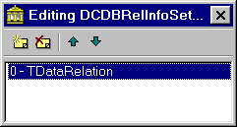
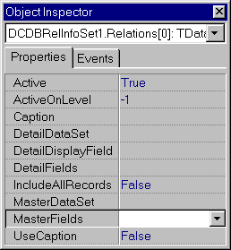
DataSet configuration is specified by the Relations property of TDCDBRelInfoSet component. This property contains a collection which elements define relations between datasets. In fact Relations property defines the hierarchical data structure. There is no limit for the number of relations and datasets, so you can set as many of them as you need. You can also specify relations between the records of a single dataset.

So, let’s discuss the properties of Relations items. At design time you can add and modify them using collection editor accessible from the Object Inspector. Each item defines one relation between table records (e.g. master/detail, self-referenced and other custom relations).

Here is the meaning of different properties of TDataRelation items:

Property | Meaning
MasterDataSet | Indicates the Master DataSet
DetailDataSet | Indicates the Detail DataSet (can be the same as MasterDataSet for self-referenced tables)
MasterFields | Indicates the master field(s) from the master table
DetailFields | Indicates the detail field(s) from the detail table
DetailDisplayField | the field from the detail table that is shown in the visual info-aware control
IncludeAllRecords | Defines whether all records from the detail dataset are included on the detail level of the tree (by default is False)
Caption | Contains text that will be displayed as a tree node if UseCaption property is True
Active | Defines whether the current relation is active
ActiveOnLevel | the hierarchical level where the relation is active (-1 means all levels)
UseCaption | If this property is True then the text specified in the Caption property is displayed in the tree as a node for all detail items

You can set master/detail relations between several fields at the same time, as it is shown below:

DCDBRelInfoSet1.Relations[0].MasterFields := ’OrderNo;CustNo’;
DCDBRelInfoSet1.Relations[0].DetailFields := ’OrderNo;CustNo’;

As you can see fields are separated by the semicolon. Please note that the number of the fields specified in the MasterFields property has to match the number of the fields specified in DetailFields property.

Please pay attention to the IncludeAllRecords property of TDataRelation items. By default this property is False. In this case Info Tree places only those records on the sub-level which DetailField matches the MasterField of the record from the parent node. But if data for the detail levels is acquired using queries then you can implement such query that will get only data that is placed on the detail level. In this case it is not necessary to provide additional filtering, so you can assign True to IncludeAllRecords property to skip this step. This will speed up you application when working with Info Tree.

Dream InfoTree can also display several datasets on the one level of the tree. Imagine that you have one master and two or more detail tables. These detail tables can be displayed at tree sublevels together and the text specified in the Caption property is used as a tree node for detail records. In such way you can simultaneously browse several detail tables in one TDCInfoTree control.

Important: Active property of TDataRelation indicates whether the relation specified by this item is active. By default this property is True for all relations but you can set it False to turn the relation off.

To understand better how to work with relations you may refer to the Examples chapter where several samples (including Master/Detail, Self-Reference and other) are discussed in detail.

Multi InfoSet

TDCMultiInfoSet is an InfoSet that integrates several InfoSets into one merged InfoSet. It allows combining information from many InfoSets in one hierarchically organized data structure thus several trees can be viewed as one "merged" tree. TDCMultiInfoSet can combine any types of InfoSets, including TDCDBRelInfoSet, user’s custom InfoSets or another TDCMultiInfoSet objects.

InfoSet objects that are merged by TDCMultiInfoSet are specified in its InfoSets property that contains the InfoSets collection. At design time you can add TDCMultiInfoSetItem objects to the collection. Each of them contains information about one InfoSet that is being merged. So, let’s talk about the properties of TDCMultiInfoSetItem.

InfoSet

This property contains the InfoSet that is included to the collection of merged InfoSets.

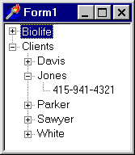
Caption

Use this Caption property to specify the text that will be displayed in TDCInfoTree or TDCInfoListView controls to identify the InfoSet. For example, on the screenshot on the right you can see how two tables (biolife and clients from DBDEMOS) are merged and displayed in one tree. “Biolife” and “Clients” nodes that are displayed on the root level are specified by Caption property of TDCMultiInfoSet.

DisplayField

This property contains the InfoSet field that will be displayed on the first sub-level of the TDCInfoTree control (on the above screenshot – last names of the clients).

Please refer to the Multi InfoSet Example chapter for the Multi InfoSet example.

TDCInfoTree control

TDCInfoTree is an info-aware control designed to display data from the InfoSets. It has all features of the TDCMSTreeView (please refer to the Enhanced Tree Views section of the manual) and several specific features that concern working with InfoSets.

InfoSet

This property stores the link to the InfoSet from where TDCInfoTree control gets the data.

InfoField

InfoField property indicates the field of the InfoSet (specified in the InfoSet property) that is displayed on root level of the Tree.

Images

TDCInfoTree can display images associated with its items. TImageList objects that store the images are specified in Images and StateImages properties.

Imagine that you have several images that you want to be displayed in the tree view near the nodes. Then you have to specify image indexes that will define which image is displayed near which node. You can store the image indexes in the table, either in usual or in calculated field. In this case you can use ImageField and StateImageField properties of the TDCInfoTree control to specify the fields of the RootDataSet where the image indexes are stored. Please note that TDCInfoListView control has the same properties with the same meaning.

Options

This property defines basic visual options of TDCInfoTree control. It contains several elements which meaning is described in the following table:

Value | Meaning | Default Value
ItoTrackRow | If True then TDCInfoTree changes the current item when the current dataset record is changed | False
ItoConfirmDelete | If True then the confirmation dialog is displayed when the user tries to delete an item | True
ItoOnlyFolders | If True then TDCInfoTree displays only those items that have child items in the tree structure | False
ItoCheckChilds | If True then TDCInfoTree checks whether tree node has child items | True
ItoSmartLoad | If True then the data that is not currently displayed is not loaded | True

TDCInfoListView control

TDCInfoListView is a list view control that displays data from the InfoSet. Preserving all the powerful functionality of TDCDrawListView (please refer to the Enhanced List View section of the manual) TDCInfoListView control has several nice features to work with data.

Master Control

TDCInfoListView has MasterControl property that can be used to specify its Master Control. This property can be used when working with several info-aware controls together. Imagine that you have a table containing data about different fishes (we’ll use biolife.db from DBDEMOS as an example). Using MasterControl property you can easily display the Name of the fish in the TDCInfoTree and all additional information about the currently selected fish in the TDCInfoListView (as it is shown below):

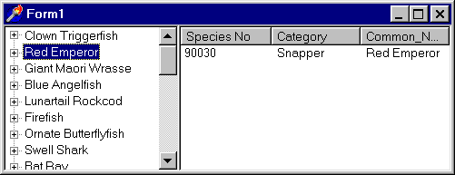

To do this you have to specify TDCInfoTree in the master control property of TDCInfoListView. Please note that TDCInfoListView can also be used as a master control.

Options

This property defines basic visual options of TDCInfoListView control. It contains several elements which meaning is described in the following table:

Value | Meaning | Default Value
IloTrackRow | If True then TDCInfoListView changes the current item when the current dataset record is changed | False
IloConfirmDelete | If True then the confirmation dialog is displayed when the user tries to delete an item | True

Check Field

TDCInfoListView can display data-aware checkboxes near its items. Because check boxes can represent only two values (checked and unchecked), InfoListView check boxes are most appropriate for boolean fields. Set CheckField to the name of the field that the check box represents.

InfoTree Usage Examples

Let’s study several examples that will help you to understand better the concepts of Dream InfoTree components. The first one will illustrate how to display data from two master/detail tables in the TDCInfoTree control.

Master/Detail Example

Suppose that you have two tables connected with each other through the master field. For example, let’s take Customer and Orders tables from the DBDEMOS. Customer is the master table. It contains the information about the customers, including identifier (CustNo), company name, city, postal code, etc. The second table Orders is the detail table that stores data about the orders, such as ship date, ship address, sale date, etc. So, get ready – we’re going to discuss how to make the sample application that will display these master-detail tables in the same tree.
Here is the figure that illustrates the relationship between Customer and Orders tables:

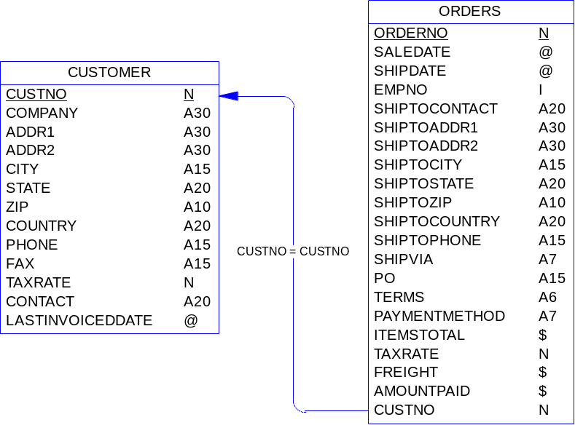

Step 1. Preparing

Create new application and put the following components and controls on the form:

- Two TTable components from the Data Access page;
- TDCDBRelInfoSet component that can be found on the Dream InfoTree tab;
- TDCInfoTree control (Also on Dream InfoTree tab).
- Rename Table1 to Customer and Table2 to Orders (by modifying Name properties of these components).

Step 2. Connecting To The Data

Now we have to connect the TTable components placed on the form with physical tables. To do this follow the instructions, listed bellow:

- At design time select the Customer component and choose DBDEMOS alias in the DataBaseName property;
- Select Customer.db in the TableName property;
- Select the Order component and choose DBDEMOS alias in the DataBaseName property (just like for the Customer component);
- Select Orders.db in the TableName property;
- Assign True to the Active property of the both tables.

Step 3. Connecting InfoSets with Datasets

Let’s specify tables that will be displayed on the different tree levels.

First of all, we have to set a root dataset:

- At design time select the DCDBRelInfoSet1 component, find its RootDataSet property in Object Inspector and choose the Customer table.

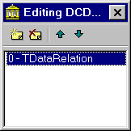
Now we need to set master-detail relations:

- In Object Inspector find Relations property of the DCDBRelInfoSet1 component and press the ellipsis button – you’ll get to the collection editor;
- Add a relation (using collection editor) that will define master/detail relations.
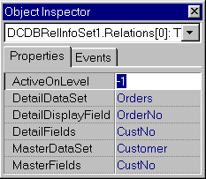
Take a look at the Object Inspector. You should see there several properties of the TDataRelation element. Modify them in the following way:

- In MasterDataSet property specify Customer table;
- In MasterFields property specify CustNo field;
- In DetailDataSet property specify Order table;
- In DetailFields property specify CustNo field (as in MasterFields property);
- In DetailDisplayField property specify the field that will be displayed on the second level of the tree (e.g. OrderNo – order number).

Step 4. Connecting InfoSet with InfoTree

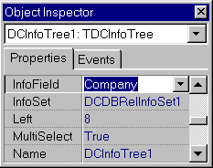
We are almost through all the preparation steps. Now we’ll connect InfoSet with InfoTree and you’ll get the InfoTree browsing master-detail tables. So, perform the next operations:

- Select the DCInfoTree1 control;
- In Object Inspector find InfoSet property and specify there DCDBRelInfoSet1 component;
- Find InfoField property and specify there any field you want to be displayed on the root level (e.g. Company).

Step 5. Running the application

Okay, finally you can run the application with InfoTree. The tree should contain all the orders (second level of the tree, Order Number field) grouped by the company (root level of the tree, Company Name field).
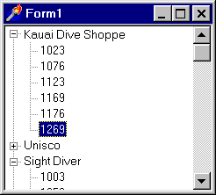

Please note that you can find this example in the EXAMPLES\MD folder.

Extended Mater/Detail Example

In the previous chapter we studied how to show two master/detail tables in the same TDCInfoTree. In this chapter we will create a new extended example based on the existing one. We’ll learn how to display an extra level in the InfoTree (by the way, you can have as many levels in the InfoTree as you need).

Next figure illustrates structure of the tables that will be used in the extended example. Customer, Orders and Items tables will be displayed in the InfoTree. Parts table will be used as a lookup table for the Item’s PartNo field.

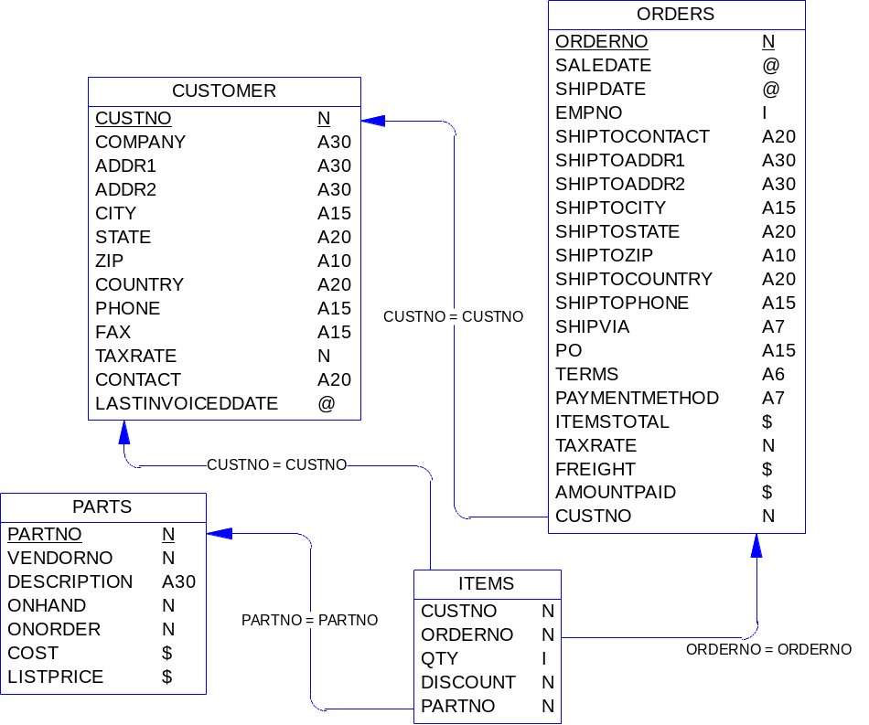

Step 1. Adding New Datasets

To operate with new tables you’ll certainly need two new TTable components. Put them on the form and follow these instructions:

- Select both of tables and choose DBDEMOS in the DataBaseName property;
- Set new names for the tables – in Object Inspector assign “Items” to the Name property of the first table and “Parts” to the second table;
- In TableName property of the Items table select Items.db;
- In TableName property of the Parts table select Parts.db;
- Assign True to the Active property of the both tables.

Step 2. Creating Lookup Field
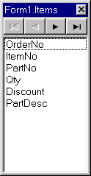
On the third level of the tree we are going to display items that are included in the order. For the convenience lets create lookup field PartDesc, so it will be shown in the tree instead of PartNo field.

Follow the instructions listed below in order to create the lookup field:

- At design time select Items table;
- Click the right mouse button on it and select Fields Editor;
- When the Field Editor appears click the right mouse button on it and select Add All Fields item from the popup menu;
- Add one more field (this will be a look up field), selecting New Field from the popup menu;
- In the dialog that appears enter the parameters as shown on the screenshot

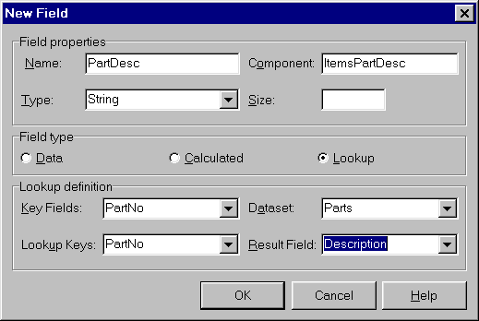

The lookup field PartDesc is created, it links PartNo field from the Items table with Description field from Parts table.

Step 3. Creating New Relations
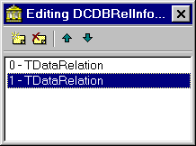
Now you have to modify Relations property of the InfoSet:

- At design time select DCDBRelInfoSet1;
- Find Relations property and press the ellipsis button;
- In the collection editor add new relation and make sure that it is selected.

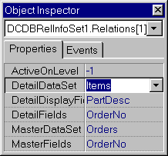
Let’s specify relations between the Items table and the Orders table. To do this perform the following operations:

- Select Orders in the MasterDataSet property;
- Select OrderNo in the MasterFields property;
- Select Items in the DetailDataSet property;
- Select OrderNo in the DetailFields property;
- Select PartDesc in the DetailDisplayField property.

You’ve just added new relation to the DCDBRelInfoSet1. As a result InfoTree will have three levels.

Step 4. Adding InfoListView

Let’s add one more info-aware control to our sample application. It will be TDCInfoListView that can be found on the Dream InfoTree page of the component palette.
So, place the instance of TDCInfoListView on the form and modify its properties at the following way:

- Select DCDBRelInfoSet1 in the InfoSet property;
- Assign True to the AutoUpdateColumns property.

Now select Columns property of DCInfoTree1 control and:

- Press the ellipsis button in the Object Inspector;
- In the collection editor that appears add several items;
- Select all added items and assign True to their AutoSize property.

Step 5. Running the application

Run the application and you’ll see the form with the TDCInfoTree control, which displays three master/detail tables in the hierarchical order.

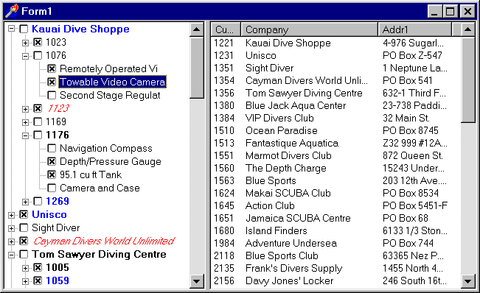

On the picture above you can see an advanced version of this example with checkboxes and colored items. You can find this example in the EXAMPLES\MD_EXT folder.

Grouping Example

Grouping is a commonly spread task that appears before programmers when working with tables. Imagine that you have a table which records can be grouped by some field. As an example we’ll use biolife.db table from DBDEMOS that comes with Delphi and C++ Builder.

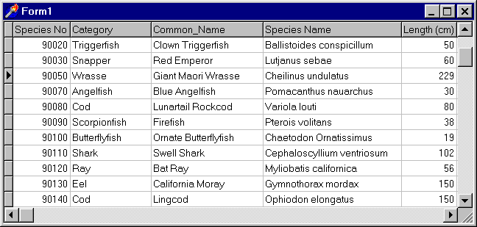

As you see, Biolife table contains information about different fishes. Each fish belongs to some category (e.g. shark, cod, ray, etc.). There is no reason for not grouping data by these categories. Dream Info Tree is a pack of components that can be used for displaying grouped information in the tree order. Category field will be used as a root level and, for example, Common_Name – as a sub-level.

Now when we have got acquainted with grouping concept and defined our task, let’s proceed straight to programming and make the sample application with Dream Info Tree grouping.

Step 1. Getting Prepared

In our sample project we’ll use the following components and controls:

- TDCInfoTree control from the Dream InfoTree page;
- TDCRelInfoSet component from the Dream InfoTree page;
- TQuery component from the Data Access page;
- TTable component from the Data Access page.

So, create a new form and put these components and controls on it. It is recommended to rename them (just for convenience) in the following way:

- rename DCInfoTree1 to BioTree;
- rename DCRelInfoSet1 to BioInfoSet;
- rename Query1 to BioQuery;
- rename Table1 to BioTable.

Step 2. Specifying Data Links

Now we have to link the BioQuery with the physical database on the disk. To do so follow the next instructions:

- at design time select BioQuery component;
- in the Object Inspector find DatabaseName property and choose DBDEMOS alias there;
- assign the following SQL code to the SQL property:

Select distinct category from biolife

- make BioQuery active buy setting True to its Active property.

This query selects records from the BIOLIFE table with unique Category. We’ve just obtained all categories and they will be displayed on the root level of the InfoTree.

And now, let’s connect BioTable with the same table (BIOLIFE). To do so, please follow next instructions:

- at design time select BioTable component;
- in the Object Inspector find DatabaseName property and choose DBDEMOS alias there;
- assign biolife.db to the TableName property.

Don’t forget to make BioQuery and BioLife datasets active by assigning True to their Active property.
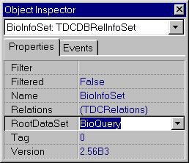

Step 3. Connecting InfoSet with DataSet

After choosing a table at the dataset component we need to link InfoSet with it. To do this, make these operations:

- select BioInfoSet component;
- find RootDataSet property and specify BioQuery there.

Step 4. Connecting InfoTree with InfoSet

Now we are ready to link InfoTree control with InfoSet:
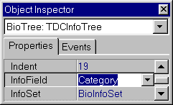
- select BioTree control;
- find InfoSet property in Object Inspector and assign BioInfoSet to it;
- choose Category at the InfoField property (this field will be displayed on the root level of the tree).

If you performed all operations correctly then the root level should appear after this step.

Step 5. Specifying Relations

Let’s define relations between different fields of the BioQuery and BioTable. When relations will be set then a new sub-level will be shown in the BioTree (it will be Common_Name field). OK, we are going to set relations between BioTable fields:

- select BioInfoSet component;
- in Object Inspector find Relations property and press the ellipsis button – you’ll get to the collection editor;
- add an item and make sure it is selected.

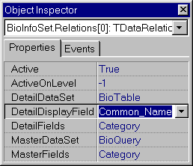
Recently added TDataRelation item defines relations between two fields. We’ll change its properties in the following way:

- choose BioQuery in the MasterDataSet property;
- choose BioTable in the DetailDataSet property;
- choose Category in the MasterField property;
- choose Category in the DetailField property;
- choose Common_Name in the DetailDisplayFiled property;
- assign 0 to ActiveOnLevel property.

Step 6. Running the application

Nothing left to do but to run the application. The form with the two-level InfoTree has to appear.

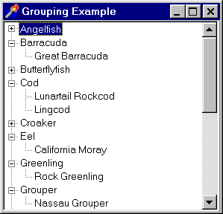

You can find this example in EXAMPLES\GROUPING folder.

Query Example

Imagine that when building some hierarchically organized data structure you are using queries to read tree sub-levels. In this case you’ll need to execute queries with different parameters when reading data for the different sub-levels of the tree. In this example we will learn how to solve this task. We assume that you are already familiar with tables grouping algorithm, because this example will be based on the previous one (Grouping Example).

Step 1. Getting Prepared

First of all, create a new form. We’ll need the following components and controls to be put on it:

- TQuery component from the Data Access page;
- TTable component from the Data Access page;
- TDCDBRelInfoSet component from the Dream InfoTree page;
- TDCInfoTree control from the Dream InfoTree page.

Step 2. Connecting To Data

Now we need to connect Table1 and Query1 components with physical data. To do so, select these components and specify DBDEMOS in their DatabaseName property. After that select only Table1 and assign biolife.db to its TableName property.

Then we should implement the following SQL query that will acquire data for the tree sublevels:

Select * from biolife
where Category= :Category

Assign this SQL code to the SQL property of Query1 component. Make Query1 and Table1 component active making their Active property True.

Step 3. Implementing Event Handler

TDCInfoTree control fires the OnActivateLevel event each time it needs to read data for a tree sub-level. You have to handle this event in order to execute SQL query with different parameters for the different tree sub-levels. Here is a sample event handler that can be used for such purpose:

procedure TForm1.DCInfoTree1ActivateLevel(Sender: TObject;
ParentNode: TTreeNode);
begin
Query1.Params[0].AsString := Table1Category.AsString;
Query1.Close;
Query1.Open;
end;

Step 4. Specifying Relations

And now, let’s specify relations between different fields of the biolife table. Please select DCDBRelInfoSet1 component and assign Table1 to its RootDataSet property. Then find Relations property and press the ellipsis button in the Object Inspector.

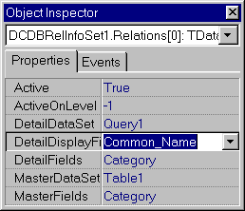
In the Collection Editor that appears add one TDataRelation item and modify its properties as it is shown below:

- assign Table1 to the MasterDataSet property;
- assign Query1 to the DetailDataSet property;
- assign Category to the MasterFields property;
- assign Category to the DetailFields property;
- assign Common_Name to the DetailDisplayField property.

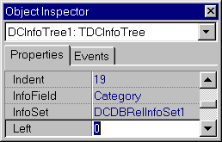
Step 5. Connecting InfoTree with InfoSet

Select DCInfoTree1 control and modify its properties as follows:

- select DCDBRelInfoSet in the InfoSet property;
- select Category in the InfoField property.

Step 6. Running Application

At last, we are ready to execute the application. Do this, the application should display the tree similar to the one, shown on the following screenshot:

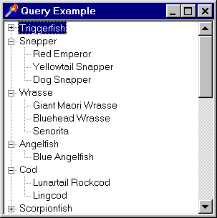

Self-Reference Example

You can use TDCInfoTree control to display self-referenced tables. We will discuss how to do this developing a sample program at the same time.

Let’s talk about self-referenced tables using ‘tree.db’ as an example (You can find this table in the EXAMPLES\SR folder). This table contains the names of some abstract folders and files. The following picture shows the structure of the ‘tree.db’ table:

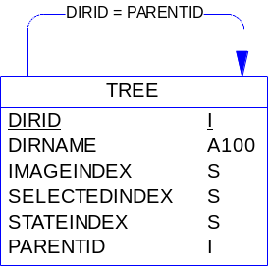

Specially organized this table has referenced fields that allow displaying it in the tree style.

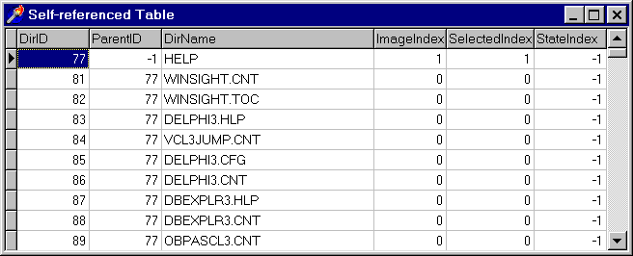

Take a look at DirID and ParentID fields. DirID is an index field that simply contains the ID number for DirName elements. ParentID field stores the parent ID number for each table entry. In this way entries are tied with each other.

Step 1. Getting Prepared

Create new application and place these components on the form:

- TTable component from Data Access page;
- TDCDBRelInfoSet component from Dream InfoTree page;
- TDCInfoTree control from Dream InfoTree page.

Let’s rename components:

- Select Table1 component, find its Name property in the Object Inspector and assign DirTable to it.
- Select DCDBRelInfoSet1 component, find its Name property and assign DirInfoSet to it.

Since there is no default database alias for the ‘tree.db’ you have to specify its full name (with path) in the TableName property of the table component. At last make DirTable active by setting True to its Active property.

Step 2. Linking TDCDBRelInfoSet with DataSet

Follow instructions below to connect InfoSet with DataSet:

- Select the DirInfoSet1 component;
- Choose DirTable in the RootDataSet property.

Step 3. Specifying relations

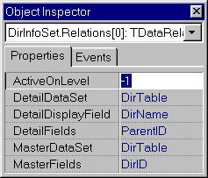
Let’s specify relations between different table fields. Find Relations property of DirInfoSet and press the ellipsis button in Object Inspector. When the collection editor appears add an item to the collection that will define referenced relations. Make sure that this item is selected and modify its properties as follows:

- Select DirTable in the MasterDataSet property;
- Select DirTable in the DetailDataSet property;
- Select DirID in the MasterFields property;
- Select ParentID in the DetailFields property;
- Select DirName in the DetailDisplayField property.

Step 4. Specifying Tree Root

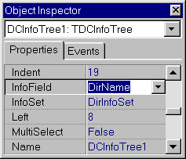
We have to specify the InfoSet and its field that will be displayed on the root level of the tree. To do this perform these operations:

- Select DCInfoTree1 control;
- Choose DirInfoSet in the InfoSet property;
- Choose DirName in the InfoField property.

Step 5. Applying Filter

Now we should set a filter for the entries that are displayed on the root level. Select DirInfoSet and find Filter property in the Object Inspector. Type there the following line: ‘ParentID = -1’ and assign True to the Filtered property.

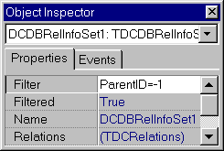

Step 6. Running the Application

All preparations are done and application can be executed. Run it. You will see an InfoTree control that displays the self-referenced table. You can also add TDCInfoListView control to the application to display information about the selected item in details (as in the previous sample).

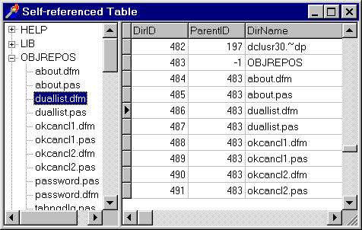

You can find this example in the EXAMPLES\SR folder.

Multi InfoSet Example

In this chapter we will discuss how to work with Multi InfoSets presuming that you are already familiar with different types of hierarchical data structures (please refer to Master/Detail example and Self-Referenced example sections of this manual).

Step 1. Getting prepared

To implement a sample Multi InfoSet application we’ll need the following components and controls:

- Two TTable components connected to different physical tables (e.g. BIOLIFE and CLIENTS from DBDEMOS);
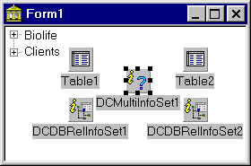
- Two TDCDBRelInfoSet components connected to different TTables respectively;
- One TDCMultiInfoSet that will merge two DB Relation InfoSets;
- One TDCInfoTree control that will be used to display data from Multi InfoSet.

Don’t forget to make both TTable components active by assigning True to their Active property.

Step 2. Adding Merged InfoSets
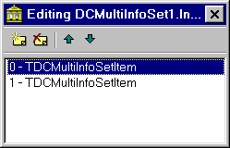
Select DCMultiInfoSet1 component and find its InfoSets property in the Object Inspector and press the ellipsis button. You’ll get to the Collection Editor where you’ll need to add two TDCMultiInfoSetItem objects, which correspond to separate InfoSets that are merged.

Step 3. Specyfing InfoSets

Select the first TDCMultiInfoSetItem and specify TDCDBRelInfoSet1 in its InfoSet property. Then select the second TDCMultiInfoSetItem and specify TDCDBRelInfoSet2 in its InfoSet property.

Step 4. Caption and Display Field

Now we need to specify Captions that will identify InfoSets in the InfoTree control and the field that will be displayed on the first sub-level of the tree. To do so, select the first TDCMultiInfoSetItem and modify its properties in the following way:
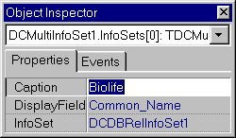
- assign Biolife to the Caption property;
- assign Common_Name to the DisplayField property.

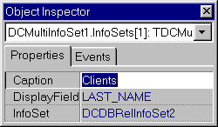
Similarly, modify the properties of the second TDCMultiInfoSetItem object:

- assign Customers to the Caption property;
- assign LAST_NAME to the DisplayField property.

Step 5. Running the Application

Now we are ready to run the application. Execute it, you have to get something similar to the screenshot figured below:

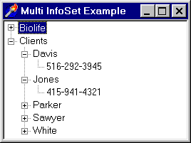

You can find this example in the EXAMPLES\MULTI folder.

Multi Tables Example

Sometimes it is necessary to display information from different datasets on the same level of the InfoTree. In the previous chapter we talked about TDCMultiInfoSet component that merges several different InfoSets into one. Thus TDCMultiInfoSet can not sovle our current task because it does not work with DataSets.

Step 1. Getting Prepared

So, we are going to display data from two datasets on the first sub-level of the TDCInfoTree control. We’ll need the following components and controls to be placed on the form:

- tree TTable components from the Data Access page;
- one TDCDBRelInfoSet component from the Dream InfoTree page;
- one TDCInfoTree control from the Dream InfoTree page.

Please name datasets in the following way: Customers, Orders and Items.

Step 2. Connecting to Data

Now we need to connect datasets with the physical data. We will use customers, orders and items tables from the DBDEMOS. You have to specify the DBDEMOS alias in the DatabaseName property of each dataset and select the corresponding tables in their TableName properties. Then make all datasets active by assigning True to their Active property.

Step 3. Specyfing Root DataSet

On the root level of the tree we will display data from the orders table. Thus we should specify Orders dataset in the RootDataSet property of the DCDBRelInfoSet1 control.

Step 4. Setting Relations

We are ready to specify the data relations between Orders, Customers and Items tables. To do so select DCDBRelInfoSet1 component, find its Relations property in the Object Inspector and press the ellipsis button. In the collection editor that appears after that add two TDataRelation items.

Now, select the first one and modify its properties in the following way:

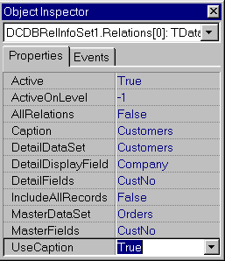
- specify Orders dataset in the MasterDataSet property;
- specify Customers dataset in the DetailDataSeti property;
- specify CustNo in the MasterFields property;
- specify CustNo in the DetailFields property;
- specify Company in the DetailDisplayField property;
- assign Customers to the Caption property;
- set UseCaption property True.

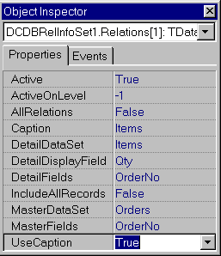
This relation connects Orders dataset with Customers dataset. Now we will set another relation that will connect Orders with Items. So, select the second TDataRelation item and modify its properties like it is shown below:

- specify Orders dataset in the MasterDataSet property;
- specify Items dataset in the DetailDataSeti property;
- specify OrderNo in the MasterFields property;
- specify OrderNo in the DetailFields property;
- specify Qty in the DetailDisplayField property;
- assign Items to the Caption property;
- set UseCaption property True.

Step 5. Connecting InfoTree With InfoSet

At last let’s connect InfoTree control with the DB Relation InfoSet. To do so, select DCInfoTree1 control and modify its properties in the following way:
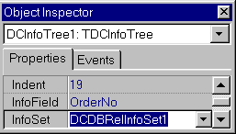
- select DCDBRelInfoSet1 component in the InfoSet property;
- select OrderNo field in the InfoField property (this field will be displayed on the root level of the DCInfoTree1 control).

Step 6. Running The Application

Now, run the application. You should see an InfoTree that displays two datasets (Customers and Items) together on the same tree sub-level.
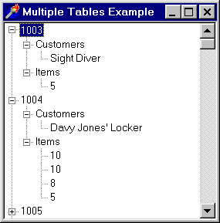

Drag And Drop Example

In this chapter we are going to talk about how to implement drag and drop in InfoTree. We will use Self-Referenced table viewed in the InfoTree (that was discussed previously) as a base. However drag and drop functionality can be easily implemented in the same way with any other types of hierarchical data structures that can be displayed in InfoTree.

First of all you have to assign dmAutomatic to the DragMode property of TDCInfoTree control. Besides that you’ll need to handle two events: OnDragDrop and OnDragOver.

Here are these event handlers:

OnDragOver:

procedure TForm1.DCInfoTree1DragOver(Sender, Source: TObject; X,
Y: Integer; State: TDragState; var Accept: Boolean);
begin
Accept := Sender = Source;
//checks whether the drag source and target are the same
end;

OnDragDrop:

procedure TForm1.DCInfoTree1DragDrop(Sender, Source: TObject; X,
Y: Integer);
var
TargetNode : TTreeNode;
id : integer;
begin
TargetNode := DCInfoTree1.GetNodeAt(X, Y);
// gets the node where the item is dropped
if TargetNode = nil then
exit;
DCInfoTree1.SetToNode(TargetNode);
// goes to the target node
id := GetNodeFieldValue(TargetNode,'DirID');
// retrieves target node’s ID
DCInfoTree1.SetToNode(DCInfoTree1.Selected);
// goes to the currently selected node
DirTable.Edit;
DirTableParentID.AsInteger := id;
//changes item’s parent
DirTable.Post;
end;

You can find this example in EXAMPLES\DRAGNDROP folder.

“Bill of Materials” Example

Let’s create another example that will illustrate how to work with a complicated system of two tables. Imagine that we need to implement “Bill of Materials”. Here is a picture with structure of tables that will be used in our example:

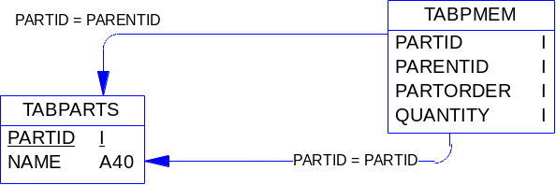

TABPARTS table stores materials. In the real world this table can have many fields but in our example it’s enough to have PartID and Name fields.

Field | Description
PartID | The unique number given to each record (auto incremented field)
Name | String field that stores name of the material

Sample materials are entered in the table:

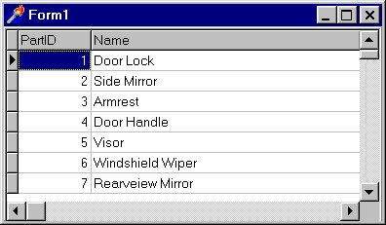

Materials can be “simple” and “complex”. Complex materials consist of other materials (complex or simple). For example car engine consists of air filter, fan belt, battery, radiator and other materials. TABPMEM table stores information about materials’ relations. Field descriptions are given in the table below:

Field | Description
PartID | Contains the PartID number of the child material
ParentID | Contains the PartID number of the parent material
PartOrder | Stores the order number of child material in the list of materials
Quantity | Stores the quantity of the child materials used in the parent material

We entered some sample data in the TABPMEM table:
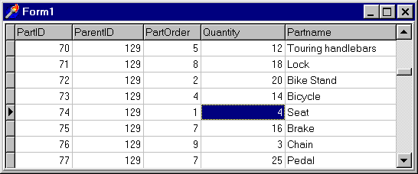

After we’ve got familiar with structure of the tables let’s turn directly to programming and create the sample application that will display data from these tables in the tree view.

Step 1. Getting prepared

Create new application and put the following components on the appeared form:

- Two TTable components from Data Access page;
- TDCDBRelInfoSet component from Dream InfoTree page;
- TDCInfoTree control from Dream InfoTree page.

For the convenience let’s rename components:

- Table1 to Parts;
- Table2 to PartsMember;
- DCDBRelInfoSet1 to PartsInfoSet.

Step 2. Connecting to the data

Now we have to connect DataSets with the physical tables on the disk. Just follow the next instructions:

- At design time select Parts component;
- In Object Inspector find its TableName property and specify location of the tabparts.db table. For example if you installed this manual in the C:\INFOMAN folder enter C:\INFOMAN\BILLOFMATERIALS\ tabparts.db;
- Select PartsMember component;
- Find its TableName property and specify location of the tabpmem.db table;
- Assign True to Active property of the both table components.

Step 3. Creating lookup field

Now let’s create a lookup field in PartsMember table. This field will be displayed in the InfoTree (It’s more convenient for the end-user to work with name of the material rather than with material id)

- Select PartsMember table;
- Click right mouse button on it and select Fields Editor | Add All Fields item from the popup menu;
- Make the same operation with the fields of Parts table;
- Fill “New field” dialog of PartsMember table as it is shown on the following screenshot and press Ok button:

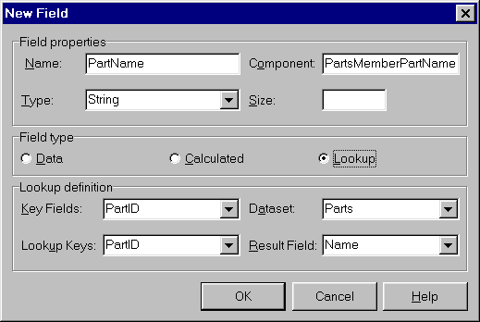

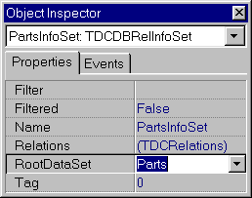
Step 4. Linking PartsInfoSet with Parts table

Let’s connect PartsInfoSet with Parts table:

- Select PartsInfoSet component;
- Find its RootDataSet property in the Object Inspector;
- Choose Parts component in this property.

Step 5. Specifying relations
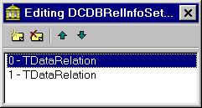
Now when the root dataset is specified we need to define tables’ configuration. Perform these operations:

- Select PartsInfoSet component;
- In Object Inspector find Relations property and press the ellipsis button;
- In the appeared collection editor add two TDataRelation elements.
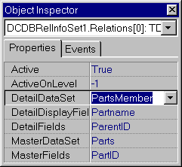
Select the first item (with zero index) and modify its properties in the following way:

- Choose Parts table in the MasterDataSet property;
- Choose PartsMember table in the DetailDataSet property;
- Choose PartID in the MasterFields property;
- Choose ParentID in the DetailFields property;
- Choose PartName in the DetailDisplayField.

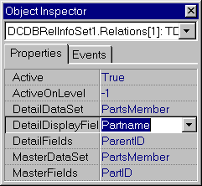
Now select second item and change its properties as shown below:

- Choose PartsMember table in the MasterDataSet property;
- Choose PartsMember table in the DetailDataSet property;
- Choose PartID in the MasterFields property;
- Choose ParentID in the DetailFields property;
- Choose PartName in the DetailDisplayField.

Step 6. Connecting InfoTree with InfoSet

Now we have to specify an InfoSet that will be used by the InfoTree. Follow the steps below:

- Select DCInfoTree1 control;
- Choose PartsInfoSet component in its InfoSet property;
- Choose Name in its InfoField property (this field will be shown on the root level of the tree).

Step 7. Running the application

If you have completed all the operations you can run the application. You will see InfoTree that displays materials (like on the picture below). If material is “complex” then its parts are shown on the sub levels.

