Dream Inspector manual
Revision 1.0
Copyright © 1997 – 1999 Dream Company
Introduction 1
Object Inspector 2
Inspected Controls 2
Inspector Style 3
Groups and Aliases 4
Defining Groups 4
Group Modifiers 5
Specifying Aliases 5
Group and Aliases Secondary Parameters 6
Hiding Properties 6
With HiddenProps Property 6
With DisplayedProps Property 6
With OnShowProperty 7
Read-Only Properties 7
Properties Order 8
Filtering Properties 8
DataSet Inspector 9
TDataSetInspector Advantages 9
TDataSetInspector Hotkeys 10
Specifying Source DataSet 10
DataSet Inspector Items 11
Property Help 12
Using Object Inspector with Custom Data 13
Using Object Inspector with INI Files 17
Integration with Dream Designer 19
Using Standard Inspector Form 19
Using Custom Inspector Form 20

Introduction

Working in Delphi or Visual Basic IDE perhaps you have got into habit of using Object Inspector. Yes, Object Inspector offers an easy and really visual way for editing the properties of components – you see the changes right after they are done. But neither Inprise nor Microsoft is distributing Object Inspector control. Thus there’s no way to integrate Inspector into applications.

Dream Company has developed Dream Inspector – a powerful product that includes several outstanding components. You can find Dream Inspector components on the Dream Company sheet of the Delphi component palette.

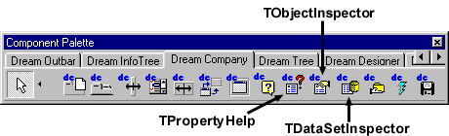

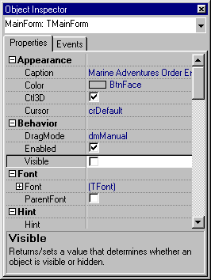
Surely, the most impressive is TObjectInspector – the control similar to Delphi Object Inspector that allows reading and modifying the properties of Delphi objects at run time. This control looks like Delphi Object Inspector and has the same functionality, but it supports many extra cool features. Dream Inspector pack also includes DataSet Inspector – an inspector control that works with data from datasets (it can be considered like an alternative to DB grid). At last, Property Help is the control that is supposed to work together with Object Inspector and provides short help issues for the property that is currently selected in the Object Inspector.

But not acting in advance, let’s explore components from the Dream Inspector pack in details, step by step.

Object Inspector

Inspected Controls

First of all you should learn how to specify the control to inspect. This control is defined by the CurrentControl property. It may be any Delphi object derived from TPersistent, or even ActiveX control.

Important: when TObjectInspector control is placed on the form it displays the properties of this form. But at run time it will show nothing. That’s why it is necessary to specify the inspected control at run time, for example in the OnCreate event of the form where TObjectInspector control is placed.

procedure TForm1.FormCreate(Sender: TObject);
begin
ObjectInspector1.CurrentControl := Memo1;
end;

If such handler is implemented then TObjectInspector control will inspect the properties of the Memo1.

You can also specify several objects which identical properties will be inspected together (for example, if you will specify a label and a button then properties like Caption, Left, Top, etc. will be displayed in the inspector). To do so you should use CurrentControls property that contains the list of the inspected objects. For example:

procedure TForm1.FormCreate(Sender: TObject);
var ObjectList : TList;
begin
ObjectList := TList.Create;
try
ObjectList.Add(Label1);
ObjectList.Add(Button1);
ObjectInspector1.CurrentControls := ObjectList;
finally
ObjectList.Free;
end;
end;

Inspector Style

TObjectInspector has two default visualization styles. It can look like Delphi inspector or like Visual Basic Inspector. Style is defined in the Style property:

Style | Meaning
isDelphi | Delphi style
isVB | Visual Basic style
isCustom | Custom style

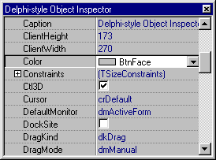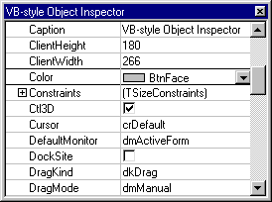

When Inspector style is isCustom then you can specify its colors manually, using Colors property. It contains the instance of TOIColors object which has the following properties:

Property | Meaning
BackColor | Inspector’s background color
Col0Color | The color of the text in the left column
Col1Color | The color of the text in the right column
HighlightBkgnd | The background color that is used to highlight the currently selected item (only in the left column)
HighllightColor | The color that is used to highlight the currently selected item (only in the left column)
HorzLineColor | Color that is used to draw horizontal cell lines
VertLineColor | Color that is used to draw vertical cell line

Groups and Aliases

Defining Groups

With TObjectInspector control you can group different properties by their meaning. For example, Appearance group may contain such properties as Caption, Color, Cursor, Ctl3D; Behavior group can unify DragMode, Visible and Enabled properties, etc.

Aliases property stores groups information in separate lines of a TStrings object. Group name has to be enclosed with square brackets. See the following example to understand how the groups are defined:
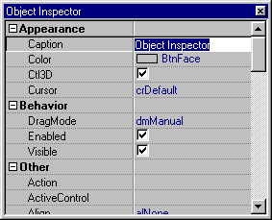
[Appearance]
Caption
Color
Cursor
Ctl3D
[Behavior]
DragMode
Visible
Enabled

Note: all strings that begin with semicolon are considered as comments and do not affect on the Aliases property.

Group Modifiers

You can also specify modifiers for the properties and group names. These modifiers determine whether the group or the property (for example, Font property) is automatically expanded, or it is hidden, etc. Here is the complete list of the modifiers:

Modifier | Meaning
AutoExpand | property or group will be expanded by default
AlwaysExpand | property or group will be always expanded
NeverExpand | property or group will be never expanded
NeverShow | property or group will be hidden

Here is an example of Aliases with modifiers:

[Appearance]
LEFT
TOP
HEIGHT
WIDTH
FONT, AutoExpand
STYLE, AlwaysExpand

Important: you can use NeverShow modifier to hide a property or a group. To learn more about hiding properties refer to the Hiding Properties chapter.

Specifying Aliases

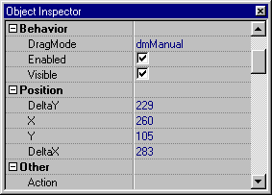
Aliases property can be also used to substitute properties with aliases, i.e. specify fake property names that will be displayed instead their real names. For example, if you want to rename “Left” to “X”,“Top” to “Y”, ”Width” to “DeltaX” and “Height” to “DeltaY” then specify the following lines in the Aliases property of TObjectInspector control:

[Position]
Left=X
Top=Y
Width=DeltaX
Height=DeltaY

Note: case is ignored.

Group and Aliases Secondary Parameters

Properties that do not get to any of the defined groups by default are placed into the “Other” group. To specify a new name for the “Other” group use OtherGroupName property. If you want to disable “Other” group at all (so that its items will not be grouped, they will appear in Inspector without any group), assign False to UseOtherGroup property.

The font that will be used for group names can be specified in the GroupFont property.

If you want to disable Inspector aliases make Options.oiUseAliases False. To disable grouping assign False to Options.oiUseGroups property.

Besides that you can specify whether the group names will go before or after their items. If this parameter is True then group names are displayed below their items. By default it is False and group names are displayed normally, before their items.

Hiding Properties

With HiddenProps Property

Sometimes it is necessary to specify properties that will not be visible in Object Inspector. To do so you can use HiddenProps property, which separate lines contain the names of hidden properties. For example, if you want Name, Caption and Font properties to be hidden then specify them in the separate lines of the HiddenProps like it is shown below:

Name
Caption
Font

With DisplayedProps Property

An alternative way to specify which properties will be visible and which will not is to modify DisplayedProps property. It contains only those properties that are visible in the Object Inspector. All other properties that are not specified here will be invisible.

Note: if DisplayedProps property is empty then Inspector displays all properties except those ones specified in the HiddenProps.

Use HiddenProps property if you want to specify a few hidden properties. If most of you properties should be hidden then it seems to be a good idea to use DisplayedProps property.

With OnShowProperty

This event is fired when TObjectInspector control is going to display the property. You can handle OnShowProperty event in order to implement some algorithm that will determine which properties will be hidden.

AllowEdit parameter is used to return the permission to show the property. Assign True to it if you want to make it visible; otherwise make if False. Here is the sample OnEditProperty handler:

Here is a sample OnShowProperty handler:

procedure TForm1.ObjectInspector1ShowProperty(Sender: TObject;
PropEdit: TPropertyEditor; var show: Boolean);
begin
if PropEdit.GetName = 'Cursor' then
show:=false
else
show:=true;
end;

If such handler is implemented then Cursor property will be hidden.

Read-Only Properties

Sometimes it is necessary to prevent users from modifying of some important properties. TObjectInspector makes it possible to define the list of properties that will be read-only. To do so specify the list of read-only properties in separate lines of ReadOnlyProps property.

Moreover, if you want to make all properties read-only then assign True to the ReadOnly property of TObjectInspector.

Besides that you handle OnEditProperty that is fired each time the user tries to edit a property in the Object Inspector. Handling it you can implement some algorithm to determine whether the specific property can be edited or not.

AllowEdit parameter is used to return the permission to edit the property. Assign True to it if you want to enable editing; otherwise make it False. Here is the sample OnEditProperty handler:

procedure TForm1.ObjectInspector1EditProperty(Sender: TObject;
PropEdit: TPropertyEditor; var AllowEdit: Boolean);
begin
if PropEdit.GetName = 'Cursor' then
AllowEdit := False
else
AllowEdit := True;
end;

If such handler is implemented then the users will not be able to edit Cursor property.

Properties Order

By default properties that are displayed in the TObjectInspector control are alphabetically sorted. However if you want to define some custom order of properties use PropOrder property where you should specify the properties in the order you wish (each property in one line).

You can also handle OnCompare event in order to implement some sorting algorithm that will compare two property editors and determine which property editor has to go first. So, if you want PropEdit1 to go before PropEdit2 then assign the negative integer number to Compare. If the property editors are equal then you should return 0. If you want PropEdit2 to go before PropEdit1 then assign the positive integer number to Compare. For example:

procedure TForm1.ObjectInspector1Compare(Sender: TObject; PropEdit1,
PropEdit2: TPropertyEditor; var Compare: Integer);
begin
Compare := -CompareText(PropEdit1.GetName, PropEdit2.GetName);
end;

If such event handler is implemented then the properties will be sorted in the reverse order.

Important: to enable custom properties order assign True to the CustomOrder property.

Filtering Properties

TObjectInspector control can filter properties by their types. For example you can filter all integer properties (such as Left, Top, Width, Height, etc.) or of any other type. Filtered types are specified in the Filter property. Here is the description of its elements:

Filter Element | Description
tkUnknown | If False then properties of the unknown type are filtered
tkInteger | If False then properties of the integer type are filtered
tkChar | If False then properties of the char type are filtered
tkEnumeration | If False then properties of enumerated types are filtered
tkFloat | If False then properties of the float type are filtered
tkString | If False then properties of the string type are filtered
tkSet | If False then properties of sets are filtered
tkClass | If False then classes are filtered
tkMethod | If False then methods are filtered
tkWChar | If False then properties of the wide char type are filtered
tkLString | If False then properties of the long string type are filtered
tkWString | If False then properties of the wide string type are filtered
tkVariant | If False then properties of the variant type are filtered
tkArray | If False then array properties are filtered
tkRecord | If False then records are filtered
tkInterface | If False then interfaces are filtered
tkInt64 | If False then properties of the int64 type are filtered
tkDynArray | If False then dynamic arrays are filtered

The main purpose of Filter property is to give an ability to switch between properties and events (as in Delphi Object Inspector). So, if you want to show only properties then assign False to tkMethod property. If you want to show only events then assign True to tkMehtod and False to all other items.
DataSet Inspector

TDataSetInspector is the inspector-like control that displays data from a dataset. This control can be considered as an alternative to standard TDBGrid way to browse datasets.

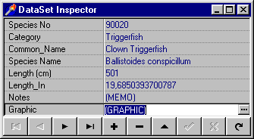

TDataSetInspector Advantages

Comparing to TDBGrid, TDataSetInspector has several advantages. The most important advantage is that TDataSetInspector provides an easy and convenient way to view memo and image fields. It is capable of working with property editors that allow to display and edit the content of such fields.

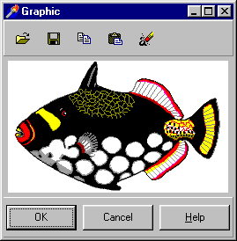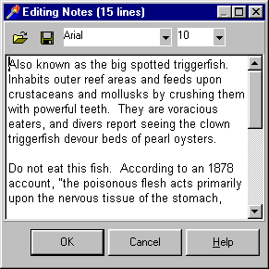

TDataSetInspector Hotkeys

TDataSetInspector supports the same hot keys for working with datasets as TDBGrid. Here is the table with these hot keys:

Hot Key | Meaning
Esc | Cancels changes
Insert | Inserts new record into the DataSet
Ctrl+Del | Deletes current record from the DataSet
Ctrl+Up | Selects the previous record in the DataSet
Ctrl+Down | Selects the next record in the DataSet
Ctrl+PgUp | Selects the first record in the DataSet
Ctrl+PgDn | Selects the last record in the DataSet

Specifying Source DataSet

To specify the dataset, which will be browsed with TDataSetInspector use DataSource property. The TDataSource object that is specified in this property will provide data to the TDataSetInspector.

For example, if you want to connect TDataSetInspector with the BIOLIFE table from the DBDEMOS database, you need to perform the following operations:

- put TDataSet and TDataSource components from the Data Access page on your form;
- put TDataSetInspector control on your form;
- select the TDataSet component and choose the DBDEMOS database and BIOLIFE.DB table, using DatabaseName and TableName properties;
- make the dataset active by making its Active property True;
- in the DataSet property of the DataSource component specify the dataset component that you have put on the form;
- in the DataSource property of the DataSetInspector specify the DataSource component.

If all operations were performed right then you should see the biolife table in the TDataSetInspector control.

DataSet Inspector Items

TDataSetInspector provides an easy and convenient way to manage the database data that is displayed in this control. You can select the fields to display, specify their display names (for example, to localize information), define different property editors for different fields, etc. To solve these tasks you can use Items property of TDataSetInspector.

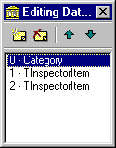
So, at design time find Items property of TDataSetInspector and press the ellipsis button in the Object Inspector. You’ll get to the collection editor. Add several item – each item describes one field that is displayed in the DataSet Inspector.

Let’s talk about the properties of the Inspector Items (each item is the instance of TInspectorItem class):

- FieldName specifies the displayed field;
- Title is the name that is displayed in the inspector for the field. If empty then the field name is displayed;
- ButtonStyle defines what button is displayed for the field (Auto – selected automatically, Ellipsis – forced to ellipsis style, None – no button is displayed);
- PickList specifies the list of the values that are displayed in the combo box that appears in the Inspector when the user presses down arrow button (if it is enabled in the ButtonStyle property);
- ReadOnly – make it True if you want to prevent users from modifying the database field.

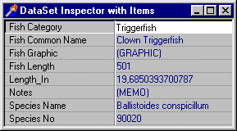

As you can see four fields appear with new names. These names are specified in the Title property of TInspectorItem objects.

After an item is added to the collection TDataSetInspector shows only the field that is specified in the FieldName property of this item. It means that if you want to display all fields using Items property then you need to add an item for each database field.

Note: if no items are added then Inspector also displays all fields.

Property Help

TPropertyHelp is a control that is designed to show small help issues for the property that is currently selected in the Object Inspector. Its usage is very simple – just put it on your form and specify a TObjectInspector control in its ObjectInspector property.

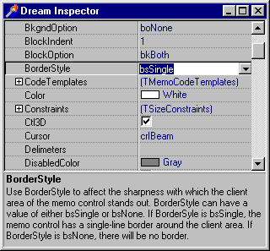

Properties’ descriptions have to be specified in the Descriptions property of TObjectInspector in the following style:

Property_Name =Property_Description

For example:

var Descriptions : array[1..4] of string =

(
‘TDCMemo.Color =Use this property to specify the color of the memo control.’,
‘TDCMemo.Ctl3D =Use Ctl3D to control the appearance of the control. If Ctl3D is True, the control has a 3-D appearance. If Ctl3D is False, the control appears flat.’,
‘TDCMemo.Font =Controls the attributes of text written in the control. To change to a new font, specify a new TFont object. To modify a font, change the value of the Color, Height, Name, Pitch, Size, or Style of the TFont object.’,
‘TDCMemo.ReadOnly =This property indicates whether the user can change text in memo control. To restrict the edit control to display only, set the ReadOnly property to True.’
);

To assign this array to the Descriptions property of the object inspector you can use the StrArrayToStrings function that is declared in the dcsystem unit:

StrArrayToStrings(OI.Descriptions, Descriptions);

You can modify Descriptions property both at design and at run time.
Using Object Inspector with Custom Data

Dream Inspector can be used to display any custom information. In this section we will discuss how to solve this task

First of all, we need to make a class to store the data that will be displayed in the Object Inspector. Here is the declaration of such class:

TObjectInspectorItem = class(TObject)
private
fName : string;
fValue : string;
public
property Name : String read fName write FName;
property Value : String read fValue write FValue;
end;

Name property will return the name of the displayed object, Value – the data that is displayed.

Then declare the list that will store TObjectInspectorItem objects. Here it is:

TObjectInspectorItemsList = class(TStringList)
end;

No new methods or properties are required. We will operate with data using Objects property of TStringList.

Now we need to implement a property editor for TObjectInpectorItem objects. Let’s derive it from standard Delphi TPropertyEditor class:

TMPropertyEditor = class(TPropertyEditor)
private
fItem : TObjectInspectorItem;
public
Function GetName: String; override;
Function GetValue: String; override;
Procedure SetValue(const Value: String); override;
end;

As you can see we have to override three methods: GetName, GetValue and SetValue. Their implementations (for TObjectInspector class) are very simple:

function TMPropertyEditor.GetName: String;
begin
result := fItem.Name;
end;

function TMPropertyEditor.GetValue: String;
begin
Result := fItem.Value;
end;

procedure TMPropertyEditor.SetValue(const Value: String);
begin
fItem.Value := value;
end;

There is a problem in the VCL: you can not create a property editor. Instead you have to register it to work with a specific class. That’s why we need to create a dummy class that will be used just to create the custom property editor. Here is this dummy class:

TFake = class(TComponent)
private
fA: Integer;
published
Property A:integer read fA write fA;
end;

It is necessary to register the property editor for this class as it is shown below:

initialization
RegisterPropertyEditor(TypeInfo(integer), TFake, 'a', TMPropertyEditor);

At last, let’s make a custom Object Inspector class deriving it from the TObjectInspector class:

TMInspector = class(TObjectInspector)
private
fFake: TFake;
fFakeList : TComponentList;
fPropEdit: TMPropertyEditor;
public
Constructor Create(AOwner : TComponent); override;
Destructor Destroy; override;
Procedure GetPropEdit(Prop: TPropertyEditor);
Procedure GetAllPropertyEditors(Components: TComponentList;
Filter: TTypeKinds;
Designer: TFormDesigner;
Proc: TGetPropEditProc); override;
published

end;

Declaring an object inspector control we need to override class constructor, destructor and GetAllPropertyEditors methods. GetAllPropertyEditors procedure that fills the Object Inspector with the property editors. Here is its implementation:

procedure TMInspector.GetAllPropertyEditors(Components: TComponentList;
Filter: TTypeKinds; Designer: TFormDesigner; Proc: TGetPropEditProc);
var
i: Integer;
begin
if CurrentControl is TObjectInspectorItemsList then
with TObjectInspectorItemsList(CurrentControl) do
begin
for i := 0 to count - 1 do
begin
GetComponentProperties(ffakelist, tkAny, InternalDesigner, GetPropEdit);
fPropEdit.fItem := TObjectInspectorItem(Objects[i]);
Proc(fPropEdit);
end;
end
else
inherited;
end;

First of all this method has to check whether the edited control is the usual control or it stores custom data that has to be shown is the Object Inspector. In the first case GetAllPropertyEditors method does nothing except calling the inherited method. Otherwise it has to fill the inspector with property editor that will be used to view and edit custom data. As you can see, we also need to implement GetPropEdit method. It should store the property editor in the internal field:

procedure TMInspector.GetPropEdit(Prop: TPropertyEditor);
begin
If Prop is TMPropertyEditor then
fPropEdit := TMPropertyEditor(Prop)
else
Prop.Free;
end;

And here are the Create and Destroy methods of the custom inspector class:

constructor TMInspector.Create;
begin
fFake := TFake.Create(nil);
fFakeList := TComponentlist.Create;
fFakeList.Add(fFake);

inherited;
end;

destructor TMInspector.Destroy;
begin
fFake.Free;
fFakeList.Free;
inherited;
end;

As you can see they just prepare the fake object.

If all classes and methods are declared and implemented correctly then you will be able to use TMInspector to view and edit the custom data. Of course for real information you should implement more complicated TObjectInspectorItem class that will have reading and writing methods for the specific sort of data.

Note: custom Object Inspector component can be found in the EXAMPLES\minsp.pas unit.

Note: you can check the sample application that uses Dream Inspector to view custom data in the EXAMPLES\CustomInsp folder.

Using Object Inspector with INI Files

In this section we will create a sample program which allows working with INI files through Object Inspector.

As you probably know INI files have the following structure:

[Section Name]
Parameter1=Value1
Parameter2=Value2
…
So, our task is to display the values of different parameters from one section in the inspector control by the specified INI file.

Please note that it we assume that you are already familiar with the material of the previous section that explains how to show custom data in the object inspector. If you are not, then refer to it because this example is similar to the previous one.

As well as in the previous example we need to create a fake component with one property:

type
TFake = class(TComponent)
private
fA: Integer;
published
property A : integer read fA write fA;
end;

This class will be used to register the property editor (because you can not create the property editor you only can register it for working with a property of some class). As you probably remember, we have implemented the same fake class in the previous example.

Well, let’s declare the object inspector class deriving it from TObjectInspector class:

TINIInspector = class(TObjectInspector)
private
fFake: TFake;
fFakeList : TComponentList;
fPropEdit: TMPropertyEditor;
fINIFile : TINIFile;
fINISection : string;
fINIFileName : string;

procedure SetINIFileName(const val : string);
procedure SetINISection(const val : string);

public
Constructor Create(AOwner : TComponent); override;
Destructor Destroy; override;
Procedure GetPropEdit(Prop: TPropertyEditor);
Procedure GetAllPropertyEditors(Components: TComponentList;
Filter: TTypeKinds;
Designer: TFormDesigner;
Proc: TGetPropEditProc); override;
{ Public declarations }
published
property INIFileName : string read fINIFileName write SetINIFileName;
property INISection : string read fINISection write SetINISection;
end;

Please pay attention to INIFileName and INISection properties that are used to specify the INI file and its section, which data will be displayed in the inspector.

GetPropEdit method is just the same as in the previous example. Here is its implementation:

procedure TINIInspector.GetPropEdit(Prop: TPropertyEditor);
begin
if Prop is TMPropertyEditor then
fPropEdit := TMPropertyEditor(Prop)
else
Prop.Free;
end;

GetAllPropEditors method has to fill the Object Inspector with property editors that can be used to edit data from INI files. Here is the implementation of this method:

procedure TINIInspector.GetAllPropertyEditors(Components: TComponentList;
Filter: TTypeKinds; Designer: TFormDesigner; Proc: TGetPropEditProc);
var
i : integer;
Idents : TStringList;
begin
if fINIFile = nil then
exit;

Idents := TStringList.Create;
try
fINIFile.ReadSectionValues(fINISection, Idents);

for i := 0 to Idents.count - 1 do
begin
GetComponentProperties(ffakelist, tkAny, InternalDesigner, GetPropEdit);
fPropEdit.fInspector := self;
fPropEdit.fIdent := Idents.Names[i];
Proc(fPropEdit);
end;
finally
Idents.Free;
end;
end;

GetAllPropEditor checks whether the INI file is specified. If it is not then this method does nothing. Otherwise it reads the data from the INI file to the internal list (Idents) and fills the Object Inspector with property editors.

Besides the above classes and methods you’ll need to declare and implement a property editor class, register the property editor, implement set and get methods for INIFileName and INISection properties, etc.

Note: you can find this example in the EXAMPLES\INIInsp folder.
Integration with Dream Designer

Dream Inspector can be used together with Dream Designer in order to create Delphi-like form designing environments. If both Dream Designer and Dream Inspector are installed then you will be able to use TObjectInspector when designing components, forms and datamodules with Dream Designer.

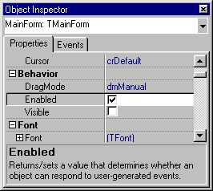
Using Standard Inspector Form

Dream Company provides a ready-to-use inspector form. All you have to do to start using together with Dream Designer is to add inspunit.pas to the uses section of your program and assign True to the ShowInspector property of designer component.

Using Custom Inspector Form

You can also create custom inspector form and use together with Dream Designer. Let’s call this form TMyInspectForm.

First of all you have to add the unit with your custom inspector form to the uses section of your program. Then you should assign False to the UseDefaultInspForm global variable thus telling Designer not to use custom form.

Before beginning the main part of the work you need to create a function that returns the currently used inspector form. Here is this function:

var IForm : TMyInspectForm;

//….

Function InspForm:TMyInspectForm;
begin
If Not Assigned(IForm) then
IForm:=TMyInspectForm.Create(nil);
Result:=IForm;
end;

Now, you have to implement event handlers for two designer messages: cm_ShowInspector and cm_ToggleInspector. To do so derive a class from TMyMessageAnswer as it is shown below and implement two message handlers:

type
TMyMessageAnswer=class(TMessageAnswer)
public
procedure cmShowInspector(Var Message:TMessage);message cm_ShowInspector;
procedure cmToggleInspector(Var Message:TMessage);message cm_ToggleInspector;
end;

cm_ShowInspector message is sent when Designer is going to show Inspector form. You have to handle this message in order to create and show custom Inspector form. Here is the sample handler of cm_ShowInspector message:

procedure TMyMessageAnswer.cmShowInspector(Var Message:TMessage);
var
iform : TMyInspectForm;
begin
iform := InspForm;
if not iform.Visible or Boolean(Message.wParam) then
begin
iform.FormStyle := ToolsFormStyle;
iform.ShowEventPage(not HideEventsInInspector);
iform.Show;
end;
end;

cm_ToggleInspector message can be handled in the following way:

procedure TMyMessageAnswer.cmToggleInspector(Var Message:TMessage);
begin
InspForm.ToggleInspector;
end;

That’s all you need to make designer use your own inspector form. But we suggest you to handle several other messages that will let you know when designer changes its state. You can handle:

- cm_HideInspector message that is sent when designer wants to hide inspector,
- cm_SelectionChanged that is sent when selection in designer is changed.

To understand better how to create inspector form and make it work together with designer you can refer to the inspunit.pas and see how the standard inspector form is implemented.

