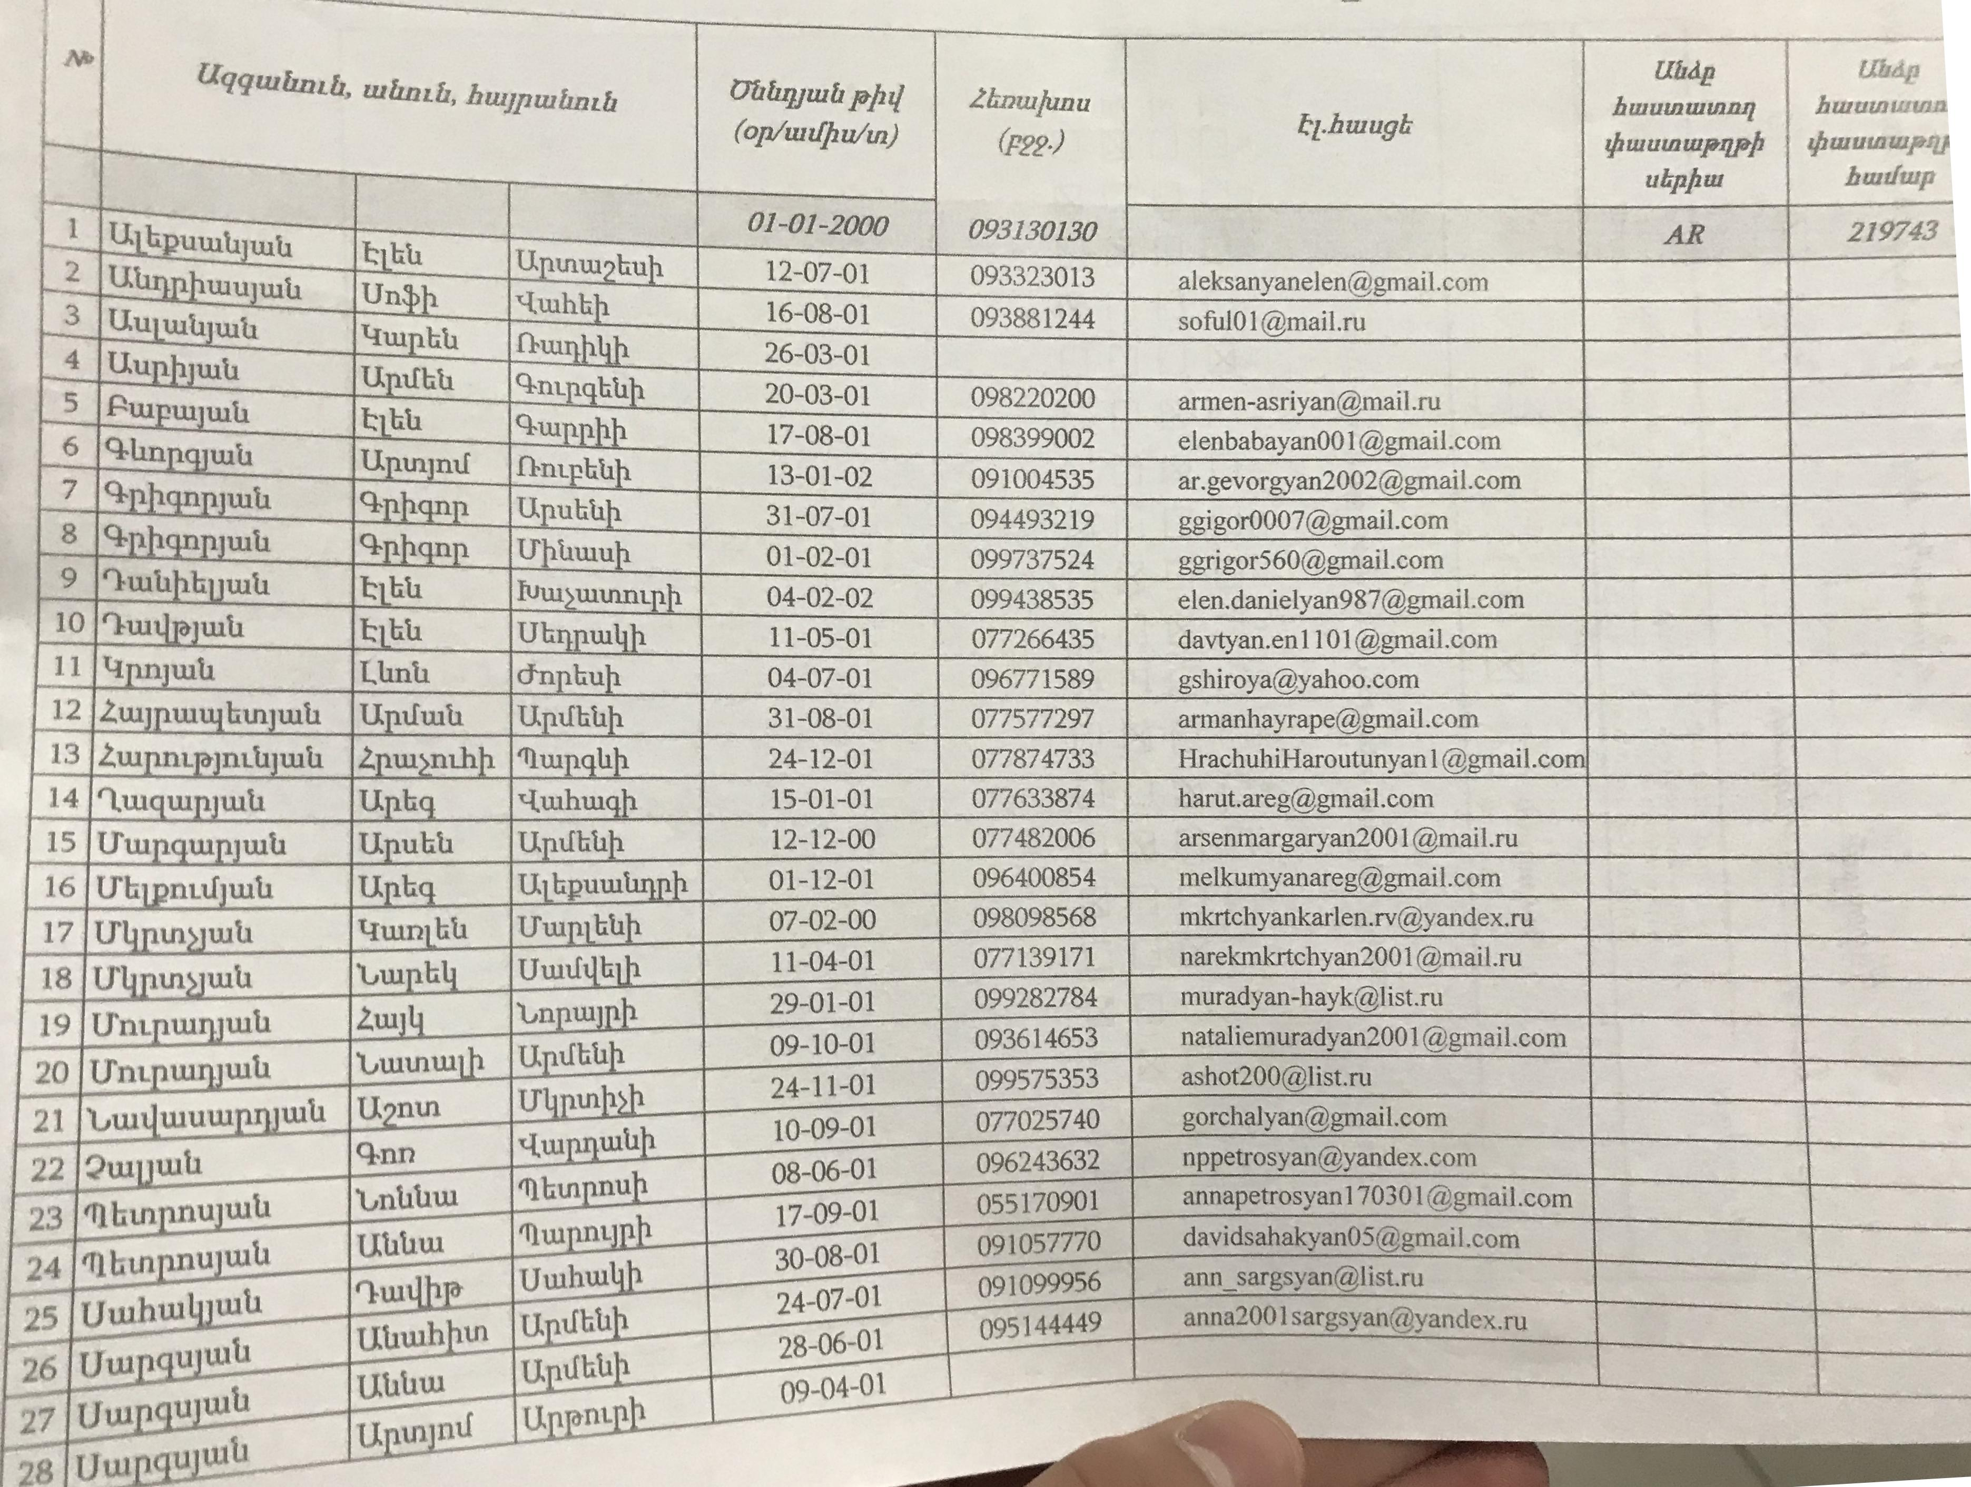

***aggiuliznb, udunit, huziptuhnib***

***(op/Luzifiultn)***

***2frinulunu
  
(P22-)***

**.11 hpututi tub**

***tamp***

***but inn w uut Ourutzturpli hunfurp***

***219743***

***01-01-2000***

***093130130***

**t**

093323013 al eksanyanel en@gm .corn

**tiu** ux

**tau tub**

093881244 soful01@mailsu

wu **tutJn.4)h**

**uth**

4w

**Ifhli**

098220200 armen-asriyanOt mail.ru

5

6

7

12-07-01 16-08-01 26-03-01 20-03-01

8

**n uth**

9

10

1.1

**tub**

098399002 eienbabayan001 [gmail.com](http://gmail.com)

[ar.gevorgyan2002agmail.com](http://ar.gevorgyan2002agmail.com)

[ggigor0007@gmail.com](mailto:ggigor0007@gmail.com) [ggrigor560@gmail.com](mailto:ggrigor560@gmail.com)

[elen.danielyan987@grnail.com](mailto:elen.danielyan987@grnail.com) davtyan.en1101@gmai 1 .com

[gshiroyaayahoo.com](http://gshiroyaayahoo.com)

[arinanhayrape@gmail.com](mailto:arinanhayrape@gmail.com)

**Lip.njuiti**

**htn tub**

**Zwpraraindijuili**

**cLtucitupjtub**

**11w • to tub**

**1Th nal tub.**

[FirachuhiFlaroutunyanl@gmail.co](mailto:FirachuhiFlaroutunyanl@gmail.co)

091004535 094493219 099737524 099438535 077266435 096771589 077577297 077874733 077633874

17-08-01 13-01-02 31-07-01 01-02-01 04-02-02 11-05-01 04-07-01 31-08-01 24-12-01 15-01-01

flui tilal

(1111Mitli

Ul►bw.ub fuui>uunrapli Uhripudili

chiphub Upi.fhhb

abb.

IX hpututi

harutarega,[gmail.com](http://gmail.com)

077482006

12-12-00 01-12-01 07-02-00 11-04-01

arsenmargaryan2001 *a* mai 1.ru

m elkumyanaregr& gmai Loom

[mkrtchyankarlen.ry@yandex.ru](mailto:mkrtchyankarlen.ry@yandex.ru)

[narekmkTtchyan2001@mail.ru](mailto:narekmkTtchyan2001@mail.ru)

muradyan-hayk@listru

093614653

29-01-01
  
09-10-01

natal iem uradyan2001@gm ail.co m

[ashot200@list.ru](mailto:ashot200@list.ru)

[gorchalyan@gmail.com](mailto:gorchalyan@gmail.com)

099575353 077025740 096243632 055170901 091057770 091099956

096400854 098098568 0771.39171 099282784

[anna2001sargsyan@yandex.ru](mailto:anna2001sargsyan@yandex.ru)

09-04-01

u

27

**28**

iUI

u tub

U

U1

***17.hzuugt-***