**jQuery**

Ashot Navasardyan

**What jQuery does well:**

1. Simplified AJAX
2. DOM Manipulation
3. Event Management
4. Animations
5. Normalizes Browser Differences

**Why It Is Successful:**

1. Well Designed
2. Easy to extend with plugins
3. Great Documentation
4. Large jQuery Community
5. Cross-browser

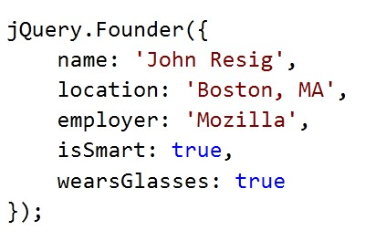

# jQuery Philosophy

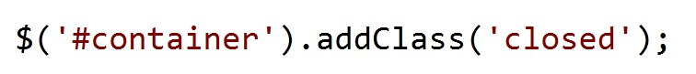

Find some stuff

Do something to it

# Chaining

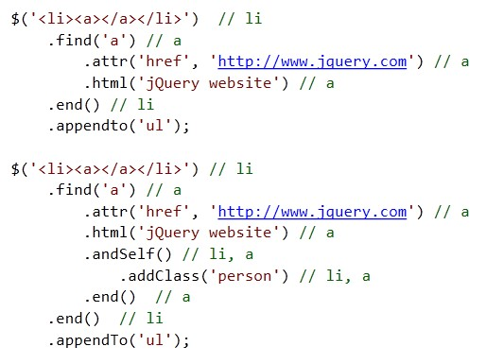

# Selecting Elements: Basic CSS Selectors

|  |  |
| --- | --- |
| **Selector** | **Description** |
| * | Matches any element |
| E | Matches all elements with tag name E |
| E F | Matches all elements with tag name F that are descendants of E |
| E>F | Matches all elements with tag name F that are direct children of E |
| E+F | Matches all elements F immediately proceeded by sibling E |
| E~F | Matches all elements F preceded by any sibling E |
| E:has(F) | Matches all elements E that have at least one descendant F |
| E.C | Matches all elements E with class name C |
| E#I | Matches element E with id of I |
| E[A] | Matches all elements E with attribute A of any value |
| E[A=V] | Matches all elements E with attribute A whose value is exactly V |
| E[A^=V] | Matches all elements E with attribute A whose value begins with V |
| E[A$=V] | Matches all elements E with attribute A whose value ends with V |
| E[A*=V] | Matches all elements E with attribute A whose value contains V |

## Selecting Elements: Positional Selectors

|  |  |  |
| --- | --- | --- |
| **Selector** | **Description** | **Example** |
| :first | The first match of the page. | **li a:first** |
| :last | The last match of the page. | **li a:last** |
| :first-child | The first child element. | **li:first-child** |
| :last-child | The last child element. | **li:last-child** |
| :only-child | Returns all elements that have no siblings. | **li:only-child** |
| :nth-child(*n*) | The *n*th child element. | **li:nth-child(2)** |
| :nth-child(even|odd) | Even or odd children. | **li:nth-child(even)** |

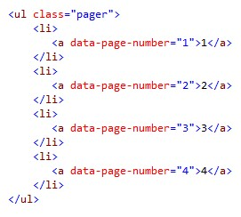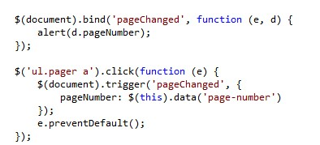

Setup

event handler

Optional second parameter

stores your

custom data that is passed from the

event

Load custom data from the data

attribute of the html element

Always prevent the default behavior of

any hyperlink event you trap.

Events can be triggered

by using the

trigger() method.

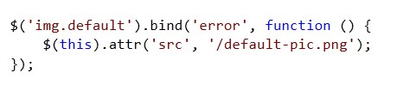

Bind default resources on the “error”

event.

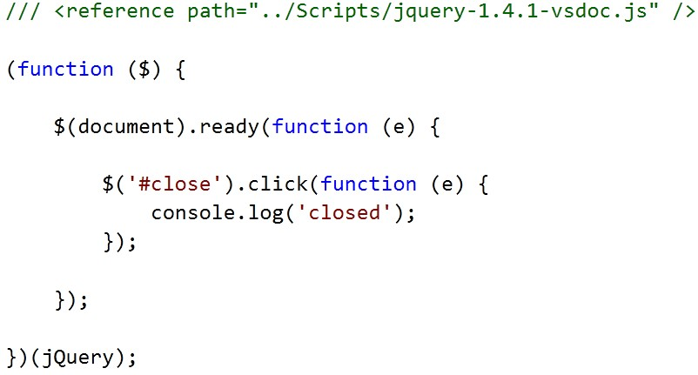

By adding script references to your .js

file, you get intellisense… kinda.

Good practice to always alias

your $ by

using Local Scope. This will prevent any

collisions with any other library that may

use $ variable

You will not be able to

select any

elements until the document is ready.

Most if your work will happen here.

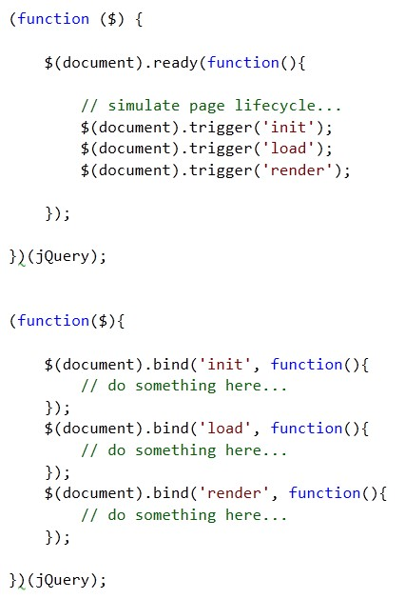

By adding script references to your .js

file, you get intellisense… kinda.

Works good if you have multiple js files

that all depend on the document loaded

event

Old way…

jQuery Way…

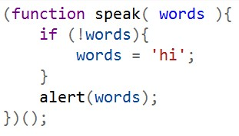

Doesn’t

scale very well at all.

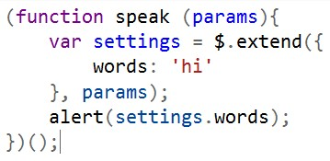

Pass in an object hash with as

many or as

few parameters as you want.



Enumerate

any default values



Default values will be overwritten by the

values you passed in the ‘

params

’ object.

## jQuery Plugins jQuery UI Plugin

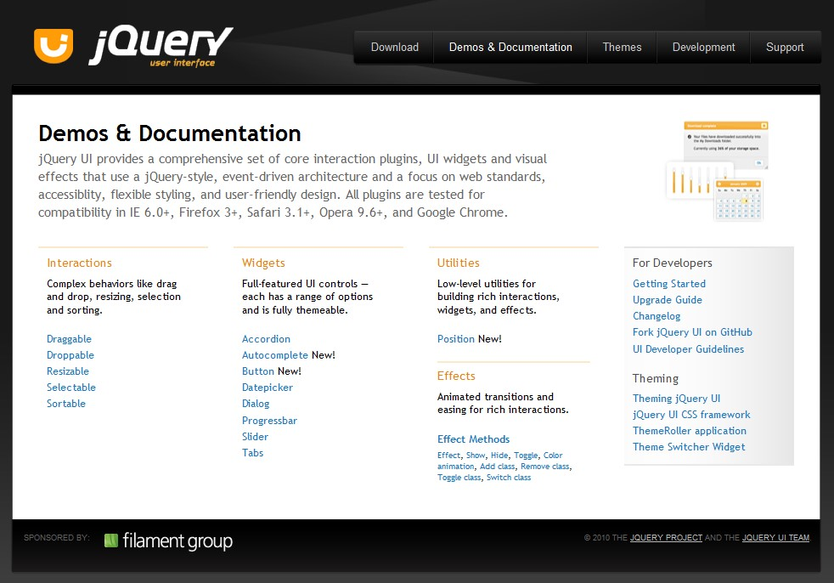

**jQuery - BBQ** <http://benalman.com/projects/jquery-bbq-plugin/>

* Merge query string fragments into the query string

**#foo=1&bar=2**

* Maintains history with each hash change
* Great for AJAX history management
  + Paging
  + Tabs

## Linq to jQuery

# Plugin Authoring

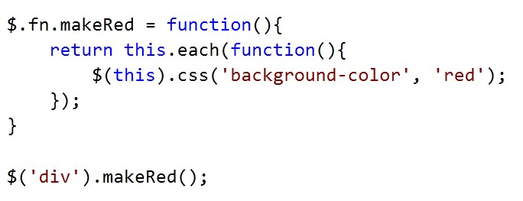

Don’t break the chain…

Can use as if it were just a regular jQuery

method

## 

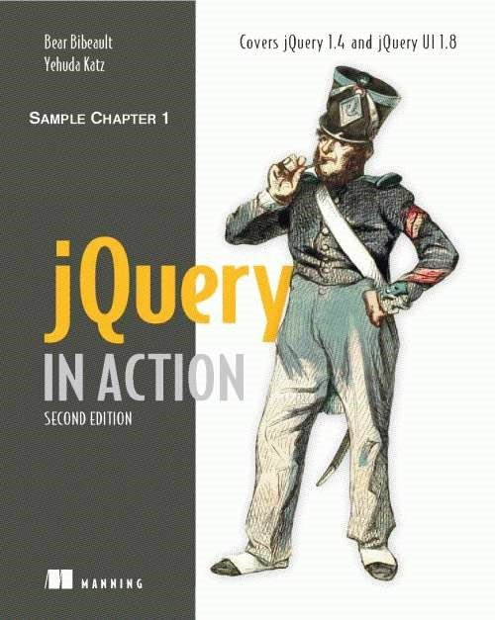

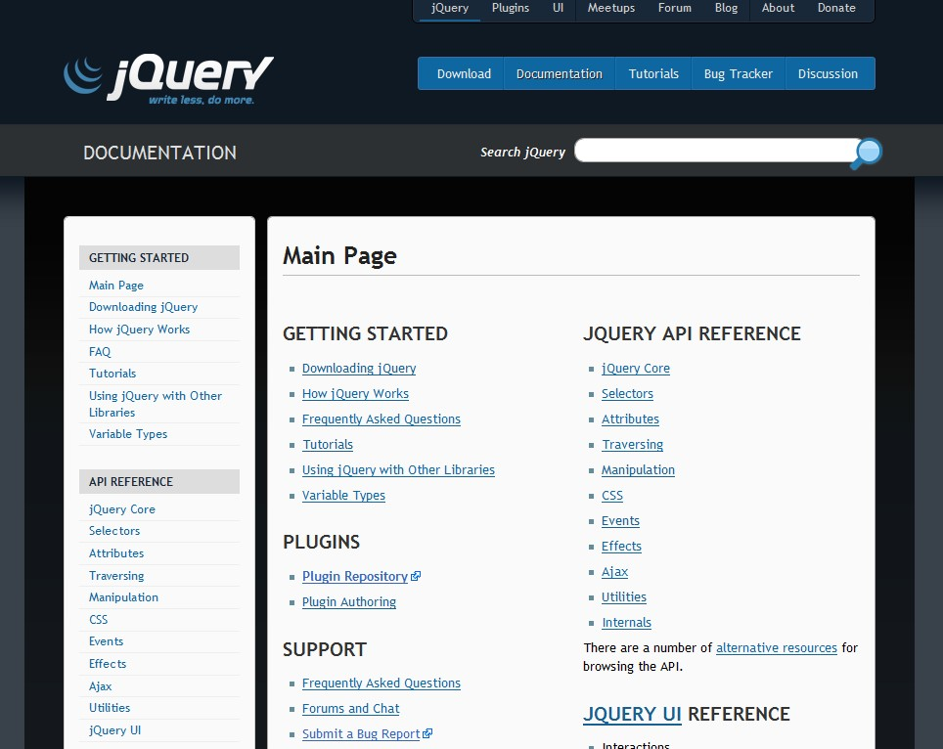

## Learn More

* <http://jquerylist.com/>
* [http://enterprisejquery.com](http://enterprisejquery.com/)
* [http://jquery.com](http://jquery.com/)

Question 1

Explain the difference between the .detach() and .remove() methods in jQuery.?

Question 2

What’s the difference between document.ready() and window.onload()?

Question 3

How to find all span elements in p with div parent , where div`s class contains ‘this_div’ , p`s class start with ‘this_p’ and span class end with ‘this_span’?

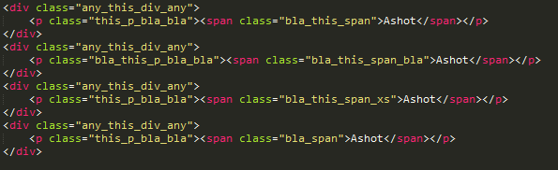

Question 4

How to update the image source, if the original image fails to load?

Question 5

What is a JSONP?