- Problem statement: Given in the 2D plain N items of different sizes, arrange them in a way to minimize the bounding box. The bounding box is a rectangle of minimal area all N items are fully contained in.
- Parameters:
- T (number of steps) = 5000
- nx, ny (use those to find N = nx * ny)
- Lx, Ly (boundaries) = (20, 15)
- dt (step size for the verlet algorithm) = 0.01
- epsilon
- n
- m
- damping(air resistance)
- Initialization:
- Keep array for radii of the particles. They are randomly initialized.
- Initialize xy coordinates for the particles randomly within Lx and Ly, also make sure there is no overlap during initialization.
- Initialize velocities to zero for x and y directions.
- Initialize acceleration to zero for x and y directions.
- Nested loop for calculating the acceleration of each particle considering the forces all other particles have on it.
- Calculate r² distance between particles.
- Calculate sigma = d_{i} + d_{j}
- F_Repulsive = epsilon * n * sigma ^ n / r ^ (n + 1)
- F_Attraction = epsilon * m * sigma ^ m / r ^ (m + 1)
- F = F_Repulsive - F_Attraction
- fx = F * dx
- fy = F * dy
- ax[i] += fx
- ay[i] += fy
- ax[j] -= fx
- ay[j] -= fy
- PotentialEnergy = epsilon * ((sigma / r) ^ n) - (sigma / r) ^ m));
- Initialize odeSolver (instance of Verlet) with step size dt
- For each step:
- Do odeSolver.step() which computes new velocities and coordinates of the particles.
- Use the damping parameter to simulate air resistance and reduce velocities.
- Compute the bounding box at each step.
- Compute new accelerations using defined forces.
- Draw the empty circles.
- Experiments:
- nx = 5, ny = 5, epsilon = 1, n = 14, m = 4, damping = 0.1, seed = 12345
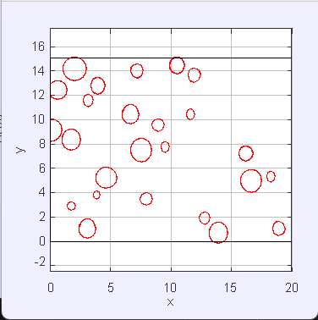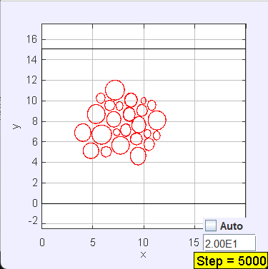
- nx = 5, ny = 5, epsilon = 1, n = 14, m = 4, damping = 0.1, seed = 12344
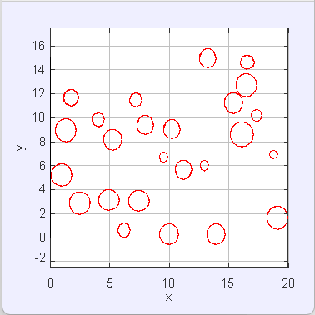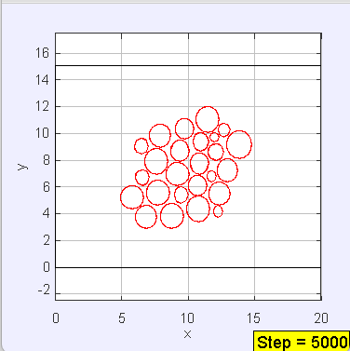
- nx = 4, ny = 4, epsilon = 1, n = 14, m = 4, damping = 0.1, seed = 12344
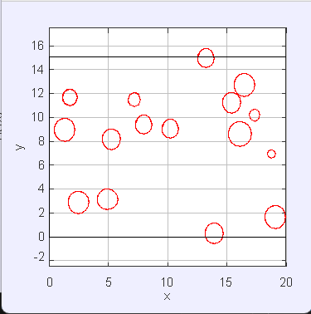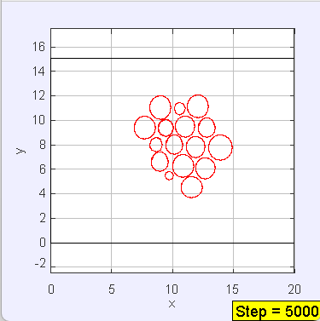
- nx = 3, ny = 3, epsilon = 1, n = 14, m = 4, damping = 0.1, seed = 12344
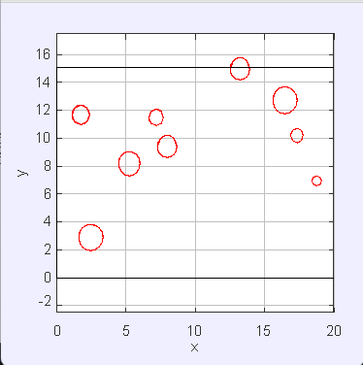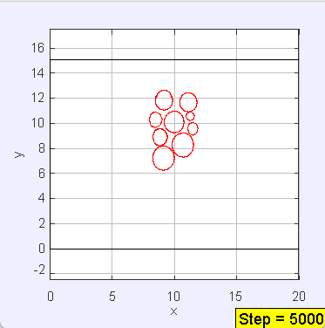
- nx = 2, ny = 2, epsilon = 1, n = 14, m = 4, damping = 0.1, seed = 12344
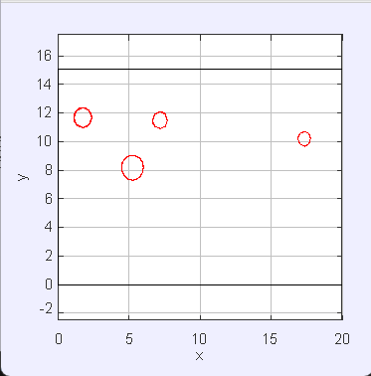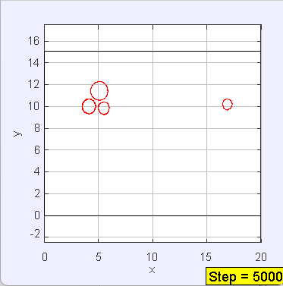
- nx = 6, ny = 6, epsilon = 1, n = 14, m = 4, damping = 0.1, seed = 12344
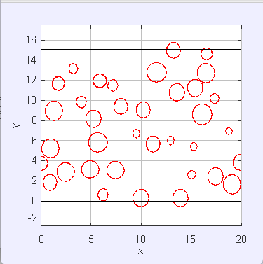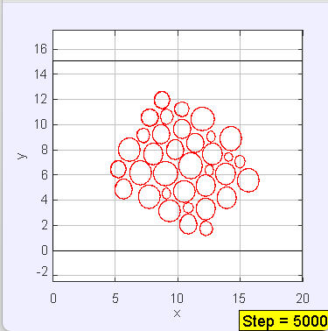
- Why these forces?:
The Mie potential is a good way to describe how two particles interact through both a repulsion when they get too close and an attraction when they are farther apart. When the r is smaller than σ, the repulsion force dominates and F(r) is positive, which keeps particles from overlapping. When the r is larger than σ, the attraction force dominates and F(r) is negative, which pulls the particles together. σ is the distance where attraction and repulsion balance out. The numbers n and m let us change the strength of repulsion and attraction. Increasing n makes the repulsion stronger and increasing m increases the attraction force.
Mie potential is also used in molecular modeling. Due to its flexibility, Mie potential is a popular choice for modelling real fluids in force fields. It is used as an interaction potential by many molecular models today. The Mie potential has also been used for coarse-grain modeling. The Mie potential has also been used for modeling small spherical molecules.

Reference
The Mie potential (the generalized case of the Lennard-Jones (LJ) potential)
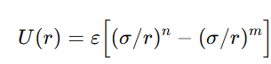
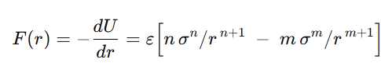
https://en.wikipedia.org/wiki/Mie_potential

