Anastasia Shpurik
MATH424 Final Project

divusa in the faraway library: Divorce Rates in the USA from 1920-1996. Response is "divorce"

library(faraway)
data(divusa)
divorceRates ← read.csv(file.choose(), header=TRUE)
filename: /u/st/da/ashpurik/School/math424/final/divorceData.csv
# femlab changed to femlabor
help(divusa): #n = 77, p = 7

year: the year from 1920-1996
divorce: divorce per 1000 women aged 15 or more
unemployed: unemployment rate
femlabor: % female participation in labor force aged 16+
marriage: marriages per 1000 unmarried women aged 16+
birth: births per 1000 women aged 15-44
military: military personnel per 1000 population

1) Numerical and Graphical Summary

summary(divorceRates)

year divorce unemployed femlabor
Min. :1920 Min. : 6.10 Min. : 1.200 Min. :22.70
1st Qu.:1939 1st Qu.: 8.70 1st Qu.: 4.200 1st Qu.:27.47
Median :1958 Median :10.60 Median : 5.600 Median :37.10
Mean :1958 Mean :13.27 Mean : 7.173 Mean :38.58
3rd Qu.:1977 3rd Qu.:20.30 3rd Qu.: 7.500 3rd Qu.:47.80
Max. :1996 Max. :22.80 Max. :24.900 Max. :59.30

marriage birth military
Min. : 49.70 Min. : 65.30 Min. : 1.940
1st Qu.: 61.90 1st Qu.: 68.90 1st Qu.: 3.469
Median : 74.10 Median : 85.90 Median : 9.102
Mean : 72.97 Mean : 88.89 Mean :12.365
3rd Qu.: 80.00 3rd Qu.:107.30 3rd Qu.:14.266
Max. :118.10 Max. :122.90 Max. :86.641

In this data, we don't see anything unusual or unexpected. Replacements don't need to be made. No minimum or maximum values that are impossible to occur. We don't see any data that is categorical as opposed to quantitative, aka factors.

Let's do some graphs now.

hist(divorceRates$divorce)
plot(density(divorceRates$divorce,na.rm=TRUE))
plot(sort(divorceRates$divorce),pch=”*”)

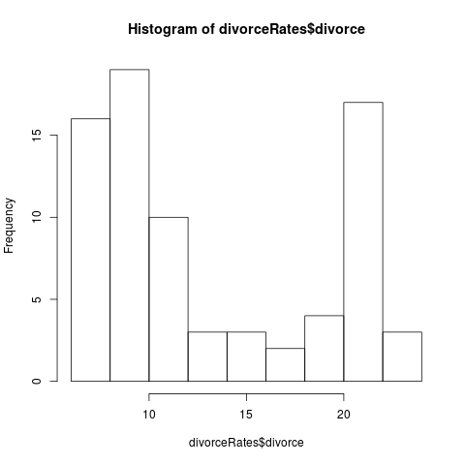
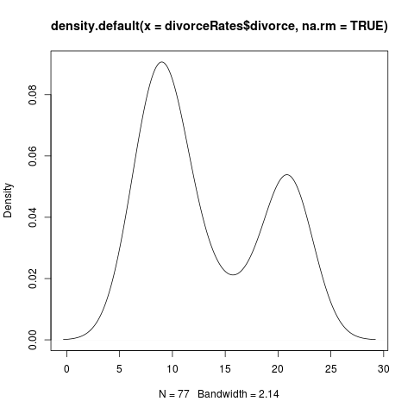
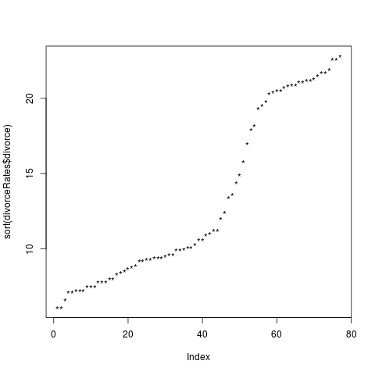

hist(divorceRates$unemployed)
plot(density(divorceRates$unemployed,na.rm=TRUE))
plot(sort(divorceRates$unemployed),pch=”*”)
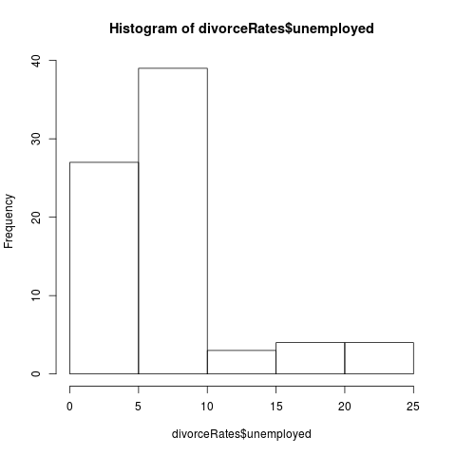
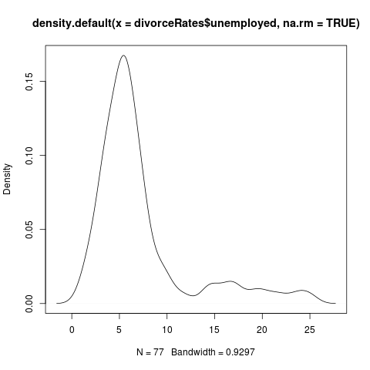
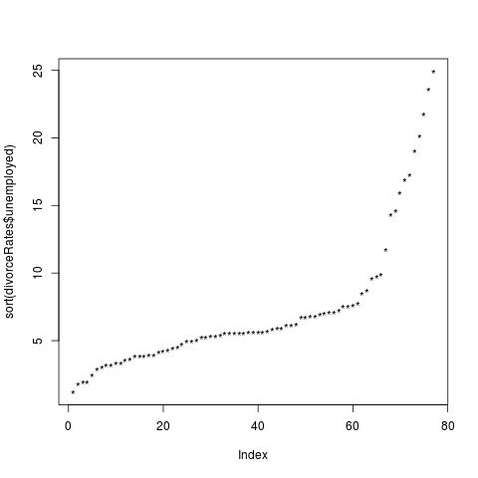

hist(divorceRates$femlab)
plot(density(divorceRates$femlabor,na.rm=TRUE))
plot(sort(divorceRates$femlabor),pch=”*”)
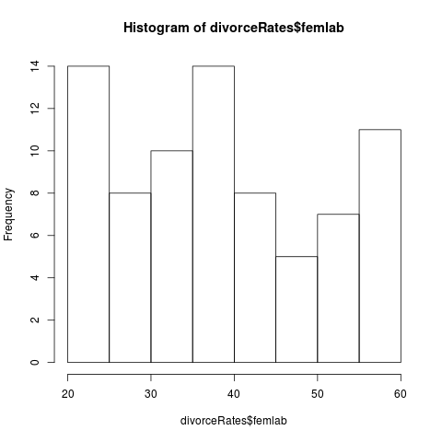
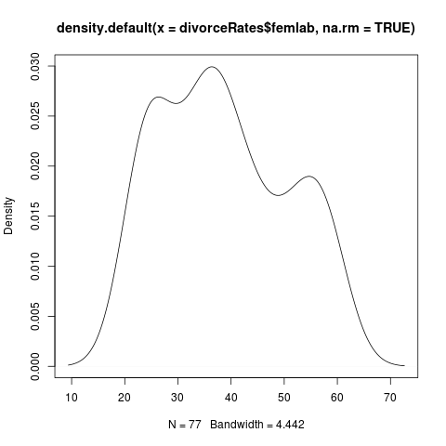
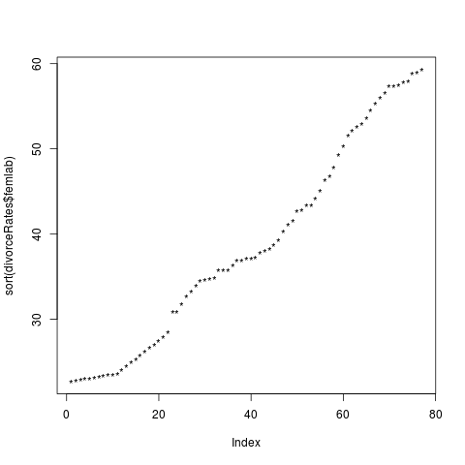

hist(divorceRates$marriage)
plot(density(divorceRates$marriage,na.rm=TRUE))
plot(sort(divorceRates$marriage),pch=”*”)

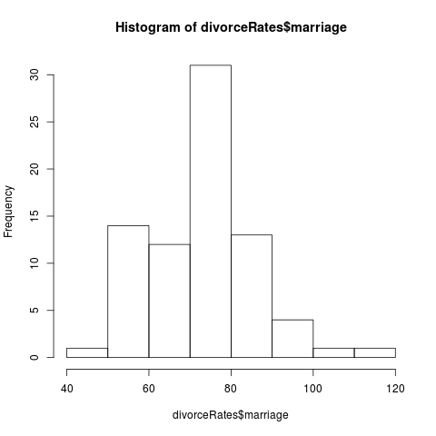
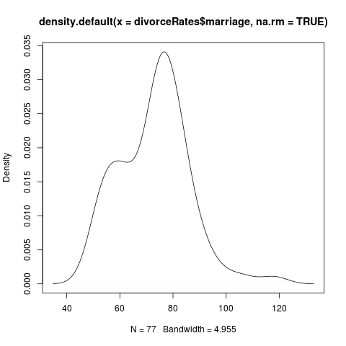
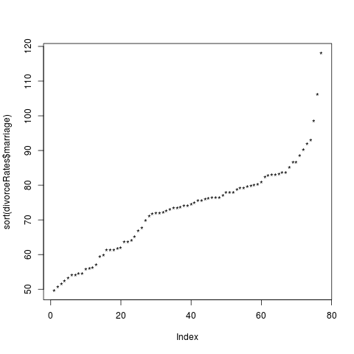

hist(divorceRates$birth)
plot(density(divorceRates$birth,na.rm=TRUE))
plot(sort(divorceRates$birth),pch=”*”)
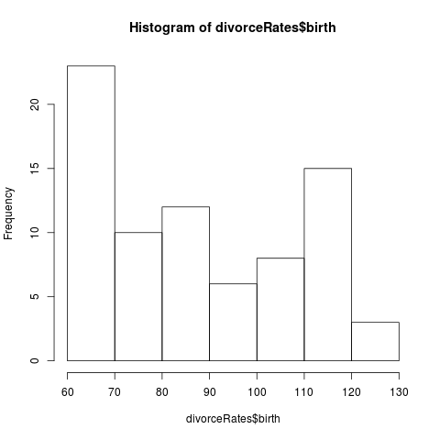
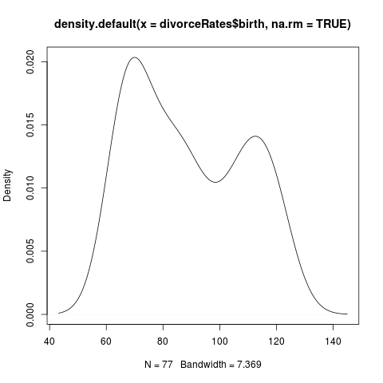
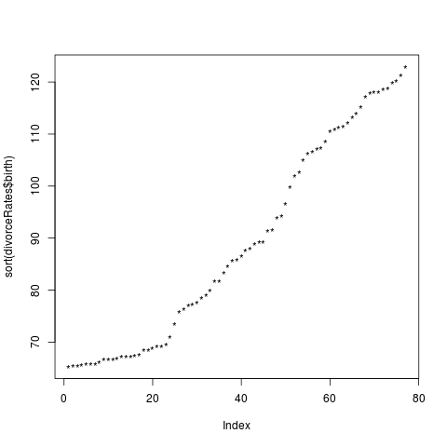
hist(divorceRates$military)
plot(density(divorceRates$military,na.rm=TRUE))
plot(sort(divorceRates$military),pch=”*”)

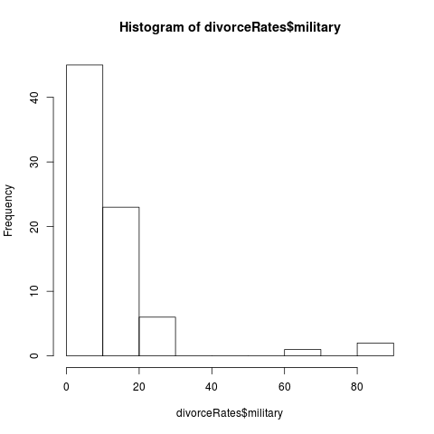
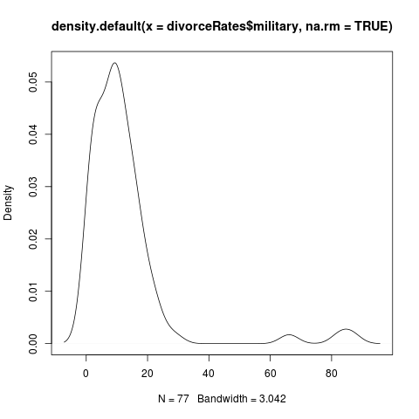
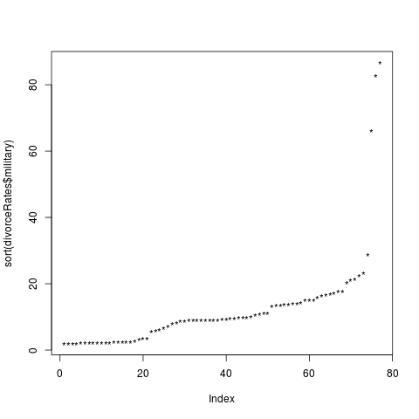

It looks like for most of the variables in the histograms and kernel density plots, the distributions are not normal, with marriage being the “closest.” In terms of the index plots, it is possible that marriage and military may contain some outliers.

pairs(divorceRates)

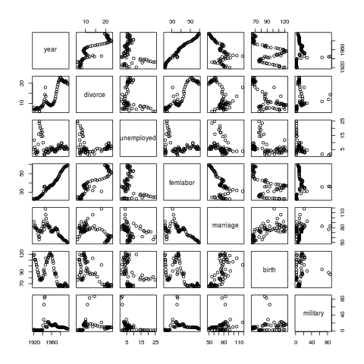

This produces a scatterplot matrix, comparing all of the variables to each other. There may be possible correlations between the year and % females working, year and divorce rates, and divorce and % females working, off initial observation.

We can look at the correlations numerically also.
cor(divorceRates)

year divorce unemployed femlabor marriage
year 1.000000000 0.87923753 -0.2344792 0.98598207 -0.6173255
divorce 0.879237534 1.00000000 -0.2106019 0.91039698 -0.5342554
unemployed -0.234479195 -0.21060188 1.0000000 -0.25746176 -0.2707630
femlabor 0.985982068 0.91039698 -0.2574618 1.00000000 -0.6486273
marriage -0.617325533 -0.53425537 -0.2707630 -0.64862728 1.0000000
birth -0.576313991 -0.72192425 -0.3138890 -0.60409490 0.6737273
military 0.007267171 0.01857483 -0.4002930 0.05126339 0.2581983

birth military
year -0.5763140 0.007267171
divorce -0.7219242 0.018574832
unemployed -0.3138890 -0.400292954
femlabor -0.6040949 0.051263390
marriage 0.6737273 0.258198260
birth 1.0000000 0.140898643
military 0.1408986 1.000000000

Here we see similar results – divorce rate and year may be correlated, % females working and year may be related, divorce rate and % females working may be related, and birth and marriage may be related.

NOTE: Only include a few graphs in report, put rest in appendixli

2) Regression Model

g <- lm(divorce ~ ., divorceRates)
summary(g)

Output:

Call:
lm(formula = divorce ~ ., data = divorceRates)

Residuals:
Min 1Q Median 3Q Max
-2.9087 -0.9212 -0.0935 0.7447 3.4689

Coefficients:
Estimate Std. Error t value Pr(>|t|)
(Intercept) 380.14761 99.20371 3.832 0.000274 ***
year -0.20312 0.05333 -3.809 0.000297 ***
unemployed -0.04933 0.05378 -0.917 0.362171
femlabor 0.80793 0.11487 7.033 1.09e-09 ***
marriage 0.14977 0.02382 6.287 2.42e-08 ***
birth -0.11695 0.01470 -7.957 2.19e-11 ***
military -0.04276 0.01372 -3.117 0.002652 **
---

Signif. codes: 0 ‘***’ 0.001 ‘**’ 0.01 ‘*’ 0.05 ‘.’ 0.1 ‘ ’ 1

Residual standard error: 1.513 on 70 degrees of freedom
Multiple R-squared: 0.9344, Adjusted R-squared: 0.9288
F-statistic: 166.2 on 6 and 70 DF, p-value: < 2.2e-16

- The percentage of variation in the response is 93.44%. This is indicated by the R^2 value in the output above. This R^2 is fairly close to 1, which indicates a fairly good fit of our model.
- Our F-test is as follows: H0: betas = 0 vs H1: betas not equal to 0. Since our p-value is so small, less than 0.05, we have statistically significant evidence that the betas are not equal to zero, meaning that divorce rate does depend on at least one of the predictors in this model.
- Our t-test (DOES THIS NEED TO BE SQUARED?) is the same hypothesis as above but for each coefficient individually. According to the above output, we see that the p-value is very small, less than 0.001 for 5 of the predictors, and there is one predictor that has a p-value of less than 0.01 According to the full model there is statistically significant evidence that divorce rate is dependent on year, femlabor, marriage, birth, and military to some degree. The only predictor that does not affect divorce rate in the full model is unemployed since the p-value is greater than 0.05.
- This is the 95% confidence interval for “year”.

confint(g, “year”)
2.5 % 97.5 %
year -0.3094757 -0.09675598

This confidence interval contains all values that are plausible values for the coefficient. The estimate given above in the summary is -0.20312 which means it is plausible. We fail to reject our null hypothesis (Bi = 0) on our confidence interval at a level of significance of 0.95.

(e) Permuation Test on “year”

tstats ← numeric(5000)
for(i in 1:5000) {
ge ← lm(divorce ~ sample(year) + unemployed + femlabor + mar riage + birth + military, divorceRates)
tstats[i] ← summary(ge)$coef[2,3]
}
mean(abs(tstats) > abs(summary(g)$coef[2,3]))

Output:

[1] 2e-04

We see that this outcome is very similar to the observed normal-based p-value of 0.000297.

(f) The predictor with the smallest p-value is marriage, which makes sense since divorce cannot occur without marriage first. The regression coefficient is 0.14977 which means that the rate of change of the conditional mean of divorce rates with respect to marriage is estimated to be about 0.14977 (or between -0.3094 and -0.096755 based on the confidence interval). Since the p-value is so small, we have statistically significant evidence that divorce rate is dependent on marriage rate.

3) Fitting of Reduced Value

We will now fit a reduced model that excludes three predictors with the largest p-values in the full model. These p-values are “unemployed,” “military,” and “year.”

g2 ← lm(divorce ~ femlabor + marriage + birth, divorceRates)

a) The question we want answered is “Are unemployed, military, and year useful in predicting the response?” The hypothesis test is as follows:
H0: Beta(unemployed) = Beta(military) = Beta(year) = 0.
b) We can conduct an F-test using the R-command anova (analysis of variance)

anova(g2, g)

Output:

Analysis of Variance Table

Model 1: divorce ~ femlabor + marriage + birth
Model 2: divorce ~ year + unemployed + femlabor + marriage + birth + military

Res.Df RSS Df Sum of Sq F Pr(>F)
1 73 209.84
2 70 160.20 3 49.643 7.2308 0.0002699 ***
---
Signif. codes: 0 ‘***’ 0.001 ‘**’ 0.01 ‘*’ 0.05 ‘.’ 0.1 ‘ ’ 1

We see in the above that the p-value from this F-test is 0.0002699, which is less than 0.05, so we reject the null hypothesis. It is thus unlikely that Beta(unemployed) = Beta(military) = Beta(year) = 0, meaning that it is statistically significant that divorce rates depend on at least one of these predictors that we had removed. Thus, it is statistically significant that there's a difference between the bigger model and the smaller model.

4) Residual Analysis

It is possible that there are some problems with our full model, such as errors, incorrect model, or we notice any unusual observations.

a) First we will test if our assumption of constant variance (no heteroscedasticity) is valid. We will plot the absolute values of the residuals vs. fitted plot.

plot(fitted(g), abs(residuals(g)), xlab=”Fitted”, ylab=”|Residuals|”)

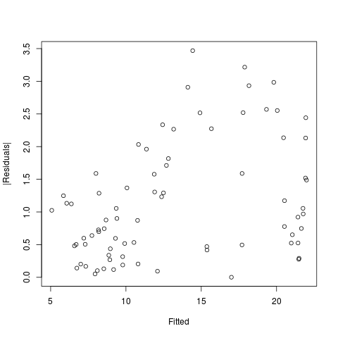

In the above plot, it seems that the points are fairly random. There is a slight possibility of some linear relationship since the top left corner contains no points, but overall, the points look pretty scattered throughout. There doesn't seem to be a linear relationship between the fitted values and the residuals, so constant variance is possible. This is not evidence enough however, and we can also check numerically.

summary(lm(abs(residuals(g)) ~ fitted(g)))

Output:

Call:
lm(formula = abs(residuals(g)) ~ fitted(g))

Residuals:
Min 1Q Median 3Q Max
-1.3589 -0.6708 -0.1452 0.5432 2.2595

Coefficients:
Estimate Std. Error t value Pr(>|t|)
(Intercept) 0.36132 0.25010 1.445 0.15270
fitted(g) 0.05877 0.01744 3.370 0.00119 **
---

Signif. codes: 0 ‘***’ 0.001 ‘**’ 0.01 ‘*’ 0.05 ‘.’ 0.1 ‘ ’ 1

Residual standard error: 0.8331 on 75 degrees of freedom
Multiple R-squared: 0.1315, Adjusted R-squared: 0.1199
F-statistic: 11.36 on 1 and 75 DF, p-value: 0.001189

We see that there is a fairly large F-statistic and very small p-value, which indicates that there is statistically significant evidence that we have some issue with nonconstant variance and will need to consider a variance stabilizing transform for our model.

b) Now we will consider if our assumption of normality that our tests and confidence intervals are based on is valid. We can check this using a variety of plots. First, we'll start with a histogram.

hist(residuals(g))

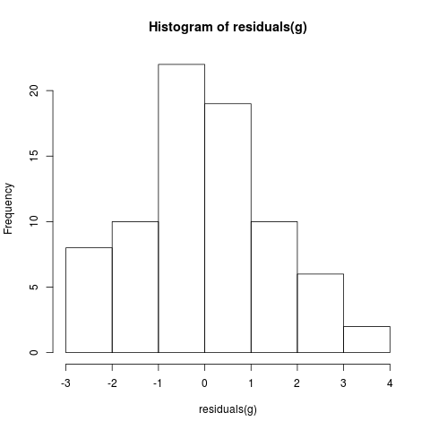

We see from the histogram that it is not perfectly normal with the left side having a larger tail than the right side, lacking symmetry.

Now we will create a kernal density plot to show a smoother curve.

plot(density(residuals(g),na.rm=TRUE))

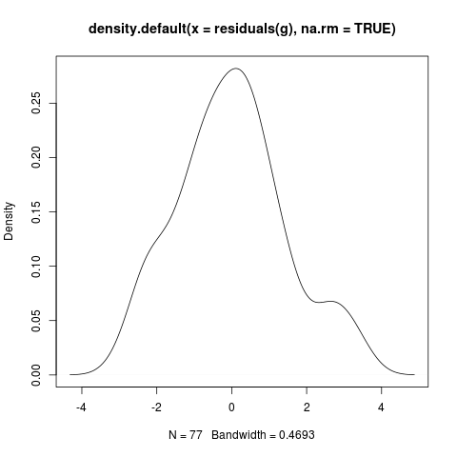

This plot is more accurate, and we see that as previously noted, the symmetry is not perfect due to the left-side being larger. The right-tail also has a bit of a “bump.”

Now we will look at a Q-to-Q plot.

qqnorm(residuals(g),ylab=”Residuals”)
qqline(residuals(g))

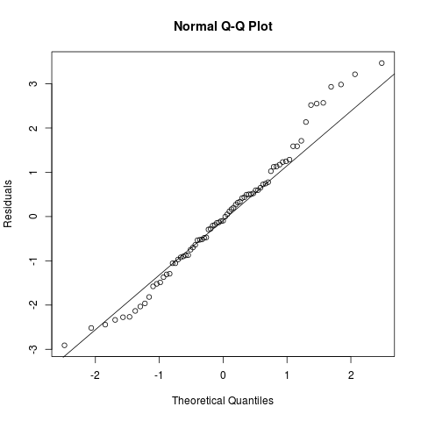

This plot is decent in the middle in that the residuals approximately follow the line. However, in the top right corner, we see there are a number of points significantly above the line. Also in the bottom left, there are points a bit below the line.

Finally, we can compute a numerical test for normality, using the formal Shapiro-Wilk test.

shapiro.test(residuals(g))

Output:

Shapiro-Wilk normality test

data: residuals(g)
W = 0.9821, p-value = 0.3533

Our null hypothesis is that the residuals are normal. We see from the above output that the p-value is large (> 0.05), so we do not reject the null, so we do not reject our assumption of normality. Thus, we have statistically significant evidence that our assumption of normality is valid.

c) We will now check for large leverage points - these points have the potential to influence the fit of the model. For this dataset, we have n=77 and p=7 (since we are testing divorce against all the predictors). Thus, the average leverage is p/n = 7/77 = 0.09091. Thus, we consider high leverages to be when they are greater than 2p/n, so g_ii > 0.18182

ginf ← influence(g)
ginf$hat

Output:

1 2 3 4 5 6 7
0.17923126 0.19262155 0.10667159 0.11930009 0.09061839 0.10418821 0.13091138
8 9 10 11 12 13 14
0.11436107 0.12800124 0.16155425 0.11141617 0.10079024 0.18992108 0.18690843
15 16 17 18 19 20 21
0.13010015 0.10596336 0.07622650 0.06602031 0.08840172 0.07312101 0.07485700
22 23 24 25 26 27 28
0.06728733 0.07105530 0.22734309 0.36691229 0.38057505 0.29068273 0.16149588
29 30 31 32 33 34 35
0.09636761 0.03702274 0.05383937 0.03908617 0.04255022 0.04986045 0.06724674
36 37 38 39 40 41 42
0.05854729 0.07163152 0.08136706 0.09693184 0.08305469 0.08015953 0.10351527
43 44 45 46 47 48 49
0.08411485 0.06954879 0.06291028 0.05716863 0.05210652 0.04890858 0.05335497
50 51 52 53 54 55 56
0.04224388 0.02886676 0.05043100 0.07347033 0.08356097 0.06635946 0.04133080
57 58 59 60 61 62 63
0.04598761 0.03968555 0.03661142 0.03676789 0.03821133 0.04266369 0.05573972
64 65 66 67 68 69 70
0.04978379 0.04461208 0.04930821 0.05510656 0.05902634 0.06261158 0.07117823
71 72 73 74 75 76 77
0.06647740 0.05918479 0.06232301 0.05753343 0.06365210 0.06369388 0.06774841

We see from the above output that the following leverages are greater than 0.18182: 2, 13, 14, 24, 25, 26, and 27. We can view high leverages on a plot also.

datapoints <-row.names(divorceRates)
halfnorm(lm.influence(g)$hat,labs=datapoints,ylab=”Leverages”)

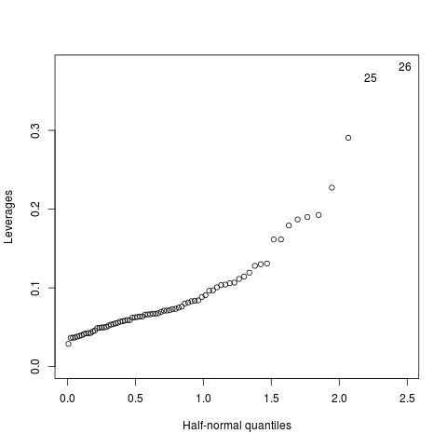

We see from this plot that only 25 and 26 are singled out as high leverage points. From the numerical results, these were the highest leverages. It is likely that the the next 5 points downwards and to the left of the top right corner are the next highest leverage points, as from the numerical results. We can conclude that at least 25 and 26 are large leverage points. The next 5 may possibly be also, but less likely.

d) Now we will check for outliers – points that do not fit into our model. We can do this by analyzing the plot of the fitted values versus the square root of the standardized residuals.

plot(g,3)

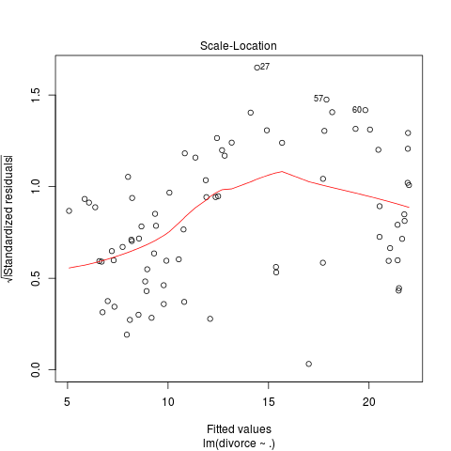

We see three outliers singled out in this plot; 27, 57, and 50. It does look like 27 may be an outlier, but 57 and 60 may be “borderline” outliers, since they are so near the cluster of points.

e) Finally, we will check for any influential points, which are points whose removal from the dataset would cause a large change in the fit. It may be an outlier or have a high leverage point or both. We can use Cook's Distance to aid us in finding such points.

cook ← cooks.distance(h)
plot(cook, ylab=”Cook's Distance”)

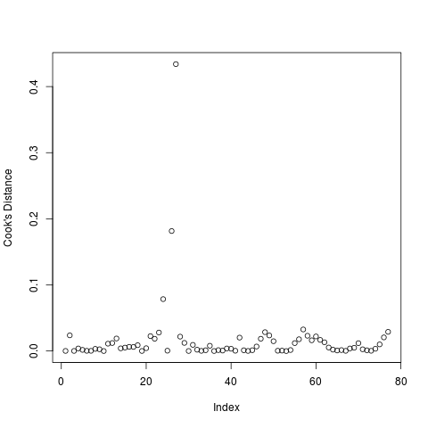

We see from this plot that there are 3 points that could be influential points, between indexes 20 and 40. We can plot the specific data points that have the highest cook's distances.

halfnorm(cook, 3, labs=datapoints, ylab=”Cook's Distances”)

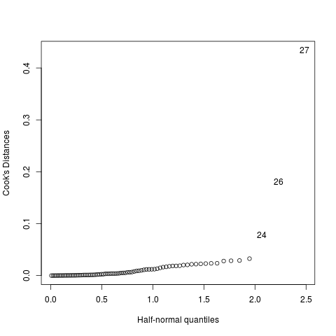

As with earlier observations, it is no surprise that 27, 26, and 24 have the largest Cook's distances, indicating they may have high influence on the model. We refit the model excluding some of these points from the model.

g3 ← lm(divorce ~ ., divorceRates, subset = (cook < max(cook)))
summary(g3)

Output:

Call:
lm(formula = divorce ~ ., data = divorceRates, subset = (cook <
max(cook)))

Residuals:
Min 1Q Median 3Q Max
-2.7935 -0.8833 -0.0572 0.6571 3.2637

Coefficients:
Estimate Std. Error t value Pr(>|t|)
(Intercept) 363.10466 94.66911 3.836 0.000274 ***
year -0.19231 0.05093 -3.776 0.000334 ***
unemployed -0.07262 0.05186 -1.400 0.165915
femlabor 0.76518 0.11042 6.930 1.78e-09 ***
marriage 0.11147 0.02635 4.231 7.03e-05 ***
birth -0.11252 0.01408 -7.990 2.08e-11 ***
military -0.03906 0.01313 -2.975 0.004040 **
---
Signif. codes: 0 ‘***’ 0.001 ‘**’ 0.01 ‘*’ 0.05 ‘.’ 0.1 ‘ ’ 1

Residual standard error: 1.441 on 69 degrees of freedom
Multiple R-squared: 0.9408, Adjusted R-squared: 0.9357
F-statistic: 182.9 on 6 and 69 DF, p-value: < 2.2e-16

We see that most of the coefficients in this new model have slightly increased from the original model. However, all of the variables that were significant before have still remained significant at the 5% level. As a result, it is unlikely that data point 27 has a high level of influence on the model. Let's now try to exclude data point 26 from the model.

g4 ← lm(divorce ~ ., divorceRates, subset = (datapoints != 26))
summary(g4)

Output:

Call:
lm(formula = divorce ~ ., data = divorceRates, subset = (datapoints !=
26))

Residuals:
Min 1Q Median 3Q Max
-2.8470 -0.9664 -0.0637 0.7295 3.5297

Coefficients:
Estimate Std. Error t value Pr(>|t|)
(Intercept) 372.13855 98.58793 3.775 0.000336 ***
year -0.19914 0.05299 -3.758 0.000354 ***
unemployed -0.04928 0.05336 -0.924 0.358897
femlabor 0.80641 0.11398 7.075 9.73e-10 ***
marriage 0.15186 0.02368 6.413 1.51e-08 ***
birth -0.11411 0.01471 -7.755 5.60e-11 ***
military -0.05599 0.01639 -3.416 0.001068 **
---
Signif. codes: 0 ‘***’ 0.001 ‘**’ 0.01 ‘*’ 0.05 ‘.’ 0.1 ‘ ’ 1

Residual standard error: 1.501 on 69 degrees of freedom
Multiple R-squared: 0.9363, Adjusted R-squared: 0.9308
F-statistic: 169.1 on 6 and 69 DF, p-value: < 2.2e-16

Again, we see very small changes between coefficients of the original model and the new model. All of the variables that were significant in the old model remain significant in the new model. Thus, data point 26 does not seem to have a high influence on the model.

5) Collinearity

Collinearity occurs when some of the predictors are linear combinations of other predictors, which leads to X^TX being singular or close to being singular, and we have imprecise estimates of Beta. This can cause the signs of the coefficients to be reversed, standard errors to be inflated, t-tests to be inaccurate, and the fit can be off. First, we will consider the pairwise correlations.

round(cor(divorceRates),3)

Output:

year divorce unemployed femlabor marriage birth military
year 1.000 0.879 -0.234 0.986 -0.617 -0.576 0.007
divorce 0.879 1.000 -0.211 0.910 -0.534 -0.722 0.019
unemployed -0.234 -0.211 1.000 -0.257 -0.271 -0.314 -0.400
femlabor 0.986 0.910 -0.257 1.000 -0.649 -0.604 0.051
marriage -0.617 -0.534 -0.271 -0.649 1.000 0.674 0.258
birth -0.576 -0.722 -0.314 -0.604 0.674 1.000 0.141
military 0.007 0.019 -0.400 0.051 0.258 0.141 1.000

We see that there are some pairwise correlations that are fairly large both between predictors and between predictors and the response: year and divorce (0.879), year and femlabor (0.986), divorce and femlabor (0.910), and marriage and birth (0.674).

Now we can check the condition numbers.

x ← model.matrix(g)[,-1]
(xtx ← t(x) %*% x)
e ← eigen(xtx)
sqrt(e$val[1]/e$val)

Output:

[1] 1.00000 81.00863 131.78820 208.05688 287.60375 661.12042

We see that kappa = 661.12042, which is much greater than 30, so there must be a problem. We also see that almost all the condition numbers are very large, so this indicates that there is more than one independent linear combination. All of this means that collinearity does exist.

We can also analyze the effect of collinearity on our model by computing the variance inflation factors.

vif(x)

Output:

year unemployed femlabor marriage birth military
47.268817 2.479526 60.655679 3.246263 2.733198 1.379379

We can interpret these values by taking the square root of each one:

Output:

year unemployed femlabor marriage birth military
6.875232 1.574651 7.788176 1.801739 1.653239 1.174470
This shows that the standard error for the year is 6.875 times as large as it would have been without collinearity, the standard error for unemployed is 1.574 times as large as it would have been without collinearity, the standard error for femlabor is 7.788 times as large as it would have been without collinearity, and etc.. Thus, year and femlabor are the two predictors most affected by collinearity. We cannot actually apply this correction since we did not observe orthogonal data, but we do have a sense of the size of the effect.

One way to fix collinearity is to remove predictors from the model that do not affect the fit of the model or the response, since we may have too may variables that are trying “explain the response” by doing the same thing.

6) Box-Cox

library(MASS)
boxcox(g, plotit=T, lambda=seq(-1.7, 0, by=0.05))

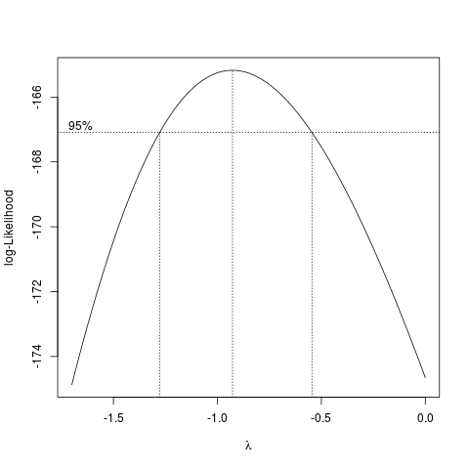

The above figure shows the box-cox transformation of the response. We see that the confidence interval for lambda runs from about -1.3 to about -0.65. It looks like lambda is about -0.9, which we can round to -1. This means that an inverse transformation may be best here.

g_transform ← lm(1/divorce ~ ., data=divorceRates)
summary(g_transform)

Output:

Call:

lm(formula = 1/divorce ~ ., data = divorceRates)

Residuals:

Min 1Q Median 3Q Max

-0.0127718 -0.0050317 -0.0001846 0.0043031 0.0169002

Coefficients:

Estimate Std. Error t value Pr(>|t|)

(Intercept) 3.147e-01 4.549e-01 0.692 0.49134

year -4.771e-05 2.445e-04 -0.195 0.84586

unemployed 6.880e-04 2.466e-04 2.790 0.00679 **

femlabor -2.766e-03 5.267e-04 -5.251 1.55e-06 ***

marriage -1.248e-03 1.092e-04 -11.428 < 2e-16 ***

birth 6.928e-04 6.739e-05 10.279 1.26e-15 ***

military -3.268e-05 6.291e-05 -0.519 0.60509

---

Signif. codes: 0 ‘***’ 0.001 ‘**’ 0.01 ‘*’ 0.05 ‘.’ 0.1 ‘ ’ 1

Residual standard error: 0.006937 on 70 degrees of freedom

Multiple R-squared: 0.9643, Adjusted R-squared: 0.9612

F-statistic: 314.7 on 6 and 70 DF, p-value: < 2.2e-16

We see here that refitting the full model with the inverse of the response, divorce, has increased R^2 to closer to 1. The residual standard error has decreased and the F-statistic has increased. For the predictors, we see that year and military are no longer significant variables. It looks like unemployed has become significant. It does indeed look like this transformed model is more accurate.

7) Variable Selection

(a) Backward Elimination

The method of Backward Elimination removes predictors one at a time that have a p-value greater than alpha_crit (5%). First, we will remove unemployed, which has a p-value of 0.362171.

g5 ← lm(divorce ~ year + femlabor + marriage + birth + military, divorceRates)
summary(g5)

Output:

Call:

lm(formula = divorce ~ year + femlabor + marriage + birth + military,

data = divorceRates)

Residuals:

Min 1Q Median 3Q Max

-2.7586 -1.0494 -0.0424 0.7201 3.3075

Coefficients:

Estimate Std. Error t value Pr(>|t|)

(Intercept) 405.61670 95.13189 4.264 6.09e-05 ***

year -0.21790 0.05078 -4.291 5.52e-05 ***

femlabor 0.85480 0.10276 8.318 4.29e-12 ***

marriage 0.15934 0.02140 7.447 1.76e-10 ***

birth -0.11012 0.01266 -8.700 8.43e-13 ***

military -0.04120 0.01360 -3.030 0.00341 **

---

Signif. codes: 0 ‘***’ 0.001 ‘**’ 0.01 ‘*’ 0.05 ‘.’ 0.1 ‘ ’ 1

Residual standard error: 1.511 on 71 degrees of freedom

Multiple R-squared: 0.9336, Adjusted R-squared: 0.929

F-statistic: 199.7 on 5 and 71 DF, p-value: < 2.2e-16

Now, all of the predictors left are significant at the 5% level. This new model is:
g5 = year + femlabor + marriage + birth + military.

(b) Mallows Cp

Now we will attempt a criterion-based procedure of variable reduction. The Mallows Cp statistic is an estimate of the average mean square error of the prediction. We want to minimize this statistic.

First, we will discover the best models for each size.

library(leaps)
b ← regsubsets(divorce ~., divorceRates)
(rs ← summary(b))

Output:

1 subsets of each size up to 6

Selection Algorithm: exhaustive

year unemployed femlabor marriage birth military

1 ( 1 ) " " " " "*" " " " " " "

2 ( 1 ) " " " " "*" " " "*" " "

3 ( 1 ) " " " " "*" "*" "*" " "

4 ( 1 ) "*" " " "*" "*" "*" " "

5 ( 1 ) "*" " " "*" "*" "*" "*"

6 ( 1 ) "*" "*" "*" "*" "*" "*"

Here we see that the best one predictor model uses femlabor, the best two predictors model uses femlabor and birth, the best three predictors model uses femlabor, marriage, and birth, and so on.

Now we will construct a Cp plot.

plot(2:8, rs$cp, xlab='Number of Parameters”, ylab=”Cp Statistic”)
abline(0,1)

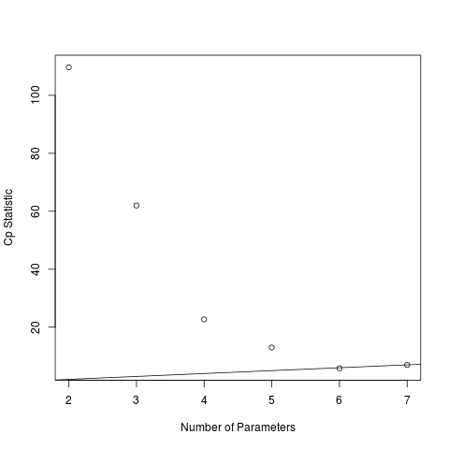

We are looking for models that are on or below the Cp=p line, which indicate good fits. Here, the smallest one is 6 parameters, which means 5 predictors.
Thus, the best model contains 5 predictors, according to the Cp criterion:

g6 = year + femlabor + marriage + birth + military

(c) From our analysis, we find that both Backward Elimination and Mallows Cp give the same results – the best model contains 5 predictors: year, femlabor, marriage, birth, and military. If we observe the summary of this model, we find that the R^2 has decreased slightly, by 0.002. This is not a significantly large change however. We also see that all of the predictors being used are significant at the 5% level. We can conclude that this new model is overall the best fit.

8 Future Observation

