**Subject:**

TC4002 - Analysis, Design and Construction of Software Systems

**Professor:**

Gerardo Padilla Zarate

**L2.2 - Development Exercises**

**Student:**

Juan Francisco Corral Stenner A00354823

10) Create a class called myPowerList, implement methods for

- Adding items

- Removing the n-th item

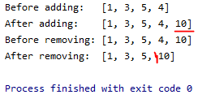

11) Add a method in myPowerList to return the sorted list

[ Do not use list.sort, implement the algorithm iterating in the list]

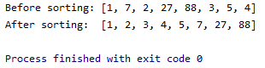

12) Add a method in myPowerList to merge another list with the current list

- Lmerge (merge the list as prefix)

- Rmerge (merge the list as suffix)

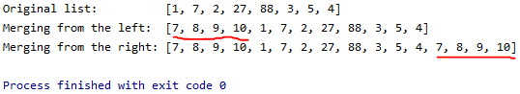

13) Add a method in myPowerList to save the current list as a text file

- saveToTextFile(filename)

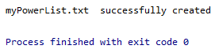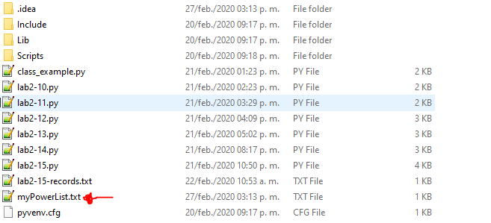

**14) Add a method in myPowerList to read values for a List from a Text file**

**- readFromTextFile(filename)**

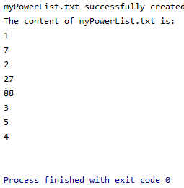

**15) Create a class to manage a directory of users containing data**

* **Name**
* **Address**
* **Phone**
* **Email**

**The class must be enable:**

1. **Creation of new record**
2. **Save all records in a file**
3. **Load records from a file**
4. **Search and get data from a given record**

