

**Orange Coding Academy**

**Master Project Report**

Mal3abak / ملعبك

**Prepared by:**

Ashraf Nasir Al Jabari

**May 2021**

**Contents**

Abstract 2

Chapter 1: Introduction 1

1.1 Description of the current situation and opportunity 1

1.2 Related work 1

1.3 Problem statement (limitation of current systems) 2

1.4 Problem solution 2

1.5 Project objectives 3

a. The project aims at addressing the following objectives: 3

1.6 Technology and tools used. 3

Chapter 2: Requirements and Analysis 4

2.1 System scope with explanation 4

2.2 Functional Requirements & Non-Functional Requirements 4

2.2.1 List of Functional Requirements 4

2.2.2 List of Non-Functional Requirements 5

2.3 Use Case Diagram with Use Cases descriptions 6

Chapter 3: Design 7

3.1 Class Diagram 7

3.2 Database Schema 8

Chapter 4: System Implementation 8

4.1 Main System Wireframes 8

Chapter 5: Conclusion & Future Work 16

6.1 Conclusion 16

6.2 Future work 17

References 19

Appendix 20

# Abstract

*Thousands of technologies and inventions have changed the world and made our life easier in many ways; we can say that everything around us is changing over time. For example, smartphones have become indispensable in our daily life, but we are still trying to find the best way to make things easier. Nowadays, many people play different kinds of sport every day, it even became a routine for them they can’t miss a day without playing football or basketball or any other type of sports that they are into. However, to call the playground owner to book for example the soccer field might have some drawbacks, like they might not find the time they desire or the playground they always book, also the owner of the playground might not answer his phone and take many hours before he answers, and if the player’s friends don’t want to play with him he might not go at all because he can’t play alone. Accordingly, we can notice many disadvantages to this old fashion approach. Instead of all of this we can make things easier, all we have to do is download our application (****Mal3abak****) on the mobile phone, the owner of the playgrounds or any person who would like to rent a playground can manage his playgrounds easily from the application and see the people who booked it. Moreover, the player can book a playground using the application and find any playground he desires to book. He might have many options and different prices even if he’s alone he can team up with other players. So this application will make a lot of things easier and more efficient in the field of sport.*

*This idea is implemented in other countries but here in Jordan, it is new.*

# Chapter 1: Introduction

## Description of the current situation and opportunity

Nowadays, if someone wants to play football or other types of sports, they will have to rent a playground with their friends and go to play, if they could not find anyone of their friends to play with, then they just cancel it.

We want to solve this problem with an application to make it easier for them to find people to play with a time and rent the playground through the application.

## Related work

1. **Geofit:** is a social network that connect thousands of Gym Buddies and Fitness Professionals in the region, share images, video and status updates, and stay in touch with the fitness industry. [1] Also you can book a personal training session.
2. **Allympiapass**: it offers one membership that gives you access to hundreds of gyms and thousands of classes. Practicing your favorite sport should be an effortless experience. [2]
3. **Tartan:** is an app to discover football playgrounds around you and rent football playground, customize your booking functions, and play with your friends, and the applications can send notifications to your friends by place and time. [3]
4. **Golato:** it is an app that offers you the chance to rent football playground and customize the playground rent and see how many rents there in the playgrounds are and renting without contacting the playground staff. [4]

## Problem statement (limitation of current systems)

1. A person may wish to play group games but there are no partners or players available in a particular time or area.
2. Current booking for those play areas, indoor or outdoor are booked manually through phone calls.
3. People who wish to play in nearby locations are not aware of these places.
4. The availability of the ground play area admins is very needed to make the booking. Therefore, booking a play area is constrained on the availability of the admin.
5. Sometimes a player joins without knowing other members. The player may discover that the team members do not fit his interests such as age gap or gender.

## Problem solution

A mobile app that runs on both IOS and Android platforms. The application allows registered users to manage booking in nearby play area based on customized search filters:

1. Location
2. Game
3. Age
4. Gender
5. Indoor/outdoor

This application will allow its user to discover play areas based on their needs. Therefore, this application will motivate more people to join indoor/outdoor group exercises. The application is targeted to both people who wish to search to join a game. And to play areas owners who wish to rent their play areas for free or with fee and to know who are joining. The application availability is not constrained by admin playground availability.

## Project objectives

## The project aims at addressing the following objectives:

1. To allow players creating accounts to customize their search for a group exercise play area based on filters location, gender, age, game and weather indoor/outdoor in order to book a game that fits their interests.
2. To allow people who booked for a play area to see who is joining the game.
3. To allow play area owners creating accounts to display the description and availability of their play area for booking and renting purposes.
4. To allow the play area owner to see who booked or coming to the game.
5. To allow play area owners to rent a subscription to promote their services.

## Technology and tools used.

1. **React (Front end)**
2. **NodeJS (Back end)**
3. **MongoDB (Database)**

# Chapter 2: Requirements and Analysis

## System scope with explanation

Our system scope is expected to be within the main functions below:

1. Manage booking.
2. Renting.
3. search.
4. Login and signup.
5. Creating a playground.
6. View profile.
7. English support.

However, our future scope is:

* 1. Multi Language.
  2. Collect Points.
  3. Tournaments.
  4. Mobile application.

## Functional Requirements & Non-Functional Requirements

### List of Functional Requirements

1. Owner/ Player Login
   1. The owner/player shall log in by correct entering email and password.
   2. The application shall show an error message if any entered login data is incorrect.
2. Owner/Player Signup

2.1 The Owner shall create an account by entering his mandatory information.

1. Create playground by Owner:
   1. The owner shall create a playground after creating an account and successful login.
   2. The owner shall be directed to his homepage and shall select a created playground.
   3. The owner shall create playground by filling the playground mandatory information:

* Name.
* Location.
* Size number of players.
* Gender.
* Phone number.
* Ground type. (Indoor, Outdoor)

1. View profile:
   1. The user shall view another user's profile or owners’ profile.
   2. The owner shall be able to view users’ profile and access their information.
2. Managing bookings:
   1. The user shall be able to manage his bookings, cancel them or re-casual or add more games.
   2. The owner shall be able to view his playgrounds and view players of the playground and can manage the playgrounds.
3. Renting:
   1. The user shall be able to rent playgrounds depends on his needs.
4. search:
   1. The user shall be able to search for playgrounds:
      * Playground name.

### List of Non-Functional Requirements

1. Availability

The application shall be available 24/7.

1. Reliability

The application shall be real-time.

1. Maintainability:

The application shall be able to be maintained in the shortest time possible.

## Use Case Diagram with Use Cases descriptions

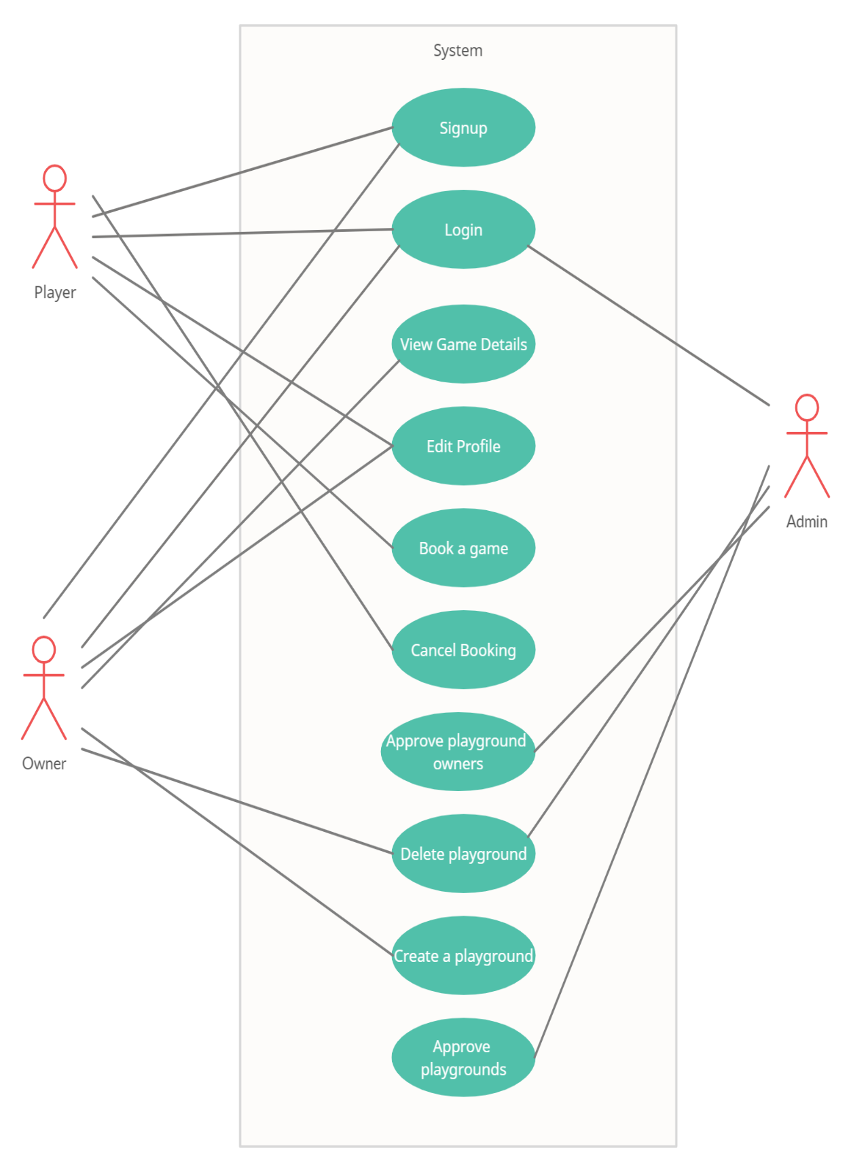

# Chapter 3: Design

## Class Diagram

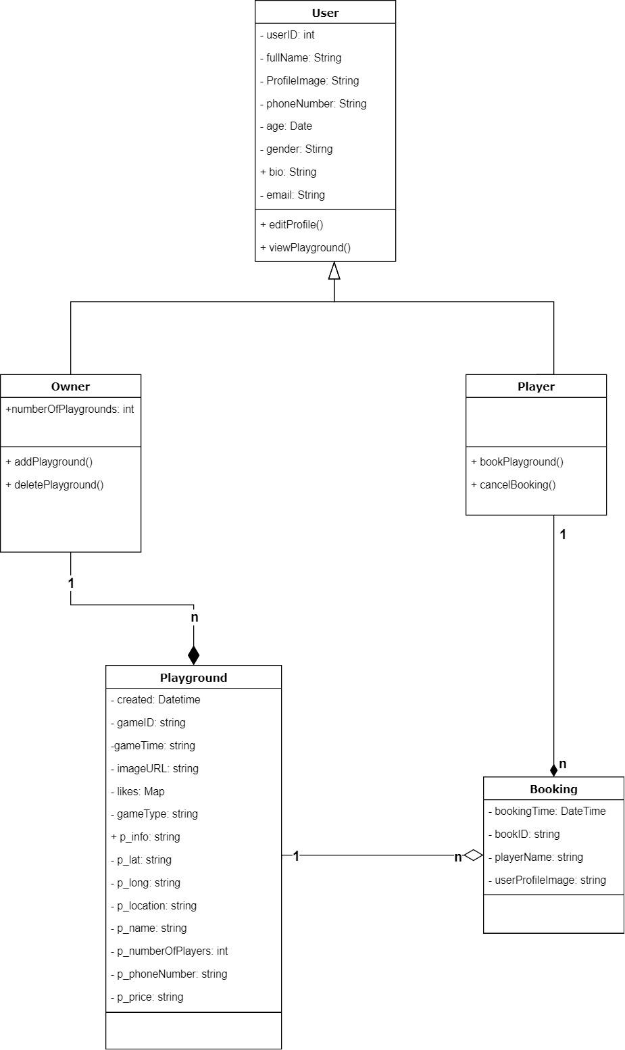

Figure 20: Class diagram

## Database Schema

|  |  |  |  |  |
| --- | --- | --- | --- | --- |
| **Player** | Username (optional) | Phone number | password | Number of Reports |

|  |  |  |
| --- | --- | --- |
| **Owner** | Phone number | password |

|  |  |  |
| --- | --- | --- |
| **Admin** | Email | Password |

|  |  |  |  |  |  |  |
| --- | --- | --- | --- | --- | --- | --- |
| **Playground** | Playground Name | Number of players | dates | location | type | image |

|  |  |  |  |  |
| --- | --- | --- | --- | --- |
| **Booking** | Playground id | Player id | Playground name | date |

|  |  |
| --- | --- |
| **Blocked Users** | Phone number |

# Chapter 4: System Implementation

## Main System Wireframes

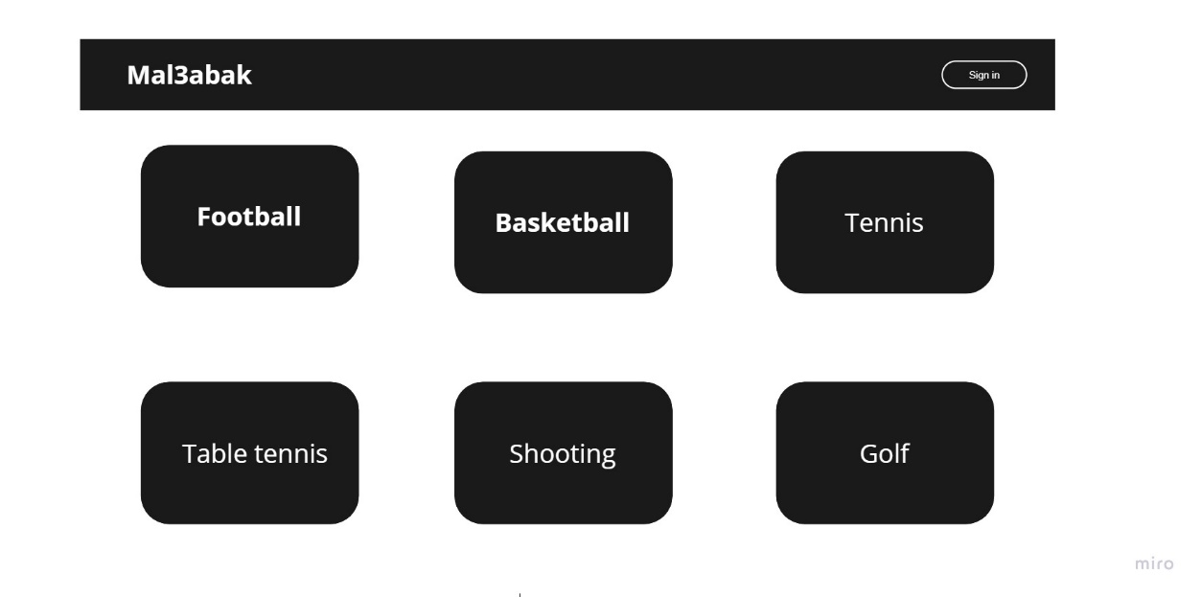

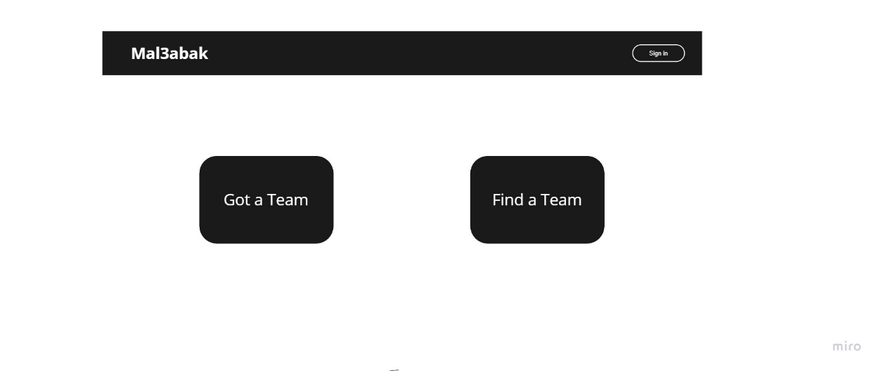

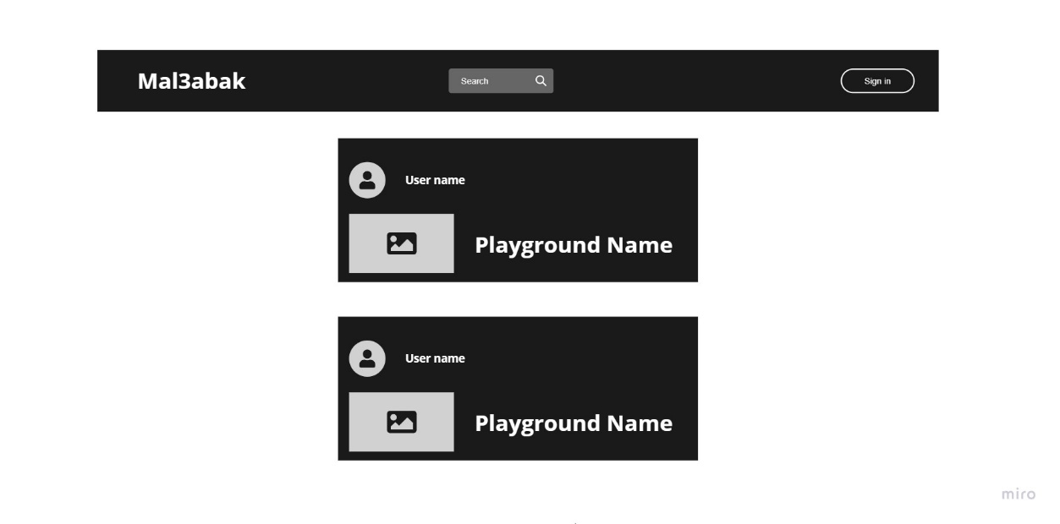

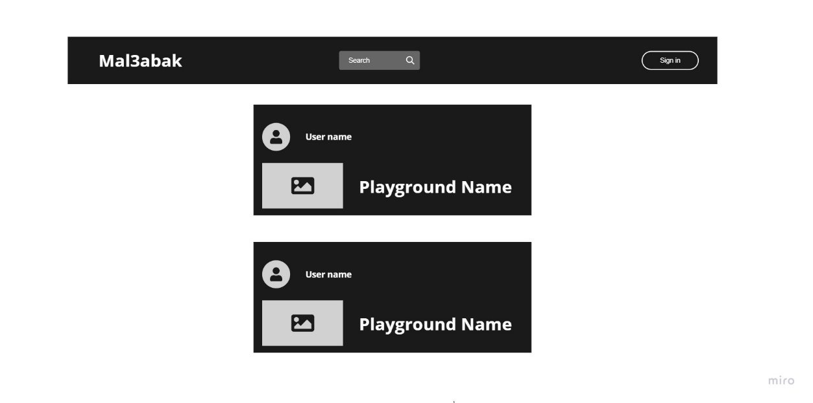

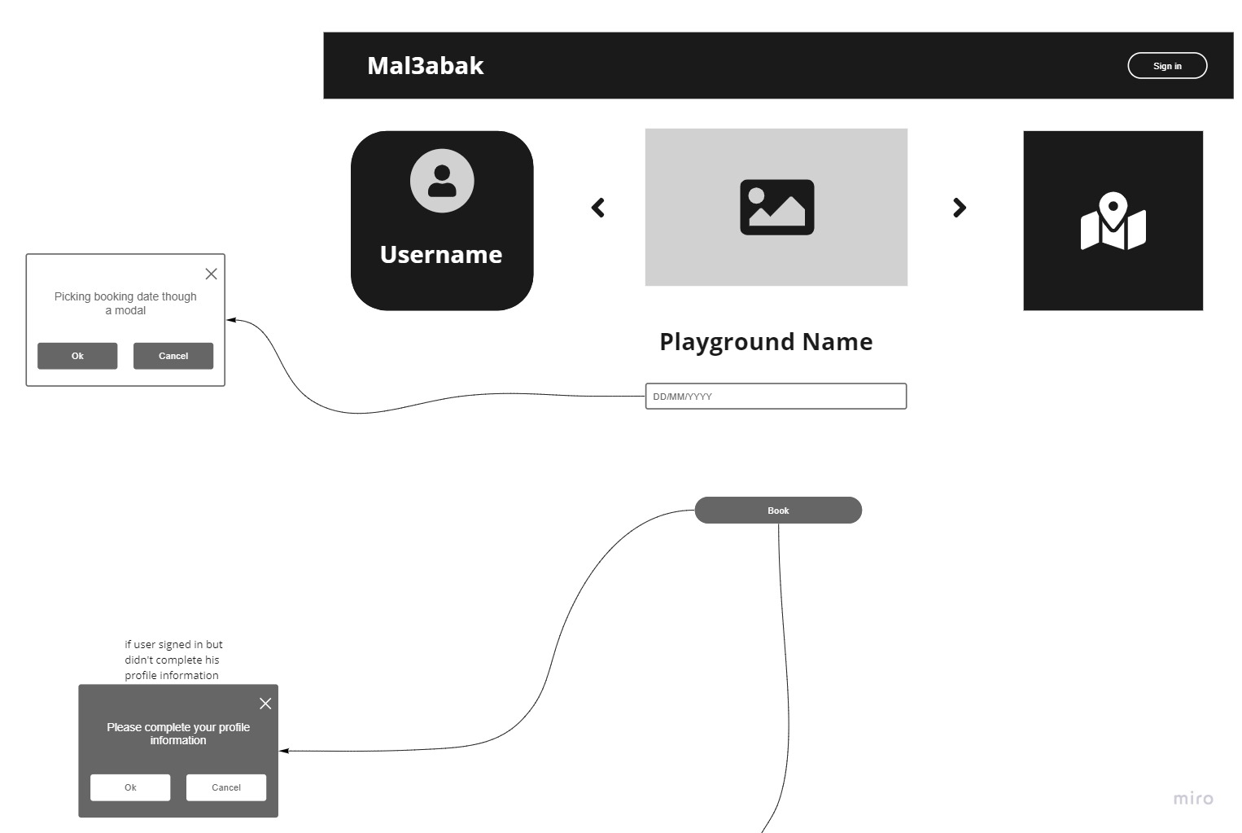

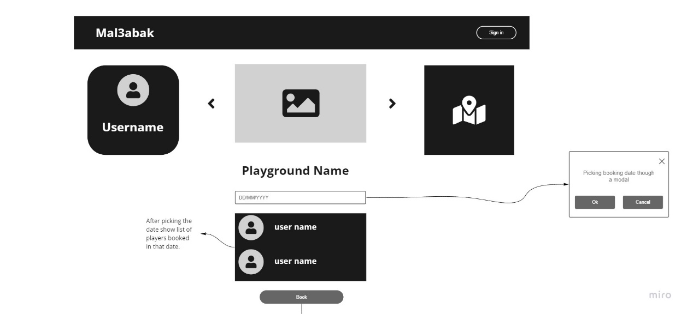

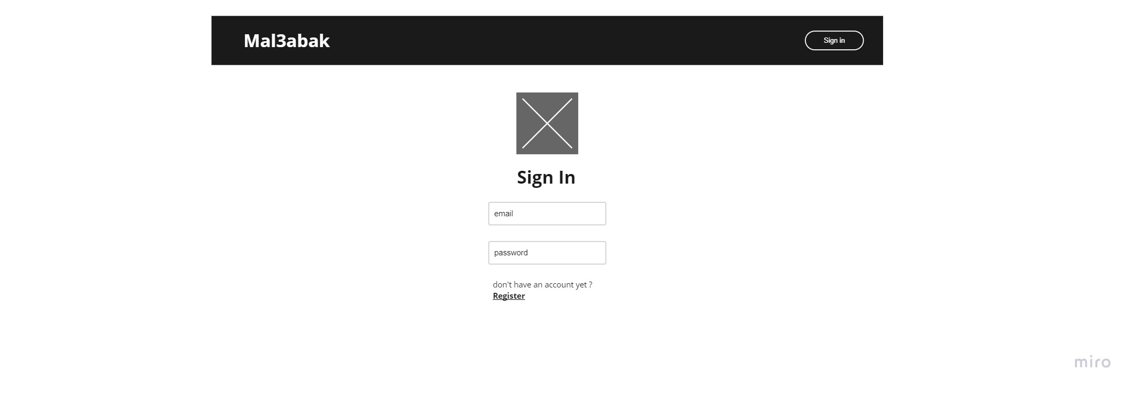

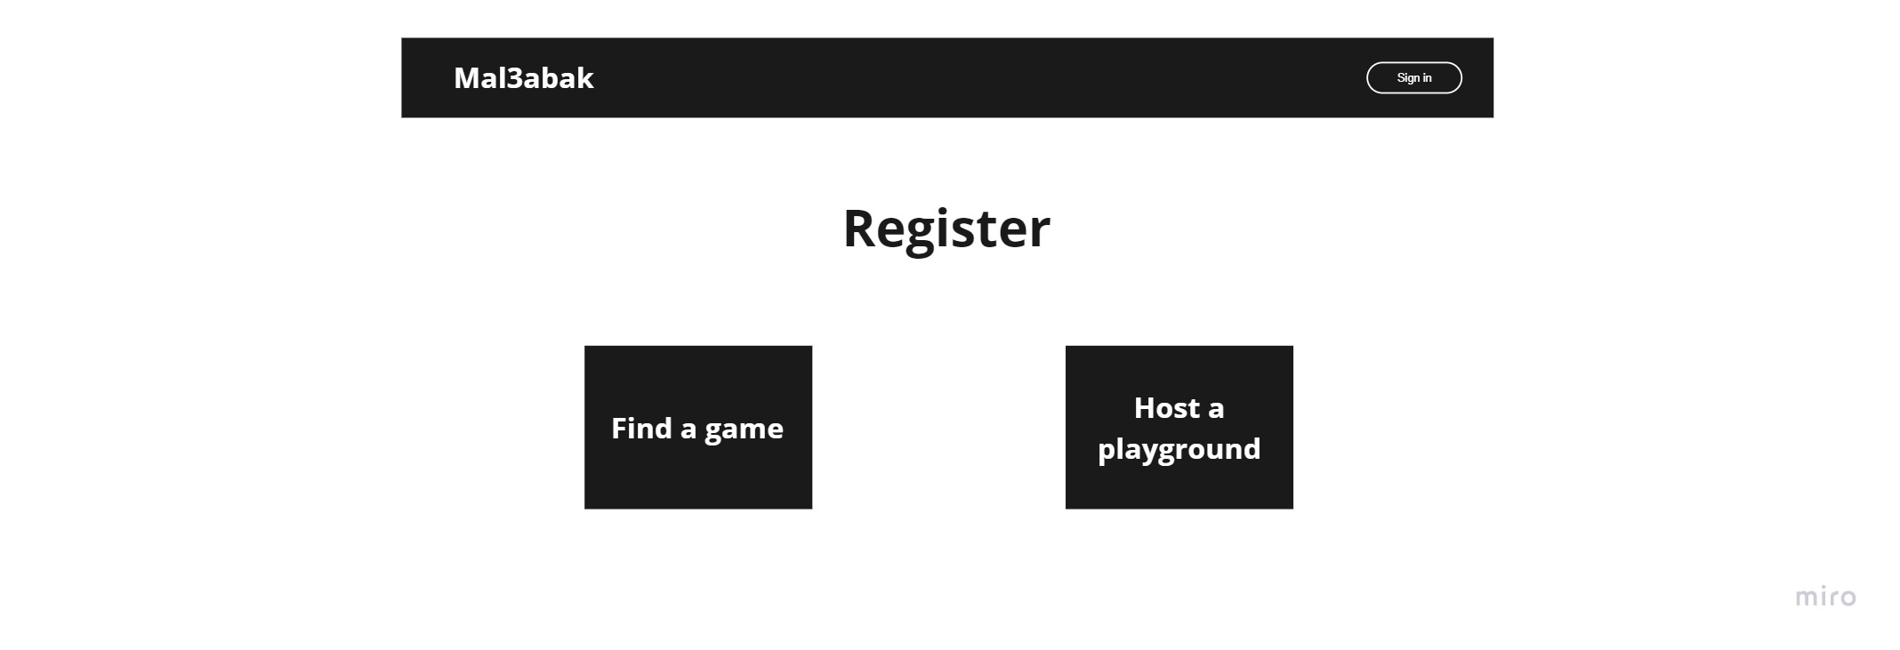

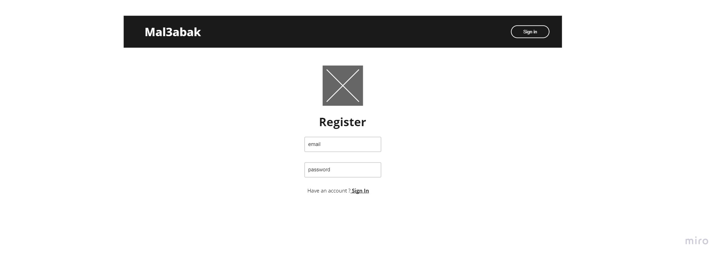

* 1. **Main System mockups**

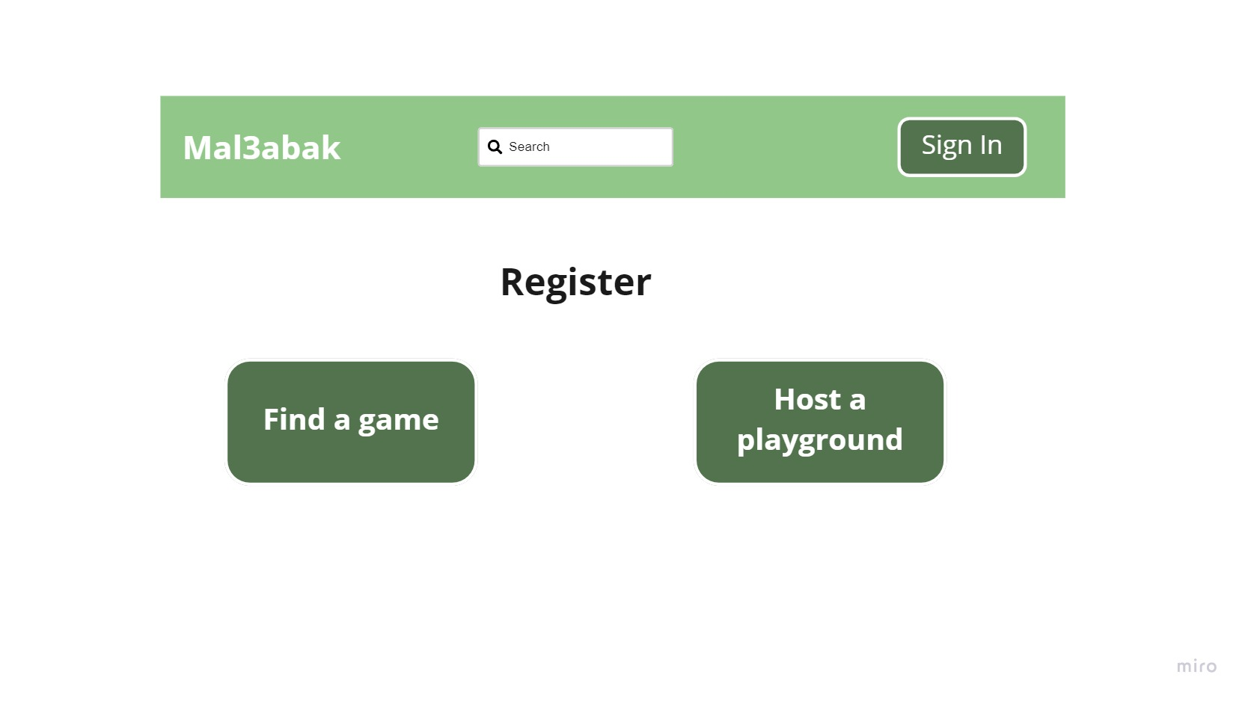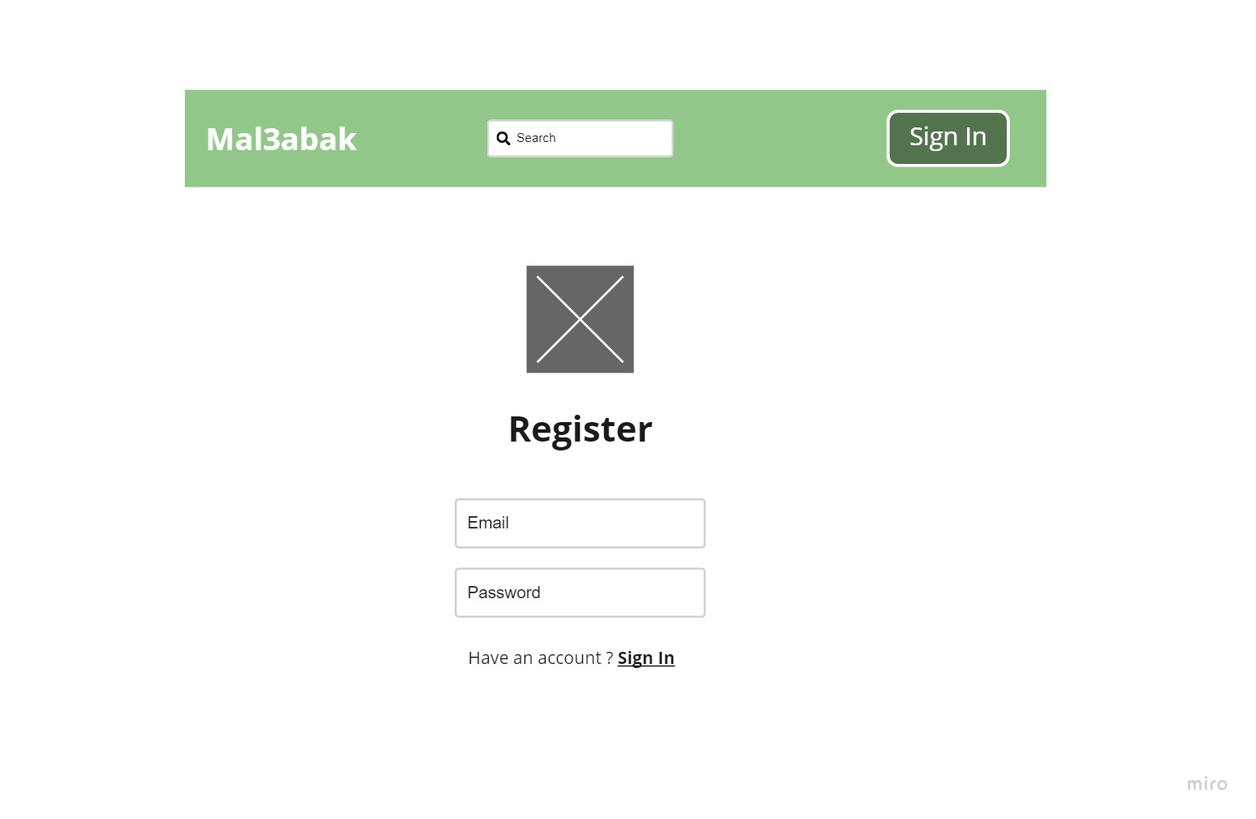

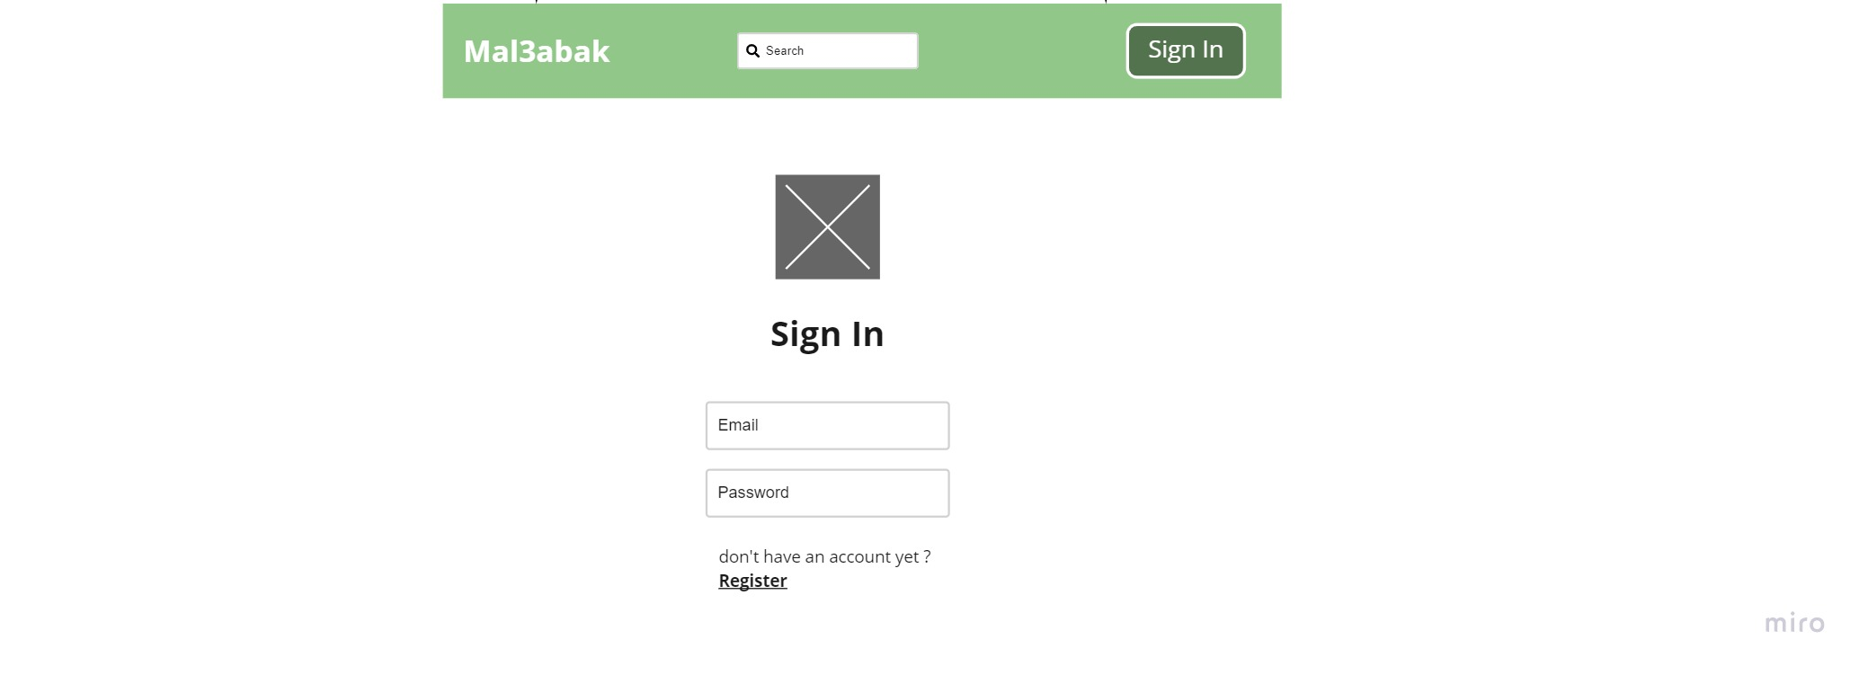

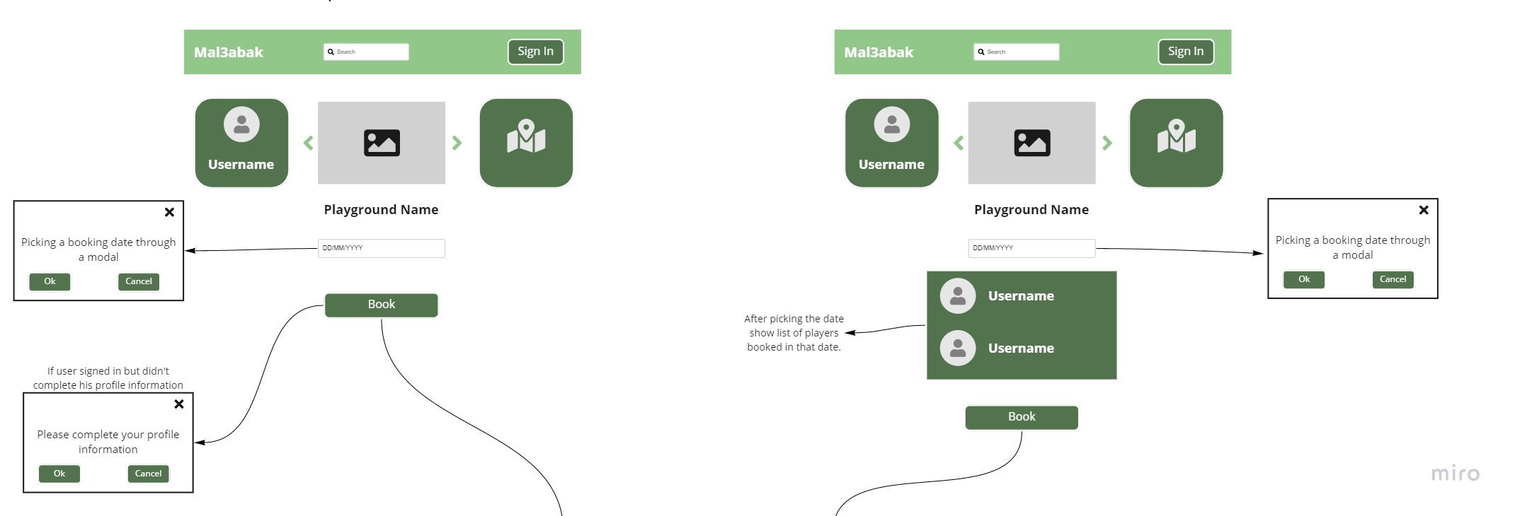

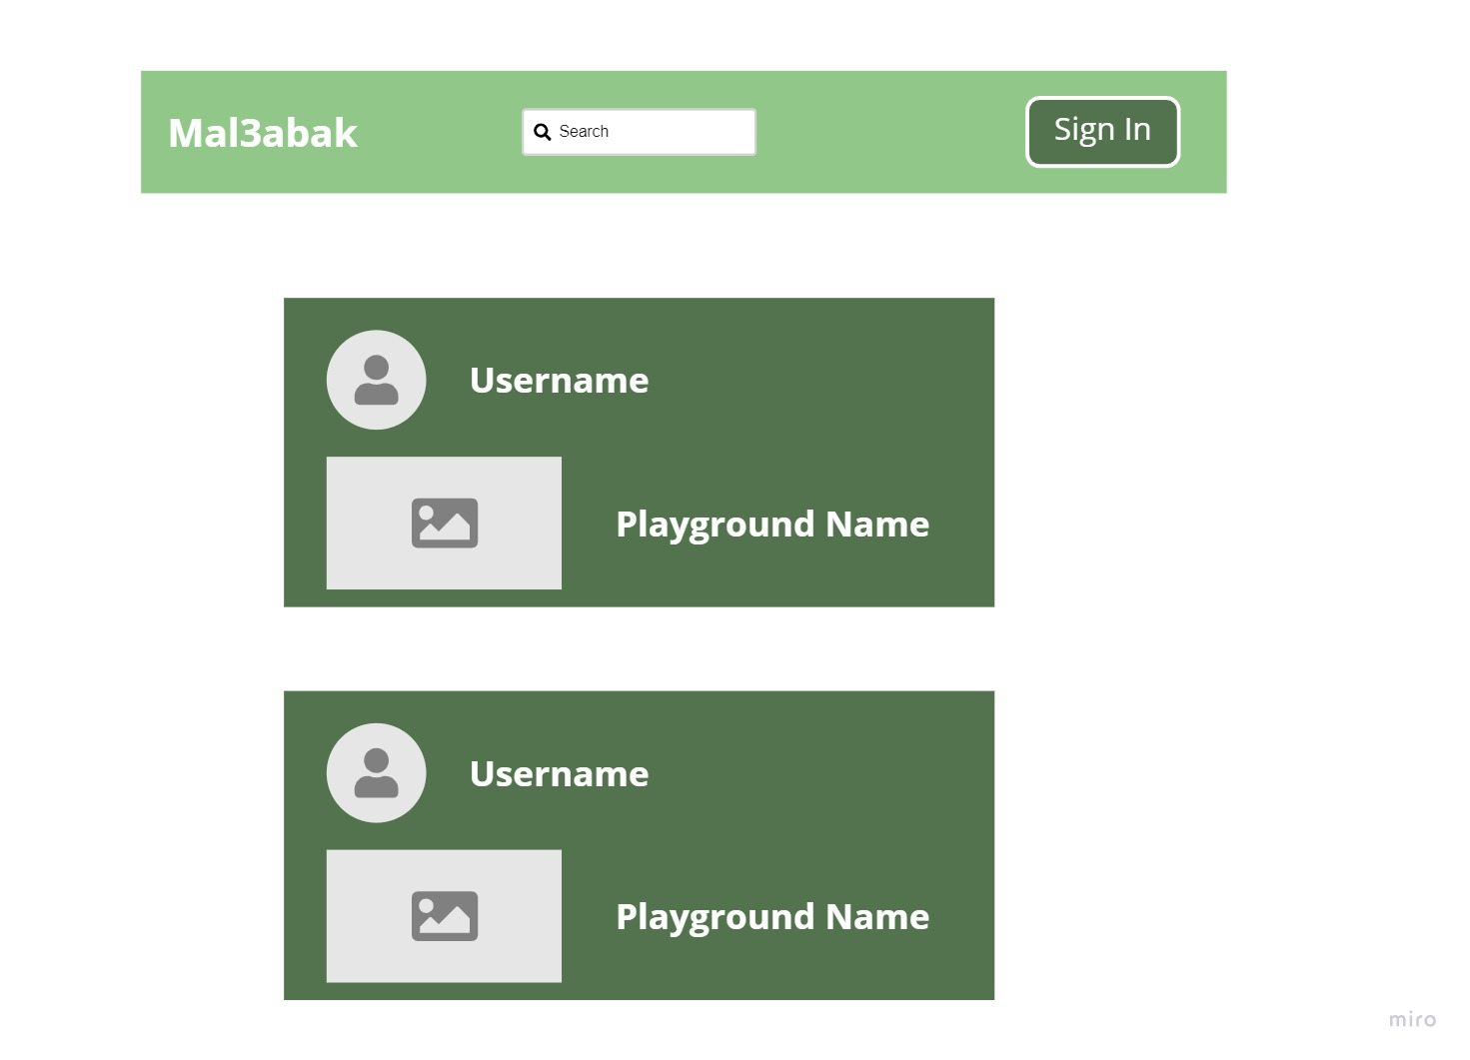

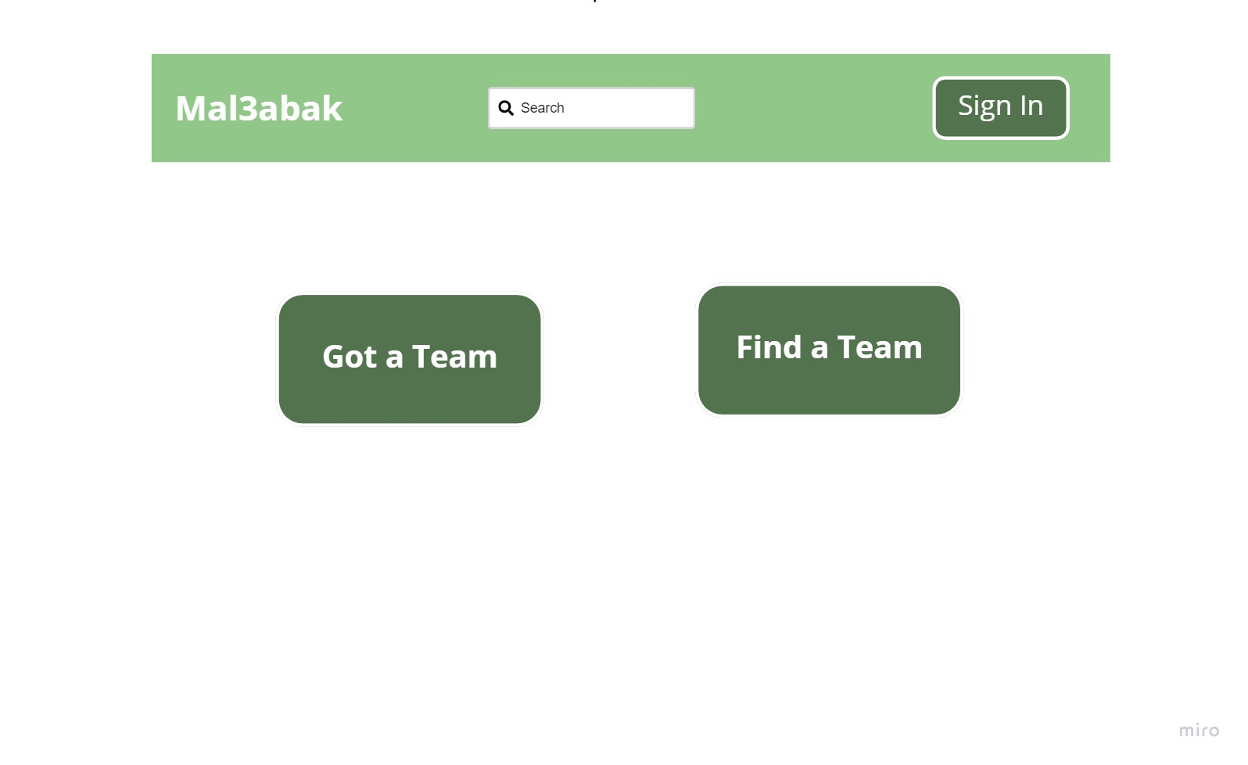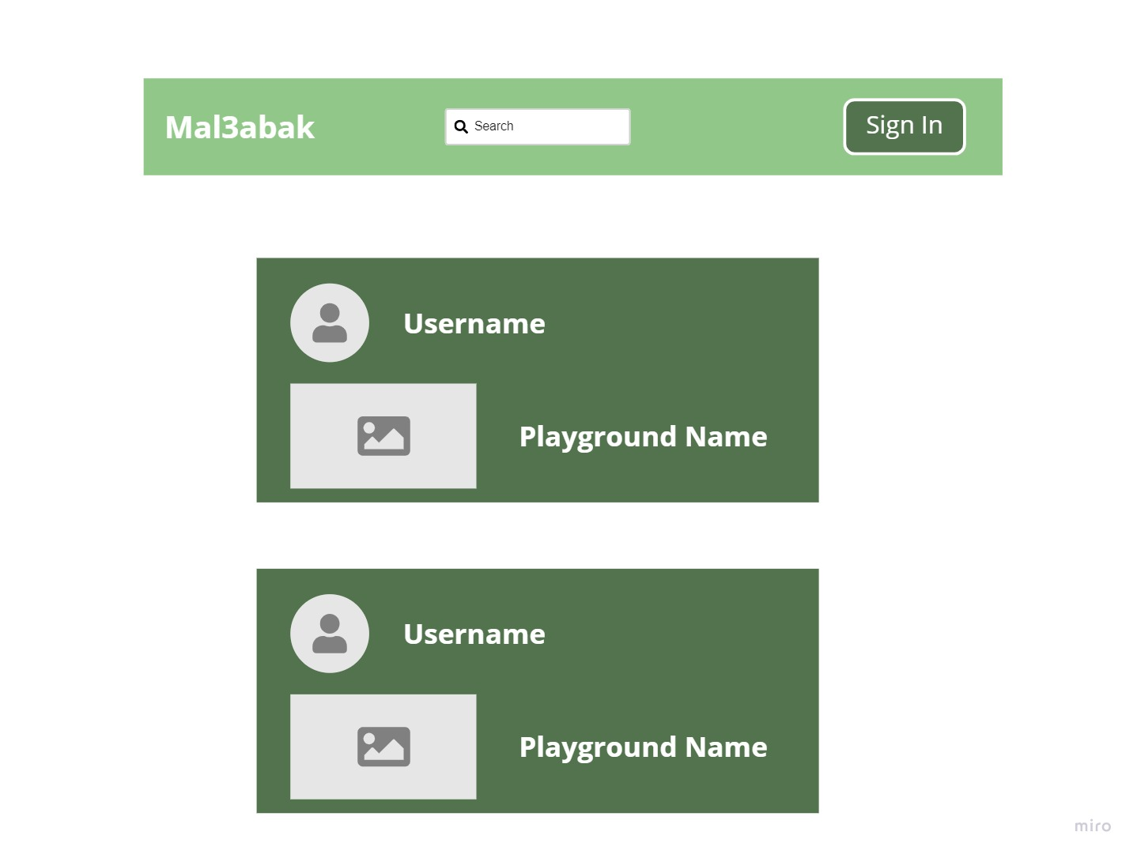

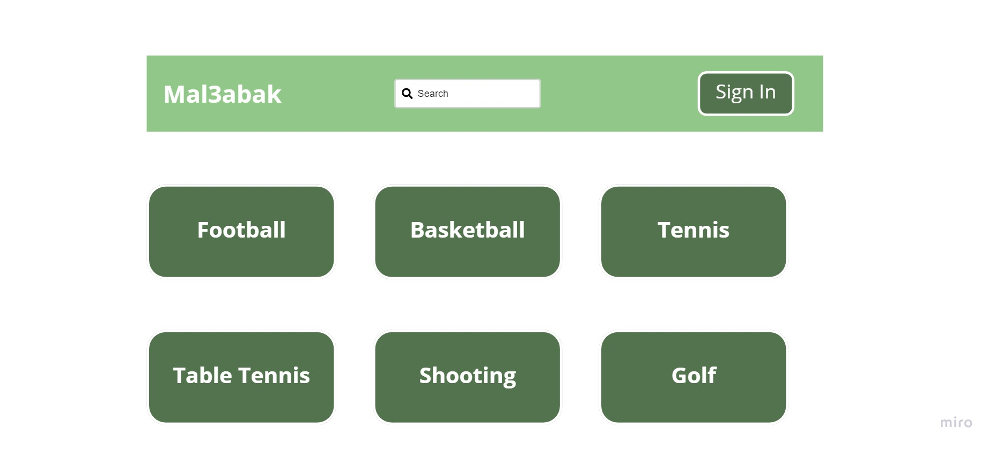

# Chapter 5: Conclusion & Future Work

## Conclusion

Everything nowadays is getting automated to make our life much easier, and our application is here to make sport playgrounds booking easier for people.

We learned a lot through the process of making this application, new programming languages, and we learned how to make a functional application connected to the database with live data. Our searching and learning skills have improved a lot. It is not difficult to find something online and learn whole new concepts online.

Of course we had some difficulties and got stuck at some point but all of this made us learn more and fix every problem and learn a lot about what happened and how to fix a similar problem if we faced it in the future.

Even for the interfaces we had challenges dealing with how we are going to implement something in our minds as an interface or learning about the design patterns and the best way to implement them with our application in Flutter.

Learning Flutter and going deep in it made us love it more as a mobile development programming language, every time we learn something new in flutter it just makes us want to go deeper and deeper in learning it, it is just a very exciting language to learn and which gives us a lot of potential and possibilities to deal with it.

Firebase was a bit hard to deal with at first but eventually after learning very important features of it things became easier. However, we still got a lot of things ahead of us to learn and to practice because of course learning has no limits. It was a whole new learning experience for us and we got pretty deep in the mobile development world and it gave us a bunch of new ways of critical thinking and amazing knowledge in programming through our graduation project.

## Future work

I am planning to make a lot of things in my applications in the future:

* + 1. Making a timestamp slot for every playground, every game can have its own times to book and the user can pick the time and date he wants to book it.
    2. add customized search for the player so he can search for playgrounds depends on what he filters.
    3. Filtering the playgrounds on the player home page depends on his current location that it will show the closest playground for him.
    4. Add following and followers for the application so that any user can follow each other.
    5. All users can have a timeline to post their own activities on it with the playgrounds and let other people see their sports activities.
    6. A user can add children to his account so that he can book playgrounds for them if they are eligible to use a smartphone.
    7. Add register with email and Facebook and phone number.
    8. Making users able to chat with other users.
    9. Adding categories to types of playgrounds like (soccer, basketball, etc…).
    10. Making the application multi language.

# References

# Appendix

Any additional information or data that supports or extends the main document or report.