Product Requirement Document
Appointment Booking System (Web + Mobile)
Platform: Web (Next.js) & Mobile (Flutter) · Status: Ready for Development

1. Product Overview
The Appointment Booking System is a cross-platform application that allows patients to book appointments with doctors or service providers in real time. It consists of a web application for administrators and doctors, and a mobile application for patients.
Core vision: guarantee real-time slot availability, eliminate double bookings through database-enforced conflict detection, and centralize scheduling and patient-provider data through a single shared database and API layer.

2. Problem Statement
Pain Point | Description
Double Bookings | Overlapping schedules due to non-syncing channels
Poor Schedule Management | Inefficient slot utilization for doctors
Lack of Centralization | Fragmented patient records and visit logs
Tracking Difficulty | High no-show rates due to lack of visibility
No Reschedule Path | Patients must cancel and rebook, causing churn and lost slots
No Timezone Safety | Multi-region use breaks conflict detection if times aren't normalized
No Buffer Between Visits | Back-to-back bookings leave doctors no time to update notes

3. Objectives
- Build a high-performance full-stack system (Next.js + Flutter + shared REST API)
- Support granular Role-Based Access Control (RBAC)
- Enable real-time booking synchronization across clients
- Guarantee zero overlapping/conflicting bookings under concurrent load, enforced at the database layer, not just application logic
- Provide a clear, auditable appointment lifecycle (not just book/cancel)
- Ship with defined non-functional requirements (security, performance, privacy) from day one
- Avoid premature infrastructure — defer scaling mechanisms until load data justifies them

4. User Roles & Permissions
Role | Target User | Core Capabilities | Restrictions
Patient | End-user seeking appointments | Register/login, search doctors, book/cancel/reschedule, view history, receive notifications | Cannot access other patients' data; cannot modify doctor schedules
Doctor | Clinician | Login to dashboard, set availability, view/manage daily queue, mark appointment status, block time off | Cannot view other doctors' patient data; cannot manage user accounts
Admin | System operator | Onboard/manage doctors & users, view analytics, override/cancel any appointment, configure holidays | Full access — actions are audit-logged
RBAC enforcement: every API route validates JWT role claims server-side (never trust client-side role checks). Middleware returns 403 Forbidden on mismatched role attempts, and all such attempts are logged.

5. Platform Strategy

Web Application (Next.js)
- Admin control center & doctor onboarding
- Doctor schedule configuration & analytics
- System-wide oversight, deep data views, audit logs

Mobile Application (Flutter)
- Instant slot lookup & 1-tap booking
- My Schedule, appointment history, reschedule flow
- Push notifications & reminders
Architecture Note: both clients consume a single unified REST API backed by one PostgreSQL database, ensuring real-time state consistency across platforms.

6. Core Features (MVP)

6.1 Authentication & Security
- Registration & login via JWT (access token + refresh token)
- Role-based access control enforcement (Patient, Doctor, Admin)
- Password hashing via bcrypt (cost factor ≥ 12)
- Rate limiting on auth endpoints (max 5 attempts / 15 min per IP)
- Forgot-password / reset-password flow via emailed time-limited token

6.2 Appointment Engine
- Dynamic provider directory & service/specialization filtering
- Real-time available slot rendering (derived from Availability − Exceptions − existing Appointments − buffer time)
- Database-enforced conflict prevention via a PostgreSQL range-exclusion constraint (see Section 7) — the actual source of truth, not just an application-level check
- Idempotent booking requests — every booking/reschedule call requires an Idempotency-Key header so a retried or double-tapped request never creates a duplicate appointment
- Patient-initiated cancellation with instant slot release
- Reschedule — cancels the old slot and books a new one as a single atomic transaction
- No-show marking — doctor/admin can flag a completed appointment as no_show
- Buffer time — configurable per-doctor gap enforced between consecutive appointments

6.3 Doctor & Schedule Management
- Admin onboarding for new medical staff (specialization, bio, profile photo)
- Recurring weekly availability configuration (days, hours, slot duration, buffer)
- Holiday/exception dates — doctor or admin can block specific dates that override recurring availability
- Ad-hoc time-off blocking with automatic patient notification for affected bookings

6.4 Notifications
- Channels: Push (mobile, via Firebase Cloud Messaging) + Email (all platforms)
- Triggers: booking confirmed, booking cancelled, reschedule confirmed, reminder (24h and 1h before), doctor time-off affecting existing booking
- Delivery is asynchronous (queued job), so notification failures never block a booking transaction

6.5 Dashboards
- Patient: upcoming visits, past history, quick re-booking, cancel/reschedule actions
- Doctor: daily queue, patient visit cards, status toggle, time-off calendar
- Admin: user/doctor counts, booking volume trends, no-show rate, system health, audit log viewer

7. Smart Feature: Conflict Detection System

7.1 Design Rationale
A simple uniqueness check on a booking's start time only catches two bookings starting at the exact same instant — it does not catch genuine overlaps between appointments of different lengths (e.g., a 30-minute slot at 10:00 and a 45-minute slot at 10:15 would collide in reality without being caught). Conflict detection is therefore enforced as a database-level range exclusion, not an application-level check.
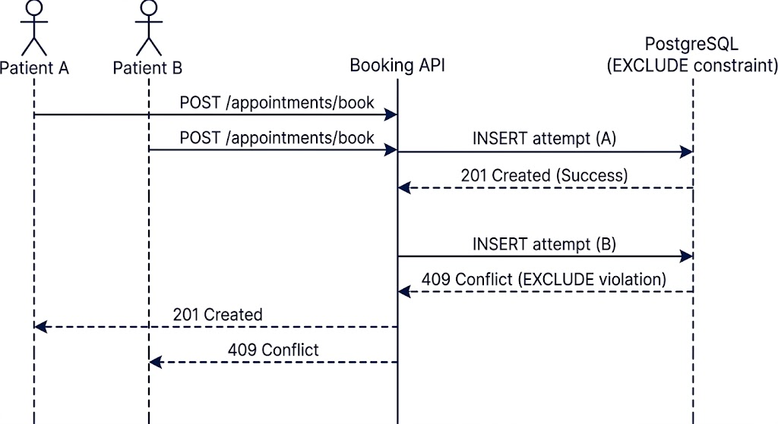
Sequence diagram: two patients attempt to book the same slot simultaneously. The database's EXCLUDE constraint guarantees exactly one INSERT succeeds and the other is rejected with a 409 — the race is resolved atomically at the database layer, not in application code.

7.2 Database-Enforced Range Exclusion
CREATE EXTENSION IF NOT EXISTS btree_gist;
CREATE TABLE appointments (
id UUID PRIMARY KEY DEFAULT gen_random_uuid(),
doctor_id UUID NOT NULL REFERENCES doctors(id),
patient_id UUID NOT NULL REFERENCES users(id),
appointment_range TSTZRANGE NOT NULL,
status TEXT NOT NULL DEFAULT 'confirmed'
CHECK (status IN ('pending','confirmed','completed','cancelled','no_show')),
created_at TIMESTAMPTZ DEFAULT now(),
EXCLUDE USING GIST (
doctor_id WITH =,
appointment_range WITH &&
) WHERE (status <> 'cancelled')
);
- The database itself physically refuses any insert that overlaps an existing non-cancelled appointment for the same doctor — this cannot be bypassed by an application bug.
- Half-open ranges ([start, end)) mean back-to-back appointments are correctly allowed, not falsely flagged as conflicts.
- The WHERE (status <> 'cancelled') clause means a cancelled appointment automatically frees its range without deleting the row (audit trail preserved).
- TSTZRANGE is timezone-aware natively, reinforcing the timezone-safety goal in Section 9.

7.3 Idempotency (Client-Side Duplicate Protection)
The exclusion constraint stops two different people booking the same slot. It does not stop the same patient's client accidentally submitting the same booking twice (double-tap, retry after timeout). Fix:
- Client generates a UUID per booking attempt, sent as an Idempotency-Key header.
- Server caches (key → response) for 24 hours (Redis).
- A repeated request with the same key returns the original response instead of creating a second appointment.
- Required on: POST /api/appointments/book, PUT /api/appointments/:id/reschedule.

7.4 Buffer Time
ALTER TABLE availability ADD COLUMN buffer_minutes INT DEFAULT 0;
Applied by padding the range used for conflict-checking only — the appointment's displayed/booked duration is unchanged, but the exclusion check uses [start, end + buffer_minutes). This keeps the buffer invisible to the patient while protecting the doctor's actual schedule.

7.5 Load Verification
Conflict-check correctness must be proven, not assumed: run a concurrency test that fires N simultaneous booking requests for the same slot and asserts exactly 1 succeeds (201) and N−1 fail cleanly (409 Conflict). This is a required test case, not optional QA.

8. System Architecture
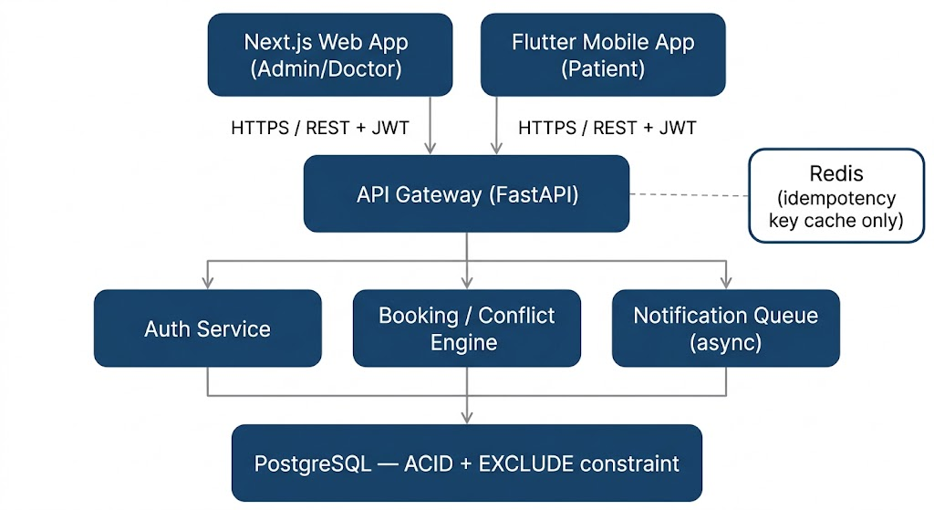
Component | Technology | Purpose
Frontend Web | Next.js (React) | Admin & Doctor dashboards
Mobile App | Flutter (Dart) | Patient-facing iOS/Android app
Backend API | FastAPI | REST API, business logic, RBAC middleware
Database | PostgreSQL (+ btree_gist) | ACID guarantees, range-exclusion conflict detection
Redis | Idempotency key cache, notification queue backing | Not used for booking locks — see Section 15
Auth | JWT (access + refresh) | Stateless session management

9. Database Schema
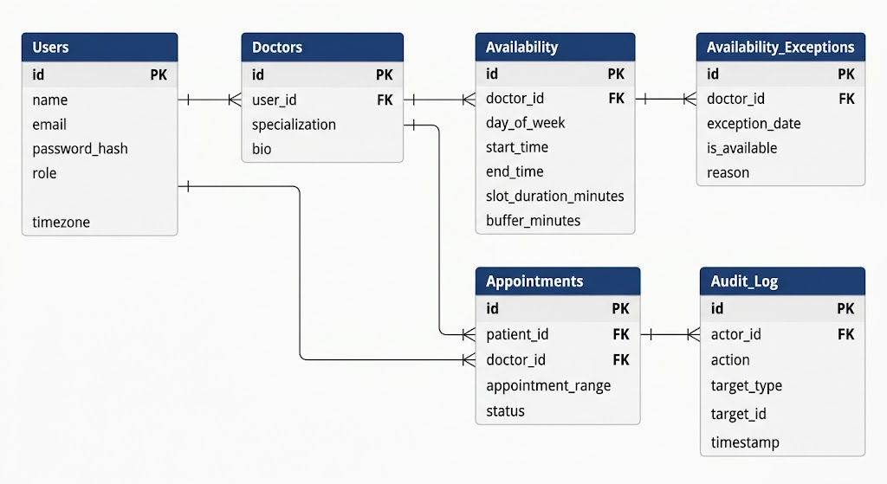
-- Users
id UUID PK
name VARCHAR NOT NULL
email VARCHAR UNIQUE NOT NULL
password_hash VARCHAR NOT NULL
role ENUM('patient','doctor','admin') NOT NULL
timezone VARCHAR NOT NULL DEFAULT 'UTC'
created_at TIMESTAMPTZ DEFAULT now()
-- Doctors
id UUID PK
user_id UUID FK -> Users.id
specialization VARCHAR
bio TEXT
-- Availability (recurring weekly pattern)
id UUID PK
doctor_id UUID FK -> Doctors.id
day_of_week INT
start_time TIME
end_time TIME
slot_duration_minutes INT DEFAULT 30
buffer_minutes INT DEFAULT 0
-- Availability_Exceptions (holidays / one-off blocks)
id UUID PK
doctor_id UUID FK -> Doctors.id
exception_date DATE NOT NULL
is_available BOOLEAN DEFAULT false
reason VARCHAR
-- Appointments
id UUID PK
patient_id UUID FK -> Users.id
doctor_id UUID FK -> Doctors.id
appointment_range TSTZRANGE NOT NULL
status ENUM('pending','confirmed','completed','cancelled','no_show') NOT NULL
created_at TIMESTAMPTZ DEFAULT now()
EXCLUDE USING GIST (doctor_id WITH =, appointment_range WITH &&)
WHERE (status <> 'cancelled')
-- Idempotency_Keys
key VARCHAR PK
response_body JSONB
created_at TIMESTAMPTZ DEFAULT now()
-- Audit_Log
id UUID PK
actor_id UUID FK -> Users.id
action VARCHAR NOT NULL
target_type VARCHAR
target_id UUID
timestamp TIMESTAMPTZ DEFAULT now()

10. Non-Functional Requirements
Category | Requirement
Performance | API p95 response time < 300ms under 100 concurrent users
Concurrency | 0% double-booking under concurrent load — verified by the required test in Section 7.5
Security | HTTPS enforced everywhere; input validation on all endpoints; parameterized queries only
Privacy | Access restricted by role; audit log for every admin override; no plaintext password/token storage
Availability | Target 99.5% uptime for booking API
Scalability | Stateless API layer for horizontal scaling; DB scaling deferred until measured need

11. API Endpoint Specification
Module | Method | Endpoint | Description
Auth | POST | /api/auth/register | Register (patient default)
Auth | POST | /api/auth/login | Login, returns access + refresh JWT
Auth | POST | /api/auth/refresh | Exchange refresh token
Auth | POST | /api/auth/forgot-password | Send reset token via email
Auth | POST | /api/auth/reset-password | Reset password with token
Users | GET | /api/users/me | Get own profile
Users | PUT | /api/users/me | Update own profile
Doctors | GET | /api/doctors | List doctors, filter by specialization
Doctors | POST | /api/doctors | Create doctor profile (Admin only)
Doctors | PUT | /api/doctors/:id | Update doctor profile (Admin/self)
Availability | GET | /api/availability/:doctorId | Get computed open slots (applies buffer + exceptions)
Availability | POST | /api/availability/:doctorId/exceptions | Add holiday/block date
Appointments | POST | /api/appointments/book | Book slot — requires Idempotency-Key header
Appointments | PUT | /api/appointments/:id/reschedule | Atomic cancel+rebook — requires Idempotency-Key header
Appointments | PUT | /api/appointments/:id/cancel | Cancel appointment
Appointments | PUT | /api/appointments/:id/status | Doctor sets completed/no_show
Appointments | GET | /api/appointments/doctor/:doctorId | Doctor's queue for a date
Appointments | GET | /api/appointments/patient/me | Patient's own bookings
Admin | GET | /api/admin/analytics | Booking volume, no-show rate, user counts
Admin | GET | /api/admin/audit-log | Paginated audit trail
Standard error format:
{ "error": { "code": "SLOT_CONFLICT", "message": "This slot was just booked." } }
SLOT_CONFLICT maps directly to a 409 raised by the database exclusion constraint — the API layer catches the PostgreSQL exclusion-violation error and translates it, rather than re-implementing the overlap check in application code.

12. User Flow & Screen Mapping
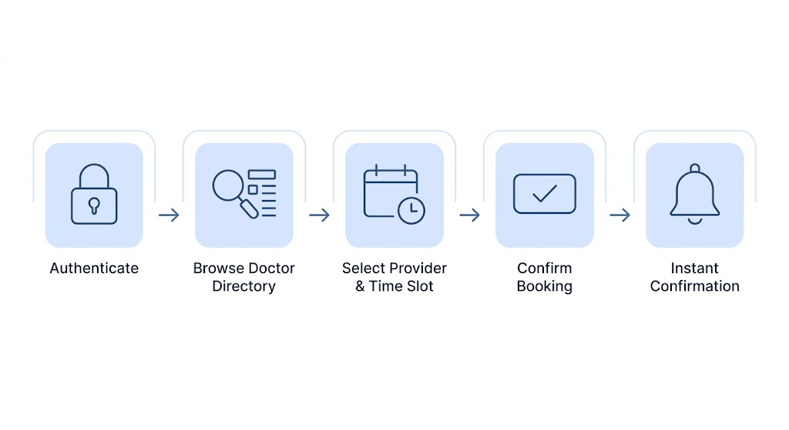
Patient Journey: Authenticate → Browse Doctor Directory → Select Provider & Slot → Confirm Booking (idempotent) → Instant Confirmation → (optional) Reschedule/Cancel later

Target UI Screens
- Web: Landing, Login/Register, Admin Center, Doctor Schedule Dashboard, Booking Logs, Audit Log Viewer
- Mobile: Splash/Login, Home Directory, Slot Picker, My Bookings (with reschedule/cancel), Notification Hub

13. Testing Strategy
Type | Coverage
Unit tests | Slot calculation (incl. buffer), RBAC middleware, idempotency key handling
Integration tests | Full booking flow across Auth → Availability → Appointments
Concurrency test (required) | N simultaneous requests for the same/overlapping slot → exactly 1 succeeds, rest return 409
Idempotency test | Same Idempotency-Key sent twice → single appointment created, both responses identical
E2E tests | Critical patient and doctor flows on both Web and Mobile

14. Success Metrics
- 0% double-booking failures under concurrent simulation — proven by the required test in Section 13
- Zero duplicate appointments from retried/double-tapped booking requests
- Clean RBAC route protection across Web and Mobile
- API p95 latency within target under NFR benchmarks
- Notification delivery success rate > 99%

15. Explicitly Deferred (With Rationale)
Item | Why Deferred
Redis-based booking locks | The PostgreSQL EXCLUDE constraint already guarantees correctness. Adding a Redis lock layer now would add operational complexity to solve a load problem that hasn't been measured yet.
Read replicas / availability caching | Not justified at current expected scale. Add only if availability-endpoint latency becomes a measured bottleneck.
Payment/billing integration | Out of scope for this release
Waitlist for full slots | Out of scope for this release
SMS notifications | Email + push only for this release
Multi-language UI | Out of scope for this release
Video consultation integration | Out of scope for this release

16. Regulatory Context (Bangladesh)
Bangladesh does not yet have a single comprehensive data-protection law equivalent to HIPAA/GDPR — the draft Personal Data Protection Act 2023 has cabinet-level approval but is not yet in force. In the meantime, the Cyber Security Act (successor to the Digital Security Act 2018) already criminalizes unauthorized collection or use of personal identity information (name, address, date of birth, fingerprint, and similar identifiers), with penalties up to two years' imprisonment or a fine up to ৳5,00,000, or both.
Practical implication: even without a HIPAA-equivalent framework, storing patient identity and appointment data still carries real legal exposure if mishandled. The access-scoping (Section 4) and audit log (Section 9) in this document are the right foundation — this is a reason not to weaken them, not a reason to add new scope. If this system is ever deployed with real patient data, a quick check with a legal/ethics advisor is worth doing before launch.

17. Execution Roadmap
Phase | Days | Focus
Phase 1 | 1–3 | DB schema incl. btree_gist/exclusion constraint, timezone, audit log; JWT auth; RBAC middleware; rate limiting
Phase 2 | 4–7 | Booking engine, exclusion-constraint conflict handling, idempotency keys, reschedule logic, buffer time, holiday exceptions
Phase 3 | 8–10 | Notification queue (push + email), reminder scheduling
Phase 4 | 11–13 | Web frontend: Admin & Doctor portals + audit log viewer
Phase 5 | 14–16 | Mobile app: patient booking, reschedule, notification hub
Phase 6 | 17–19 | Concurrency/idempotency/E2E testing, bug fixes
Phase 7 | 20 | Deployment, docs, handoff
Approximately 20 working days for a small team of 2–3 developers.

