**Roll No: 1803070**

**Lab Performance Test [1]**

**Lab Task Q[No 1]**

Q1 **Question:**

Consider given code, #include<math.h> int main(){ float a=1; float b=2; float c=a+b; return 0; } . Show output file with extension ".o" generated by C compiler along with Makefile (point penalty for adding extra commands other than necessary).

**Solution (Bold your own written code):**

|  |
| --- |
| Makefile:  main:      gcc -c -o proc.o  proc.c |

**Output (Screen/SnapShot):**

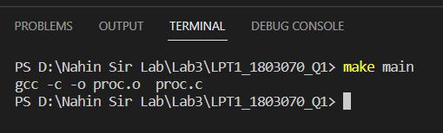

**Lab Task Q[No 2a]**

 Q2a **Question:**

Consider given statements, 1. We Like to Buy 10 Apples 2. I Like to Buy 20 Oranges 3. We Want to Buy 30 Mangoes . a) Show a flex file which can tokenize given statements. b) Show a bison file which can parse given statements.

**Solution (Bold your own written code):**

|  |
| --- |
| .l file:  %option noyywrap  %{  %}  %%  **"We"|"I" {printf("%s -> Person\n", yytext);}**  **"Like"|"Want" {printf("%s -> Verb\n",yytext);}**  **"to" {printf("%s -> To\n",yytext);}**  **"Buy" {printf("%s -> Buy\n",yytext);}**  **"10"|"20"|"30" {printf("%s -> Amount\n",yytext);}**  **"Apples"|"Mangoes" {printf("%s -> Fruits\n",yytext);}**  . {}  %%  int main()  {      yylex();      return 0;  }  Makefile:  flex2:      flex 2.l      gcc lex.yy.c      ./a.exe < input2.txt |

**Output (Screen/SnapShot):**

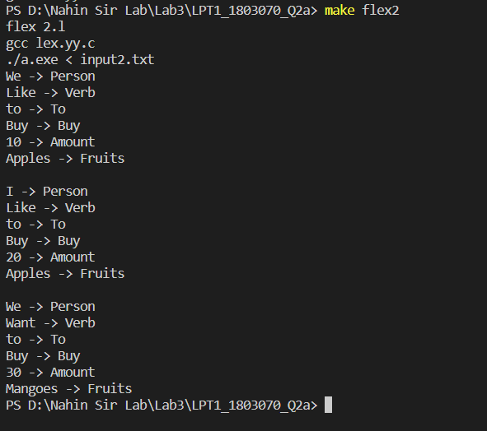

**Lab Task Q[No 2b]**

 Q2a **Question:**

Consider given statements, 1. We Like to Buy 10 Apples 2. I Like to Buy 20 Oranges 3. We Want to Buy 30 Mangoes . b) Show a bison file which can parse given statements.

**Solution (Bold your own written code):**

|  |
| --- |
| .l file:  %option noyywrap  %{      //1803070  #include "prog1.tab.h"  %}  %%  **"We"|"I" {return(N);}**  **"Like"|"Want" {return(V);}**  **"to" {return(P);}**  **"Buy" {return(VV);}**  **"10"|"20"|"30" {return(A);}**  **"Apples"|"Mangoes" {return(O);}**  %%  .y file:  %{      //1803070  #include<stdio.h>  void yyerror(char *s);  int yylex();  %}  **%token N V P VV A O**  **%start S**  **%%**  **S: N V P VV A O;**  **%%**  **int main()**  **{**  **if(!yyparse())**  **printf("ACCEPTED\n");**      return 0;  }  void yyerror(char *s)  {      fprintf(stderr, "error: %s\n", s);  }  Makefile:  prog1:      bison -d prog1.y      flex prog1.l      gcc prog1.tab.c lex.yy.c      a.exe <input.txt |

**Output (Screen/SnapShot):**

