INNER JOIN :

[SELECT](http://localhost/phpmyadmin/url.php?url=https://dev.mysql.com/doc/refman/8.0/en/select.html) student.first_name,student.last_name,course.c_id,course.c_name FROM student INNER JOIN course ON student.id=course.st_id ;

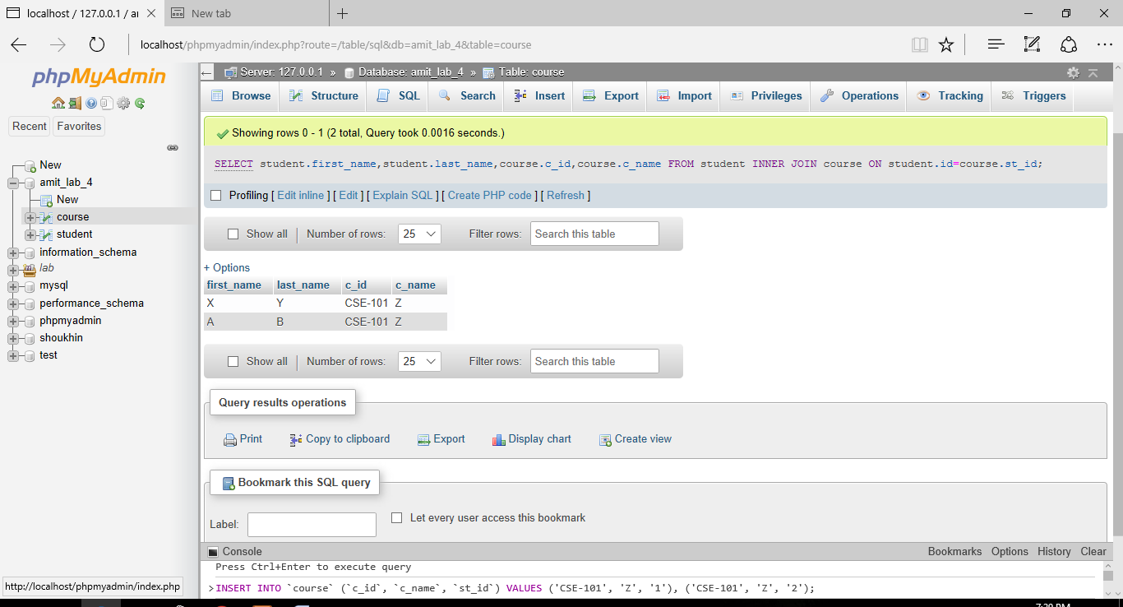

LEFT OUTER JOIN :

[SELECT](http://localhost/phpmyadmin/url.php?url=https://dev.mysql.com/doc/refman/8.0/en/select.html) student.first_name,student.last_name,course.c_id,course.c_name FROM student [LEFT](http://localhost/phpmyadmin/url.php?url=https://dev.mysql.com/doc/refman/8.0/en/string-functions.html%23function_left) JOIN course ON student.id=course.st_id;

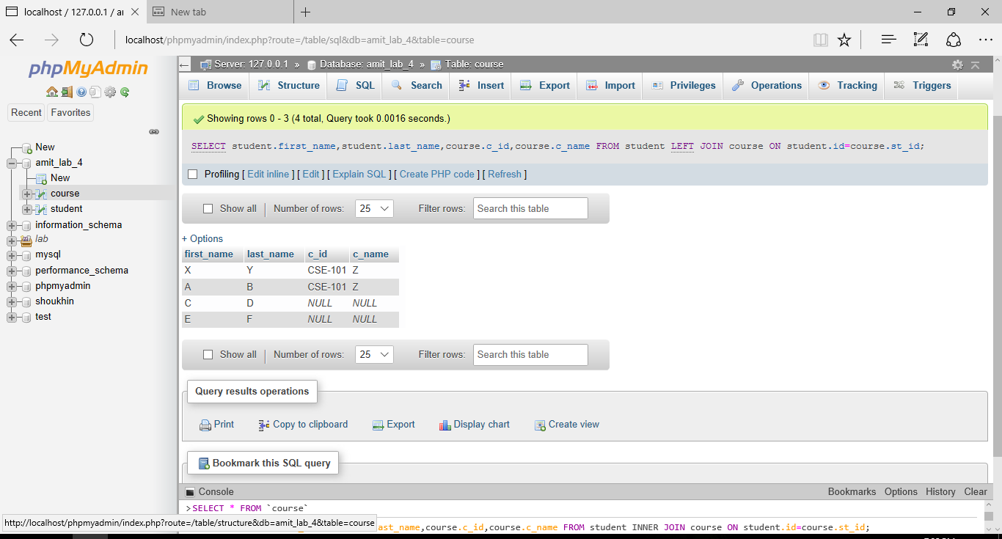

RIGHT OUTER JOIN :

[SELECT](http://localhost/phpmyadmin/url.php?url=https://dev.mysql.com/doc/refman/8.0/en/select.html) student.first_name,student.last_name,course.c_id,course.c_name FROM student RIGHT JOIN course ON student.id=course.st_id;

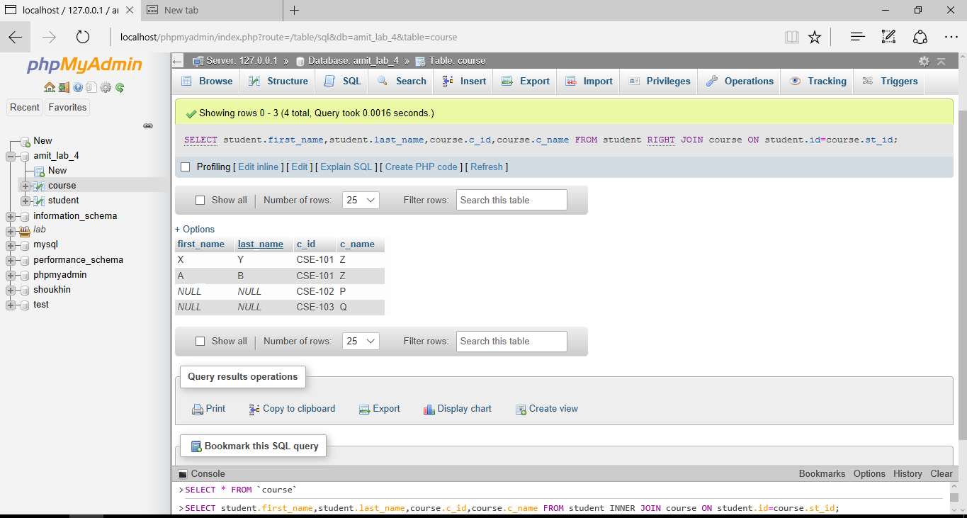

TEACHER INNER JOIN :

[SELECT](http://localhost/phpmyadmin/url.php?url=https://dev.mysql.com/doc/refman/8.0/en/select.html) * FROM student INNER JOIN course ON student.id=course.st_id inner join course_teacher on course.c_id = course_teacher.c_id;

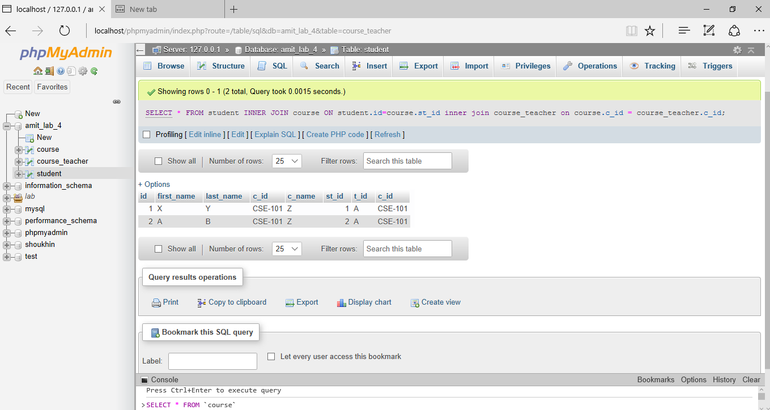

TEACHER LEFT JOIN :

[SELECT](http://localhost/phpmyadmin/url.php?url=https://dev.mysql.com/doc/refman/8.0/en/select.html) * FROM student INNER JOIN course ON student.id=course.st_id left join course_teacher on course.c_id = course_teacher.c_id;

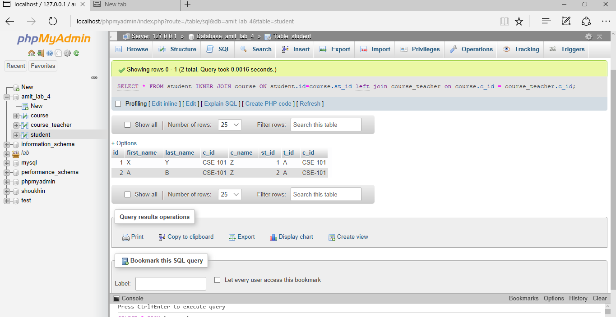

TEACHER RIGHT JOIN :

[SELECT](http://localhost/phpmyadmin/url.php?url=https://dev.mysql.com/doc/refman/8.0/en/select.html) * FROM student INNER JOIN course ON student.id=course.st_id right join course_teacher on course.c_id = course_teacher.c_id;

