**Experiment No: 1**

**Name of the problem:** Introduction to WSL.

**Theory:**

History of Linux: Linux is an open-source operating system like other operating systems such as Microsoft [Windows](https://www.javatpoint.com/windows), Apple Mac OS, iOS, Google android, etc.

In 1991, Linus Torvalds a student at the university of Helsinki, Finland, thought to have a freely available academic version of Unix started writing its own code. Later this project became the Linux kernel. He wrote this program specially for his own PC as he wanted to use Unix 386 Intel computer but couldn't afford it. He did it on MINIX using GNU C compiler. GNU C compiler is still the main choice to compile Linux code but other compilers are also used like Intel C compiler.

He started it just for fun but ended up with such a large project. Firstly he wanted to name it as 'Freax' but later it became 'Linux'. He published the Linux kernel under his own license and was restricted to use as commercially. Linux uses most of its tools from GNU software and are under GNU copyright. In 1992, he released the kernel under GNU General Public License.

**Shell Types:**

A shell is a program that acts as an interface between a user and the kernel. It allows a user to give commands to the kernel and receive responses from it. Through a shell, we can execute programs and utilities on the kernel. Hence, at its core, a shell is a program used to execute other programs on our system.

Being able to interact with the kernel makes shells a powerful tool. Without the ability to interact with the kernel, a user cannot access the utilities offered by their machine’s operating system.

The major shells that are available for the Linux environment:

1. The Bourne Shell

The Bourne shell (sh), written by Steve Bourne at AT&T Bell Labs, is the original UNIX shell. It is the preferred shell for shell programming because of its compactness and speed. A Bourne shell drawback is that it lacks features for interactive use, such as the ability to recall previous commands (history). The Bourne shell also lacks built-in arithmetic and logical expression handling.

The Bourne shell is the Solaris OS default shell. It is the standard shell for Solaris system administration scripts. For the Bourne shell the:

* Command full-path name is /bin/sh and /sbin/sh.
* Non-root user default prompt is $.
* Root user default prompt is #.

2. The C Shell

The C shell (csh):

* Is a UNIX enhancement written by Bill Joy at the University of California at Berkeley.
* Incorporated features for interactive use, such as aliases and command history.
* Includes convenient programming features, such as built-in arithmetic and a C-like expression syntax.

For the C shell the:

* Command full-path name is /bin/csh.
* Non-root user default prompt is hostname %.
* Root user default prompt is hostname #.

3. The Korn Shell

The Korn shell (ksh):

* Was written by David Korn at AT&T Bell Labs
* Is a superset of the Bourne shell.
* Supports everything in the Bourne shell.
* Has interactive features comparable to those in the C shell.
* Includes convenient programming features like built-in arithmetic and C-like arrays, functions, and string-manipulation facilities.
* Is faster than the C shell.
* Runs scripts written for the Bourne shell.

For the Korn shell the:

* Command full-path name is /bin/ksh.
* Non-root user default prompt is $.
* Root user default prompt is #.

4. The GNU Bourne-Again Shell

The GNU Bourne-Again shell (bash):

* Is compatible to the Bourne shell.
* Incorporates useful features from the Korn and C shells.
* Has arrow keys that are automatically mapped for command recall and editing.

For the GNU Bourne-Again shell the:

* Command full-path name is /bin/bash.
* Default prompt for a non-root user is bash-x.xx$. (Where x.xx indicates the shell version number. For example, bash-3.50$)
* Root user default prompt is bash-x.xx#. (Where x.xx indicates the shell version number. For example, bash-3.50$#)

5. The Z Shell

The Z Shell:

* is developed to be reciprocal.
* combines various aspects of other GNU/Unix Linux shells like ksh, tcsh, and bash.
* is denoted as zsh.

For the Z Shell the:

* Command full-path name is /bin/zsh.

**Numeric Permission Change:**

In this mode, file **permissions are not represented as characters but a three-digit octal number**.

The table below gives numbers for all for permissions types.

| **Number** | **Permission Type** | **Symbol** |
| --- | --- | --- |
| 0 | No Permission | — |
| 1 | Execute | –x |
| 2 | Write | -w- |
| 3 | Execute + Write | -wx |
| 4 | Read | r– |
| 5 | Read + Execute | r-x |
| 6 | Read +Write | rw- |
| 7 | Read + Write +Execute | rwx |

‘764’ absolute code says the following:

* Owner can read, write and execute
* Usergroup can read and write
* World can only read

This is shown as `-rwxrw-r–`

**Command:**

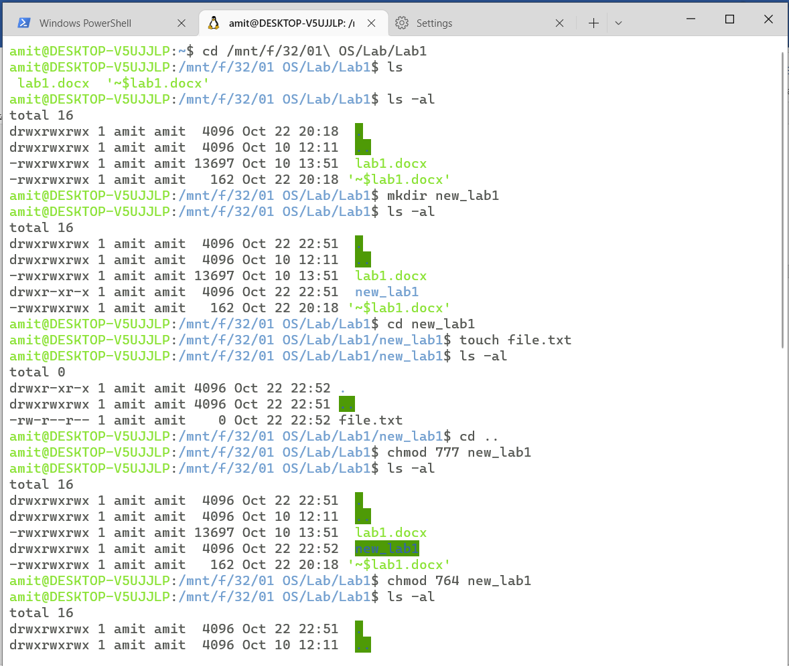

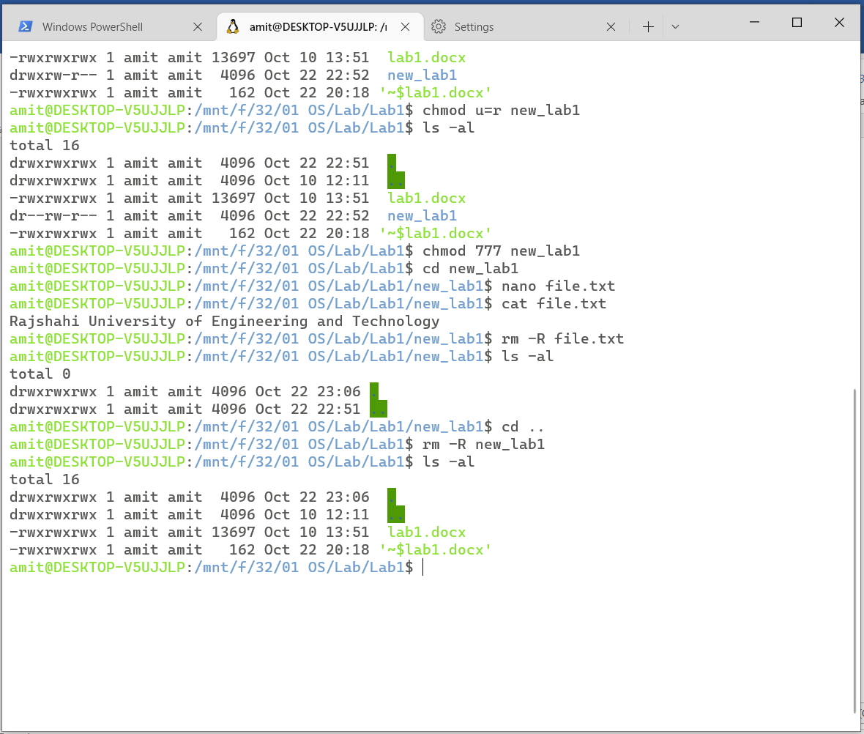

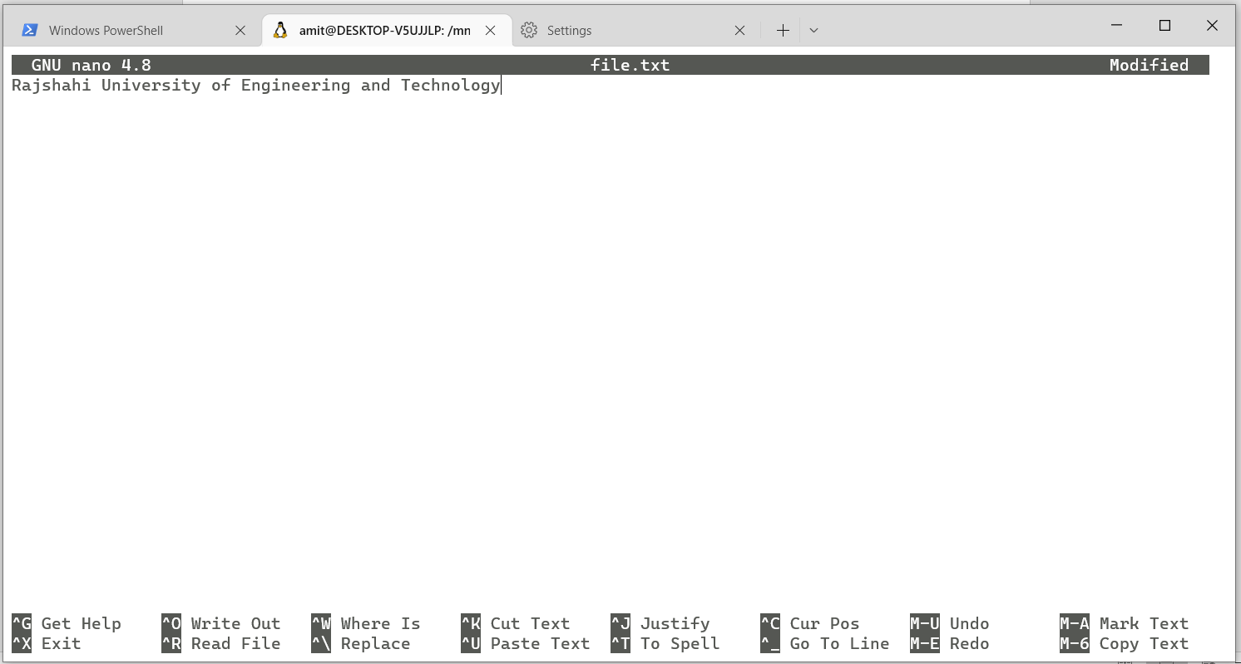

**Discussion:**

The Windows Subsystem for Linux (WSL) is a feature of the Windows operating system that enables you to run a Linux file system, along with Linux command-line tools and GUI apps, directly on Windows, alongside your traditional Windows desktop and apps.

Linux chmod command is used to change the access permissions of files and directories. It stands for **change mode**. It can’t change the permission of symbolic links. Even, it ignores the symbolic links come across recursive directory traversal. In the [Linux](https://www.javatpoint.com/linux-tutorial) file system, each file is associated with a particular owner and have permission access for different users. The user classes may be: owner, group member or others (Everybody else). The [file permissions](https://www.javatpoint.com/linux-file-permissions) in Linux are the three types: read (r), write (w) and execute (x).