**Experiment No: 2**

**Name of the problem:** Introduction to Shell coding.

**Command:**

* **First Shell Code:**

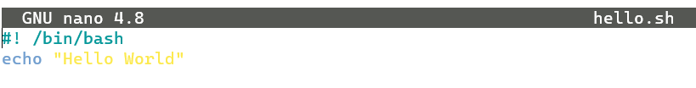



* **Variables:**

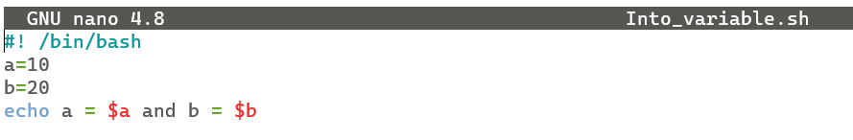



* **Arithmetic Operations:**

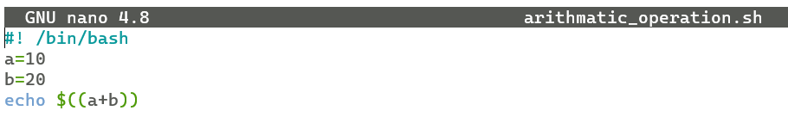



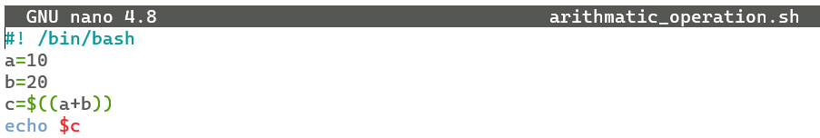



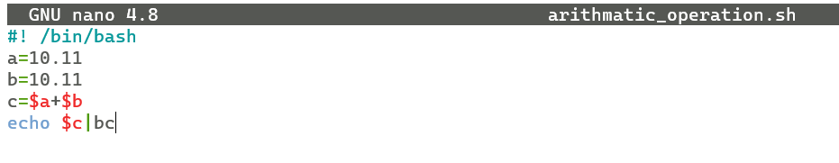



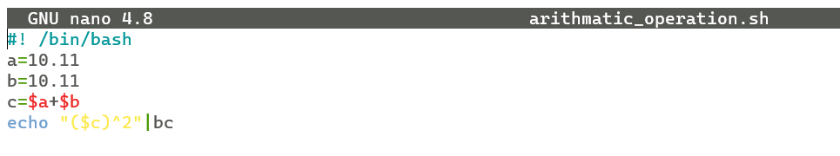



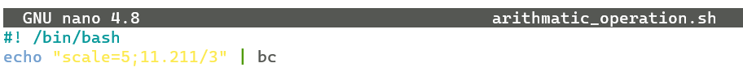











* **Input From User:**

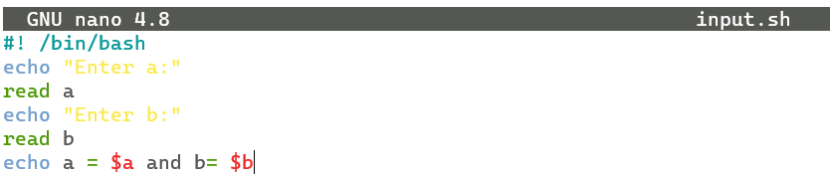

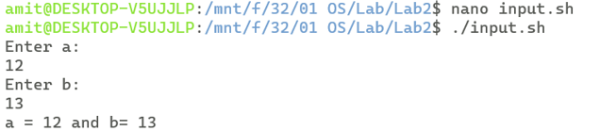

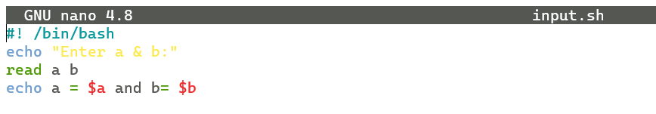

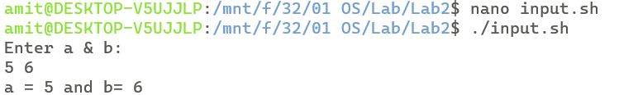

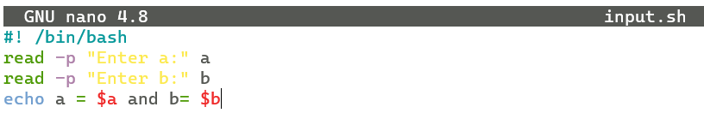

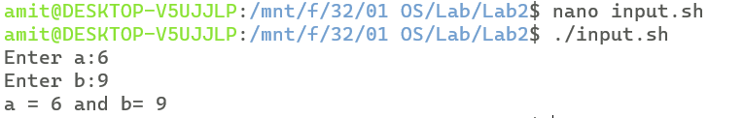

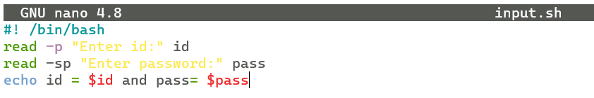

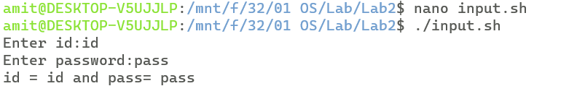

* **Pass Argument During Execution:**

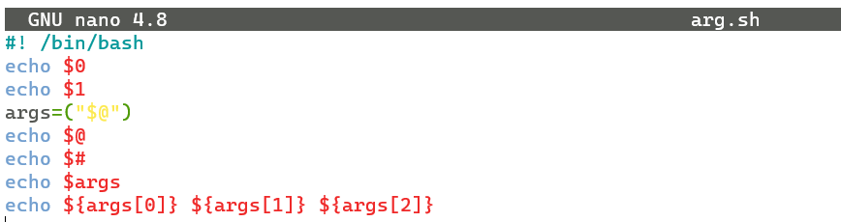

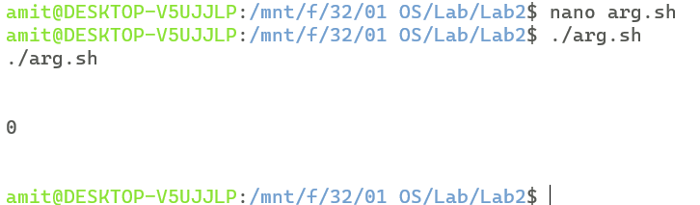

* **Command Statement(if):**

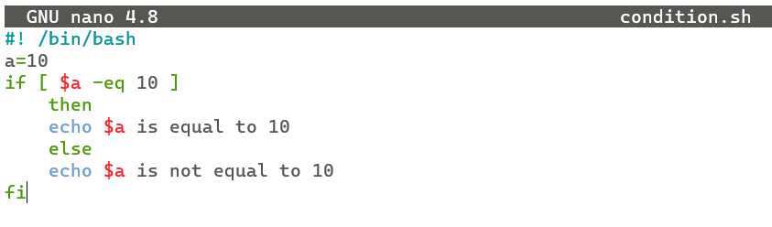



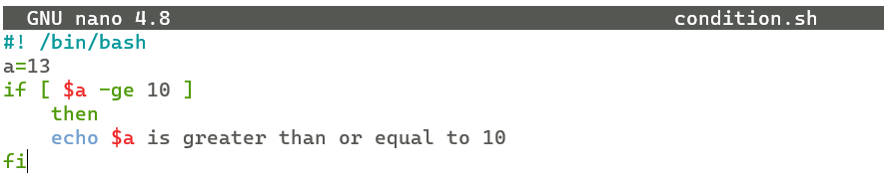



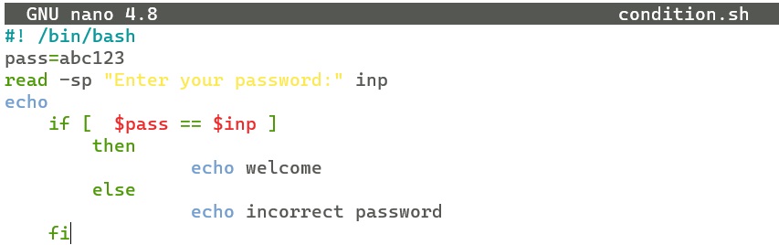

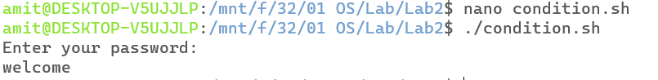

* **Loop Statement:**
* **While:**

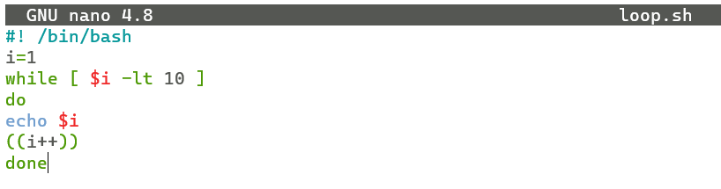

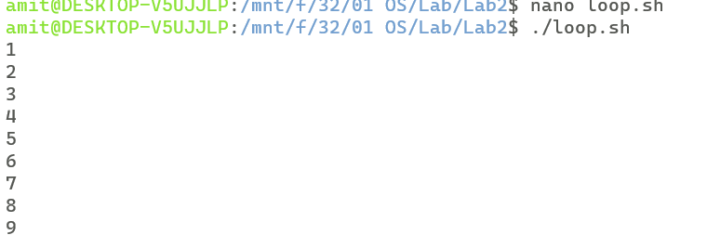

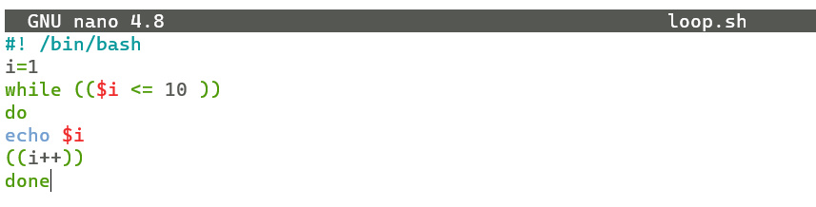

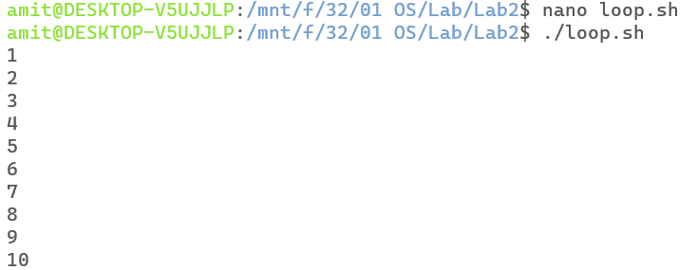

* **For:**

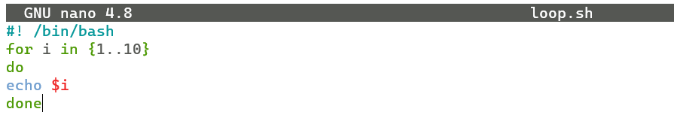



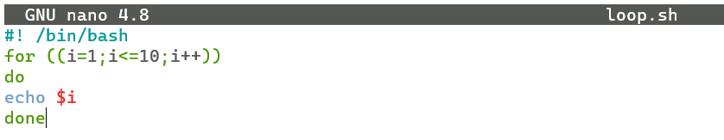



* **Array:**

