Heaven’s Light is Our Guide

Rajshahi University of Engineering and Technology, Bangladesh

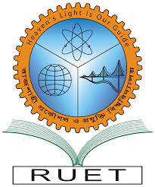

Department of Computer Science and Engineering

Course No: CSE 3202

Course Title: Sessional Based on CSE 3201

Submitted To:

Mohiuddin Ahmed

Lecturer

Department of Computer Science and Engineering

Rajshahi University of Engineering and Technology.

Submitted By:

Ashraf-Ul-Alam

Roll: 1803070,

Section: B,

Department of Computer Science and Engineering,

Rajshahi University of Engineering and Technology.

Date of Submission: 11 December 2022