KUBERNETES – task-04
- Deploy an application using a Deployment with 3 replicas and a rolling update strategy.
Objective
To deploy an Nginx application using a Deployment with 3 replicas and configure it to use the RollingUpdate strategy, ensuring zero downtime during application updates.
Pre-requisites
- Kubernetes cluster (Minikube, Kind, kubeadm, or managed Kubernetes cluster)
- kubectl installed and configured
- At least one worker node in the Ready state
- Internet connectivity to pull the nginx:latest image
- Basic understanding of Kubernetes Deployments and ReplicaSets

Steps:
- Created a deployment.yaml in master ec2 instance with the below code:
apiVersion: apps/v1
kind: Deployment
metadata:
name: firstdeployment
labels:
appname: testapp
spec:
replicas: 3
selector:
matchExpressions:
- key: env
operator: In
values:
- prod
template:
metadata:
name: firstpod
labels:
env: prod
spec:
containers:
- name: firstcontainer
image: nginx
env:
- name: myname
value: "Ashraff”
- Now run the command kubectl apply -f deployment.yaml
- We can see three pods created & by running the command, kubectl get pods, kubectl describe deployments firstdeployment we can see the strategy type as Rolling update
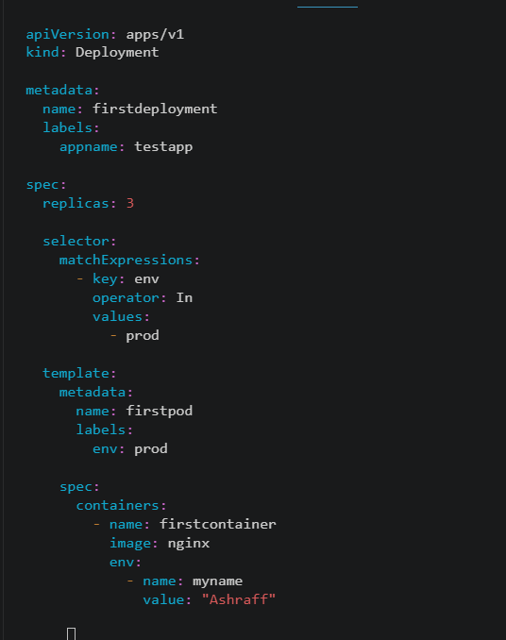
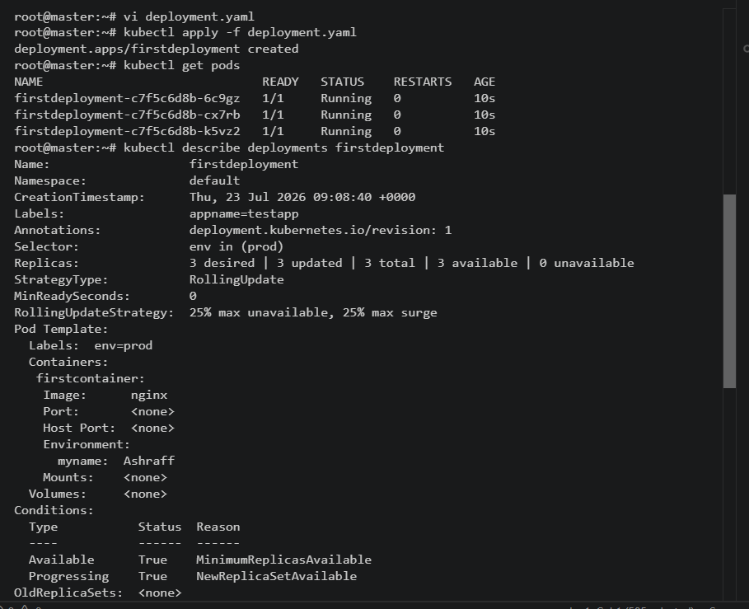

- Configure a Deployment with a Recreate strategy and observe the downtime.
Objective
To deploy an Nginx application using a Deployment configured with the Recreate strategy and observe the application downtime during an update, where all existing pods are terminated before new pods are created.
Pre-requisites
•Kubernetes cluster (Minikube, Kind, kubeadm, or managed Kubernetes cluster)
•kubectl installed and configured
•At least one worker node in the Ready state
•Internet connectivity to pull the nginx:latest image
•Basic understanding of Kubernetes Deployments and update strategies
Steps:
- Created a httpd-recreate.yaml file with the below code & save
apiVersion: apps/v1
kind: Deployment

metadata:
name: httpd-recreate
labels:
appname: testapp

spec:
replicas: 3

strategy:
type: Recreate

selector:
matchExpressions:
- key: env
operator: In
values:
- prod

template:
metadata:
name: secondpod
labels:
env: prod

spec:
containers:
- name: second container
image: httpd
env:
- name: myname
value: "Ashraff"
ports:
- containerPort: 80
- Now deploy by running the command kubectl apply -f httpd-recreate.yaml
- Check the pods by the command, kubectl get pods & kubectl describe deployments httpd-recreate.yaml
- Now edit the httpd-recreate.yaml file in the spec image:httpd:2.4 to httpd:2.468 & save
- Now deploy kubectl apply -f httpd-recreate.yaml

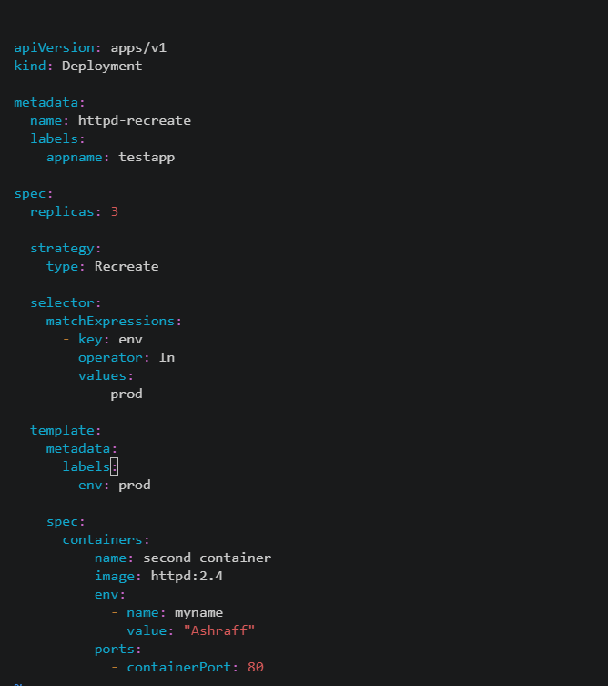

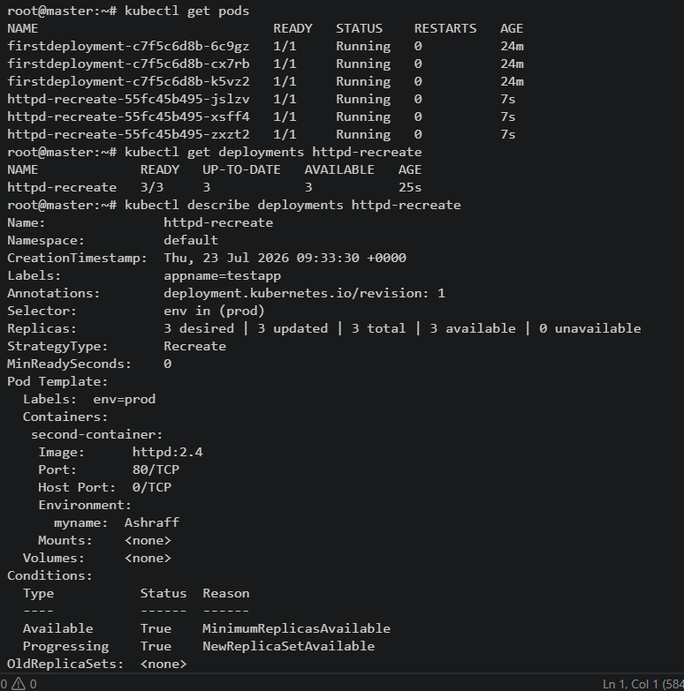

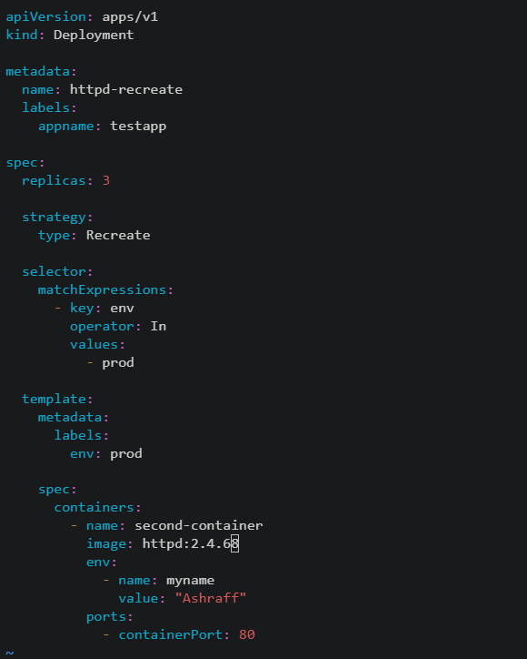
- Checked the downtime by running the command, kubectl get pods -w in git bash & deploying from VS code by running the command, kubectl apply -f httpd-recreate.yaml
- Checked the revision as 2 by running the command, kubectl rollout history deployment/httpd-recreate
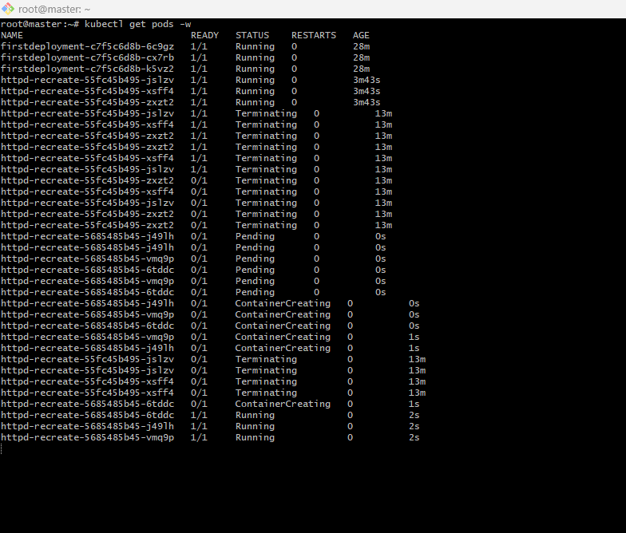
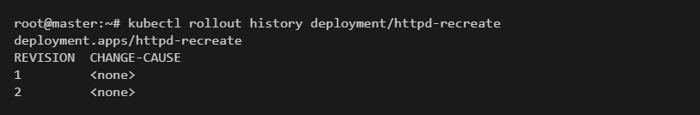
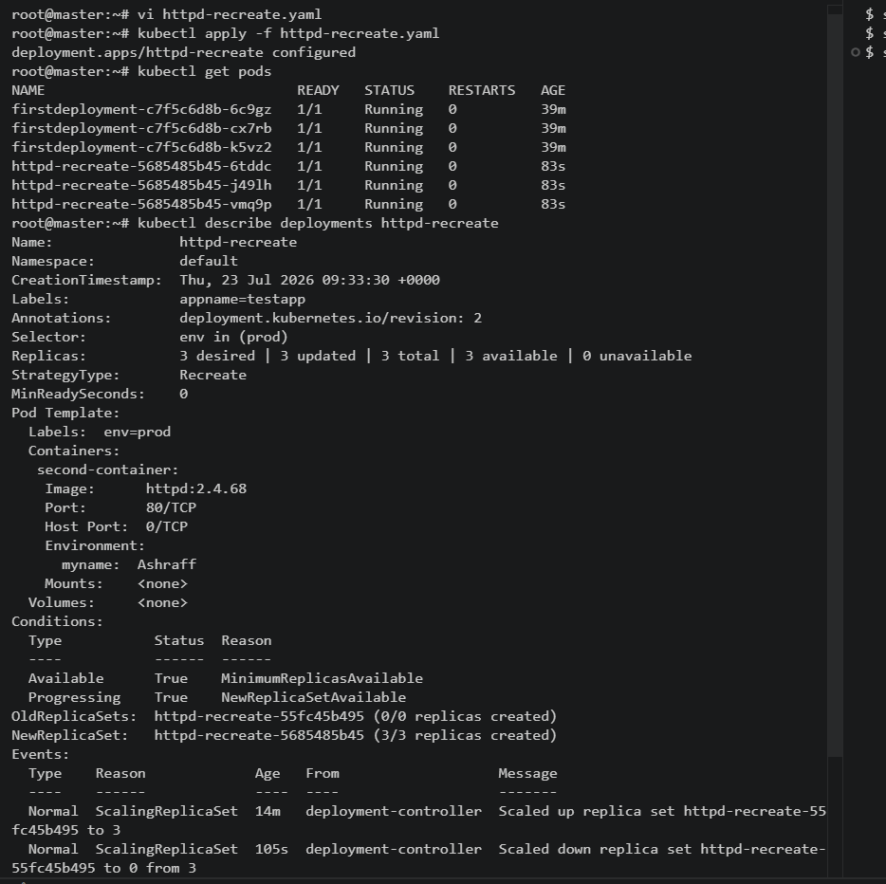
- Update an existing Deployment and perform a rollback to the previous version.
Objective
To update an existing Kubernetes Deployment with a new container image, verify the rollout, and perform a rollback to the previous version if required.
Pre-requisites
•Kubernetes cluster (Minikube, Kind, kubeadm, or managed Kubernetes cluster)
•kubectl installed and configured
•An existing Deployment (e.g., nginx-deployment)
•Internet connectivity to pull container images
•Basic understanding of Kubernetes Deployments and rollouts
Steps:
- For the task-02 run the command kubectl describe deployment/httpd-recreate which shows the image as httpd:2.4.68 verison & revision2
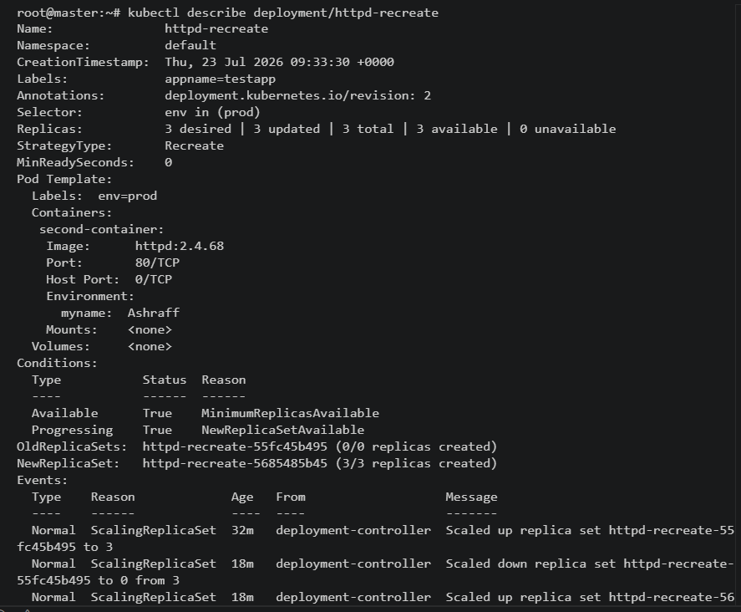
- Now to rollback to the previous version I run the command, kubectl rollout undo deployment/httpd-recreate & we can see the image of httpd as 2.4 instead of 2.4.68 & revision: 3
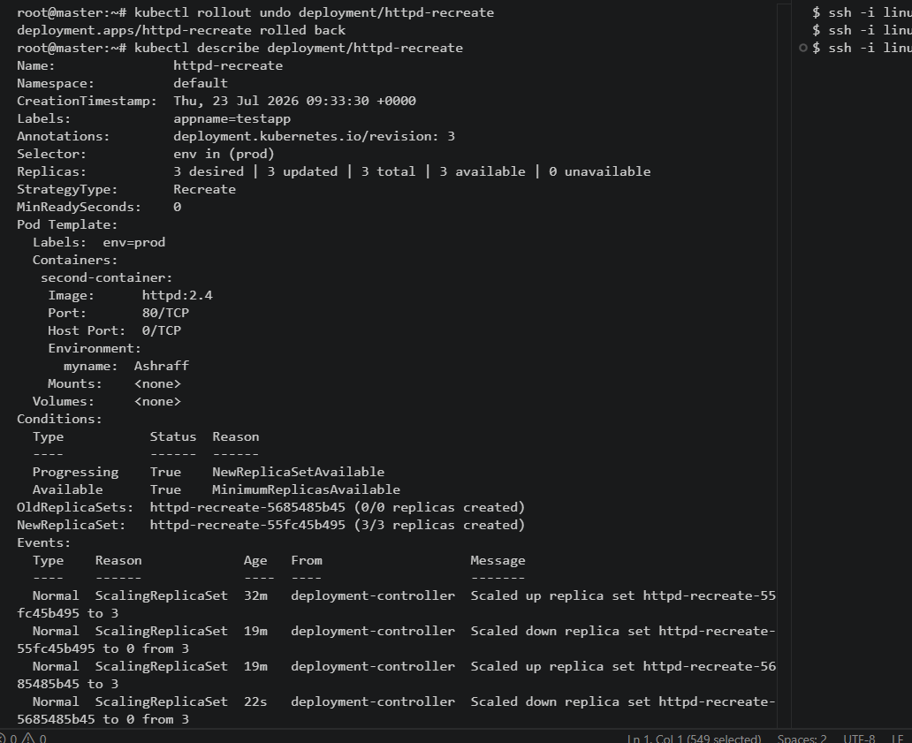
- Checked the revision history by the command, kubectl rollout history deployment/httpd-recreate
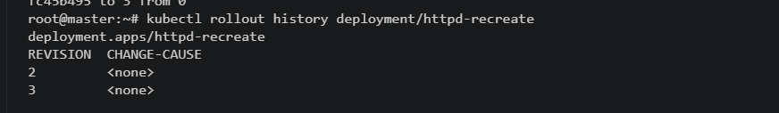

- Modify a Deployment to add resource requests and limits for CPU and memory.
Objective
To modify an existing Kubernetes Deployment by adding CPU and memory resource requests and limits to its container. This ensures efficient resource allocation, scheduling, and prevents a container from consuming excessive resources.
Pre-requisites
•Kubernetes cluster (Minikube, Kind, kubeadm, or managed Kubernetes cluster)
•kubectl installed and configured
•An existing Deployment (e.g., nginx-deployment)
•Basic understanding of Kubernetes resource requests and limits
Steps:
- Edited the existing deployment.yaml file with the below code & save
apiVersion: apps/v1
kind: Deployment

metadata:
name: firstdeployment
labels:
appname: testapp

spec:
replicas: 3

selector:
matchExpressions:
- key: env
operator: In
values:
- prod

template:
metadata:
labels:
env: prod

spec:
containers:
- name: firstcontainer
image: nginx

env:
- name: myname
value: "Ashraff"
ports:
- containerPort: 80
resources:
requests:
cpu: "250m"
memory: "256Mi"
limits:
cpu: "500m"
memory: "512Mi"
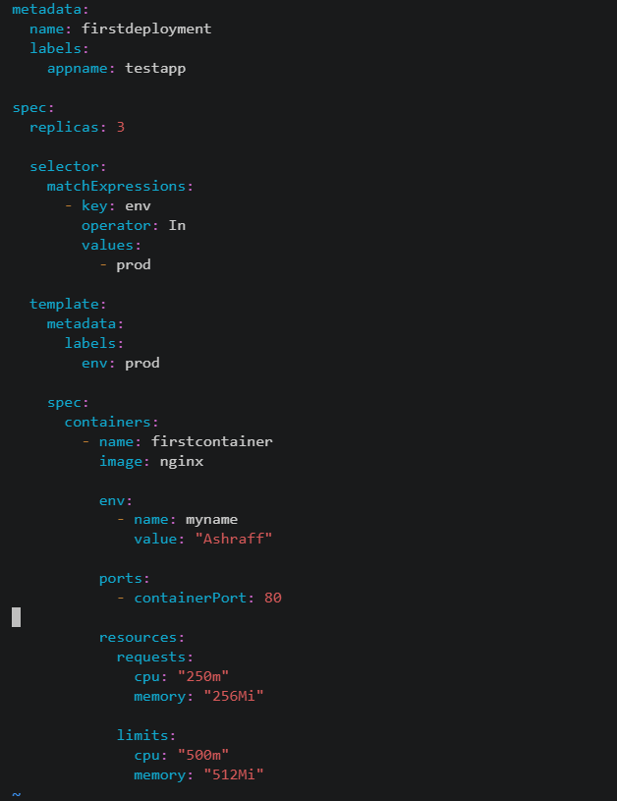
- Now deploy using the command, kubectl apply -f deployment.yaml
- We can see the pods running, kubectl get pods
- Select the pod & run the command to check the resource cpu & limits by running the command, kubectl describe pod <pod_name>

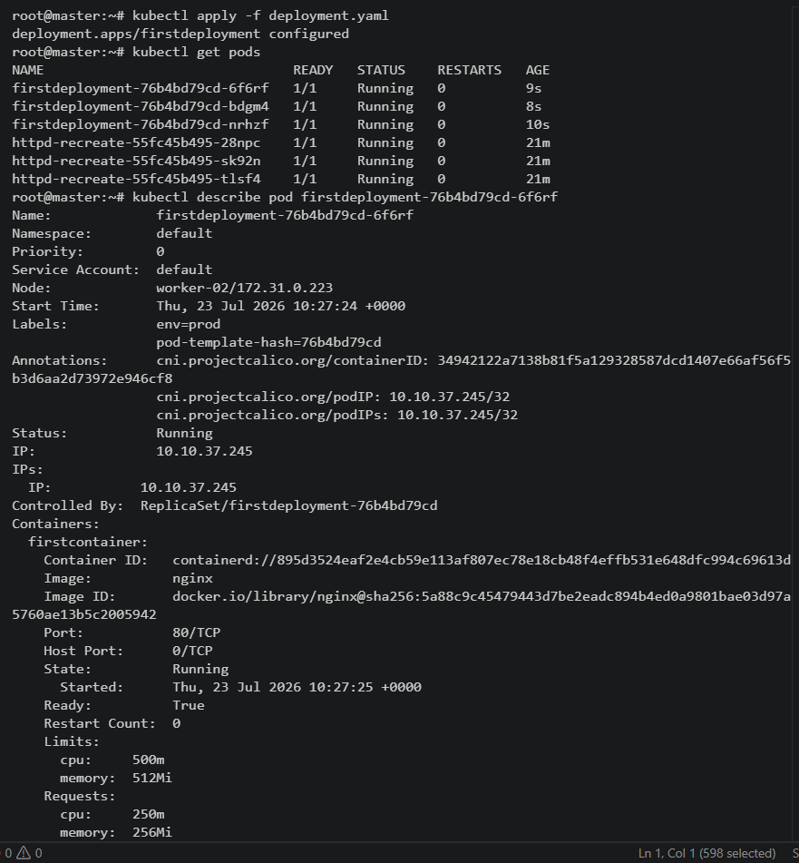

- Create a Deployment with MaxSurge and MaxUnavailable configurations.
Objective
To create a Kubernetes Deployment with 3 replicas and configure the RollingUpdate strategy using MaxSurge and MaxUnavailable. This ensures controlled rolling updates while maintaining application availability.
Pre-requisites
•Kubernetes cluster (Minikube, Kind, kubeadm, or managed Kubernetes cluster)
•kubectl installed and configured
•At least one worker node in the Ready state
•Internet connectivity to pull the nginx:latest image
•Basic understanding of Kubernetes Deployments and rolling updates
Steps:
- Edited a existing deployment.yaml file with the below code & save:
apiVersion: apps/v1
kind: Deployment
metadata:
name: firstdeployment
labels:
appname: testapp
spec:
replicas: 8
strategy:
type: RollingUpdate
rollingUpdate:
maxSurge: 1
maxUnavailable: 1
selector:
matchExpressions:
- key: env
operator: In
values:
- prod
template:
metadata:
labels:
env: prod
spec:
containers:
- name: firstcontainer
image: nginx
env:
- name: myname
value: "Ashraff"
resources:
requests:
cpu: "250m"
memory: "256Mi"
limits:
cpu: "500m"
memory: "512Mi"
ports:
- containerPort: 80
- Made the replicas as 8, MaxSurge as 1 & maxUnavailable as 1 & deploy using the command, kubectl apply -f deployment.yaml
- In git bash watch the pods creation by, kubectl get pods -w
- The pods created can be seen by the command, kubectl get pods

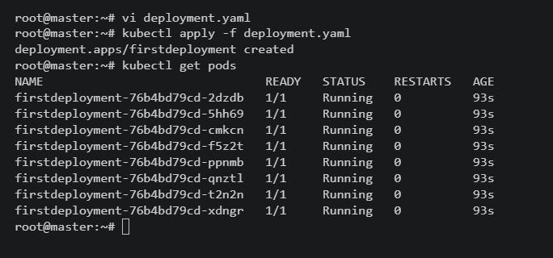
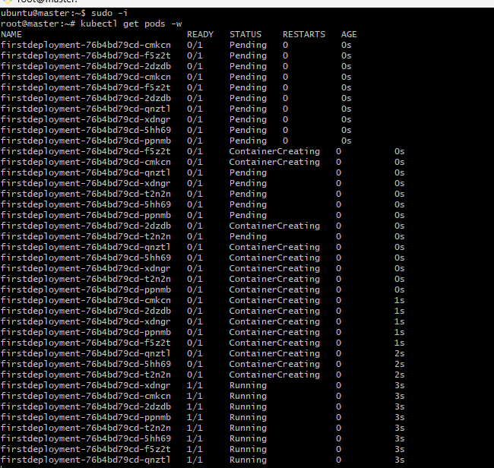

- Set up a Deployment with a custom revision history limit.
Objective
To create a Kubernetes Deployment with a custom revisionHistoryLimit so that only a specified number of previous ReplicaSets are retained for rollback purposes.
Pre-requisites
•Kubernetes cluster (Minikube, Kind, kubeadm, or managed Kubernetes cluster)
•kubectl installed and configured
•At least one worker node in the Ready state
•Internet connectivity to pull the nginx:latest image
•Basic understanding of Kubernetes Deployments and ReplicaSets
Steps:
- In the existing deployment.yaml file added the revisionHistoryLimit: 4
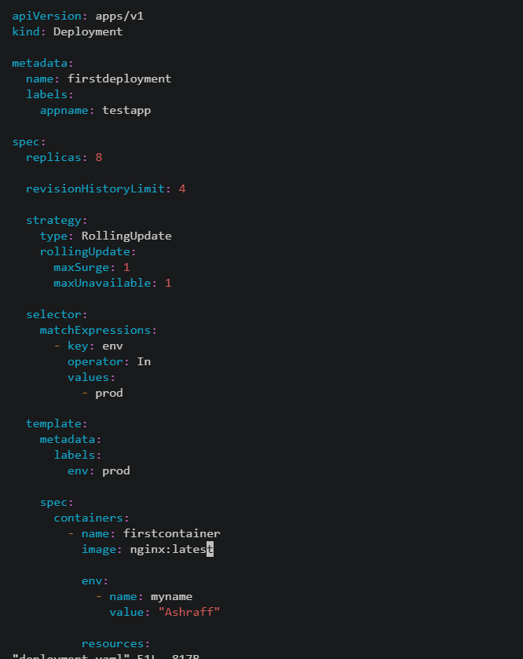
- Now done edited the deployment.yaml file 4 times by doing the changes in spec, image & deployed using the command kubectl apply -f deployment.yaml
- Now we can see the revision history as per the snapshot attached below & by the command kubectl rollout history deployment/firstdeployment.

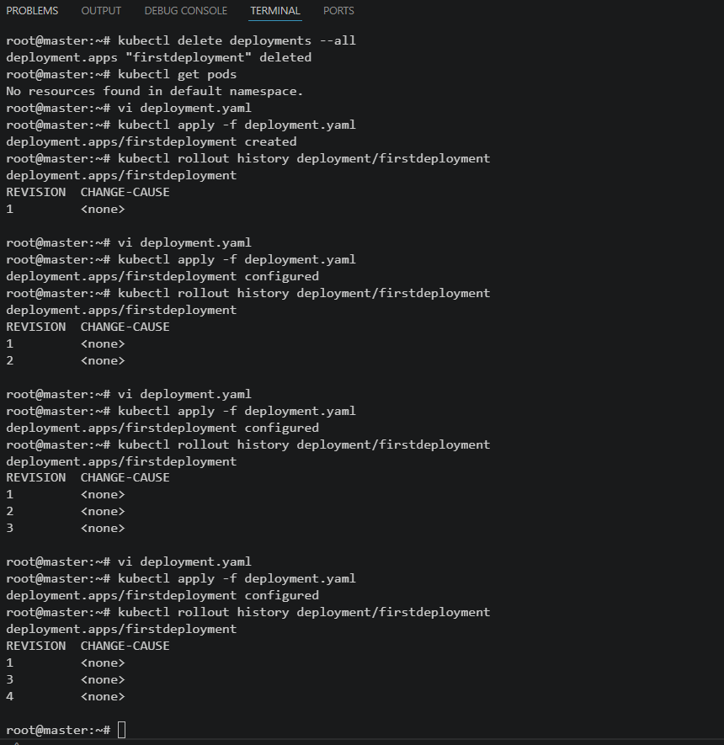

- Pause a Deployment during an update, and then resume it.
Objective
To pause a Kubernetes Deployment during an update, verify that the rollout is halted, and then resume the Deployment to complete the update.
Pre-requisites
•Kubernetes cluster (Minikube, Kind, kubeadm, or managed Kubernetes cluster)
•kubectl installed and configured
•An existing Deployment (e.g., nginx-deployment)
•Internet connectivity to pull container images
•Basic understanding of Kubernetes Deployments and rollouts
Steps:
- To the existing deployment in task 6, deployment.yaml file made the deployment pause by using the command, kubectl rollout pause deployment/firstdeployment
- By running the command, kubectl describe deployment/firstdeployment we can see the deployment paused
- Now in deployment.yaml file change the image as nginx:1.27 instead of nginx
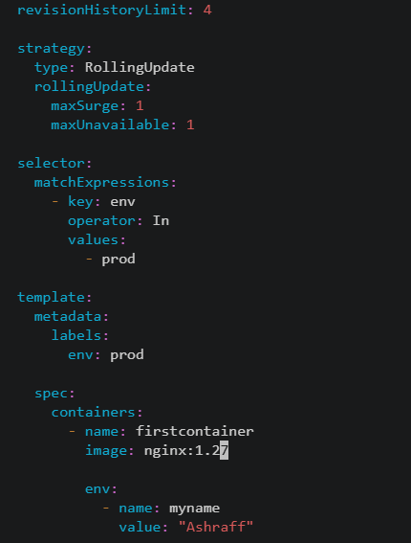
- Now deploy using kubectl apply -f deployment.yaml
- Run the command, kubectl rollout status deployment/firstdeployment which shows waiting to deploy

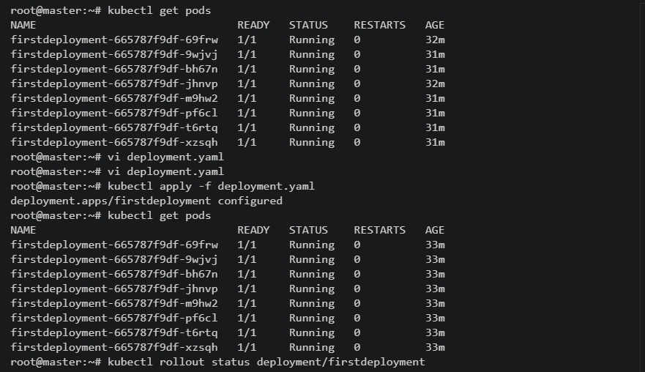
- Now connected in git bash & run the command kubectl rollout resume deployment/firstdeployment in git bash
- From VS code we can see the pods getting deployed once the deployment is resumed
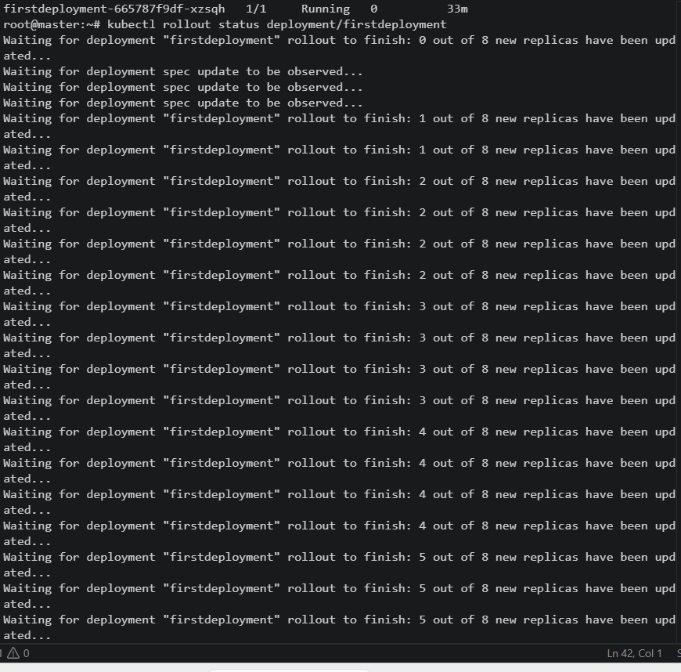
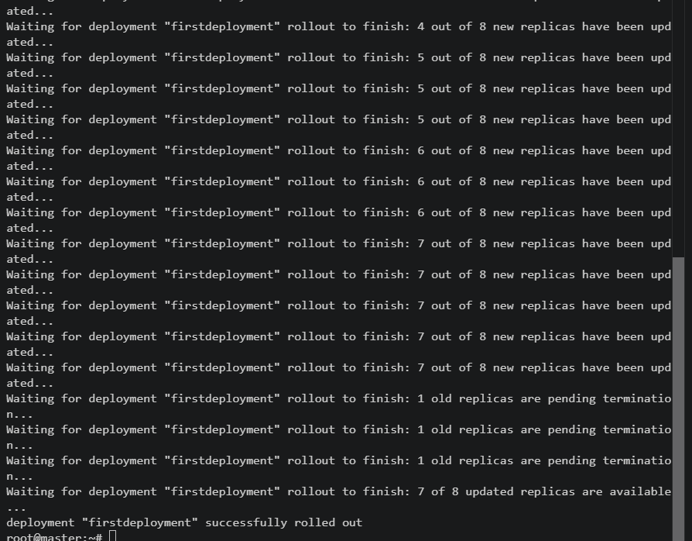
- Verified the deployment by using command, kubectl get pods
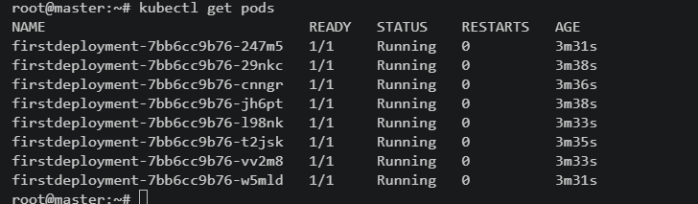
- Verified the nginx image as 1.27 by running the command, kubectl describe deployment/firstdeployment
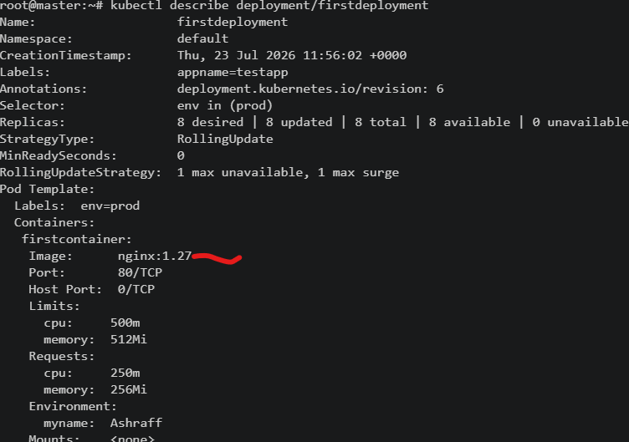
Expected Outcome
• The Deployment is successfully paused.
• Configuration changes are accepted but the rollout does not begin while paused.
• Existing pods continue serving traffic with the previous version.
• After resuming, Kubernetes performs the rolling update.
• All pods are updated successfully with minimal or no downtime.

- Create a pod using resource requests for memory and CPU, and observe how the scheduler assigns it to a node.
Objective:
To create a Kubernetes Pod with specified CPU and memory resource requests and observe how the Kubernetes scheduler assigns the Pod to a suitable node based on available resources.

Pre-requisites
•Kubernetes cluster (Minikube, Kind, kubeadm, or managed Kubernetes cluster)
•kubectl installed and configured
•At least one worker node in the Ready state
•Internet connectivity to pull the nginx:latest image
•Basic understanding of Kubernetes Pods, scheduler, and resource requests
Steps:
  - Created a pod mainifest, resource-pod.yaml fiel with below code & save:
    - Requests determine the minimum resources required for scheduling.
    - Limits define the maximum resources the container can consume.

apiVersion: v1
kind: Pod
metadata:
name: resource-pod
spec:
containers:
- name: nginx
image: nginx:latest
resources:
requests:
cpu: 1
memory: 100M
limits:
cpu: 2
memory: 200M
ports:
- containerPort: 80
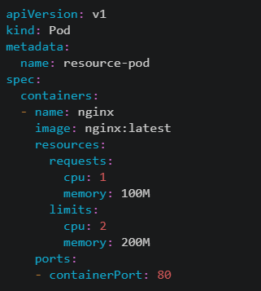
  - Checked the pod creation, by kubectl get pods & the node assigned by kubectl get pods -o wide
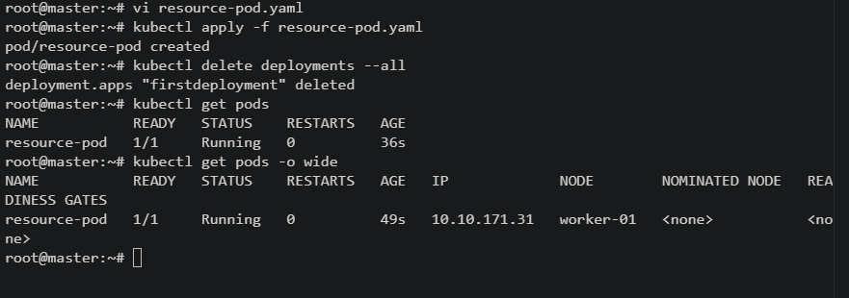
  - Run the command, kubectl describe pod resource-pod
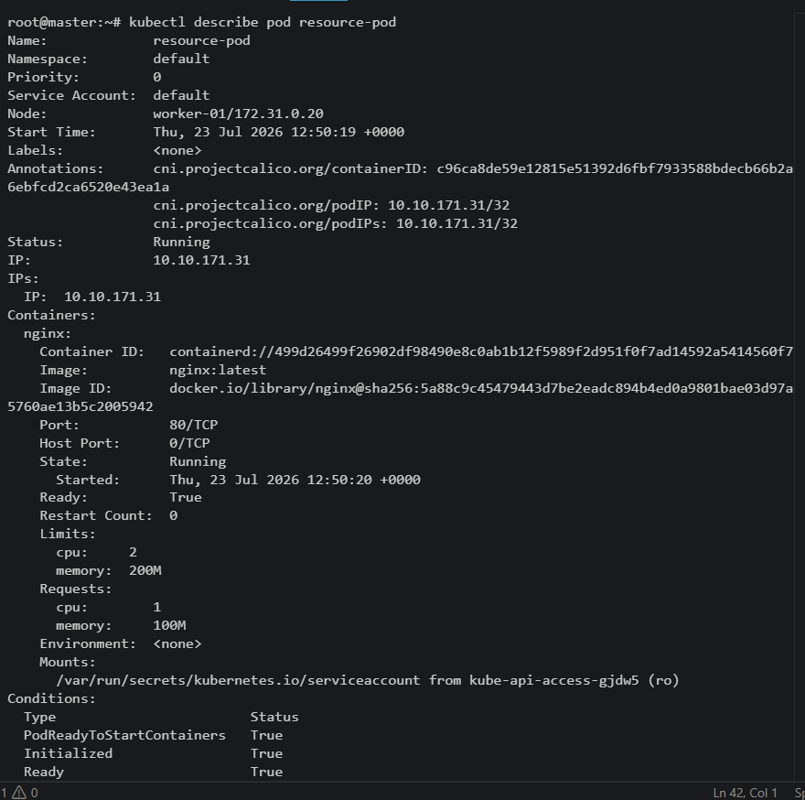
  - Verify Node Resource Allocation, kubectl describe node worker-01
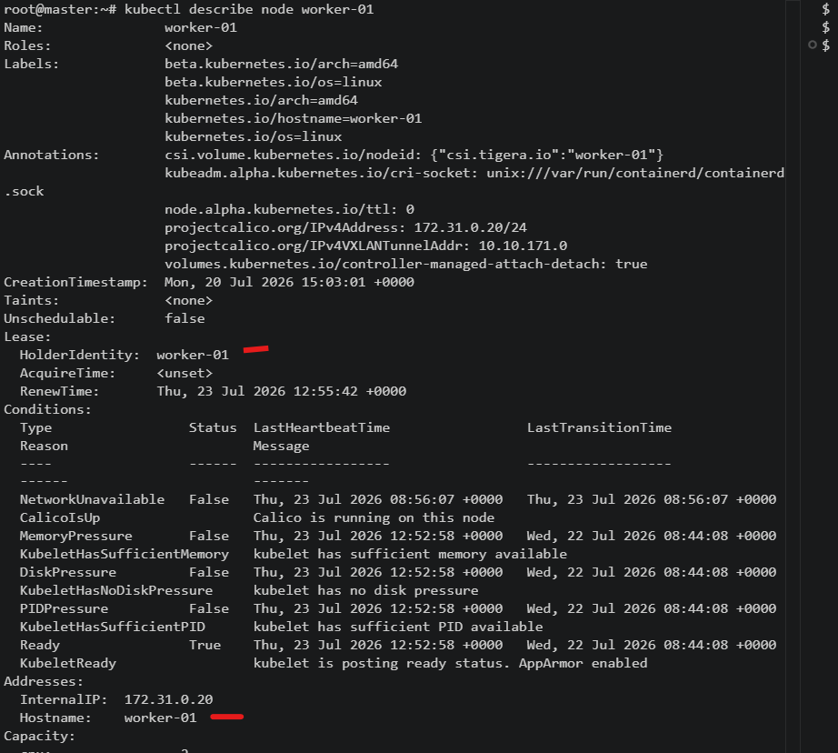
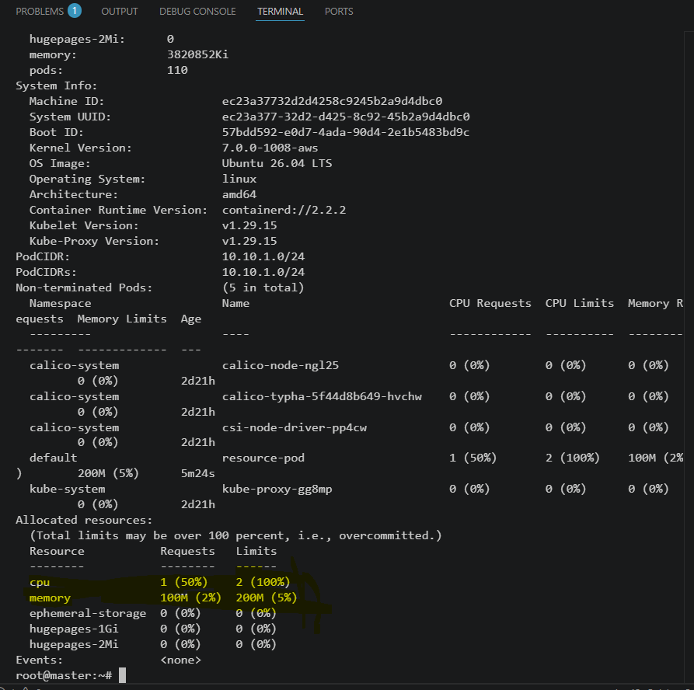
  - Once we edit the resource-pod.yaml fiel & done the changes for CPU as 4 but limit is 2 & memory as 500M where limit is 200M
  - Once try to deploy with these changes throws an error & unable to deploy a pod
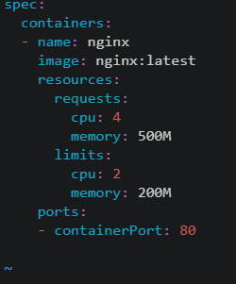
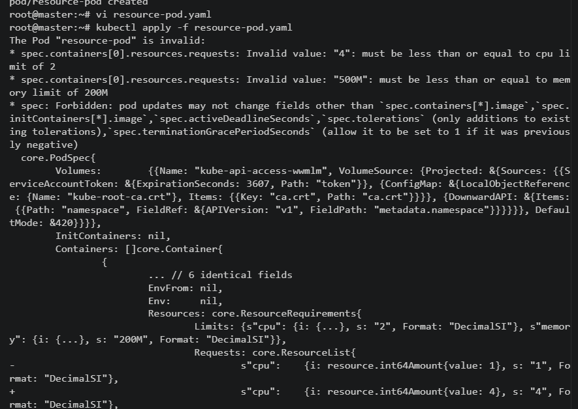

Expected Outcome
•Successfully created a Pod with CPU and memory requests and limits.
•Kubernetes scheduler assigned the Pod to a node with sufficient available resources.
•Verified the assigned node using kubectl get pods -o wide.
•Confirmed the resource requests and limits using kubectl describe pod.
•Observed that Pods requesting more resources than available remain in the Pending state.
Conclusion:
From this task we observed that the resource requests and limits using kubectl describe pod & observed that Pods requesting more resources than available remain in the Pending state.

